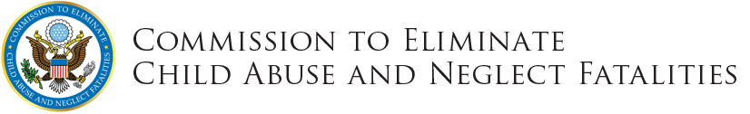

WITHIN OUR ReACH: A NATIONAL STRATEGY TO ELIMINATE CHILD ABUSE AND NEGLECT FATALITIES

Social MEDIA toolKIT

RECOMMENDED Social Media POSTS
Thursday, March 17 at 8am EDT – includes data focused options and editorial options
UPLOAD:
If on Twitter: Upload Image A – DOWNLOAD HERE
If on Facebook: Upload Image B – DOWNLOAD HERE

- Together, we can end child maltreatment fatalities. Read the report and #protectourkids: http://bit.ly/CECANF
- Each year an estimated 1,500-3,000 children die from abuse and neglect. This is preventable. http://bit.ly/CECANF
- Public health and child safety agencies can ensure that the most vulnerable children are seen and supported. http://bit.ly/CECANF
- Child maltreatment fatalities damage communities and our nation. Let's take action. READ: http://bit.ly/CECANF
- We must prioritize innovative solutions to prevent child abuse, not just react to it. READ: http://bit.ly/CECANF

ACCOMPANYING Image ASsets
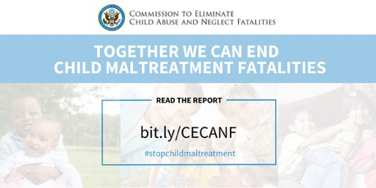
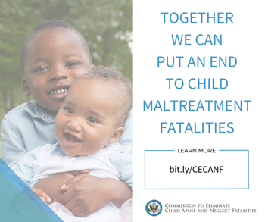
- B.

A. Twitter
DOWNLOAD: CLICK HERE
Image Description: Headline includes the Commission to Eliminate Child Abuse and Neglect Fatalities logo. The copy reads “Together, we can end child maltreatment fatalities,” in white font against a light blue background. Image includes copy that says “read the report,” referring to a link reading bit.ly/CECANF. There is a hashtag that reads #stopchildmaltreatment. In the background are faded images of smiling children.

B. Facebook
DOWNLOAD: CLICK HERE
Image Description: On the left side is a picture of two smiling children. To the right of them, the copy reads “Together, we can put an end to child maltreatment fatalities,” in blue font against a white background. In the bottom right corner, it reads “learn more: bit.ly/CECANF,” above the Commission to Eliminate Child Abuse and Neglect Fatalities logo.

