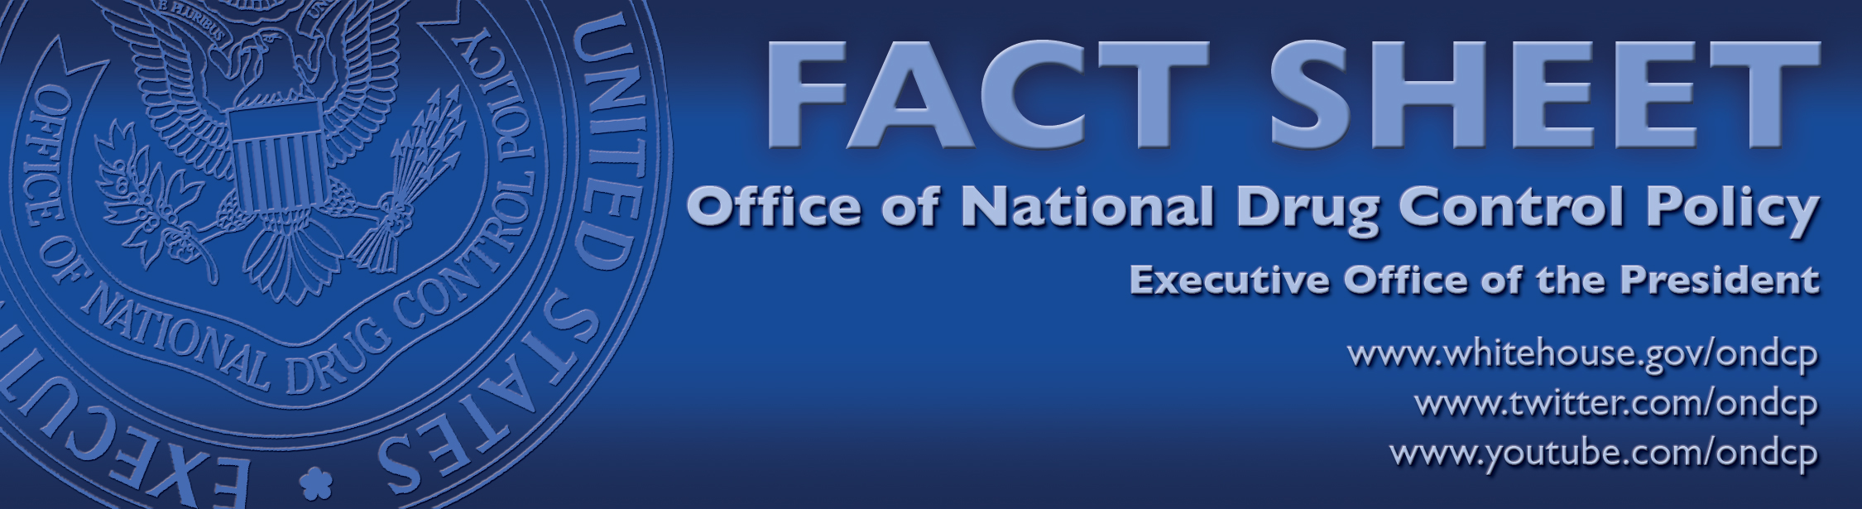

Reducing Drug Demand in the U.S.

Reducing the demand for drugs in the United States is the underlying theme that drives President Obama’s Strategy to reduce the shared threat of drug use and its consequences. By aggressively working to reduce U.S. drug consumption by preventing drug use before it begins and helping Americans suffering from addiction enter treatment, we not only improve public health and safety in the United States, but we also deprive violent Transnational Criminal Organizations of an important source of income.

Ongoing violence between transnational criminal organizations in Mexico has recently spurred increased discussion of drug legalization as a “silver bullet” policy solution. The U.S. continues to oppose drug legalization because evidence shows our shared drug problem is a major public health and safety threat, and drug addiction is a disease that can be successfully prevented and treated. Already, drug use – legal and illegal – is the source of too many social, health, and safety consequences. Research also shows that policies that would make drugs more available would likely not eliminate the black market or improve public health and safety.

Unprecedented Efforts to Reduce Drug Demand in the U.S.
- The Obama Administration’s budgetary commitment to further reduce domestic drug use is real and significant. The President’s National Drug Control Strategy contains specific actions and targets to reduce drug use. Last Fiscal Year (FY11) alone, the United States spent over $10 billion to support drug demand reduction programs, compared to $2.4 billion for international drug control programs.
- In 2011, the Obama Administration provided over $88 million to prevent drug use before it begins as part of the U.S. Drug Free Communities Support Program. These resources are supporting community-based coalitions in over 1,750 communities across the United States to prevent youth substance use.
- In June of 2011, the Obama Administration released the first-ever National Prevention Strategy. The comprehensive plan focuses in part on preventing drug consumption by preventing drug use before it starts.
- The Obama Administration is also the first in history to establish an Office on Recovery at the White House Office of National Drug Control Policy. The office works to advance policies and programs that help provide support to millions of Americans who are in successful recovery from drug or alcohol addiction.
- While still too high, the rate of overall drug use in America has dropped by roughly one-third over the past three decades. More recently, cocaine use has dropped by 43 percent, and meth use in America has been cut by half.
Drug Legalization Will Not Eliminate Organized Crime
- Independent research has shown that legalizing marijuana would not dramatically reduce Mexican drug trafficking revenue. In fact, the gross revenues to Mexican Transnational Criminal Organizations from illegal exports of marijuana to wholesalers in the United States are likely less than $2 billion.
- Transnational Criminal Organizations operating in Mexico do not derive revenue exclusively from drugs, nor would they disband if drugs were legalized. They are increasingly diversified businesses, profiting off human trafficking, kidnapping, extortion, and intellectual property theft, etc.
- The brutal murder of 72 Central American immigrants by the Zeta Criminal Organization in Tamaulipas, Mexico, in 2010 had little to do with drug trafficking. While there certainly is violence connected to drug trafficking and distribution, this violence expands to other arenas as these criminal organizations expand.
- Drug cartels will also find ways to profit even from regulated drug markets. Sweden experimented with providing drugs through a state-regulated process in the 1960s. Unsurprisingly, users soon began to divert drugs to others and often sold them on the black market. During this period of permissive drug-use policies, drug use in Sweden began to rise.
Keeping Drugs Illegal Deters Consumption
Legality increases the availability and acceptability of drugs, as we see with the use of alcohol and tobacco – which far outpaces the use of illegal drugs.
- Laws keeping marijuana use illegal help keep prices higher, which helps hold use rates relatively low. Drug use, as we have seen with tobacco, especially among young people, is known to be sensitive to price.
- More available drugs at a cheaper price with less risk will lead to increased rates of drug addiction. Addictive substances like alcohol and tobacco, which are legal and taxed, already cost much more in social costs than the revenue they generate. The social costs of these two drugs are 10 times the revenue gained by their taxation.
- Two economists who examined the impact on prevalence rates for marijuana after the decriminalization of marijuana through the cannabis cafes found that, initially, there was little measurable impact on Dutch youth cannabis use rates – but that soon changed. As marijuana use became “normalized,” and as there was increased commercialization, youth marijuana use rates soared, from 15 percent for 18-20 year olds to 44 percent.
Increased Drug Availability Leads to Increased Health and Safety Costs
- Already, drug use and its consequences, according to an estimate for 2007, cost the U.S. $193 billion for that year. Greater prevalence of drug use would increase these public health and crime challenges.
- In the U.S., drugs are present in roughly half of all those who commit crimes, ranging from misdemeanors to felonies.
- In addition to the negative health effects of drug use on individual users, drug use is associated with the spread of HIV-AIDS, Hepatitis C, and drugged driving. It is also associated with child neglect and domestic violence.
- One needs to look no further than our current experience with America’s prescription drug abuse epidemic to see how legalization would fail to control health and safety consequences. Prescription drugs are legal, regulated, and taxed – and yet roughly every 19 minutes, someone dies from an unintentional drug overdose in America – driven in large part by prescription drug abuse.

For more information, visit www.WhiteHouse.gov/ONDCP

