CHAPTER 40 – COOPERATION

International Agreements 3
Canada Support – Operational Guidelines 3
Canada Support – Policy 17
Australia Support – Policy 26
Australia Support – Operational Guidelines 33
New Zealand Support – Policy 42
New Zealand Support – Operational Guidelines 47
Mexico Support – Policy 55
Mexico Support – Operational Guidelines 60

Interagency Agreements 66
Interagency Agreement for Air Traffic Control Services Temporary 66
Mobile Air Traffic Control Tower
Interagency Agreement for the Provision of Temporary Support 76
During Wildland Firefighting Operations among the United States
Department of the Interior, the United States Department of
Agriculture, and the United States Department of Defense
Interagency Agreement for Fire Management between the Bureau of 83
Land Management, Bureau of Indian Affairs, National Park
Service, U.S. Fish and Wildlife Service of the United States
Department of the Interior and the Forest Service of the United
States Department of Agriculture
Interagency Agreement for Meteorological and Other Technical 90
Services between the United States Department of Interior, the
United States Department of Agriculture, and the National Weather
Service Land Management
Memorandum of Understanding between the United States 103
Department of Agriculture Forest Service and the United States
Department of the Interior – Bureau of Land Management, Bureau
of Indian Affairs, National Park Service, Fish and Wildlife Service,
and Bureau of Reclamation (Law Enforcement)
International Emergency Assistance Response Process – Operating 107
Plan for USDA Forest Service, Bureau of Land Management,
Assistant Directorate – Resource Use & Protection, Office of Fire
and Aviation Management, International Program Interagency Memorandum of Agreement between U.S. Department 110
of Agriculture – Forest Service, U.S. Department of the Interior –
Bureau of Land Management, and United States Army – Special
Operations Command
Smokejumper Agreement 116
Interagency Agreement between the U.S. Department of Interior –
Bureau of Land Management, and U.S. Department of
Agriculture – Forest Service, for the Joint Operation of
Smokejumper Resources

Modular Airborne Firefighting System Agreements 118
Agreement between North Carolina Department of Natural Resources
and Community Development, Division of Forest Resources, and
Forest Service – United States Department of Agriculture
Agreement between California – Department of Forestry, the
National Guard, and USDA – Forest Service, Pacific Southwest
Region
Collection Agreement between Wyoming State Forestry Division
and the Forest Service – United States Department of Agriculture

International Agreements

Canada Support - Policy

CANADA / UNITED STATES RECIPROCAL FOREST
FIRE FIGHTING ARRANGEMENT

Dated: January 15, 2011

Operating Plan for 2011

Contents

1. Purpose
2. Definitions
3. Authority
4. General Procedures
4.1 Requests for Wildland Fire Management Assistance
4.2 Personnel
4.3 Equipment and Supplies
4.4 Aircraft
4.5 Withdrawal
4.6 Invoicing and Payment
5. Situation Report
6. Authorization and Amendments
7. Participating Agencies

Annex A Directory of Designated Officials
Annex B Arrangement in the Form of an Exchange of Notes between the Government of Canada and the Government of the United States of America
Annex C Wildland Suppression Assistance Act (United States)

Operating Plan

1. Purpose

This Operating Plan is to facilitate mutual assistance in wildland fire between Canada and the United States of America (USA). This Plan does not override or supersede any existing cooperative wildland firefighting arrangements such as border agreements as specified in Annex B, paragraph (k). Local agencies sharing common international borders are encouraged to enter into "Border Agreements" to facilitate pre-suppression and suppression on fires posing common threat.

2. Definitions

“Arrangement” means the Arrangement for the Exchange of Wildland Fire Management Resources between Canada and the United States of America Participants dated May 7, 1982;

“CIFFC” means the Canadian Interagency Forest Fire Centre Inc.; the Coordinating Authority for the Canadian Participants;

“Designated Official” means officials from the Participants authorized to request and to receive wildland fire management resources;

“NICC” means the National Interagency Coordination Center; the Coordinating Authority for the American Participants;

“Participant” means a Canadian or American signatory to this Arrangement;

“Plan” means the annual Operating Plan

“Receiving Participant” means a Participant receiving Wildland Fire Management Resources under this Plan;

“Sending Participant” means a Participant sending Wildland Fire Management Resources under this Plan;

“Wildland” means an area in which development is essentially non-existent, except for roads, railroads, powerlines, and similar transportation facilities and where structures, if any, are widely scattered;

“Wildland Fire” means unplanned or unwanted natural or human-caused fire (i.e., forest, range or bush fire), regardless of the ignition source, damages or benefits; and

“Wildland Fire Management Assistance” means assistance in the prevention or management of wildland fire under this Plan;

“Wildland Fire Management Resources” means personnel, aircraft, equipment, and supplies available or potentially available for wildland fire management assistance.

3. Authority

The Canada/United States Reciprocal Forest Fire Fighting Arrangement which was concluded by an exchange of Diplomatic Notes on May 7, 1982 (Annex B) and further defined in Public Law 101-11 [(HR 829) (Annex C)].

4. General Procedures

4.1 Request for Wildland Fire Management Assistance

Requests for assistance shall be carried out through the countries respective Coordinating Authority.

4.1.1 Requests for assistance from Canada to USA shall be placed by NICC to CIFFC.

4.1.2 Requests for assistance from the USA to Canada shall be placed by CIFFC to NICC.

4.1.3 CIFFC and NICC separately shall be responsible for providing the names of the Canadian and American designated officials by January 15 each year as specified in Annex B, paragraph (e).

4.1.4 For general information on Invoicing and payment as per Clause 4.6, or other correspondence: for the Canadian Participants it shall be CIFFC and for USA Participants, it shall be NICC.

4.1.5 To minimize delays at border crossings for Customs & Immigration clearances, CIFFC or NICC shall supply to the Customs & Immigration Point of Entry (PoE), along with all transport and arrival information, in the form specified, 24 hours prior to mobilization, containing but not limited to the following items.

a) Personnel: The Full Name, Citizenship, Date and Country of Birth, Home Base and Departure Point.

b) Equipment: The Item, Quantity and Serial or Identification Numbers, Carrier and Bill of Lading Number, Country of Manufacturing.

c) Aircraft: The Registration Number, Call Sign, Aircraft type, Flight Crew Information (same as Personnel) and Registered Owner.

4.1.6 Customs Declaration forms shall be completed for presentation to Customs & Immigration at PoE.

4.2 Personnel

4.2.1 Reimbursement for personnel shall be on the following basis:

a) The Receiving Participant shall be responsible for the payment of, or shall reimburse the Sending Participant in relation to, all salaries; associated benefits; overtime and hazard pay submitted for payment by the Sending Participant in accordance with salary schedules and/or union contracts in existence with the Sending Participant.

b) The costs of travel, per diem, vehicle hire, communication equipment, medical insurance as well other expenditures approved by the Receiving Participant and supported by receipts shall be reimbursed to the Sending Participant when the Receiving Participant cannot provide these services.

c) Where lodging and meals are not provided by the Receiving Participant, expenses shall be reimbursed under the Sending Participant per diem regulations.

4.2.2 An acceptable daily flat rate, established and documented prior to mobilization for overhead and crew personnel, may be used in lieu of Clauses 4.2.1a.

a) The flat rate shall include all salaries, associated benefits, overtime, and hazard pay.

b) The costs of travel, per diem, vehicle hire, communication equipment, medical insurance as well other expenditures approved by the Receiving Participant and supported by receipts shall be reimbursed to the Sending Participant when the Receiving Participant cannot provide these services.

c) Where lodging and meals are not provided by the Receiving Participant, expenses shall be reimbursed under the Sending Participant per diem regulations.

4.2.3 The parties to this Arrangement may request specialized expertise for wildland fire requirements.

4.2.4 The Receiving Participant should send documentation outlining the requirements of the position requested. The Sending Participant will make every effort to ensure, that the personnel sent meet the requirements as listed. The Receiving Participant shall accept the Sending Participant personnel qualifications, as equivalent.

4.2.5 Any change in assignment position, from that which was originally ordered, shall be sanctioned by either the on site Agency Representative (AREP) or the Sending Participant Designated Official.

4.2.6 When appropriate the Sending Participant and Receiving Participant will provide for adequate liaison.

a) The AREP from the Sending Participant will be responsible for the health, safety, welfare and commissary needs of the Sending Participant personnel.

b) CIFFC or NICC may request an Interagency Resource Representative (IARR) to assist at the respective National Interagency Centre/Center, to assist in the mobilization of their resources.

c) The national IARR through their Coordinating Authority may request assistance at the Regional Centre. The regional IARR shall coordinate the resources and AREPs’ assigned to that region and shall report to the national IARR.

4.2.7 All Sending Participant personnel shall receive an orientation session prior to deployment and a debriefing prior to demobilization, by the Receiving Participant.

4.2.8 Personnel shall be prepared for a 19 day mobilization including 14 day assignment duration. The first day of the 14 day assignment is defined as the first full work day including orientation.

4.2.9 All personnel shall carry a passport or two pieces of identification (a government-issued photo identification, such as a driver’s licence AND either a birth certificate or a citizenship card).

Note: Any felony or criminal conviction may prohibit mobilization to the Requesting country.

4.2.10 An individual who is deemed inadmissible due to minor criminal/felony offences may be required to undergo an interview process with Immigration. All costs associated with the process shall be paid by the individual or the Sending Participant.

4.2.11 Controlled substances (i.e. prescription drugs) must remain in their original labelled container or be accompanied by the prescription.

4.2.12 The Sending Participant shall provide all the safety equipment required to meet its regulations. Should additional equipment be required by the Receiving Participant, the Receiving Participant shall supply at their expense.

4.2.13 The Receiving Participant shall insure that immediate medical services are provided to any member of the incoming Sending Participant personnel regardless of the nature of the requirement or the type of medical aid required. Costs for medical services shall be covered by the Receiving Participant until the employee is returned to the fireline or Sending Participant.

4.2.14 Compensation claims for death or long term injury to Sending Participant personnel shall be processed through the Sending Participant workers compensation program and shall be invoiced to the Receiving Participant as specified in Annex B, paragraph (h).

4.2.15 In the event of an accident or incident involving the Sending Participant personnel, the Sending Participant should be invited to be part of the investigation team and process.

4.2.16 Personal cargo weight shall be a total of 29.5 kg (65 lbs), which includes a personal or deployment pack of 20.4 kg (45 lbs) and a line pack of 9.1 kg (20 lbs). Additional cargo must be identified and approved by the Lending and Receiving Participant.

Note: For US mobilization, the 29.5 kg (65 lbs) weight limit includes the US fire shelter which will be issued by the US.

4.3 Equipment and Supplies

4.3.1 Equipment provided by the Sending Participant remains the property of the Sending Participant.

4.3.2 Equipment provided to the Sending Participant by the Receiving Participant remains the property of the Receiving Participant.

4.3.3 Expendable equipment and supplies shall be considered purchased on delivery, and full replacement costs shall be reimbursed by the Receiving Participant. Items should be considered expendable if they are not reusable and/or refurbishable.

4.3.4 Non-expendable equipment and supplies shall be returned to the Sending Participant by the Receiving Participant. The Receiving Participant shall reimburse the Sending Participant for all replacement or refurbishing cost unless the Sending Participant agrees that the Receiving Participant will refurbish the equipment and supplies.

4.3.5 In the event that any equipment and/or supplies are damaged beyond repair or not returned, they shall either be:

a) Replaced by the Receiving Participant with new equipment and/or supplies of the same quality and to the Sending Participant's standard.

b) Full replacement cost shall be reimbursed by the Receiving Participant to the Sending Participant.

4.3.6 Some specialized equipment may be accompanied by trained technicians and/or operators to ensure safe and efficient set-up and operation of equipment.

4.3.7 It is recommended that all equipment and/or supplies be registered in the specified format with the respective lending country Customs authority prior to mobilization.

4.3.8 All transportation costs of equipment and/or supplies sent by the Sending Participant shall be reimbursed by the Receiving Participant.

4.4 Aircraft (This section applies to government contracted and government owned aircraft.)

4.4.1 Reimbursement shall be made on the following basis with the rate to be established and approved prior to mobilization:

a) All fees associated with the mobilization shall be reimbursed by the Receiving Participant.

b) Minimum contract guarantees shall be reimbursed by the Receiving Participant unless the aircraft is used solely to transport personnel between countries.

c) Unless otherwise agreed upon between parties to this Arrangement, maintenance and/or damage to the aircraft are the responsibility of the contractor and/or owner, and is not reimbursable. Damage to an aircraft caused as a direct result of Participant personnel actions are the Receiving Participant responsibility and are reimbursable.

d) There shall be no charge for days where the aircraft is unserviceable, but may be prorated for partial days.

4.4.2 All aircraft shall meet the Receiving Participant specifications for standards and pilot qualifications and shall be inspected by the Receiving Participant prior to being put into service.

4.4.3 Flight following procedures and protocol shall be defined prior to mobilization.

4.4.4 Aircraft shall have North American Free Trade Agreement (NAFTA) Operating Certificate to operate in the Receiving Participant country.

4.4.5 In the event of an accident or incident involving the Sending Participant aircraft, the Sending Participant should be invited to participate in the agency investigation process.

4.5 Withdrawal

The Sending Participant may withdrawal its’ Wildland Fire Management Resources from the Receiving Participant with 24 hours notice.

4.6 Invoicing and Payment

Invoicing and payment procedures are as follows:

4.6.1 Invoicing and payment provisions as specified in Annex B, paragraph (d) should provide for direct payment to the Sending Participant as specified Clauses 4.2.1 or 4.2.2, 4.3.3, 4.3.4, 4.3.5, 4.3.8, and 4.4.1.

4.6.2 Invoices for goods and services, provided by Canada to the United States, and United States to Canada shall be paid in United States currency. All invoices in Canadian currency shall be converted to US currency using the exchange rate on the “close of business day”. The date of the billing invoice shall be used as the conversion date.

4.6.3 All interest charges shall be forgiven for overdue accounts on Government to Government invoices provided payment is made within 4 months of the last date of invoicing document being received by the Receiving Participant.

4.6.4 Invoicing shall include the following:

a) A cover letter identifying the specific resource/reference number(s).

b) An original itemized invoice.

c) Backup documentation shall provide a complete list of cost incurred by the Sending Participant.

d) Backup documentation shall not be required for flat rate invoicing as provided in Clause 4.2.2 a, except for expenses incurred by the Sending Participant as per Clauses 4.2.2 b and 4.2.2 c.

4.6.5 Canadian invoices will be sent to the following address:

National Interagency Fire Center
USDA Forest Service
c/o Financial Manager
3833 South Development Avenue
Boise, ID 83705-5354

4.6.6 United States invoices will be sent to the Canadian agency that requested the resource. Individual agency addresses are listed in the Directory of Designated Official in Annex A.

5. Situation Reporting

CIFFC and NIFC will exchange daily wildland fire situation reports throughout the period of the normal fire season. The report should include information about the:

Number of Fires
Resources Committed
Weather
Potential for Large Fire Occurrence
Problem Fires

6. Authorization and Amendments

The Operating Plan may be amended at any time with the concurrence of the Participating Agencies as specified in Clause 7.

7. Participating Agencies

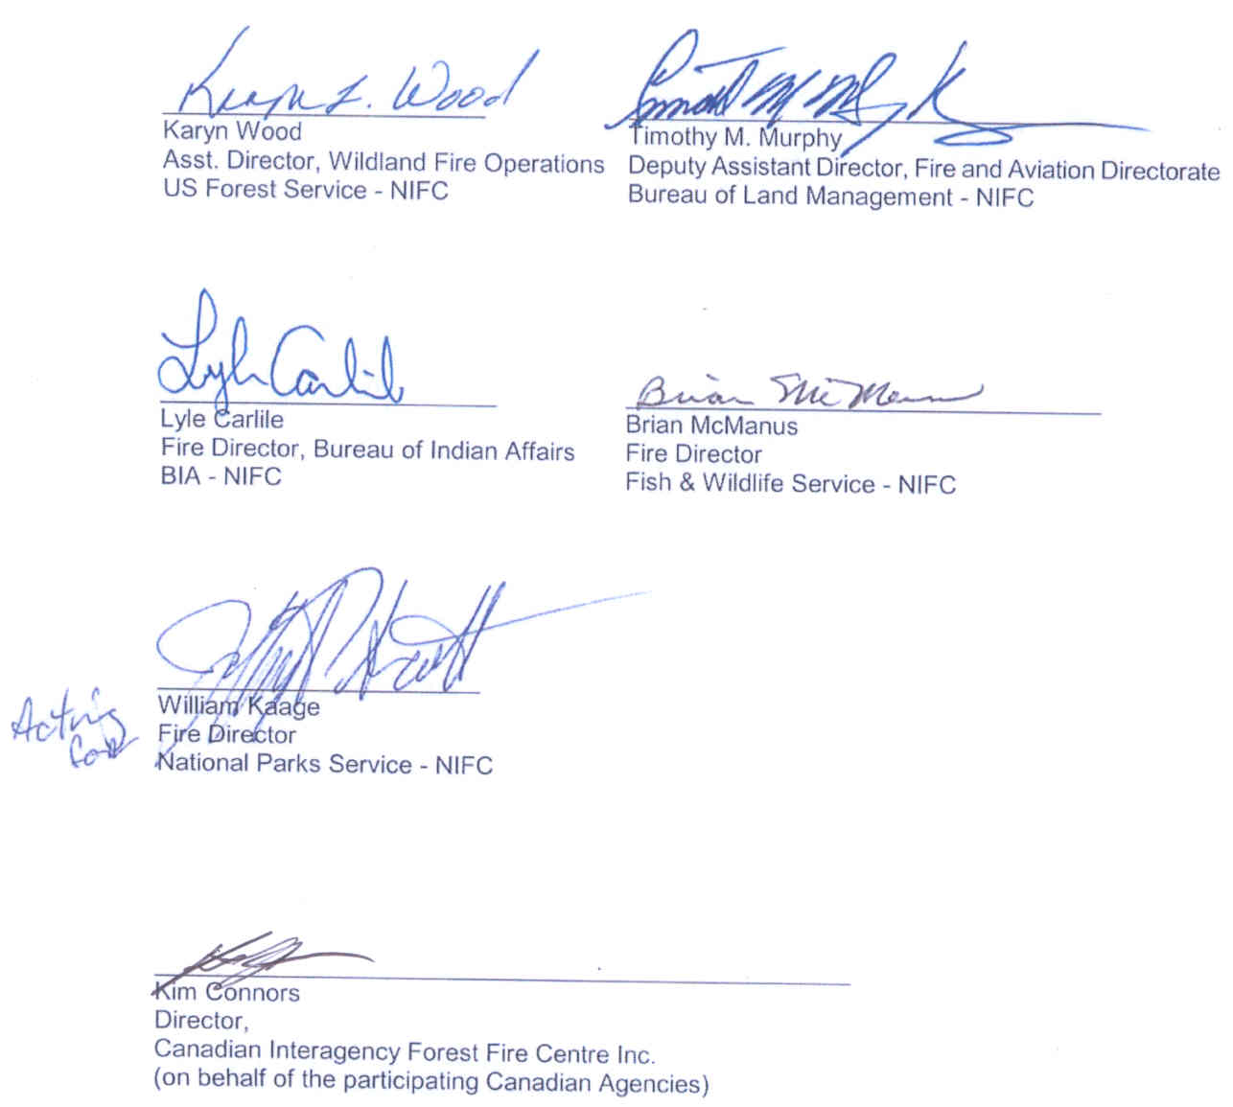

DIRECTORY OF DESIGNATED OFFICIALS

CANADA

Canadian Interagency Forest Fire Centre Inc.

Connors, Kim Canadian Interagency Forest 204-784-2030
Director Fire Centre Cell 204-250-1990
210 - 301 Weston Street Fax 204-956-2398
Winnipeg, Manitoba Email kim.connors@ciffc.ca
R3E 3H4

Duty Officer " 204-784-2030
CIFFC Fax 204-956-2398
Email ciffc@ciffc.ca

British Columbia

Simpson, Brian Forest Protection Branch 250-387-6368
Director Ministry of Forests and Range 250-387-1717 (24 hr)
Building A, 2nd Floor, Fax 250-387-5964
2957 Jutland Road Email brian.simpson@gov.bc.ca
Victoria, B.C.
V8W 3E7

Provincial Fire Control Officer “ 250-387-1717 (24 hr)
(Duty Officer) Fax 250-387-5964
Email provfire@gov.bc.ca

Yukon

Colbert, Ken Wildland Fire Management 867-456-3904
Director, Protective Services Protective Services Branch Cell 867-334 -1894
P.O Box 2703 Fax 867-667-3191
Whitehorse, YT Email ken.colbert@gov.yk.ca
Y1A 2C6

Yukon Duty Officer " 867-667-3128
Fax 867-667-3148
Email YDO@gov.yk.ca

Alberta

Boyd, Hugh Sustainable Resource Development 780-427-6807
Executive Director Forest Protection Division Fax 780-422-7230
Branch 10th floor, 9920-108 Street Email Hugh.Boyd@gov.ab.ca
Edmonton, Alberta

T5K 2M4

Duty Officer " 780-415-6460
Fax 780-422-7230
Email pffc.wfops@gov.ab.ca

Northwest Territories

Mawdsley, William Forest Management Division 867-872-7705
Director, Forest Mgmt Dept. of Resources, Wildlife & Fax 867-872-2077
Economic Development Email William_Mawdsley@gov.nt.ca
Box 7, Fort Smith, NT
X0E 0P0

Duty Officer " 867-872-7710
Fax 867-872-2077
Email forest_management@gov.nt.ca

Saskatchewan

Roberts, Steve J. Saskatchewan Environment 306-953-2206
Executive Director, Fire Fire Mgmt & Protection Branch Fax 306-953-3575
Mgmt & Protection Branch P.O. Box 3003, Hwy #2 North Email steve.roberts@gov.sk.ca
Prince Albert, SK, S6V 6G1

Duty Officer " 306-953-3430
Fax 306-953-2530
Email ffmbdispatch@gov.sk.ca

Manitoba

McTavish, Blair Manitoba Conservation 204-945-6647
Director, Headquarters Operations Cell 204-793-4927
Headquarters Operations Box 44, 200 Saulteaux Crescent Fax 204-945-7782
Winnipeg, Manitoba Email blair.mctavish@gov.mb.ca
R3J 3W3

Duty Officer " 204-945-5252
Fax 204-945-7782
Email hqfire@gov.mb.ca

Ontario

Wheeler, Ralph Aviation & Forest Fire Mgmt 705-945-5937
Director, Ministry of Natural Resources Fax 705-945-5959
Aviation & Forest Fire 70 Foster Drive, Suite 400, Email ralph.wheeler@ontario.ca
Management Branch Sault Ste. Marie, Ontario,
P6A 6V5

Duty Officer “ 705-945-5751
Cell 705-255-1505
Fax 705-945-5785
Email meoc-duty.mnr@ontario.ca

Québec

Fortin, Julie Ministère des Ressources naturelles 418-627-8642 x4037
Liaison avec SOPFEU Direction de la Conservation Fax 418-643-2368
des forêts Email julie.fortin@mrn.gouv.qc.ca
880 chemin Sainte-Foy - 6^{è} étage
Québec (Québec) G1S 4X4

Normand, Daniel Société de protection 418-871-3341 x5420
Directeur du centre des forêts contre le feu Fax 418-874-2629
provincial de lutte Aéroport international Jean-Lesage Cell 418-564-3310
715 - 7^{ième} rue Email dnormand@sopfeu.qc.ca
Sainte-Foy, Québec, G2G 2S7

Officier en devoir (Duty Officer) “ 418-871-3341
April - Oct Cell 418-564-3310
Fax 418-874-2629
Email cpl@sopfeu.qc.ca

New Brunswick

Conn, Stephen N.B. Dept. of Natural 506-453-2530
Manager, Resources Direct Line 506-453-6171
Forest Fire Mgmt 1350 Regent Street, Fax 506-453-2412
Fredericton, N.B.E3C 2G6 Email Stephen.conn@gnb.ca

Duty Officer " 506-453-3335
Fax 506-453-2412
Email provincial.firecentre@gnb.ca

Nova Scotia

Fanning, Walter Forest Protection 902-758-7236
Manager, Forest Protection Dept. of Natural Resources Fax 902-758-3210
P.O. Box 130 Email fanninwf@gov.ns.ca
Shubenacadie, N.S., B0N 2H0

Duty Officer 902-758-7230
Fax 902-758-3210
Email protinfo@gov.ns.ca

Prince Edward Island

McAskill, J. Dan Dept. of Environment, Energy 902-368-6730
Senior Manager, Special & Forestry Fax 902-368-4713
Projects & Forest Fire & Forest Fire Protection Pager 902-892-2323
Protection P.O. Box 2000 Email jdmcaskill@gov.pe.ca
Charlottetown, P.E.I.
C1A 7N8

Duty Officer (work hours) “ 902-368-6730/4800
Pager 902-892-2323
Email fbeachgrove@gov.pe.ca

Newfoundland & Labrador

Young, Eric Newfoundland & Labrador Forest 709-637-2349
Director, Fire Management Service Fax 709-637-2403
and Coordination Section Dept. of Natural Resources Email emyoung@gov.nl.ca
P.O. Box 2006, Fortis Building
Corner Brook, Newfoundland
A2H 6J8

Duty Officer " 709-637-2328/2653
Fax 709-637-2403
Email nlfsfire@gov.nl.ca

Parks Canada

Etches, Mike Parks Canada 819-994-2912
National Fire Mgmt Officer 25 Eddy St, 4th Floor Cell 613-290-4051
Ottawa, Ontario Fax 819-997-3380
K1A 0M5 Email mike.etches@pc.gc.ca

Duty Officer " Cell 403-815-5533
Email fire.management@pc.gc.ca

Canadian Forest Service

Sheldan, Tim Northern Forestry Centre 780-435-7202
Director General Canadian Forest Service Fax 780-435-7359
5320 - 122 Street Email tim.sheldan@nrcan.gc.ca
Edmonton, Alberta
T6H 3S5

UNITED STATES

Requests for assistance from the U.S.A. to be made to the
National Interagency Coordination Center (NICC) at the
National Interagency Fire Center (NIFC) in
Boise, Idaho.

NICC Dispatch (24 hours) 208-387-5400

Authorized officials are:

Department of Agriculture

Wood, Karyn National Interagency Fire Center 208-387-5605
Asst. Director, Wildland Fire Ops 3833 South Development Ave.
USFS - NIFC Boise, Idaho 83705-5354

Department of Interior

Timothy M. Murphy National Interagency Fire Center 208-387-5446
Deputy Asst. Director, Fire & Aviation 3833 South Development Ave.
BLM - NIFC Boise, Idaho 83705-5354

Carlile, Lyle National Interagency Fire Center 208-387-5697
Fire Director, Bureau Indian Affairs 3833 South Development Ave.
BIA - NIFC Boise, Idaho 83705-5354

McManus, Brian National Interagency Fire Center 208-387-5583
Fire Director, Fish & Wildlife 3833 South Development Ave.
F&W - NIFC Boise, Idaho 83705-5354

William Kaage National Interagency Fire Center 208-387-5225
Fire Director, National Parks Service 3833 South Development Ave.
NPS - NIFC Boise, Idaho 83705-5354

ARRANGEMENT IN THE FORM OF AN EXCHANGE OF
NOTES BETWEEN THE GOVERNMENT OF CANADA AND
THE GOVERNMENT OF THE UNITED STATES OF AMERICA

Ottawa, May 7, 1982
Effective, May 7, 1982

ARRANGEMENT SOUS FORME D'UN CHANGE DE NOTES ENTRE LE GOUVERNEMENT DU CANADA ET LE GOUVERNEMENT DES ETATS-UNIS D'AMERIQUE

Ottawa, le 7 mai, 1982
En vi gueur, le 7 mai , 1982

OTTAWA, KlA OG2

May 4, 1982

GNG-440

Excellency,

I have the honour to refer to recent discussions between officials of our two Governments on the question of the provision of mutual assistance in fighting forest fires.

I have the honour to propose the conclusion of an arrangement on this matter on the following lines:

(a) On the part of Canada the departments and/or agencies participating in this arrangement will be those listed in the Annex to this Note. On the part of the United States of America the participating departments will be the Department of Agriculture and the Department of the Interior of the United States acting for the following Federal Agencies: Forest Service, Bureau of Land Management, National Park Service, Bureau of Indian Affairs and the Fish and Wildlife Service.

(b) Participating departments and agencies in Canada or the United States are authorized to request and to receive forest fire fighting assistance from a participating department or agency in the other country.

(c) Requests for fire fighting assistance may be made by written communications or through rapid communications methods between the parties. If the request is made by other than written communication, it shall be confirmed in writing as soon as practical after the request. Written requests shall provide an itemization of services and/or facilities needed together with an undertaking to make reimbursement in accordance with paragraphs (g) and (h). Each such request should be signed by an authorized official as designated in paragraph (e) below.

(d) The responsible Government of the requesting party shall reimburse the responsible Government of the aiding party in accordance with paragraphs (g) and (h). It is understood that reimbursement shall be made within one hundred and twenty days or four months after the receipt by the requesting party of an itemized statement of such costs.

(e) On the conclusion of this arrangement and by January 15 annually thereafter the participating departments and agencies will exchange with each other the names of officials designated to request and/or provide services under this arrangement. In accordance with the cooperative nature of this arrangement is shall be permissible and desirable for the parties to exchange recommendations and suggestions designed to render more effective operational procedures to be followed in requesting assistance and reimbursing expenses.

.../2

H.E. Paul H. Robinson, Jr.
Ambassador of the United States of America
Ottawa, Canada

(f) Personnel and facilities of the aiding party made available to the requesting party shall at all times remain under the direct control and direction of the aiding party. The activities of the personnel and facilities of the aiding party should be coordinated by the requesting party with the activities of the personnel and facilities of the requesting party, in order to achieve the maximum possible effectiveness and efficiency.

(g) Any party rendering aid pursuant to this arrangement shall be reimbursed by the responsible Government of the party receiving such aid for the cost of any damage to, loss of or expense incurred in the operation of any facility answering a request for aid (except where such loss, damage or expense is the result of negligence on the part of the operator or from deliberate acts of misuse) and for the cost of all materials, transportation, wages, salaries, and maintenance of employees and equipment incurred in connection with such request.

(h) Any party rendering aid pursuant to this arrangement shall be reimbursed by the responsible Government of the party receiving such aid for the cost of payment of compensation and death benefits disbursed to injured employees and the dependents or representatives of deceased employees in the event such employees sustain injuries or are killed while rendering aid pursuant to this arrangement, provided that such payments are made in the same manner and on the same terms as if the injury or death were sustained in the regular course of employment.

(i) Participating Canadian and United States departments and agencies shall have the right to withdraw some or all of their personnel and/or facilities whenever they are needed for the maintenance of fire fighting at home. Notice of intention in this respect should be communicated to the requesting party.

(j) Nothing in this arrangement shall be construed as obligating the parties to make expenditures or enter into obligations, contractual or otherwise, for the payment of money in excess of appropriations authorized by law and allocated for forest fire fighting.

(k) Nothing in this arrangement shall be construed as affecting any existing cooperative forest fire fighting arrangements.

(l) Except for costs set forth in paragraphs (g) and (h) no party to this arrangement or its officers or employees shall be liable to any of the other parties thereto or to their officers or employees on account of any act or omission in consequence of performance or intended performance of this arrangement.

If the foregoing proposals are acceptable to the Government of the United States of America, I have the honour to propose that this Note, together with its Annex, which is authentic in English and French, and your Excellency's reply to that effect, shall constitute an arrangement between our two Governments on this matter which will enter into force on the date of your reply and shall remain in force until terminated by either Government on six month's notice in writing to the other.

Accept, Excellency, the renewed assurances of my highest consideration.

Secretary of State
for External Affairs

ANNEX

Government of Canada:
The Department of Indian Affairs and Northern Development (Northern Affairs Programme)

Department of the Environment (Canadian Forestry Service and Parks Canada)

Government of Alberta:
Department of Energy and Natural Resources Alberta Forest Service

Government of British Columbia:
British Columbia Forest Service

Government of Manitoba:
Department of Natural Resources

Government of New Brunswick:
Department of Natural Resources

Government of Nova Scotia:
Department of Lands and Forests

Government of Ontario:
Ministry of Natural Resources

Government of Saskatchewan:
Department of Parks and Renewable Resources.

EMBASSY OF THE
UNITED STATES OF AMERICA

Ottawa, May 7, 1982

No. 127

Sir:

I have the honor to refer to your Note Number GNG - 440 of May 4, 1982, concerning an arrangement on mutual assistance in fighting forest fires between the Government of United States of America and the Government of Canada.

I have the honor to confirm that it is the desire of my Government to conclude this arrangement as set out in your note of May 4, 1982. Accordingly, I have the further honor to confirm that your note of May 4, 1982 and this reply shall constitute an arrangement to that effect between our two Governments in this matter which shall enter into force as of the date of this reply.

Accept, Sir, the renewed assurances of my highest consideration.

Richard J. Smith
Charge d'Affaires ad interim

The Honorable
Mark MacGuigan,
Secretary of State for External Affairs
Ottawa

No. 396

The Embassy of the United States of America presents its compliments to the Department of External Affairs and has the honor to refer to the arrangement between the Government of the United States and the Government of Canada on mutual assistance in fighting forest fires established by the exchange of Note No. 127 of May 7, 1982, of the Embassy of the United States of America in Ottawa and Note GNG-440 of May 4, 1982, of the Department of External Affairs. In reply to Note 310 of September 13, 1988, of the Canadian Embassy in Washington, the Embassy has the honor to inform the Department of External Affairs that its proposal to add the Government of Prince Edward Island, the Government of Newfoundland and Labrador, and the Government of the Northwest Territories to the list of Canadian participants in the arrangement is acceptable to the Government of the United States of America.

The Embassy therefore confirms that Canadian Embassy Note 310 of September 13, 1988 and its annex, together with this reply, constitute an amendment to the arrangement. The Embassy further confirms that the arrangement enters into force on September 9, 1988.

The Embassy of the United States of America avails itself of this opportunity to renew to the Department of External Affairs the assurances of its highest consideration.

Embassy of the United States of America,
Ottawa, September 21, 1988.

UNGR00006

The Embassy of Canada presents its compliments to the Department of State of the United States of America and has the honour to refer to the arrangement between the Government of Canada and the Government of the United States on mutual assistance in fighting forest fires established by the exchange of Note GNG-440 of May 4, 1982 of the Department of External Affairs and Note No. 127 of May 7, 1982 of the Embassy of the United States of America in Ottawa, and as amended by the exchange of Note No. 310 of September 13, 1988 of the Canadian Embassy in Washington, Note No. 396 of September 21, 1988 of the Embassy of the United States of America in Ottawa, and Note UNGR0268 od September 25, 2003 of the Canadian Embassy in Washington.

The Embassy has the honour to inform the Department of State that the Government of Quebec is added to the list of Canadian participants to the arrangement and that the other, technical changes have been made to clarify those Canadian entities currently participating. The updated and current Annex is attached.

The Embassy of Canada avails itself of this opportunity to renew to the Department of State of the United States of America the assurances of its highest consideration.

Washington, D.C., January 7, 2004

…/2

- 2 -

Annex

Government of Canada Department of Environment (Canadian Forestry Service and Parks Canada)

Government of Alberta Department of Energy and Natural Resources
Alberta Forest Service

Government of British Columbia British Columbia Forest Service

Government of Manitoba Department of Natural Resources

Government of New Brunswick Department of Natural Resources

Government of Newfoundland and Labrador Department of Forest Resources and Lands

Government of the Northwest Territories Department of Renewable Resources

Government of Nova Scotia Department of Lands and Forests

Government of Ontario Ministry of Natural Resources

Government of Prince Edward Island Department of Energy and Forestry

Governement du Québec Ministère des Ressources naturelles, de la Faune et des Parcs

Government of Saskatchewan Department of Tourism and Renewable Resources

Government of Yukon Department of Community Services

Wildfire Suppression Assistance Act
(United States)

PUBLIC LAW 101-11-APR. 7, 1989 103 STAT. 15

Public Law 101-11
101st Congress
An Act

To make permanent the authority provided under the Temporary Emergency Wildfire Suppression Act.

Be it enacted by the Senate and House of Representatives of the United States of America in Congress assembled,

SECTION 1. SHORT TITLE.

This Act may be cited as the "Wildfire Suppression Assistance Act".

SEC. 2. PERMANENT AUTHORITY.

The Temporary Emergency Wildfire Suppression Act (Public Law 100-428) is amended by repealing section 5.

Approved April 7, 1989.

LEGISLATIVE HISTORY-H.R. 829:

HOUSE REPORTS: No. 101-5. Pt. 1 (Comm. on Agriculture).
CONGRESSIONAL RECORD, Vol. 135 (1989)
Mar. 14, considered and passed House.
Mar. 17, considered and passed Senate.

29-139 0 - 89 (11)
Apr. 7. 1989
[H.R. 829]

Wildfire
Suppression
Assistance Act.
42 USC 1856m
note

42 USC 1856p.

PUBLIC LAW 100-428-SEPT. 9, 1988

Public Law 100-428
100th Congress
An Act

To authorize the Secretary of Agriculture and other agency heads to enter into agreements with foreign fire organizations for assistance in wildfire protection.

Be it enacted by the Senate and House of Representatives of the United States of America in Congress assembled, That this Act may be cited as the "Temporary Emergency Wildfire Suppression Act".

SEC 2. DEFINITIONS.

As used in this Act-
(1) the term "fire organization" means any governmental, public, or private entity having wildfire protection resources;
(2) the term "wildfire protection resources" means personnel, supplies, equipment, and other resources required for wildfire presuppression and suppression activities; and
(3) the term "wildfire means any forest or range fire.

SEC. 3. IMPLEMENTATION.

(a)(l) The Secretary of Agriculture or the Secretary of the Interior in consultation with the Secretary of State, may enter into a reciprocal agreement with any foreign fire organization for mutual aid in furnishing wildfire protection resources for lands and other properties for which such Secretary or organization normally provides wildfire protection.
(2) Any agreement entered into under this subsection-
(A) shall include waiver by each party to the agreement of all claims against every other party to the agreement for compensation for any loss, damage, personal injury, or death occurring in consequence of the performance of such agreement;
(B) shall include a provision to allow the termination of such agreement by any party thereto after reasonable notice; and
(C) may provide for the reimbursement of any party thereto for all or any part of the costs incurred by such party in furnishing wildfire protection resources for, or on behalf of, any other party thereto.
(b) In the absence of any agreement authorized under subsection (a), the Secretary of Agriculture or the Secretary of the Interior may-
(1) furnish emergency wildfire protection resources to any foreign nation when the furnishing of such resources is determined by such Secretary to be in the best interest of the United States, and
(2) accept emergency wildfire protection resources from any foreign fire organization when the acceptance of such resources is determined by such Secretary to be in the best interest of the United States
(c) Notwithstanding the preceding provisions of this section re- imbursement may be provided for the costs incorrect by the Government of Canada or a Canadian organization in furnishing wildfire

19-139 0 - 88 (428)
102 STAT- 1615

Sept. 9, 1988
(S.2641)

Temporary
Emergency
Wildfire
Suppression Act.
42 USC 1856a
note.

42 USC 1856a
note.

42 USC 1856a
note.

Claims

Canada
102 STAT. 1616
PUBLIC LAW 100-428-SEPT. 9, 1988

42 USC 1856a
note.

42 USC 1856a
note.
protection resources to the Government of the United States under-
(1) the memorandum entitled "Memorandum of Understanding Between the United States Department of Agriculture and Environment Canada on Cooperation in the Field of Forestry-Related Programs" dated June 25, 1982; and
(2) the arrangement entitled "Arrangement in the Form of an Exchange of Notes Between the Government of Canada and the Government of the United States of America” dated May 4, 1982.
(d) Any service performed by any employee of the United States under an agreement or otherwise under this Act shall constitute service rendered in the line of duty in such employment. The performance of such service by any other individual shall not make such individual an employee of the United States.

SEC- 4 FUNDS

Funds available to the Secretary of Agriculture or the Secretary of the Interior, for wildfire protection resources in connection with activities under the jurisdiction of such Secretary may be used to carry out activities authorized under agreements or otherwise under this Act, or for reimbursements authorized under section 3(c): Provided, That no such funds may be expended for wildfire protection resources or personnel provided by a foreign fire organization unless the Secretary determines that no wildfire protection resources or personnel within the United States are reasonably available to provide wildfire protection.

SEC- 5. TERMINATION DATE.

The authority to enter into agreements under section 3(a), to furnish or accept emergency wildfire protection resources under section 3(b), or to incur obligations for reimbursement under section 3(c), shall terminate on December 31, 1988.

Approved September 9, 1988.

LEGISLATIVE HISTORY-S.2641:
CONGRESSIONAL RECORD, Vol. 184 (1988)
Sept. 8, considered and passed, Senate and House
WEEKLY COMPILATION OF PRESIDENTIAL DOCUMENTS, Vol. 24 (1988):
Sept. 9, Presidential statement

Australia Support – Policy

The following Arrangement with Australia constitutes a signed relationship with the following five states only: New South Wales, Western Australia, Victoria, Tasmania, and South Australia.

WILDFIRE ARRANGEMENT BETWEEN
THE DEPARTMENT OF THE INTERIOR AND
THE DEPARTMENT OF AGRICULTURE
OF THE UNITED STATES OF AMERICA
AND THE AUSTRALIAN PARTICIPATING AGENCIES

The Department of the Interior and the Department of Agriculture of the United States of America, on the one hand, and the Australian Participating Agencies, on the other hand (hereinafter referred to as the “Participants”);

CONSIDERING that through an ongoing informal relationship, the Participants have had exchanges on firefighting issues since 1964;

CONSIDERING the authorities given to the United States Secretary of the Interior and Secretary of Agriculture to enter into such arrangements by the Emergency Wildfire Suppression Act as Amended, U.S. Public Law 100-428, 42 USC, Section 1856m;

CONSIDERING that in the summer of 2000, firefighters from Australia provided able assistance to the U.S. during its worst fire season in over 50 years, and;

RECOGNIZING that it is desirable and in the public interest to formalize the provision of mutual assistance in fighting fires and to share information about suppression and management of fires;

The Participants Have Reached the Following Understandings:

I. Purpose

The purpose of this Arrangement is to provide a framework for one Participant to request and receive Wildfire Suppression Resources from the other Participant and to encourage cooperation on other fire management activities.

II. Definitions

For the purposes of this Arrangement:

1. “Australian Participating Agencies” means the State Governments, Statutory Corporations, and other corporate entities of Australia who have signed this Arrangement.

2. “Receiving Participant” means the Participant receiving Wildfire Suppression Resources.

3. “Sending Participant” means the Participant furnishing Wildfire Suppression Resources.

4. “Wildfire” means any forest, range, or bush fire.
5. “Wildfire Suppression Resources” means personnel, supplies, equipment, and other resources required for presuppression and suppression activities.

III. Understanding

1. A Participant should immediately consider the request of the other Participant for Wildfire Suppression Resources, and to the fullest extent practicable, promptly approve such request.

2. The Requesting Participant should reimburse the Sending Participant in accordance with Part IV.

3. A Participant may obtain, as appropriate, the participation of its state, regional, local, private or tribal/aboriginal fire organizations in the implementation of this Arrangement, subject to its national or state laws and regulations.

4. The Receiving Participant may organize, task, and direct the Sending Participant’s Wildfire Suppression Resources as necessary to meet the Receiving Participant’s fire suppression objectives effectively and efficiently.

5. Activities contemplated under this Arrangement are subject to the availability of funds.

6. The Sending Participant should have the right to withdraw some or all of its Wildfire Suppression Resources as necessary at the Sending Participant’s discretion. Notice of intent in this respect should be communicated to the Receiving Participant.

7. The Sending Participant should provide all the safety equipment required to meet its regulations. Should additional equipment be required by the Receiving Participant, the Receiving Participant should supply it at the Receiving Participant’s expense.

IV. Reimbursement

1. Except for the costs set forth in Part V of this Arrangement, the Sending Participant should be reimbursed by the Receiving Participant for the costs incurred by the Sending Participant in furnishing Wildfire Suppression Resources for, or on behalf of the Receiving Participant. The costs may include the cost of premiums to purchase death and personal injury insurance for the employees of the Sending Participant, as more fully described in the Annual Operating Plan provided for in Part VII of this Arrangement. The specific costs and procedures for reimbursement should be set forth in the Annual Operating Plan, which should be a binding contract.

V. Cross-Waiver of Claims and Assumption of Liability

1. In the Annual Operating Plan, the Receiving and Sending Participants should include provisions by which each Participant and each component of that Participant intends to waive its claims against the other Participant and each component of that Participant for compensation for loss, damage, personal injury, or death occurring as a consequence of the performance of activities undertaken pursuant to the Annual Operating Plan.

2. The Annual Operating Plan should contain provisions whereby the Receiving Participant agrees to assume all liability for the tortuous acts or omissions of the Sending Participant’s personnel sent to provide wildfire assistance to the Receiving Participant.

VI. Entry of Personnel and Equipment

1. The Participants intend to work together, with the involved agencies of their respective governments, to process appropriate legal documentation, within the applicable laws and regulations of both countries, and to otherwise facilitate entry to and exit from its territory of all personnel engaged in wildfire suppression pursuant to this Arrangement.

2. Each Participant should undertake all reasonable steps and use its best efforts, within applicable laws and regulations of both countries, to facilitate the admission and exit of all supplies, equipment, aircraft, vehicles, specialized machinery, or other equipment whether owned or contracted, that are used or intended for use in wildfire suppression or transport of wildfire suppression equipment or personnel pursuant to this Arrangement without entry fees and without payment of any duties or taxes imposed by reason of importation.

VII. Annual Operating Plan

1. An Annual Operating Plan should be concluded and executed between the Participants as a binding contract.

2. The Annual Operating Plan should:

a) Identify designated points of contact responsible for fire suppression;
b) Set forth specific criteria and procedures for approving requests for Wildfire Suppression Resources;
c) Establish procedures for efficient and timely communication of relevant information between designated points of contact;
d) Identify the necessary procedures and legal documentation that are to be completed with agencies of the governments to allow entry into each country of Wildfire Suppression Resources:
e) Specify the conditions, costs, and procedures for the reimbursement, as deemed appropriate, of the Sending Participant for the furnishing of Wildfire Suppression Resources;
f) Include terms consistent with Part V, a cross-waiver for compensation for loss, damage, personal injury or death occurring in consequence of the performance of this Arrangement or the Annual Operating Plan;
g) Establish equivalent standards for qualifications, including physical fitness, training, and experience;
h) Provide for withdrawal rights of the Sending Participant; and
i) Provide for the Receiving Participant to assume all liability for the tortuous acts or omissions of the Sending Participant’s personnel sent to provide wildfire assistance to the Receiving Participant.

3. The Participants should use their best endeavors to complete a review of the Annual Operating Plan by 15 May in each year. Until the review is completed, the last Annual Operating Plan should continue to apply.

Status of Personnel

1. Except as provided in Clause 3 of this part, any service performed in furtherance of this Arrangement by an employee of a Participant should constitute service performed on behalf of that Participant.

2. Except as provided in Clause 3 of this part, the performance of a service under this Arrangement by any employee, contractor, subcontractor, or agent of one Participant should in no case render such person an employee, contractor, subcontractor, or agent of the other Participant.

3. For the purpose of tort liability, any employees, contractors, subcontractors, or agents of the Sending Participant sent to fight fires in a foreign country under this Arrangement are considered to be employees of the Receiving Participant. The only remedies for acts or omissions committed while fighting fires shall be that provided under the laws of the host country and those remedies shall be exclusive remedies for any claim arising out of fighting fires in a foreign country. Neither the Sending Participant nor any organization associated with the firefighter shall be subject to any tort action pertaining to or arising out of fighting fires.

Other Areas of Cooperation

1. This Arrangement constitutes a reaffirmation of the importance of engaging in cooperative fire management activities. This Arrangement is intended to encourage and strengthen other cooperative fire management activities, through the sharing among the Participants of personnel, fire management techniques, skills, and innovations. The objective of these activities is to improve the fire fighting capabilities and knowledge of each Participant, resulting in the provision of more effective fire fighting assistance to one another when necessary. Each Participant should bear all of its costs and expenses of participating in these other cooperative activities, unless otherwise mutually arranged.

X. Provisions of Mutual Aid

1. Through this Arrangement, the Participants may provide mutual aid in furnishing Wildfire Suppression Resources for lands and other properties for which the Participants normally provide Wildfire Suppression Resources.

2. This Arrangement outlines potential exchanges of wildlife suppression resources between the Participants. The specific terms of an exchange, some of which are referenced in this arrangement, should be detailed in the Annual Operating Plan provided for in Part VII of this Arrangement.

XI. Dispute Settlement

1. Any differences that arise in the interpretation or application of the provisions of this Arrangement or any Annual Operating Plan concluded pursuant hereto should be resolved by the Participants by means of negotiations and consultations.

General Provisions

1. This Arrangement supersedes any previous arrangement or understanding between the parties.

2. Activities under this Arrangement commence upon signature and continue until 15 May 2010. After that date, this Arrangement continues from year to year until it is terminated.

3. This Arrangement may only be modified by mutual written consent of the Participants.

4. A Participant or Participating Agency may withdraw from this Arrangement at any time, providing reasonable written notice to the other Participants. Withdrawal from this Arrangement should not affect the implementation by the withdrawing Participant or Participating Agency of any fire suppression initiated prior to the provision of notice of that Participant’s or Participating Agency’s withdrawal. Withdrawal of a Participant does not terminate this Arrangement as to the remaining Participants.

5. This Arrangement may be terminated with reasonable written notice to the other participants:

a) Upon the withdrawal from this Arrangement of both the Department of the Interior and the Department of Agriculture of the United States of America, or
b) Upon the withdrawal of all of the Australian Participating Agencies, or
c) With the mutual consent of all the Participants.

6. The termination of this Arrangement should not affect the implementation of any fire suppression initiated prior to such termination.

Signed in Australia and Washington, DC, in two originals, in the English language.

/s/ Gale Norton /s/ Chloe Munro
FOR THE DEPARTMENT OF THE SECRETARY
INTERIOR OF THE DEPARTMENT OF NATURAL
UNITED STATES OF AMERICA RESOURCES AND ENVIRONMENT
FOR THE STATE OF VICTORIA

Date: 8/05/02 Date: 7/08/02

/s/ Ann M. Veneman /s/ Bob Smith
FOR THE DEPARTMENT OF CHIEF EXECUTIVE
AGRICULTURE OF THE STATE FORESTS OF NEW SOUTH WALES
UNITED STATES OF AMERICA FOR THE STATE OF NEW SOUTH WALES

Date: 8/08/02 Date: 8/15/02

/s/ Kieran McNamara
ACTING EXECUTIVE DIRECTOR
DEPARTMENT OF CONSERVATION AND LAND
MANAGEMENT FOR THE STATE OF WESTERN AUSTRALIA

Date: 8/16/02

/s/ Jim Bacon
PREMIER
FOR THE STATE OF TASMANIA

Date: 9/09/02

/s/ Ian B. Millard
CHIEF EXECUTIVE
SOUTH AUSTRALIAN FORESTRY
CORPORATION FOR THE STATE
OF SOUTH AUSTRALIA

Date: 8/08/02

Australia Support – Operational Guidelines

ANNUAL OPERATING PLAN FOR THE
WILDFIRE ARRANGEMENT BETWEEN
THE DEPARTMENT OF INTERIOR AND
THE DEPARTMENT OF AGRICULTURE OF
THE UNITED STATES OF AMERICA
AND
THE AUSTRALIAN PARTICIPATING AGENCIES

Table of Contents

I. Purpose

II. Contract

III. Definitions

IV. General Procedures

A. Request for Wildfire Assistance
B. Personnel
C. Equipment and Supplies
D. Recall
E. Personal Injury, Death, and Public Liability Insurance Coverage
F. Billing and Payment
G. Situation Reporting
H. Review, Amendment, and Termination
I. Governing Law and Jurisdiction
J. Counterparts

V. Participating Agencies

ANNUAL OPERATING PLAN

I. Purpose

This Annual Operating Plan is prepared pursuant to Part VII of the United States and Australia Arrangement signed in 2002 that provides for wildfire suppression assistance and other fire management activities between Australia and the United States.

II. Contract

This Annual Operating Plan constitutes a binding contract between the parties made in consideration of the mutual obligations set out in it. The Department of the Interior and the Department of Agriculture of the United States of American enter into this contract under the Emergency Wildfire Suppression Act as Amended, U.S. Public Law 100-428, 42 USC, Section 1856m.

III. Definitions

For the purpose of this Annual Operating Plan:

“Australian Participating Agencies” means the State Governments, Statutory Corporations, and other corporate entities of Australia who have signed this Annual Operating Plan.

“Plan” means this Annual Operating Plan.

“United States” means those agencies of the U.S. Department of Agriculture and the U.S. Department of Interior involved in wildfire suppression activities and responsible for receiving Australian Participating Agencies Wildfire Suppression Resources or sending U.S. Wildfire Suppression Resources to Australia.

“Receiving Participant” means the Participant receiving Wildfire Suppression Resources.

“Sending Participant” means the Participant furnishing Wildfire Suppression Resources.

“Wildfire” means any forest, range, or bush fire.

“Wildfire Suppression Resources” means personnel, supplies, equipment, and other resources required for pre-suppression and suppression activities.

IV. General Procedures

A. Request for Wildfire Assistance

1. Requests for wildfire assistance from the United States will be made by the Chairman of the Forest Fire Management Group (FFMG) to the Manager, National Interagency Coordination Center (NICC) at the National Interagency Fire Center (NIFC) in Boise, Idaho, USA.

2. Requests for wildfire assistance from the Participating Agencies of Australia will be made by the Manager at NICC to the Chairman of the FFMG. Such requests will only occur when all U.S. civilian capabilities for the type of Wildfire Suppression Resources requested have been exhausted.

3. For billing and reimbursement or other correspondence, the designated official for the United States will be the Manager, NICC, and for Australia, the designated official will be the Chairman of FFMG or his/her delegate.

4. To minimize delays at points of entry for Customs and Immigration clearances, NICC or FFMG will, 24 hours prior to mobilization, supply to customs at the Point of Entry (POE) all transport and arrival information, in the forms specified, containing but not limited to the following details:

Personnel: The full name, country of citizenship, date and country of birth, personal identification number (e.g., Social Security), passport number, home base, and departure point.
Equipment: The item, quantity and serial numbers, carrier and bill of lading number, and country of manufacture.

5. Customs Declaration forms will be completed for presentation to customs at the POE.

B. Personnel

1. Reimbursement for personnel expenditures incurred while performing services under the Plan will be on the following basis:

a) The United States sending wildfire suppression resources to Australia:

(1) All United States salary costs to include overtime and relevant allowances submitted for payment will be reimbursed by the

Australian Participating Agency in accordance with salary schedules in existence within the United States.

(2) The costs of travel, lodging, meals, and other expenses normally approved by the United States will be reimbursed by the Australian Participating Agency when not provided by the Australian Participating Agency.

(3) Travel costs (airline tickets and local transportation) may be billed separately to the Australian Participating Agency.

(4) Upon the production of receipts, the cost of travel, lodging, meals, vehicle rentals, communication equipment, and other approved expenditures shall be reimbursed when the Australian Participating Agency cannot provide these services through their procurement methods. Lodging and meals will be reimbursed at the rate provided for in the United States travel regulations.

(5) Australian Participating Agencies will pay for all immediate medical treatment and any associated costs resulting from an injury incurred in the course of firefighting duties whilst on assignment.

b) Australian Participating Agencies sending wildfire suppression resources to the United States:

(1) All Australian Participating Agency salary costs including overtime and any other relevant allowances submitted for payment by the Australian Participating Agencies will be reimbursed by the United States in accordance with salary schedules and/or union contracts in existence within the Australian Participating Agencies.

(2) At the time of the request for assistance, the Australian Participating Agencies may be reimbursed at a daily flat rate agreed to by the Australian Participating Agencies and the United States that is established and documented prior to the mobilization of wildfire suppression personnel by the Australian Participating Agencies. The daily rate is in lieu of itemized salary costs, overtime, and relevant allowances for wildfire suppression personnel of Australian Participating Agencies.

(3) The costs of travel, lodging, meals, and other expenses normally covered by the Australian Participating Agencies will be reimbursed by the United States when not provided by the United States.

(4) Travel costs (airline tickets and local transportation) may be billed separately to the United States.

(5) Upon the production of receipts, the cost of travel, lodging, meals, vehicle rentals, communication equipment, and other approved expenditures shall be reimbursed when the United States cannot provide these services through their procurement methods. Lodging and meals will be reimbursed at the rate provided for in the Sending Participants travel regulations.

(6) The United States pay for all immediate medical treatment and any associated costs resulting from an injury incurred in the course of firefighting duties whilst on assignment.

2. The Receiving Participant will detail any specialized expertise required for fire suppression or fire management assignments.

3. Prior to mobilization, the Participating Agencies either sending or receiving wildfire suppression resources will agree to equivalent standards, training, fitness levels, and experience required for each position included in a request.

4. The United States National Wildfire Coordinating Group (NWCG) Qualifications Handbook (310-1) will be used as the basis for establishing equivalent qualifications. For any request for a position not included in the NWCG 310-1, the Receiving Participant will send documentation outlining the major requirements of the position requested. NOTE: Because of limitations of delegating authorities within the U.S. Government, the positions of Incident and Deputy Incident Commander, Area and Deputy Area Commander will not be filled by Australian Participating Agencies personnel under this Annual Operating Plan.

5. All Participating Agencies under the Plan assigning wildfire suppression personnel to resource requests will certify that the personnel assigned will meet the requirements of the position ordered.

6. Sending Participant personnel will receive an adequate orientation session from their Participating Agency prior to deployment and another briefing from the Receiving Participant upon arrival. The latter will include a summary of the Receiving Participant’s operating guidelines. Prior to demobilization, the Receiving Participant will debrief Sending Participant personnel.

7. The Sending Participant will provide all of the safety equipment required to meet its regulations. Should additional equipment be required by the Receiving Participant, the equipment will be supplied at the expense of the Receiving Participant.

8. The Sending Participant and the Receiving Participant will provide for adequate liaison for the duration of the assistance. In making a request for wildfire suppression resources, the Receiving Participant will allow for the inclusion of a Team Leader, which the Sending Participant shall provide for the full duration of the period of assistance. The Team Leader supplied by the Sending Participant shall be responsible for:

a) Operational liaison and coordination functions as required by the Receiving Participant;

b) Health, safety, welfare, and commissary needs of Sending Participant’s personnel during non-operational periods of the deployment; and

c) Liaison and public relations coordination functions for the Sending Participant.

9. Length of deployment, rest, and rotation for personnel shall be identified prior to the commencement of the deployment to the Sending Participant. The Sending Participant shall adhere to rest, rotation, and length of deployment policies of the Receiving Participant (providing they do not conflict with the Sending Participant’s policies and procedures in which case the Sending Participant’s policies and procedures shall prevail).

10. All Sending Participant personnel shall carry with them two examples of identification (at least one of which must be photographic identification).

11. Any criminal conviction may prohibit mobilization to the Receiving Participant’s country. If an individual has been convicted of minor criminal offenses, the individual may, at the discretion of the Receiving Participant, be required to undergo an interview process with the Receiving Participant’s immigration office to determine whether the individual may be mobilized. All costs associated with the process will be borne by the individual or the Sending Participant. The Receiving Participant retains the right to refuse entry to any individual from the Sending Participant whom the Receiving Participant deems undesirable.

Nothing in this clause derogates from any powers of the U.S. or Australian customs and immigration authorities to refuse entry by any person to either country under relevant legislation.

12. Prescription drugs must remain in their original labeled container or be accompanied by a prescription.

13. Personal cargo weight for incident deployment shall be a total of 65 lbs. (29.5 kg), which includes a personal or deployment pack of 45 lbs. (20.4 kg) and a line pack of 20 lbs. (9.1 kg). Additional cargo must be identified and approved by the Sending Participant and the Receiving Participant.

C. Equipment and Supplies

1. Equipment provided to the Sending Participant by the Receiving Participant remains the property of the Receiving Participant.

2. Where considered necessary by the Sending Participant, specialized equipment may be accompanied by trained technicians and/or operators to ensure safe and efficient set up and operation of the equipment. All salary costs including overtime and any other relevant allowances submitted for payment by the Sending Participant will be reimbursed by the Receiving Participant in accordance with salary schedules and/or union contracts in existence within the Sending Participating Agencies.

3. It is recommended that all equipment be registered with the respective Sending Participant’s customs authority prior to mobilization.
4. The cost of equipment refurbishing to the Sending Participant’s specification is reimbursable by the Receiving Participant unless the Sending Participant agrees that the Receiving Participant will perform the work.

5. All transportation costs of equipment belonging to the Sending Participant will be reimbursed by the Receiving Participant.

D. Recall

The recall of resources from the Receiving Participant shall be made with a minimum of 24 hours notice. Recall will be in accordance with the procedures for requesting resources.

E. Personal Injury, Death, and Public Liability Insurance Coverage

1. a) All employees, contractors, sub-contractors, or agents of the Sending Participant sent to provide wildfire assistance to the Receiving Participant pursuant to the Plan are, for the purposes of tort liability only, considered to be employees and agents of the Receiving Participant. The only remedies for acts of omissions committed while fighting fires shall be those provided under the laws of the jurisdiction in which assistance is provided to the Receiving Participant and those remedies shall be exclusive remedies for any claim in tort arising out of fighting fires in a foreign country. Neither the
Sending Participant nor any personnel sent by it to provide wildfire assistance to the Receiving Participant or any organization associated with such personnel shall be subject to any action in tort pertaining to or arising out of fighting fires.

b) The Receiving Participant agrees to assume any and all liability for the tortuous acts or omissions of personnel sent to provide wildfire assistance to the Receiving Participant pursuant to the Plan including liability for all loss and damage suffered by any person as a result of such acts or omissions. Without limiting the generality of the foregoing, the Receiving Participant’s assumption of such liability extends to the payment of any damages or other amounts awarded, whether by a court or other person or body, to any person who has suffered or claims to have suffered loss and damage as a result of such acts or omissions, any amount paid or payable to such claimant in settlement of the claim, and all costs incurred in relation to the claim.

c) In the event that the Sending Participant or any personnel sent by it to provide wildfire assistance to the Receiving Participant are the subject of any claim by any person arising out of tortuous acts or omissions committed or alleged to have been committed by them in the course of providing such assistance, the Receiving Participant will undertake at its cost the defense of such claim on behalf of the Sending Participant or its personnel, provided always that the Receiving Participant retains the right to compromise or settle any such claim on behalf of the Sending Participant or its personnel as in its sole discretion the Receiving Participant sees it.

2. Subject to Clause 1 of this Part, each Participant waives any claims against the other Participant and of each component of that Participant for compensation for loss, damage, personal injury, or death occurring as a consequence of the performance of activities undertaken pursuant to the Plan.

3. a) The U.S. Department of Interior and Agriculture, self-insure employees of the United States Government while on official work assignments and on official travel status. Therefore, employees of the U.S. Government will not require additional insurance coverage under the Plan for activities conducted on behalf of an Australian Participating Agency.

b) Prior to personnel of any Australian Participating Agency being deployed to the United States, Australian Participating Agencies will ensure that appropriate personal injury and death insurance coverage is in place for each of their personnel deployed in response to United State wildfire suppression resource requests. Additional personal injury and death insurance costs necessarily incurred by Australian Participating Agencies by reason of their deployment will be reimbursed by the United States.

F. Billing and Payment

Billing procedures for emergency fire suppression assignments are as follows:

1. The billing and payment requests should be submitted directly to the designated official of the Receiving Participant as identified in IV.A.3.

2. Invoices for goods and services will be paid in the Receiving Participant’s currency.

3. All interest charges will be forgiven for overdue accounts on Government-to-Government invoices provided payment is made within 6 months of the last date of the billing document being received by the Receiving Participant.

4. Billing will include the following:

a) Cover letter with reference to specific resource request information.

b) An original itemized invoice.

5. The Sending Participant will include backup documentation summarizing listing of salary, supplies, travel, and equipment with dates, hours, and crew, equipment, or aircraft type. This will not be required for flat rate billing as provided in IV.B.1. (b) (2), except for all travel, supplies, and equipment expenses incurred by the Sending Participant.

G. Situation Reporting

The NICC Manager and the FFMG Chairman of his delegate will exchange daily situation reports throughout the period of the deployment of Australian or U.S. Participating Agency personnel. The report should include information on activities undertaken by deployed personnel, fire situations, problems encountered, and achievements. Monitoring and evaluating the changing conditions associated with the emergency will be the responsibility of the Receiving Participant.

H. Review, Amendment, and Termination

1. The Plan shall be reviewed annually on or before 15 May by the Participating Agencies and updated and renewed as may be agreed between the Participating Agencies.

2. Any Participating Agency may terminate its participation in the Plan upon the expiration of reasonable notice in writing given to each other Participating Agency, such notice to be not less than three months.

I. Governing Law and Jurisdiction

1. Subject to Clause 2 of this Part, the Plan shall be governed by the laws of the United States of America.

2. Where wildfire suppression assistance is provided to a Receiving Participant pursuant to the Plan, all matters concerning the interpretation or enforcement of the Plan, and all questions, disputes, or claims of whatever nature, arising out of or in relation to the provision of such assistance will be governed by the laws of the jurisdiction in which the Receiving Participant receives such assistance. Each

Participant submits to the non-exclusive jurisdiction of courts exercising jurisdiction in that place and waives any right it might have to claim that those courts are inconvenient forum.

J. Counterparts

The Plan may consist of a number of counterparts, each of which when executed shall be an original and all counterparts together shall constitute one and the same instrument.

V. Participating Agencies

FOR AUSTRALIA:

/s/ Chloe Munro /s/ Bob Smith
Secretary Chief Executive
Department of Natural State Forests of New South Wales
Resources and Environment for the State of New South Wales
for the State of Victoria

Date: 8/07/02 Date: 8/15/02

/s/ Jim Bacon /s/ Kieran McNamara
Premier Acting Executive Director
for the State of Tasmania Department of Conservation
and Land Management
Date: 9/09/02 for the State of Western Australia

Date: 8/16/02

/s/ Ian B. Millard
Chief Executive
South Australian Forestry Corporation
for the State of South Australia

Date: 8/08/02

FOR THE UNITED STATES:

/s/ Alice Forbes /s/ Larry Hamilton
Assistant Director Director
Wildland Fire Operations Office of Fire and Aviation
US Forest Service – NIFC Bureau of Land Management – NIFC

Date: 8/5/02 Date: 8/5/02

/s/ Sue Vap /s/ Jim Stires
Fire Director Fire Director
National Park Service – NIFC Bureau of Indian Affairs - NIFC

Date: 8/05/02 Date: 8/05/02

/s/ Roger Spaulding /s/ Victoria E. Majors
Fire Director Administrative Officer
Fish and Wildlife Service – NIFC US Forest Service – NIFC

Date: 8/5/02 Date: 8/05/02

/s/ Richard Harter
Contracting Officer
Office of Fire and Aviation
Bureau of Land Management – NIFC

Date: 8/05/02

New Zealand Support – Policy

The following Arrangement with New Zealand constitutes a signed relationship that is inclusive of the entire country. This section also includes copies of the identical operating plans for Australia and New Zealand.

WILDFIRE ARRANGEMENT BETWEEN
THE DEPARTMENT OF THE INTERIOR AND
THE DEPARTMENT OF AGRICULTURE
OF THE UNITED STATES OF AMERICA
AND THE NEW ZEALAND PARTICIPATING AGENCIES

The Department of the Interior and the Department of Agriculture of the United States of America, on the one hand, and the New Zealand Participating Agencies, on the other hand (hereinafter referred to as the “Participants”);

CONSIDERING that through an ongoing informal relationship, the Participants have had exchanges on firefighting issues since 1964;

CONSIDERING the authorities given to the United States Secretary of the Interior and Secretary of Agriculture to enter into such arrangements by the Emergency Wildfire Suppression Act as Amended, U.S. Public Law 100-428, 42 USC, Section 1856m;

CONSIDERING that in the summer of 2000, firefighters from New Zealand provided able assistance to the U.S. during its worst fire season in over 50 years, and;

RECOGNIZING that it is desirable and in the public interest to formalize the provision of mutual assistance in fighting fires and to share information about suppression and management of fires;

The Participants Have Reached the Following Understandings:

I. Purpose

The purpose of this Arrangement is to provide a framework for one Participant to request and receive Wildfire Suppression Resources from the other Participant and to encourage cooperation on other fire management activities.

II. Definitions

For the purposes of this Arrangement:

1. “New Zealand Participating Agencies” means the State Governments, Statutory Corporations, and other corporate entities of New Zealand who have signed this Arrangement.

2. “Receiving Participant” means the Participant receiving Wildfire Suppression Resources.

3. “Sending Participant” means the Participant furnishing Wildfire Suppression Resources.

4. “Wildfire” means any forest, range, or bush fire.

5. “Wildfire Suppression Resources” means personnel, supplies, equipment, and other resources required for presuppression and suppression activities.

III. Understanding

1. A Participant should immediately consider the request of the other Participant for Wildfire Suppression Resources, and to the fullest extent practicable, promptly approve such request.

2. The Requesting Participant should reimburse the Sending Participant in accordance with Part IV.

3. A Participant may obtain, as appropriate, the participation of its state, regional, local, private or tribal/aboriginal fire organizations in the implementation of this Arrangement, subject to its national or state laws and regulations.

4. The Receiving Participant may organize, task, and direct the Sending Participant’s Wildfire Suppression Resources as necessary to meet the Receiving Participant’s fire suppression objectives effectively and efficiently.

5. Activities contemplated under this Arrangement are subject to the availability of funds.

6. The Sending Participant should have the right to withdraw some or all of its Wildfire Suppression Resources as necessary at the Sending Participant’s discretion. Notice of intent in this respect should be communicated to the Receiving Participant.

7. The Sending Participant should provide all the safety equipment required to meet its regulations. Should additional equipment be required by the Receiving Participant, the Receiving Participant should supply it at the Receiving Participant’s expense.

IV. Reimbursement

1. Except for the costs set forth in Part V of this Arrangement, the Sending Participant should be reimbursed by the Receiving Participant for the costs incurred by the Sending Participant in furnishing Wildfire Suppression Resources for, or on behalf of the Receiving Participant. The costs may include the cost of premiums to purchase death and personal injury insurance for the employees of the Sending Participant, as more fully described in the Annual Operating Plan provided for in Part VII of this Arrangement. The specific costs and procedures for reimbursement should be set forth in the Annual Operating Plan, which should be a binding contract.

V. Cross-Waiver of Claims and Assumption of Liability

1. In the Annual Operating Plan, the Receiving and Sending Participants should include provisions by which each Participant and each component of that Participant intends to waive its claims against the other Participant and each component of that Participant for compensation for loss, damage, personal injury, or death occurring as a consequence of the performance of activities undertaken pursuant to the Annual Operating Plan.

2. The Annual Operating Plan should contain provisions whereby the Receiving Participant agrees to assume all liability for the tortuous acts or omissions of the Sending Participant’s personnel sent to provide wildfire assistance to the Receiving Participant.

VI. Entry of Personnel and Equipment

1. The Participants intend to work together, with the involved agencies of their respective governments, to process appropriate legal documentation, within the applicable laws and regulations of both countries, and to otherwise facilitate entry to and exit from its territory of all personnel engaged in wildfire suppression pursuant to this Arrangement.

2. Each Participant should undertake all reasonable steps and use its best efforts, within applicable laws and regulations of both countries, to facilitate the admission and exit of all supplies, equipment, aircraft, vehicles, specialized machinery, or other equipment whether owned or contracted, that are used or intended for use in wildfire suppression or transport of wildfire suppression equipment or personnel pursuant to this Arrangement without entry fees and without payment of any duties or taxes imposed by reason of importation.

VII. Annual Operating Plan

1. An Annual Operating Plan should be concluded and executed between the Participants as a binding contract.

2. The Annual Operating Plan should:

a) Identify designated points of contact responsible for fire suppression;
b) Set forth specific criteria and procedures for approving requests for Wildfire Suppression Resources;
c) Establish procedures for efficient and timely communication of relevant information between designated points of contact;
d) Identify the necessary procedures and legal documentation that are to be completed with agencies of the governments to allow entry into each country of Wildfire Suppression Resources:
e) Specify the conditions, costs, and procedures for the reimbursement, as deemed appropriate, of the Sending Participant for the furnishing of Wildfire Suppression Resources;
f) Include terms consistent with Part V, a cross-waiver for compensation for loss, damage, personal injury or death occurring in consequence of the performance of this Arrangement or the Annual Operating Plan;
g) Establish equivalent standards for qualifications, including physical fitness, training, and experience;
h) Provide for withdrawal rights of the Sending Participant; and
i) Provide for the Receiving Participant to assume all liability for the tortuous acts or omissions of the Sending Participant’s personnel sent to provide wildfire assistance to the Receiving Participant.

3. The Participants should use their best endeavors to complete a review of the Annual Operating Plan by 15 May in each year. Until the review is completed, the last Annual Operating Plan should continue to apply.

VIII. Status of Personnel

1. Except as provided in Clause 3 of this part, any service performed in furtherance of this Arrangement by an employee of a Participant should constitute service performed on behalf of that Participant.

2. Except as provided in Clause 3 of this part, the performance of a service under this Arrangement by any employee, contractor, subcontractor, or agent of one Participant should in no case render such person an employee, contractor, subcontractor, or agent of the other Participant.

3. For the purpose of tort liability, any employees, contractors, subcontractors, or agents of the Sending Participant sent to fight fires in a foreign country under this Arrangement are considered to be employees of the Receiving Participant. The only remedies for acts or omissions committed while fighting fires shall be that provided under the laws of the host country and those remedies shall be exclusive remedies for any claim arising out of fighting fires in a foreign country. Neither the Sending Participant nor any organization associated with the firefighter shall be subject to any tort action pertaining to or arising out of fighting fires.

XI. Other Areas of Cooperation

1. This Arrangement constitutes a reaffirmation of the importance of engaging in cooperative fire management activities. This Arrangement is intended to encourage and strengthen other cooperative fire management activities, through the sharing among the Participants of personnel, fire management techniques, skills, and innovations. The objective of these activities is to
improve the fire fighting capabilities and knowledge of each Participant, resulting in the provision of more effective fire fighting assistance to one another when necessary. Each Participant should bear all of its costs and expenses of participating in these other cooperative activities, unless otherwise mutually arranged.

X. Provisions of Mutual Aid

1. Through this Arrangement, the Participants may provide mutual aid in furnishing Wildfire Suppression Resources for lands and other properties for which the Participants normally provide Wildfire Suppression Resources.

2. This Arrangement outlines potential exchanges of wildlife suppression resources between the Participants. The specific terms of an exchange, some of which are referenced in this arrangement, should be detailed in the Annual Operating Plan provided for in Part VII of this Arrangement.

XI. Dispute Settlement

1. Any differences that arise in the interpretation or application of the provisions of this Arrangement or any Annual Operating Plan concluded pursuant hereto should be resolved by the Participants by means of negotiations and consultations.

XII. General Provisions

1. This Arrangement supersedes any previous arrangement or understanding between the parties.

2. Activities under this Arrangement commence upon signature and continue until 15 May 2010. After that date, this Arrangement continues from year to year until it is terminated.

3. This Arrangement may only be modified by mutual written consent of the Participants.

4. A Participant or Participating Agency may withdraw from this Arrangement at any time, providing reasonable written notice to the other Participants. Withdrawal from this Arrangement should not affect the implementation by the withdrawing Participant or Participating Agency of any fire suppression initiated prior to the provision of notice of that Participant’s or Participating Agency’s withdrawal. Withdrawal of a Participant does not terminate this Arrangement as to the remaining Participants.

5. This Arrangement may be terminated with reasonable written notice to the other participants:

a) Upon the withdrawal from this Arrangement of both the Department of the Interior and the Department of Agriculture of the United States of America, or
b) Upon the withdrawal of all of the New Zealand Participating Agencies, or
c) With the mutual consent of all the Participants.

6. The termination of this Arrangement should not affect the implementation of any fire suppression initiated prior to such termination.

Signed in Australia and Washington, DC, in two originals, in the English language.

/s/ Gale Norton /s/ SIGNATURE UNKNOWN
FOR THE DEPARTMENT OF THE NATIONAL RURAL FIRE AUTHORITY
INTERIOR OF THE FOR THE COMMONWEALTH
UNITED STATES OF AMERICA OF NEW ZEALAND

Date: 8/05/02 Date: 8/20/02

/s/ Ann M. Veneman
FOR THE DEPARTMENT OF
AGRICULTURE OF THE
UNITED STATES OF AMERICA

Date: 8/08/02

New Zealand Support – Operational Guidelines

ANNUAL OPERATING PLAN FOR THE
WILDFIRE ARRANGEMENT BETWEEN
THE DEPARTMENT OF INTERIOR AND
THE DEPARTMENT OF AGRICULTURE OF
THE UNITED STATES OF AMERICA
AND
THE NEW ZEALAND PARTICIPATING AGENCIES

Table of Contents

I. Purpose

II. Contract

III. Definitions

IV. General Procedures

A. Request for Wildfire Assistance
B. Personnel
C. Equipment and Supplies
D. Recall
E. Personal Injury, Death, and Public Liability Insurance Coverage
F. Billing and Payment
G. Situation Reporting
H. Review, Amendment, and Termination
I. Governing Law and Jurisdiction
J. Counterparts

V. Participating Agencies

ANNUAL OPERATING PLAN

I. Purpose

This Annual Operating Plan is prepared pursuant to Part VII of the United States and New Zealand Arrangement signed in 2002 that provides for wildfire suppression assistance and other fire management activities between New Zealand and the United States.

II. Contract

This Annual Operating Plan constitutes a binding contract between the parties made in consideration of the mutual obligations set out in it. The Department of the Interior and the Department of Agriculture of the United States of American enter into this contract under the Emergency Wildfire Suppression Act as Amended, U.S. Public Law 100-428, 42 USC, Section 1856m.

III. Definitions

For the purpose of this Annual Operating Plan:
“New Zealand Participating Agencies” means the State Governments, Statutory Corporations, and other corporate entities of New Zealand who have signed this Annual Operating Plan.
“Plan” means this Annual Operating Plan.

“United States” means those agencies of the U.S. Department of Agriculture and the U.S. Department of Interior involved in wildfire suppression activities and responsible for receiving Australian Participating Agencies Wildfire Suppression Resources or sending U.S. Wildfire Suppression Resources to New Zealand.

“Receiving Participant” means the Participant receiving Wildfire Suppression Resources.

“Sending Participant” means the Participant furnishing Wildfire Suppression Resources.

“Wildfire” means any forest, range, or bush fire.

“Wildfire Suppression Resources” means personnel, supplies, equipment, and other resources required for pre-suppression and suppression activities.

IV. General Procedures

A. Request for Wildfire Assistance

1. Requests for wildfire assistance from the United States will be made by the Chairman of the Forest Fire Management Group (FFMG) to the Manager, National Interagency Coordination Center (NICC) at the National Interagency Fire Center (NIFC) in Boise, Idaho, USA.

2. Requests for wildfire assistance from the Participating Agencies of New Zealand will be made by the Manager at NICC to the Chairman of the FFMG. Such requests will only occur when all U.S. civilian capabilities for the type of Wildfire Suppression Resources requested have been exhausted.

3. For billing and reimbursement or other correspondence, the designated official for the United States will be the Manager, NICC, and for New Zealand, the designated official will be the Chairman of FFMG or his/her delegate.

4. To minimize delays at points of entry for Customs and Immigration clearances, NICC or FFMG will, 24 hours prior to mobilization, supply to customs at the Point of Entry (POE) all transport and arrival information, in the forms specified, containing but not limited to the following details:

Personnel: The full name, country of citizenship, date and country of birth, personal identification number (e.g., Social Security), passport number, home base, and departure point.
Equipment: The item, quantity and serial numbers, carrier and bill of lading number, and country of manufacture.

5. Customs Declaration forms will be completed for presentation to customs at the POE.

B. Personnel

1. Reimbursement for personnel expenditures incurred while performing services under the Plan will be on the following basis:

a) The United States sending wildfire suppression resources to New Zealand:

(1) All United States salary costs to include overtime and relevant allowances submitted for payment will be reimbursed by the New Zealand Participating Agency in accordance with salary schedules in existence within the United States.

(2) The costs of travel, lodging, meals, and other expenses normally approved by the United States will be reimbursed by the New Zealand Participating Agency when not provided by the Australian Participating Agency.

(3) Travel costs (airline tickets and local transportation) may be billed separately to the New Zealand Participating Agency.

(4) Upon the production of receipts, the cost of travel, lodging, meals, vehicle rentals, communication equipment, and other approved expenditures shall be reimbursed when the New Zealand Participating Agency cannot provide these services through their procurement methods. Lodging and meals will be reimbursed at the rate provided for in the United States travel regulations.

(5) New Zealand Participating Agencies will pay for all immediate medical treatment and any associated costs resulting from an injury incurred in the course of firefighting duties whilst on assignment.

b) New Zealand Participating Agencies sending wildfire suppression resources to the United States:

(1) All New Zealand Participating Agency salary costs including overtime and any other relevant allowances submitted for payment by the New Zealand Participating Agencies will be reimbursed by the United States in accordance with salary schedules and/or union contracts in existence within the New Zealand Participating Agencies.

(2) At the time of the request for assistance, the New Zealand Participating Agencies may be reimbursed at a daily flat rate agreed to by the New Zealand Participating Agencies and the United States that is established and documented prior to the mobilization of wildfire suppression personnel by the New Zealand Participating Agencies. The daily rate is in lieu of itemized salary costs, overtime, and relevant allowances for wildfire suppression personnel of New Zealand Participating Agencies.

(3) The costs of travel, lodging, meals, and other expenses normally covered by the New Zealand Participating Agencies will be reimbursed by the United States when not provided by the United States.

(4) Travel costs (airline tickets and local transportation) may be billed separately to the United States.

(5) Upon the production of receipts, the cost of travel, lodging, meals, vehicle rentals, communication equipment, and other approved expenditures shall be reimbursed when the United States cannot provide these services through their procurement methods. Lodging and meals will be reimbursed at the rate provided for in the Sending Participants travel regulations.

(6) The United States pay for all immediate medical treatment and any associated costs resulting from an injury incurred in the course of firefighting duties whilst on assignment.

2. The Receiving Participant will detail any specialized expertise required for fire suppression or fire management assignments.

3. Prior to mobilization, the Participating Agencies either sending or receiving wildfire suppression resources will agree to equivalent standards, training, fitness levels, and experience required for each position included in a request.

4. The United States National Wildfire Coordinating Group (NWCG) Qualifications Handbook (310-1) will be used as the basis for establishing equivalent qualifications. For any request for a position not included in the NWCG 310-1, the Receiving Participant will send documentation outlining the major requirements of the position requested. NOTE: Because of limitations of delegating authorities within the U.S. Government, the positions of Incident and Deputy Incident Commander, Area and Deputy Area Commander will not be filled by New Zealand Participating Agencies personnel under this Annual Operating Plan.

5. All Participating Agencies under the Plan assigning wildfire suppression personnel to resource requests will certify that the personnel assigned will meet the requirements of the position ordered.

6. Sending Participant personnel will receive an adequate orientation session from their Participating Agency prior to deployment and another briefing from the Receiving Participant upon arrival. The latter will include a summary of the Receiving Participant’s operating guidelines. Prior to demobilization, the Receiving Participant will debrief Sending Participant personnel.

7. The Sending Participant will provide all of the safety equipment required to meet its regulations. Should additional equipment be required by the Receiving Participant, the equipment will be supplied at the expense of the Receiving Participant.

8. The Sending Participant and the Receiving Participant will provide for adequate liaison for the duration of the assistance. In making a request for wildfire suppression resources, the Receiving Participant will allow for the inclusion of a Team Leader, which the Sending Participant shall provide for the full duration of the period of assistance. The Team Leader supplied by the Sending Participant shall be responsible for:

a) Operational liaison and coordination functions as required by the Receiving Participant;

b) Health, safety, welfare, and commissary needs of Sending Participant’s personnel during non-operational periods of the deployment; and

c) Liaison and public relations coordination functions for the Sending Participant.
9. Length of deployment, rest, and rotation for personnel shall be identified prior to the commencement of the deployment to the Sending Participant. The Sending Participant shall adhere to rest, rotation, and length of deployment policies of the Receiving Participant (providing they do not conflict with the Sending Participant’s policies and procedures in which case the Sending Participant’s policies and procedures shall prevail).

10. All Sending Participant personnel shall carry with them two examples of identification (at least one of which must be photographic identification).

11. Any criminal conviction may prohibit mobilization to the Receiving Participant’s country. If an individual has been convicted of minor criminal offenses, the individual may, at the discretion of the Receiving Participant, be required to undergo an interview process with the Receiving Participant’s immigration office to determine whether the individual may be mobilized. All costs associated with the process will be borne by the individual or the Sending Participant. The Receiving Participant retains the right to refuse entry to any individual from the Sending Participant whom the Receiving Participant deems undesirable.

Nothing in this clause derogates from any powers of the U.S. or Australian customs and immigration authorities to refuse entry by any person to either country under relevant legislation.

12. Prescription drugs must remain in their original labeled container or be accompanied by a prescription.

13. Personal cargo weight for incident deployment shall be a total of 65 lbs. (29.5 kg), which includes a personal or deployment pack of 45 lbs. (20.4 kg) and a line pack of 20 lbs. (9.1 kg). Additional cargo must be identified and approved by the Sending Participant and the Receiving Participant.

C. Equipment and Supplies

1. Equipment provided to the Sending Participant by the Receiving Participant remains the property of the Receiving Participant.

2. Where considered necessary by the Sending Participant, specialized equipment may be accompanied by trained technicians and/or operators to ensure safe and efficient set up and operation of the equipment. All salary costs including overtime and any other relevant allowances submitted for payment by the Sending Participant will be reimbursed by the Receiving Participant in accordance with salary schedules and/or union contracts in existence within the Sending Participating Agencies.

3. It is recommended that all equipment be registered with the respective Sending Participant’s customs authority prior to mobilization.

4. The cost of equipment refurbishing to the Sending Participant’s specification is reimbursable by the Receiving Participant unless the Sending Participant agrees that the Receiving Participant will perform the work.

5. All transportation costs of equipment belonging to the Sending Participant will be reimbursed by the Receiving Participant.

D. Recall

The recall of resources from the Receiving Participant shall be made with a minimum of 24 hours notice. Recall will be in accordance with the procedures for requesting resources.

E. Personal Injury, Death, and Public Liability Insurance Coverage

1. a) All employees, contractors, sub-contractors, or agents of the Sending Participant sent to provide wildfire assistance to the Receiving Participant pursuant to the Plan are, for the purposes of tort liability only, considered to be employees and agents of the Receiving Participant. The only remedies for acts of omissions committed while fighting fires shall be those provided under the laws of the jurisdiction in which assistance is provided to the Receiving Participant and those remedies shall be exclusive remedies for any claim in tort arising out of fighting fires in a foreign country. Neither the
Sending Participant nor any personnel sent by it to provide wildfire assistance to the Receiving Participant or any organization associated with such personnel shall be subject to any action in tort pertaining to or arising out of fighting fires.

b) The Receiving Participant agrees to assume any and all liability for the tortuous acts or omissions of personnel sent to provide wildfire assistance to the Receiving Participant pursuant to the Plan including liability for all loss and damage suffered by any person as a result of such acts or omissions. Without limiting the generality of the foregoing, the Receiving Participant’s assumption of such liability extends to the payment of any damages or other amounts awarded, whether by a court or other person or body, to any person who has suffered or claims to have suffered loss and damage as a result of such acts or omissions, any amount paid or payable to such claimant in settlement of the claim, and all costs incurred in relation to the claim.

c) In the event that the Sending Participant or any personnel sent by it to provide wildfire assistance to the Receiving Participant are the subject of any claim by any person arising out of tortuous acts or omissions committed or alleged to have been committed by them in the course of providing such assistance, the Receiving Participant will undertake at its cost the defense of such claim on behalf of the Sending Participant or its personnel, provided always that the Receiving Participant retains the right to compromise or settle any such claim on behalf of the Sending Participant or its personnel as in its sole discretion the Receiving Participant sees it.

2. Subject to Clause 1 of this Part, each Participant waives any claims against the other Participant and of each component of that Participant for compensation for loss, damage, personal injury, or death occurring as a consequence of the performance of activities undertaken pursuant to the Plan.

3. a) The U.S. Department of Interior and Agriculture, self-insure employees of the United States Government while on official work assignments and on official travel status. Therefore, employees of the U.S. Government will not require additional insurance coverage under the Plan for activities conducted on behalf of a New Zealand Participating Agency.

b) Prior to personnel of any New Zealand Participating Agency being deployed to the United States, New Zealand Participating Agencies will ensure that appropriate personal injury and death insurance coverage is in place for each of their personnel deployed in response to United State wildfire suppression resource requests. Additional personal injury and death insurance costs necessarily incurred by New Zealand Participating Agencies by reason of their deployment will be reimbursed by the United States.

F. Billing and Payment

Billing procedures for emergency fire suppression assignments are as follows:

1. The billing and payment requests should be submitted directly to the designated official of the Receiving Participant as identified in IV.A.3.

2. Invoices for goods and services will be paid in the Receiving Participant’s currency.

3. All interest charges will be forgiven for overdue accounts on Government-to-Government invoices provided payment is made within 6 months of the last date of the billing document being received by the Receiving Participant.

4. Billing will include the following:

a) Cover letter with reference to specific resource request information.

b) An original itemized invoice.

5. The Sending Participant will include backup documentation summarizing listing of salary, supplies, travel, and equipment with dates, hours, and crew, equipment, or aircraft type. This will not be required for flat rate billing as provided in IV.B.1. (b) (2), except for all travel, supplies, and equipment expenses incurred by the Sending Participant.

G. Situation Reporting

The NICC Manager and the FFMG Chairman of his delegate will exchange daily situation reports throughout the period of the deployment of New Zealand or U.S. Participating Agency personnel. The report should include information on activities undertaken by deployed personnel, fire situations, problems encountered, and achievements. Monitoring and evaluating the changing conditions associated with the emergency will be the responsibility of the Receiving Participant.

H. Review, Amendment, and Termination

1. The Plan shall be reviewed annually on or before 15 May by the Participating Agencies and updated and renewed as may be agreed between the Participating Agencies.

2. Any Participating Agency may terminate its participation in the Plan upon the expiration of reasonable notice in writing given to each other Participating Agency, such notice to be not less than three months.

I. Governing Law and Jurisdiction

1. Subject to Clause 2 of this Part, the Plan shall be governed by the laws of the United States of America.

2. Where wildfire suppression assistance is provided to a Receiving Participant pursuant to the Plan, all matters concerning the interpretation or enforcement of the Plan, and all questions, disputes, or claims of whatever nature, arising out of or in relation to the provision of such assistance will be governed by the laws of the jurisdiction in which the Receiving Participant receives such assistance. Each Participant submits to the non-exclusive jurisdiction of courts exercising jurisdiction in that place and waives any right it might have to claim that those courts are inconvenient forum.

J. Counterparts

The Plan may consist of a number of counterparts, each of which when executed shall be an original and all counterparts together shall constitute one and the same instrument.

V. Participating Agencies

FOR NEW ZEALAND:

/s/ Murray Dudfield
National Rural Fire Officer
For the Commonwealth of New Zealand

Date: 8/06/02

FOR THE UNITED STATES:

/s/ Alice Forbes /s/ Larry Hamilton
Assistant Director Director
Wildland Fire Operations Office of Fire and Aviation
US Forest Service – NIFC Bureau of Land Management – NIFC

Date: 8/5/02 Date: 8/5/02

/s/ Sue Vap /s/ Jim Stires
Fire Director Fire Director
National Park Service – NIFC Bureau of Indian Affairs - NIFC

Date: 8/05/02 Date: 8/05/02

/s/ Roger Spaulding /s/ Victoria E. Majors
Fire Director Administrative Officer
Fish and Wildlife Service – NIFC US Forest Service – NIFC

Date: 8/5/02 Date: 8/05/02

/s/ Richard Harter
Contracting Officer
Office of Fire and Aviation
Bureau of Land Management – NIFC

Date: 8/05/02

Mexico Support – Policy

WILDFIRE PROTECTION AGREEMENT
BETWEEN
THE DEPARTMENT OF AGRICULTURE
AND
THE DEPARTMENT OF THE INTERIOR
OF THE UNITED STATES OF AMERICA
AND
THE SECRETARIAT OF ENVIRONMENT
NATURAL RESOURCES, AND FISHERIES
OF THE UNITED MEXICAN STATES FOR THE COMMON BORDER

The Department of Agriculture and the Department of Interior of the United States of America, on the one hand, and the Secretariat of Environment, National Resources, and Fisheries of the United Mexican States, on the other hand (hereinafter referred to as the Parties);

CONSIDERING that many of the land areas along the approximately 3,200 kilometer (2,000 miles) United States-Mexico border are located such that wildfires in one country may become a threat to the resources of the other country; and

RECOGNIZING that it is desirable and in the public interest to provide for coordinated action between both countries to facilitate effective use of wildfire resources to suppress wildfires on both sides of the border;

HEREBY AGREE AS FOLLOWS:

ARTICLE I
Purpose

The purpose of this Agreement is to enable wildfire protection resources originating in the territory of one country to cross the United States-Mexico border in order to suppress wildfires on the other side of the border within the zone of mutual assistance in appropriate circumstances.

The purpose of this Agreement is further to give authority for Parties to cooperate on other fire management activities outside the zone of mutual assistance.

ARTICLE II
Definitions

For the purpose of this Agreement:

1. “Wildfire” means a fire that occurs in a “wildland” area, such as a range or forest, in which development is essentially non-existent, except for roads, railroads, power lines, and similar transportation facilities, and structures, which if these exist, are widely scattered and are used primarily for recreation or agricultural purposes.

2. “Wildfire protection resources” means personnel, supplies, equipment, aircraft, vehicles, vessels, radios and specialized machinery or other resources, whether owned or contracted, that are intended for wildfire suppression or the transport of wildfire suppression equipment or personnel.

3. “Zone of mutual assistance” means the area of up to 16 kilometers (10 miles) on each side of the United States-Mexico border.

4. “Receiving Party” means the Party receiving wildfire protection resources.

5. “Sending Party” means the party furnishing wildfire protection resources.

ARTICLE III
Obligations

1. Each Party shall immediately consider the request of the other Party, whether a Receiving Party or a Sending Party, for cross-border movement of wildfire protection resources within the zone of mutual assistance, and, to the fullest extent practicable, promptly approve such request.

2. The Parties shall ensure the Annual Operating Plans are generated in accordance with Article VII.

3. Each Party may obtain, as appropriate, the participation of its state, regional, local, private, or tribal fire organizations in the implementation of this Agreement, subject to its national laws and regulations.

ARTICLE IV
Reimbursement

Each Party shall assume all of its costs and expenses of furnishing wildland fire protection resources, including costs for lost or damaged wildfire protection resources, according to the performance of this Agreement, unless otherwise agreed by the Parties.

ARTICLE V
Cross-Waiver of Claims

1. Each Party hereby waives its claims against the other Party for compensation for loss, damage, personal injury, or death occurring as a consequence of the performance of this Agreement.

2. Each Party shall, by contract or otherwise, extend the cross-waiver of liability set forth in Paragraph 1 above to any contractors or subcontractors or agents or any state, regional, local, private, or tribal fire organizations it may designate or assign to perform activities under this Agreement.

3. The cross-waiver of liability set forth in Paragraph 1 above shall not apply to:

a) Claims between a Party and its agencies, employees, contractors, subcontractors, or agents;

b) Claims arising from willful misconduct; and

c) Claims arising from criminal conduct.

ARTICLE VI
Entry of Personnel and Equipment

The Parties are committed to work together, with the involved agencies of their respective governments, to process appropriate legal documentation, within the applicable laws and regulations of both countries, and to otherwise facilitate entry to and exit from its territory of all personnel engaged in wildfire protection pursuant to this Agreement. Also, each Party shall undertake all reasonable steps and use its best efforts, within applicable laws and regulations of both countries, to facilitate the admission of all supplies, equipment, aircraft, vehicles, specialized machinery, or other equipment whether owned or contracted, that are used or intended for use in wildfire suppression or transport of wildfire suppression equipment or personnel pursuant to this Agreement without entry fees and without payment of any duties or taxes imposed by reason of importation.

ARTICLE VII
Annual Operating Plans

1. Annual Operating Plans shall be concluded and executed between the Parties.

2. Each Annual Operating Plan shall:

a) Identify designated points of contact responsible for fire suppression within the applicable subregion within the zone of mutual assistance;

b) Set forth specific criteria for approving requests for wildfire protection resources;

c) Develop plans for mobilization of wildfire protection resources on each side of the United States-Mexico border;

d) Establish procedures for efficient and timely communication of relevant information between designated points of contact:

e) Provide for complete and timely reporting and recordkeeping of all wildfire suppression incidents occurring in the subregion within the zone of mutual assistance;

f) Identify the necessary procedures and legal documentation, which are to be completed, with agencies of the governments, for the expeditious cross-border movement of wildfire protection resources;

g) Specify the conditions and procedures for the reimbursement, as deemed appropriate, of the Sending Party for the furnishing of wildfire protection resources; and

h) Include terms consistent with Article V, a cross-waiver for compensation for loss, damage, personal injury, or death occurring in consequence of the performance of this Agreement.

3. The Parties may recommend the development of Operating Plans for other fire management activities outside the zone of mutual assistance, subject to the approval of their respective governments.

4. The Parties shall maintain on file copies of all Annual Operating Plans.

ARTICLE VIII
Status of Personnel

1. Any service performed in furtherance of this Agreement by an employee of a Party shall constitute service performed on behalf of that Party.

2. The performance of a service under this Agreement by any employee, contractor, subcontractor, or agent of one Party shall in no case render such person an employee, contractor, subcontractor, or agent of the other Party.

ARTICLE IX
Legal Considerations and Relationship to Other Agreements

1. Activities under this Agreement shall be subject to the applicable laws, regulations, and policies of each Party and subject to the availability of funds.

2. This Agreement is without prejudice to rights and obligations of the Parties under existing bilateral and multilateral agreements.

ARTICLE X
Dispute Settlement

Any differences that arise in the interpretation or application of the provisions of this Agreement or any Annual Operating Plan negotiated pursuant hereto shall be resolved by the Parties by means of negotiations and consultations.

ARTICLE XI
Final Provisions

1. This Agreement shall enter into force upon signature by the Parties and shall remain in force for five years.

2. This Agreement may only be amended or extended by mutual, written agreement of the Parties, and such agreement shall specify the date upon which such amendments shall take effect.

3. This Agreement may be terminated at any time by either Party upon six months written notice to the other Party.

4. The termination of this Agreement shall not affect the implementation of any fire suppression effort being carried out under this Agreement at the time when it was in force.

Signed in Mexico City, this fourth day of June, 1999, in three originals, in the English and Spanish languages, all texts being equally authentic.

FOR THE UNITED STATES FOR THE SECRETARIATE OF ENVIRONMENT,
DEPARTMENT OF INTERIOR NATURAL RESOURCES, AND FISHERIES OF
THE UNITED MEXICAN STATES

/s/ Bruce Babbitt /s/ Julia Carabias Lillo
Secretary Secretary

FOR THE UNITED STATES
DEPARTMENT OF AGRICULTURE

/s/ Anne Kennedy
Deputy Under Secretary for
Environment and Natural Resources

Article XI is amended such that the Agreement is extended for an additional ten years, and said extension shall take effect on June 4, 2004. All other amendments shall take effect immediately.

Approving signatures by respective agencies and an Amendment to this Agreement is located on the following page.

AMENDMENT TO THE WILDFIRE PROTECTION AGREEMENT
BETWEEN
THE DEPARTMENT OF THE INTERIOR AND
THE DEPARTMENT OF AGRICULTURE
OF THE UNITED STATE OF AMERICA
AND
THE SECRETARIAT OF ENVIRONMENT,
NATURAL RESOURCES, AND FISHERIES
OF THE UNITED MEXICAN STATES
FOR THE COMMON BORDER

Pursuant to its Article XI, the Wildfire Protection Agreement between the Department of the Interior and the Department of Agriculture of the United States of America and the Secretariat of Environment, Natural Resources, and Fisheries of the United Mexican States for the Common Border, signed in Mexico City on June 4, 1999, is hereby amended in the following manner:

The title of the Agreement is amended to be The Wildfire Protection Agreement between the Department of the Interior and the Department of Agriculture of the United States of America and the Secretariat of Environment and Natural Resources and the National Forestry Commission of the United Mexican States for the Common Border.

The Preamble is amended such that the “Parties” to the agreement are the Department of the Interior and the Department of Agriculture of the United States of America and the Secretariat of Environment and National Resources and the National Forestry Commission of the United Mexican States.

Article XI is amended such that the Agreement is extended for an additional ten years, and said extension shall take effect on June 4, 2004. All other amendments shall take effect immediately.

DONE at Washington, this twelfth day of November, 2003, in the English and Spanish languages, both texts being equally authentic.

FOR THE UNITED STATES FOR THE SECRETARIAT OF ENVIRONMENT
DEPARTMENT OF INTERIOR AND NATURAL RESOURCES OF THE
UNITED MEXICAN STATES

/s/ Gale S. Norton /s/ Alberto Cardenas

FOR THE UNITED STATES FOR THE NATIONAL FORESTRY COMMISSION
DEPARTMENT OF AGRICULTURE OF THE UNITED MEXICAN STATES
FOREST SERVICE

/s/ James R. Moseley /s/ Manuel Reed Segovia

Mexico Support – Operational Guidelines

NATIONAL GUIDELINES FOR LOCAL OPERATING PLANS
FOR THE WILDFIRE AGREEMENT
BETWEEN
THE DEPARTMENT OF THE INTERIOR AND
THE DEPARTMENT OF AGRICULTURE
OF THE UNITED STATES OF AMERICA
AND
THE SECRETARIAT OF ENVIRONMENT
AND NATURAL RESOURCES
OF THE UNITED MEXICAN STATES
FOR THE COMMON BORDER

Table of Contents

I. Purpose

II. Authority

III. General Background

A. Requests Inside Zone of Mutual Assistance

B. Requests Outside Zone of Mutual Assistance

C. Use of Non-Signatory Personnel

IV. Specific Elements of Local Operating Plans

A. Designated Points of Contact

B. Request Criteria

C. Mobilization

D. Communications

E. Reporting and Recordkeeping

F. Reimbursement

G. Cross-Waiver of Claims

V. Administrative Procedures

VI. Special Considerations for the Use of Aircraft

VII. Authorization and Amendments

NATIONAL GUIDELINES FOR LOCAL OPERATING PLANS

I. PURPOSE

These National Guidelines for Operating Plans provide a template for preparing Annual Local Operating Plans per Article VII, of the Wildfire Protection Agreement between the Department of the Interior, Department of Agriculture of the United States of America, and the Secretariat of Environment, Natural Resources, and Fisheries (SEMARNAP) of the United Mexican States for the Common Border (hereinafter referred to as the Agreement).

The primary intent of this Agreement is to provide cross-border fire suppression support for wildfires in one country that may become a threat to the resources of the other country.

NOTE: Since the original signing of this Agreement in 1999, SEMARNAP has become the Secretariat for Environment and National Resources (SEMARNAT). Fisheries is now a part of another secretariat within the Mexican Government. The implementing organization under SEMARNAT, for this Agreement, will be the National Forestry Commission of Mexico (CONAFOR).

These National Guidelines for Local Operating Plans are designed to insure U.S. agencies responsible for wildfire management along the U.S./Mexican border and within the zone of mutual assistance (the area up to 10 miles or 16 kilometers either side of the international border) annually define procedures which describe the operational relationships with Mexican agencies responsible for wildfire management within the zone of mutual assistance.

These guidelines are not intended to address other fire management activities which may be undertaken by U.S. agencies under Article I, Paragraph 2, or identified in Article VII, Paragraph 3, of the Agreement.

II. AUTHORITY

The Agreement was concluded by an exchange of signatures on June 4, 1999, and by the exchange of signatures amending this Agreement on November 12, 2003. These National Guidelines for Local Operating Plans are prepared in accordance with Article VII of the Agreement.

III. GENERAL BACKGROUND

Local Operating Plans (LOPs) should first and foremost be based on procedures that insure safe operations for all firefighters and the public.

LOPs will be prepared, pursuant to Article VI of the Agreement, in consultation with the local office of the Department of Homeland Security’s Customs and Border Protection.

LOPs will be reviewed and approved by the Southwest Area Coordination Center, the Southern Area Coordination Center, and the Southern California Area Coordination Center as appropriate. These three Geographic Area Coordination Centers will in turn incorporate these LOPs into their Geographic Area Mobilization Guides.

Upon completion of the LOPs, the Geographical Area Coordination Centers will share their plans with the appropriate Mexican officials. The National Interagency Coordination Center (NICC) will share all the LOPs with the CONAFOR national office.

A. Requests Inside Zone of Mutual Assistance

Requests to cross into the Zone of Mutual Assistance within Mexico to suppress wildfires identified to be a threat to U.S. resources will be channeled to the appropriate authorized Mexican official for approval per LOPs. The request to enter Mexico will be communicated to CONAFOR through the procedures outlined above.
Requests for assistance from CONAFOR for fires that CONAFOR has identified as potential threats to U.S. resources will follow similar procedures as outlined above.

Requests from Mexico for assistance within the Zone of Mutual Assistance for fires which are not a threat to U.S. resources will be forwarded to authorized officials within the local zone or Geographic Area Coordination Center for a determination of the action to be taken on the request.

When there is competition for fire fighting resources between wildfires within a zone or its Geographic Area, and for fire fighting resources within the Zone of Mutual Assistance inside Mexico, the Geographic Area Multi-Agency Coordinating Group will establish priorities.

When there is competition for fire fighting resources between Geographic Areas and for fires within the Zone of Mutual Assistance, the National Multi-Agency Coordination Group (National MAC Group) at the National Interagency Fire Center (NIFC) will establish geographic priorities.

The standard criteria to be used in establishing priorities for any of the above circumstances are:

1. Imminent threats to human life.
2. Threats to U.S. property and resource values.
3. Social/political and economic concerns.

The following questions will help guide the Geographic Area and the National MAC Group’s decisions:

1. Is the wildfire an immediate threat to lives within the Zone of Mutual Assistance?
2. Is the wildfire an immediate threat to U.S. property and/or resources?
3. Will the cross-border mobilization adversely affect the agencies ability to respond to a domestic incident/emergency?
4. Will the wildfire assignment involve significant health and safety threats to U.S. personnel?
5. Will large numbers of firefighting resources be requested for a long duration assignment?

B. Requests Outside Zone of Mutual Assistance

Requests from CONAFOR or a designated authority within Mexico, for the commitment of U.S. wildfire suppression resources outside the zone of mutual assistance will be forwarded from the local zone dispatch receiving the request through the Geographical Area Coordination Center (GACC) to the Manager of the National Interagency Coordination Center (NICC). The NICC Manager will notify the National MAC Group and the Forest Service’s Disaster Assistance Support Program (DASP) of the request. DASP will notify the U.S. Agency for International Development’s Office of Foreign Disaster Assistance (OFDA). OFDA will coordinate the request with the U.S. Embassy in Mexico City. The U.S. Embassy will work directly with the Mexican Government to determine if the use of U.S. wildfire suppression resources is warranted. If the U.S. Embassy authorizes consideration of the request, the National MAC Group will decide if there is sufficient fire fighting resources to meet the U.S. requirements as well as the Mexican request, using normal prioritization criteria as when there is competition for resources between geographic areas and within the Zone of Mutual Assistance inside Mexico.

U.S. requirements for assistance from Mexico outside the Zone of Mutual Assistance will be forwarded to the NICC Manager at the National Interagency Fire Center. The NICC Manager will work with the National MAC Group to decide if such a request will be approved. If approved, the NICC Manager will coordinate the request for assistance through CONAFOR’s national office.

C. Use of Non-Signatory Personnel

The Agreement, for which these local operating plans are written, is between SEMARNAT/CONAFOR, a federal agency within Mexico, and the Departments of Agriculture and Interior. This Agreement is subject to federal laws and regulations and, therefore, State, local, or private wildfire suppression resources may not be used to implement this Agreement. This is due to the fact that master agreements between States and the Forest Service’s State and Private Forestry Office, are not valid for fighting fire outside the U.S. (See Agreement, Article III.2.)

IV. SPECIFIC ELEMENTS OF LOCAL OPERATING PLANS

A. Designated Points of Contact

LOPs will include appropriate points of contact along that portion of the Zone of Mutual Assistance that borders Mexico. Those points of contact should include, but are not limited to:

1. U.S. Customs and Border Protection.
2. Equivalent Government of Mexico offices along the border.
3. CONAFOR offices within Mexico.
4. State, municipal, non-federal offices of involved agencies within Mexico.

B. Request Criteria

LOPs will identify the specific criteria and procedures for receiving, evaluating, and approving requests for wildfire protection resources and for requesting resources from Mexico. These criteria and procedures must be consistent with III.A. and B. of these Guidelines.

LOPs will identify what briefing material and which agencies will develop and be prepared to present adequate briefing sessions prior to deployment of personnel to fires within the Zone of Mutual Assistance in Mexico. LOPs will also identify a debriefing process prior to demobilization of personnel.

LOPs will define how U.S. agencies assigning personnel to fires within the Zone of Mutual Assistance will certify that the personnel assigned to meet the requirements of the positions they are filling.

LOPs will state that all U.S. wildfire suppression personnel assigned to fires in Mexico within the Zone of Mutual Assistance will wear and carry standard fireline/aircraft personal protective equipment as directed by U.S. fireline safety standards and regulations.

C. Mobilization

LOPs will include mobilization procedures and timeframes for sending and receiving resources. The procedures will include the necessary requirements and legal documentation which must be completed by agencies of both governments in order to expedite cross-border movement of people, equipment, supplies, and aircraft.

D. Communications

LOPs will include communications procedures for air to air, air to ground, and ground to ground for all agencies and resources involved in supporting cross-border activities. These procedures will involve, but not limited to, the offices and agencies listed in IV.A.

E. Reporting and Recordkeeping

Any cross-border deployment of resources within the Zone of Mutual Assistance must be reported as an incident using the normal reporting formats and procedures. The Chief-of-Party for the deployment resources should submit information equivalent to an ICS-209 to the dispatching office. The Zone Office will then submit the information through the normal coordination system reporting channels. Local zone dispatches will also exchange this information with CONAFOR or authorized counterparts in Mexico during periods of resource exchanges.

After incident actions are complete, local zone dispatches will exchange fire reports with the appropriate CONAFOR or authorized office for actions taken within the Zone of Mutual Assistance.

F. Reimbursement

Unless otherwise identified in LOPs, the conditions and procedures for reimbursement will follow Article IV of the Agreement.

G. Cross-Waiver of Claims

LOPs must have cross-waiver terms consistent with Article V of the Agreement.

V. ADMINISTRATIVE PROCEDURES

LOPs should be reviewed yearly and updated as needed. LOPs should be on file at the local /zone coordination center and the Geographic Area Coordination Center.

The signatories for the LOPs should be those Federal agencies of the Department of the Interior and the Department of Agriculture with direct wildfire management authority or support responsibilities along that portion of the border covered by the operating plans.

VI. SPECIAL CONSIDERATIONS FOR THE USE OF AIRCRAFT

LOPs will include procedures stating that aircraft under contract to the U.S. Forest Service and/or Office of Aircraft Services assigned to fires in the Zone of Mutual Assistance will respond under the following guidelines:
1. All aircraft operations will be conducted under appropriate Forest Service and/or Office of Aircraft Services (OAS) or agency contract regulations.

2. Airtankers will operate under the supervision of a qualified Air Suppression Module 1 and/or Air Tactical Group Supervisor.

3. All aircraft sent to fires within the Mexican Zone of Mutual Assistance will meet the CONAFOR specifications for standards and pilot qualifications, and at the discretion of CONAFOR, will be inspected prior to being deployed into Mexico.

4. Suppression aircraft may include restricted category aircraft. At the time of dispatch, permission must be received from CONAFOR prior to airspace entry.

5. All U.S. contract or agency aircraft will operate from facilities within the U.S. Landings (other than emergencies and to pick up and drop off U.S. Sending Agency personnel) are not authorized within the Zone of Mutual Assistance.

6. All aircraft will follow normal U.S. Customs re-entry procedures.

7. Only airtankers identified by U.S. Forest Service Office of Fire and Aviation and approved by CONAFOR will be allowed to support fires within the Zone of Mutual Assistance.

8. For requests from Mexico for the use of aviation resources outside the Zone of Mutual Assistance, the same procedures as outlined in Section III.B. of these National Guidelines for Local Operating Plans will be used.

9. Aircraft investigation procedures will be coordinated with the appropriate Mexican agencies involved at the time of the incident/accident.

VII. AUTHORIZATION AND AMENDMENTS

The authorizing officials for these National Guidelines for Local Operating Plans are the members of the National Multi-Agency Coordinating Group through their signatures in the National Interagency Mobilization Guide. These Guidelines may be amended at any time with the concurrence of participating agencies. CONAFOR and NIFC will be responsible for providing each other the names of the U.S. and Mexican authorizing officials by January 15 each year.

Interagency Agreements

FAA Temporary Mobile Air Traffic Control Tower Agreement

INTERAGENCY AGREEMENT
for
AIR TRAFFIC CONTROL SERVICES
TEMPORARY MOBILE AIR TRAFFIC CONTROL TOWER
among the
Bureau of Land Management
Bureau of Indian Affairs
Fish and Wildlife Service
National Park Service
of the
United States Department of the Interior
and the
Forest Service
of the
United States Department of Agriculture

and the
Federal Aviation Administration
of the
United States Department of Transportation

BLM Agreement No. 1422RAI080013
BIA Agreement No. RS08K42035
FWS Agreement No. 982108K002
FS Agreement No. 08-IA-11130206-084
NPS Agreement No. F9560080080
FAA Agreement No. AJR-OM-WSA-08-0365

I. INTRODUCTION.

Fire management and suppression in the Nation’s wildlands is an on-going concern to the American public and to the Department of the Interior’s Bureau of Land Management, Bureau of Indian Affairs, Fish and Wildlife Service, and National Park Service, and the Department of Agriculture, Forest Service, as well as to the Department of Transportation, Federal Aviation Administration (FAA), Western Service Area (WSA). The FAA-WSA includes the states of Alaska, Arizona, California, Colorado, Hawaii, Idaho, Montana, Nevada, Oregon, Utah, Washington, and Wyoming. Considerable cooperation and coordination exists among these agencies, which is critical to the success of fire management, suppression and safety. This agreement will herein after refer to the Federal Aviation Administration as the “FAA,” and the federal Interagency Wildland Fire Management Agencies will hereinafter be referred to collectively as the “Wildland Fire Agencies.”

The Wildland Fire Agencies are responsible for the stewardship and/or protection of lands owned or held in trust by the United States or under the jurisdiction of state agencies. A major wildland fire frequently requires the use of a strategically situated uncontrolled airport or site to serve as the staging area for aerial support activities. Mass deployment of personnel, supplies, and equipment by large numbers of aircraft congests airspace at the airport/site in use. The Wildland Fire Agencies recognize the need for efficient safety services provided by FAA and agree to enter into an agreement with the FAA to provide temporary air traffic services and control towers on short notice.

The FAA is legally mandated to honor its commitment to keep the National Airspace System (NAS) operating safely and efficiently. In accordance with this mandate, the FAA will make a commitment to provide Air Traffic Control Specialists (ATCS) to meet the needs of the Wildland Fire Agencies under the terms of this agreement. The Wildland Fire Agencies recognize this mandated function of the FAA and the critical importance of the ATCS’ role in wildland fire management.

II. AUTHORITIES.

- Economy Act of June 30, 1932, as amended (31 U.S.C. 1535).

- Federal Land Policy and Management Act of 1976 (43 U.S.C. 1701 et seq.).

- National Park Service Organic Act of August 1916 (16 U.S.C. 1).

- National Wildlife Refuge Administration Act of June 27, 1998 (16 U.S.C. 668dd).

- National Indian Forest Resources Management Act of 1990 (25 U.S.C. 3101 et seq.).

- Cooperative Forestry Assistance Act of 1978 (16 U.S.C. § 2101 et seq.).

- 49 U.S.C. 106 (l) and (m).

III. PURPOSE.

The purpose of this Interagency Agreement is to identify the services and set forth the terms and conditions under which the FAA will continue to provide temporary air traffic services and equipment to support the Wildland Fire Agencies’ management efforts.

IV. OBJECTIVES.

The objectives of this Agreement are:
- Identify those services to be exchanged between the FAA and Wildland Fire Agencies;

- Continue and maintain Interagency relationships; and

- Define roles, responsibilities and fiscal processes of the FAA and Wildland Fire Agencies.

V. RESPONSIBILITIES.

The responsibilities and services listed are not all-inclusive, but are meant to provide the overall scope of products, services and activities exchanged or requested by the respective agencies. All services undertaken by the FAA and Wildland Fire Agencies under this agreement are subject to the availability of appropriated funds.
- The FAA agrees to:

    - Provide air traffic control services.

    - Provide an FAA mobile ATCT, and/or other support equipment, to assist the firefighting effort. FAA personnel shall transport, assemble, disassemble, and maintain the FAA mobile ATCT when the unit is needed for firefighting services. Services are subject to the availability of FAA mobile ATCT and/or qualified FAA personnel needed at the time of requested service.

3. Provide adequate staffing of certified Control Tower Operators (CTO).

- Provide airport traffic control service for aircraft operating to and from staging airport/helibases.

- Provide frequency(s) for temporary tower and air traffic services.

- Issue appropriate NOTAM’s (Notice to Airmen) for the airport/helibase.

- Retain the prerogative to terminate all or any part of the temporary airport traffic control services provided to the Wildland Fire Agencies should the FAA determine a requirement of higher priority that dictates the recall of all or some of its personnel and/or traffic control equipment.

- Provide the Wildland Fire Agencies with 24 Hours/7 Days a Week Points of Contact (POC) for mobile ATCT/controller deployment; Appendix A, FAA Points of Contact of its Regional Operations Center (ROC). Changes to the POC will be provided to the participating agencies in writing separate from this agreement.

- Wildland Fire Agencies agree to:

Requests for the initiation and termination of temporary tower services will be accomplished by Resource Orders through the Geographical Area Coordination Centers (GACC) notifying the FAA Points of Contact/ROC.

Procedures for obtaining services, on-site support of non-routine services can be viewed at http://www.nifc.gov/nicc/logistics/coord_forms/temptower.pdf.

    - Operational support.

      - Ensure appropriate base station(s) and/or handheld radio(s) are available for use if not provided by the FAA.

      - Provide support equipment such as: binoculars, pens, note pads, anemometer, compass, weather equipment (wind/temperature/barometric pressure, etc.), wind sock, 24 hour clocks, and other equipment as necessary.

      - Provide hook-ups, at Wildland Fire Agencies cost, or reimburse the FAA for the fuel costs for the engine generator (E.G.), or provide the fuel needed to support the E.G. in the temporary tower.

  - Provide logistical support.

a. Restroom facilities shall be available to personnel on duty at the temporary
ATCT site.

b. Shelter from the elements to reduce fatigue and improve safety conditions while the FAA personnel are working. Provisions of Helibase or Airbase Operations trailers are to be considered when available.

c. Reasonable protection and on-site safety-related instruction to FAA personnel assigned to temporary towers in fire areas.

- Reimbursement to the FAA for the following activities associated with on-site air traffic control support:

      - Costs incurred by the FAA Air Traffic Control Tower (ATCT) duty
station related specifically to providing the requested services under this agreement.

      - Costs above base salary including overtime incurred by the FAA ATCS.

      - Costs for logistical and ATC support required by FAA personnel at operation sites, as appropriate.

      - Costs for the replacement of equipment that is damaged or fails due to on-site incident conditions.

      - All travel costs and lodging expenses are authorized as consistent with the policies in the Interagency Incident Business Management Handbook for federal employees, http://www.nwcg.gov/pms/pubs/iibmh. Whenever such transportation is to be by aircraft, it shall be in one that is properly equipped and certified for carrying passengers. Rental vehicles, or privately owned vehicle (POV) mileage, are authorized for ATCS’ due to the substantial amount of equipment they are required to bring with them to an incident.

      - Miscellaneous office supplies and equipment as appropriate and identified in the Interagency Air Space Coordination Guide necessary to accomplish on-site support. http://www.fs.fed.us/r6/fire/aviation/airspace/web/coord/index.html.

VI. JOINT RESPONSIBILITIES:

Participation in Interagency groups in meetings or teleconferencing at least annually to review the status of the current year operations and determine necessary changes. This may include estimating the costs and determining the recommended services and responsibilities among the partnering agencies for the out-year.

        - Pre-season:

- Ensure that appropriate levels of communication are taking place prior to start of fire season.

- Make updates to and disseminate (agency) points of contact list separate from this agreement and as warranted.

- Address training needs and scheduling classes, as needed.

- Update operational procedures documents, as needed and appropriate.

  - Post-season:

Conduct a post season meeting either on site or by teleconferencing or by other means to review the coordinated actions of the prior season and share any “lessons learned” and suggested improvements to the overall process.

VII. AVAILABILITY OF APPROPRIATED FUNDS.

The signatory agencies enter into this Agreement under the authority of the Economy Act (31 U.S.C. §1535); and their respective organic and appropriation acts.

The ability of the parties to carry out their responsibilities under this Interagency Agreement is subject to their respective funding procedures and the availability of appropriated funds. Should any party encounter budgetary shortfalls that may affect the activities to be carried out under this Interagency Agreement, that party will provide timely notification to the other party in writing. The Wildland Fire Agencies’ funding is identified as no-year funding.

The signatory agencies recognize that, given the current administrative process for payments for fire suppression activities, it is not feasible to obligate the full amount of funds that may be required pursuant to this Agreement, because this Interagency Agreement does not constitute a binding obligation under 31 U.S.C. §1501 and since it cannot anticipate the specific goods or services for which payment will be requested, the individual payment amounts, or the responsible jurisdictional wildland fire management agency in each future case. This information can only be provided by Resource Orders executed when the goods or services are requested. At the same time, the signatory agencies recognize that Resource Orders are insufficient to constitute a binding obligation under the statute because there is no evidence of intent to be bound, no authorized signatures are present, and no legal authorities are cited, however, these requirements are satisfied by this Interagency Agreement. The two documents, when taken together, contain all the elements required for a contingent liability obligation under the statute. Hence, the signatory agencies agree that this Interagency Agreement shall automatically be incorporated by reference into any Resource Orders issued under it for ATCS services and products, and that an obligation of funds will occur by the responsible agency at the time the FAA presents a copy of this Agreement and the Resource Orders for payment.

VIII. Reimbursement and Accounting Arrangements.

- Billing and collection procedures will follow the Intra-governmental Payment and Collection (IPAC) system process.

- Wildland Fire Suppression Activities: Obligation of funds and reimbursement of expenditures under this subsection are under the Economy Act (31 U.S.C. 1535). Total reimbursable costs are estimated at $2,500,000.00 per fiscal year. In the event this amount is insufficient for a particular fiscal year, this Agreement may be modified to increase the amount of funding, subject to the availability of funds. This Agreement is automatically incorporated by reference into any Resource Order that is issued under it, constituting a binding obligation. The Wildland Fire Agencies warrant that they will ensure the funds will be available when the obligations are recorded. The recording of the obligations will occur upon the receipt of the billing/expenditures invoice by the applicable Wildland Fire Agency from

the FAA. The billing invoice, inclusive of copies of this Agreement or reference to its applicable document number(s), the Resource Order(s) copy, and expenditure documentation, will define the specific services, supplied goods and costs for each order, and subsequent obligation and payment by the applicable jurisdictional Wildland Fire Agency.

FY 2008 | 10/01/07 – 09/30/08 | $2,500,000
FY 2009 | 10/01/08 – 09/30/09 | $2,500,000
FY 2010 | 10/01/09 – 09/30/10 | $2,500,000
FY 2011 | 10/01/10 – 09/30/11 | $2,500,000
FY 2012 | 10/01/11 – 09/30/12 | $2,500,000

- Reimbursement payments for suppression-related activities will be accomplished by submission of billing invoices by FAA, which are inclusive of copies of the Resource Orders that define the requested services and goods, and the expenditure back-up documentation to the responsible jurisdictional wildland fire agency. The FAA will charge an indirect/administrative overhead rate commensurate with their annual approved rate on all invoiced charges. Items to be included are listed as follows.

  - The fire name, jurisdictional unit, and incident number (The copy of the Resource Order), generally includes this information as does the ATCS Reimbursement Expense Form;

  - Applicable support documentation requirements, e.g. copy of FAA’s expense spreadsheet, and required agency data elements;

  - A copy of this Interagency Agreement complete with signatures, or the agency’s agreement document number for subsequent billings;

  - Identification of FAA’s financial contact (see Appendix A); and

  - IPAC billings are to be submitted to the appropriate payment center by the FAA within ninety (90)-days of completion of service.

- It is the responsibility of the requesting agency/office to develop and process a unilaterally signed funding document (containing the necessary elements of a U.S. Government funding document), or as otherwise authorized through the individual agencies’ policies, to obligate funds and provide a signed/executed original of the funding document to the FAA Contracting Officer. The funding document should list the issuing agency’s Agency Locator Code (ALC). It is also the responsibility of the requesting agency/office to:

- Conduct any required verification of costs, authorization of expenditures and reconciliation of payment;

- Provide the document number of the funding obligation, required agency data elements and billing instructions to the FAA office that provided the service; and

- Provide information to FAA regarding which payment center to send the billings for processing.

IX. TERM OF AGREEMENT.

The effective date of this Agreement will commence upon full execution of the final signature by the identified signatory agencies, and will include appropriate accrued costs for continuation of service effective October 01, 2007, and shall remain in effect through September 30, 2012, or until such time as the Interagency Agreement is terminated by mutual agreement. The Agreement shall be reviewed by all participants to determine its suitability for renewal, revision, or termination in accordance with Section X. If this Agreement is extended, the extension must be in writing, and approved and signed by authorized signatories for the agencies.

X. TERMINATION AND SEVERABILITY.

Any signatory may terminate their participation in this Interagency Agreement by written notice to all other signatories at any time before the date of expiration upon thirty (30) days written notice of such termination. Full credit shall be allowed for each affected party’s expense and all non-cancelable obligations properly incurred up to the effective date of termination. The remaining signatories may continue the provisions of this Interagency Agreement as long as the FAA remains a signatory.

Nothing herein is intended to conflict with current DOT, DOT/FAA, USDA or DOI directives. If the terms of this Interagency Agreement are inconsistent with existing directives of either of the agencies entering into this Interagency Agreement, then those portions of the Interagency Agreement that are determined to be inconsistent shall be invalid but the remaining terms and conditions not affected by the inconsistency shall remain in full force and effect. At the first opportunity for review of the Interagency Agreement, all necessary changes will be accomplished either by an amendment to this Interagency Agreement or by entering into a new agreement, whichever is deemed expedient to the interest of all Parties.

XI. RESOLUTION OF DISAGREEMENT.

Should disagreement arise on the interpretation of the provisions or implementation of this agreement, the dispute shall be resolved pursuant to the Business Rules for Intragovernmental Transactions delineated in the Treasury Financial Manual, Vol.1, Bulletin 2007-03, Section VII (Resolving Intra-governmental Disputes and Major Differences).

XII. MODIFYING THE AGREEMENT.

Any signatory agency may initiate the modification of this Interagency Agreement to incorporate any changes that are mutually agreed to by the participants. Such modifications shall be in writing and shall identify the specific activities, the total amount of funds applicable to the modification, as appropriate, and any other pertinent details of the modification. The BLM is designated as the agency responsible for all administrative oversight and preparation of modifications to this agreement. The modification(s) shall not take effect until documented and signed by authorized signatories for the agencies.

XIII. PRINCIPAL CONTACTS.

See attached Appendix A

XIV. SIGNATORY.

This Agreement shall be effective with and upon full execution of the final signature by the identified signatory agencies, and it will remain in effect until September 30, 2012, or until such time as the Interagency Agreement is modified or terminated by mutual agreement.

/s/ Mark Reeves Date: 7/23/08
Western Service Center
DOT, Federal Aviation Administration

/s/ David M. Klinger Date: 7/22/08
David M. Klinger, Contracting Officer
Western Service Area, Acquisition Gp. - LA
DOT, Federal Aviation Administration

/s/ Timothy M. Murphy Date: 8/01/08
Timothy M. Murphy, Deputy Assistant Director
Fire and Aviation (Boise)
DOI, Bureau of Land Management

/s/ Julie Whaley Date: 8/01/08
Julie Whaley, Supervisory Procurement Analyst
Bureau of Land Management- Fire and Aviation (Boise)

/s/ Brian McManus Date: 8/01/08
Brian McManus, Chief
Branch of Fire Management
DOI, Fish and Wildlife Services

/s/ Nedra Stallone Date: 7/22/08
Nedra Stallone, Contracting Officer
Fish and Wildlife Services – Division of Contracts and
Facilities Management

/s/ Lyle Carlile Date : 8/01/08
Lyle Carlile, Director
Branch of Fire Management
DOI, Bureau of Indian Affairs

/s/ Byron J. Green Date: 7/25/08
Byron J. Green, Contracting Officer
Bureau of Indian Affairs - Branch of Fire Management

/s/ Tom Nichols Date: 8/01/08
Tom Nichols, Division Chief
Division of Fire and Aviation
DOI, National Park Service

/s/ Mary Ray Date: 7/25/08
Mary Ray, Contracting Officer
National Park Service – Washington Office

/s/ Karyn L. Wood Date: 8/01/08
Karyn L. Wood, Assistant Director, Operations
Fire and Aviation Management
USDA, Forest Service

/s/ Cheryl Molis Date: 8/01/08
Cheryl Molis, Administrative Manager
USDA, Forest Service- Fire and Aviation Management

APPENDIX A

The Points of Contact are responsible for coordinating the current year operations and determine necessary changes, an annual review of the currency and adequacy of this Agreement among the signatories. Changes to the Points of Contact can be made by written notification to the participating agencies.

For the FAA: For the Interagency Wildland Fire Agencies:

Operations Support Group Contact  Ron Spina  Western Service Center  1601 E. Valley Rd.  Renton, WA 98057  Mail Address:  FAA Northwest Mountain Regional Office  1601 Lind Ave. S.W.  Renton, WA 98057  425/203-4519 Office  425/203-4505 Fax  425/308-4527 Cell  ronald.spina@faa.gov  Alternate:  William “Bill” Buck  Western Service Center  1601 E. Valley Rd.  Renton, WA 98057  Mail Address:  FAA Northwest Mountain Regional Office  1601 Lind Ave. S.W.  Renton, WA 98057  425/203-4542 Office  425/203-4505 Fax  425/698-5953 Cell  william.buck@faa.gov | Technical Contact  Interagency Airspace Coordinator  Julie Stewart  333 SW First Avenue  PO Box 2965  Portland OR 97204  503/808-6728- Office  503/780-0097 – Cell  julie_stewart@or.blm.gov
Agreement/Contracting Contact  David M. Klinger  Western Logistics Service Area  Acquisition Group – Los Angeles  P.O. Box 92007/FAA/AWP-52  Los Angeles, CA 90009-2007  310/725-7552 Office  310-725-6842 Fax  david.klinger@faa.gov | Agreement/Contracting Contact  Grants and Agreements Specialist  Sherry Garey  Bureau of Land Management, Fire &Aviation  3833 S. Development Avenue  Boise ID 83705-5354  208/387-5360 – Office  208/387-5574 – Fax  sherry_garey@nifc.blm.gov
Western Service Area – Business Services  WSA Reimbursable Agreements Program Analyst  Barbara Porter  Western Service Center  1601 E. Valley Rd.  Renton, WA 98057  Mail Address:  FAA Northwest Mountain Regional Office  1601 Lind Ave. S.W.  Renton, WA 98057  425/203-4238 Office  425/203-4238 Fax  barbara.porter@faa.gov | Contracting Contact  Procurement Analyst  Julie Whaley  Bureau of Land Management, Fire &Aviation  3833 S. Development Avenue  Boise ID 83705-5354  208/387-5546 – Office  208/387-5574 – Fax  Julie_whaley@nifc.blm.gov
Western Service Area Planning and Requirements  Planning Specialist  Marci Hollingsworth  Western Service Center  1601 E. Valley Rd.  Renton, WA 98057  Mail Address:  FAA Northwest Mountain Regional Office  1601 Lind Ave. S.W.  Renton, WA 98057  425/203-4637 Office  425/203-4624 Fax  marci.hollingsworth@faa.gov | Contracting Contact  Administrative Manager  Cheryl Molis  U.S. Forest Service, Fire Operations, FAM  3833 S. Development Avenue  Boise ID 83705-5354  208/387-5680 – Office  208/387-5398 – Fax  cmolis@fs.fed.us
Contracting Contact
Contracting Officer
Byron J. (BJ) Greene, Jr.
Bureau of Indian Affairs
Division of Acquisitions
Reston VA 20191
703/390-6491-Office
703/390-6582-Fax
byron.greene@bia.gov

Contracting Contact
Contracting Specialist
Mary Ray
National Park Service
7333 W. Jefferson Ave., Ste 130
Lakewood CO 80235
303/987-6719-Office
303/969-2402-Fax
mary_ray@nps.gov
Contracting Contact
Contracting Officer
Nedra Stallone
U.S. Fish and Wildlife, Div. of Contracts
4401 N. Fairfax Drive
Arlington VA 22203
703/358-2221-Office
nedra_stallone@fws.gov

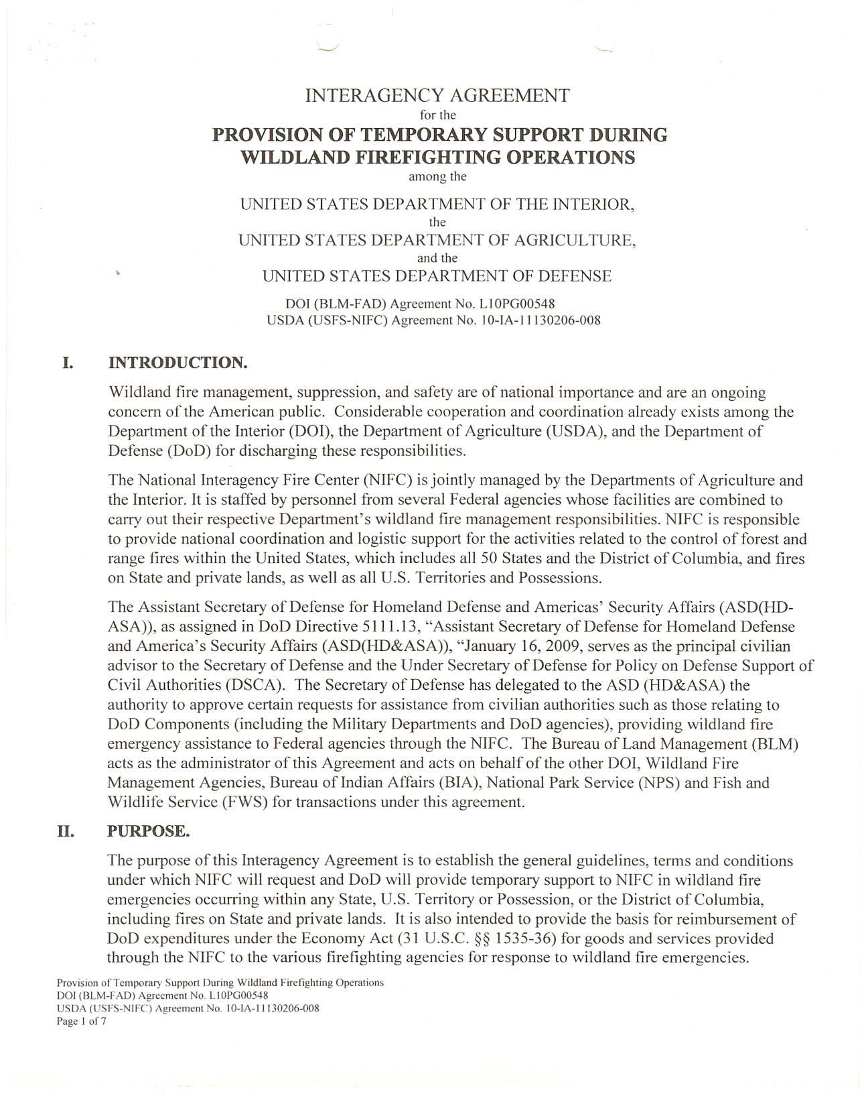

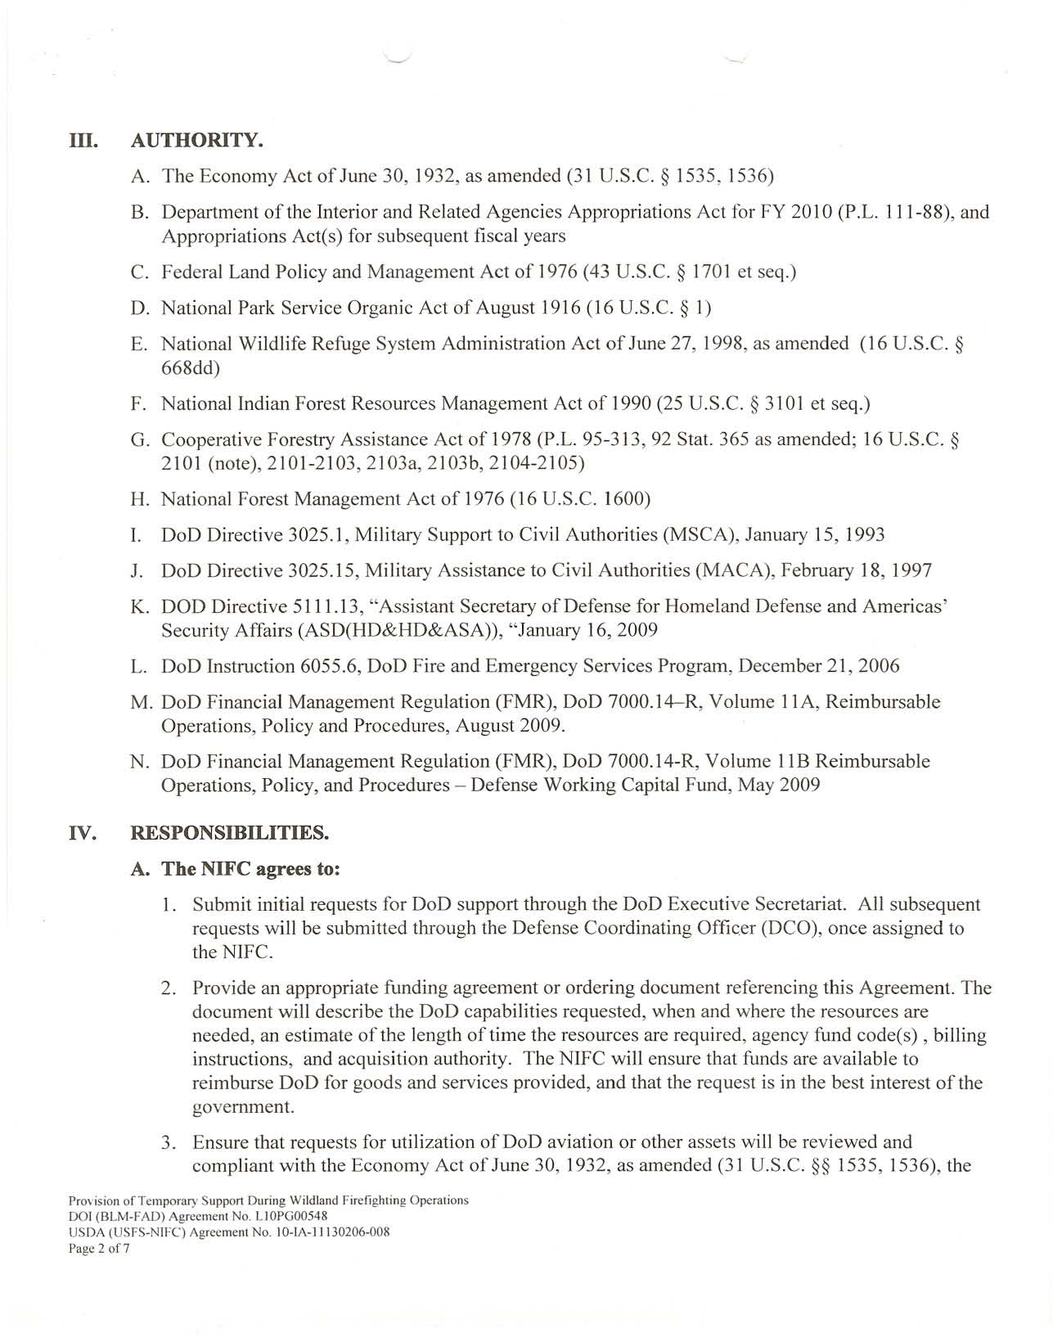

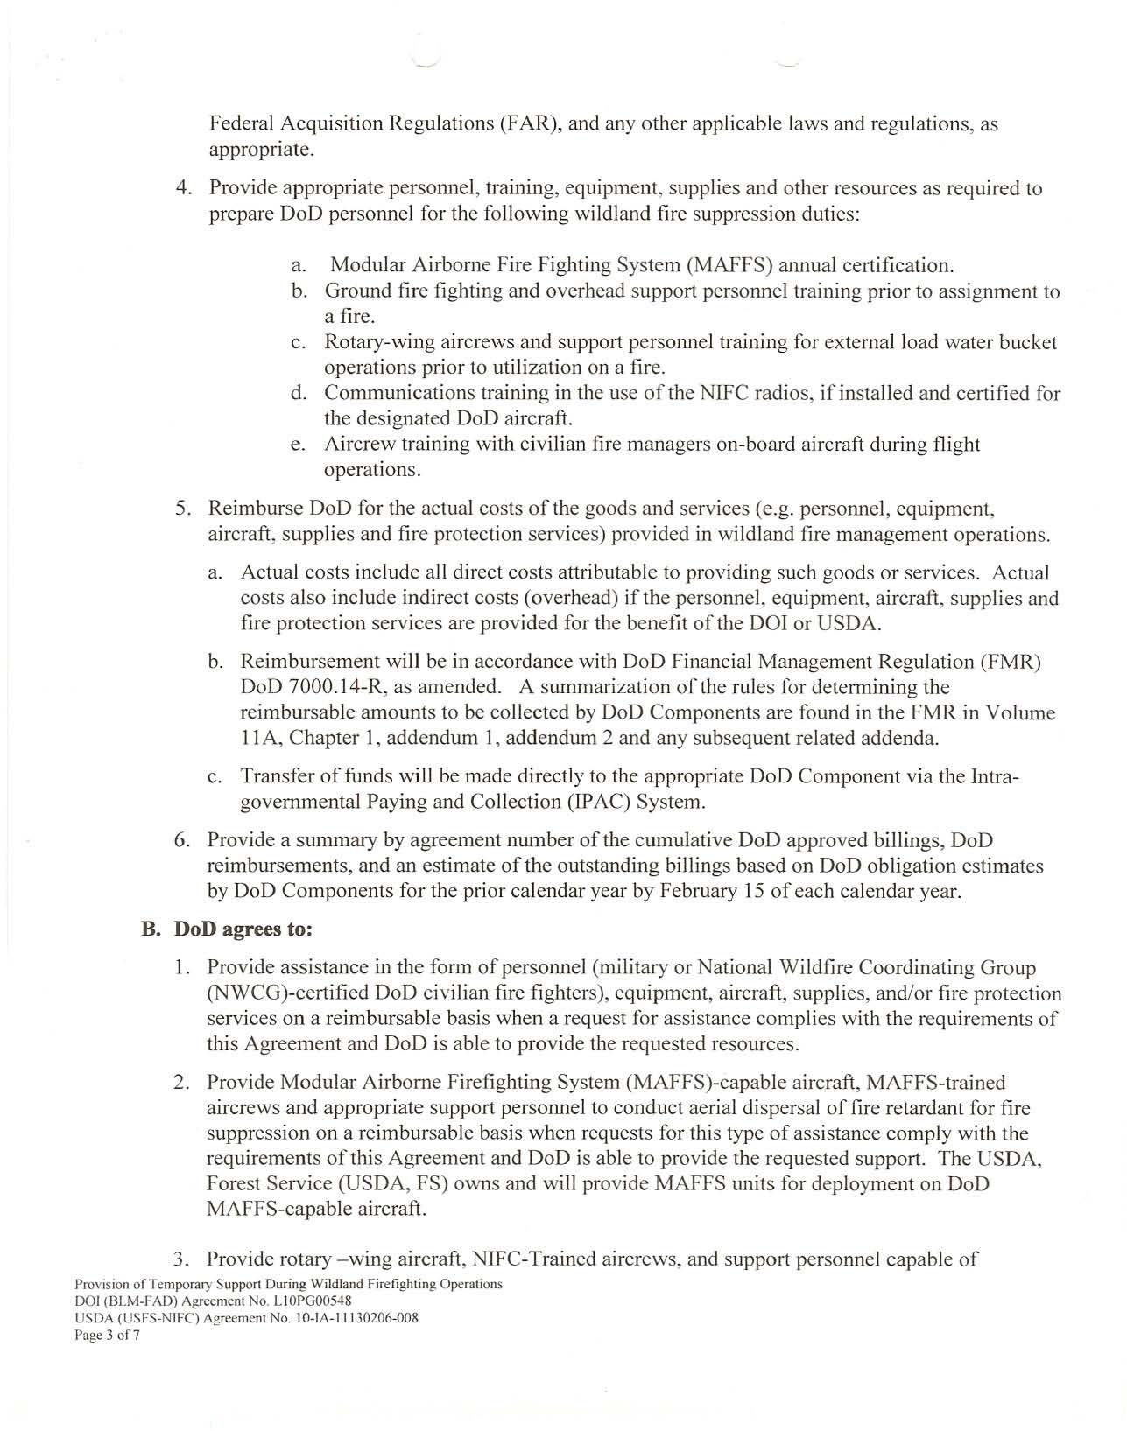

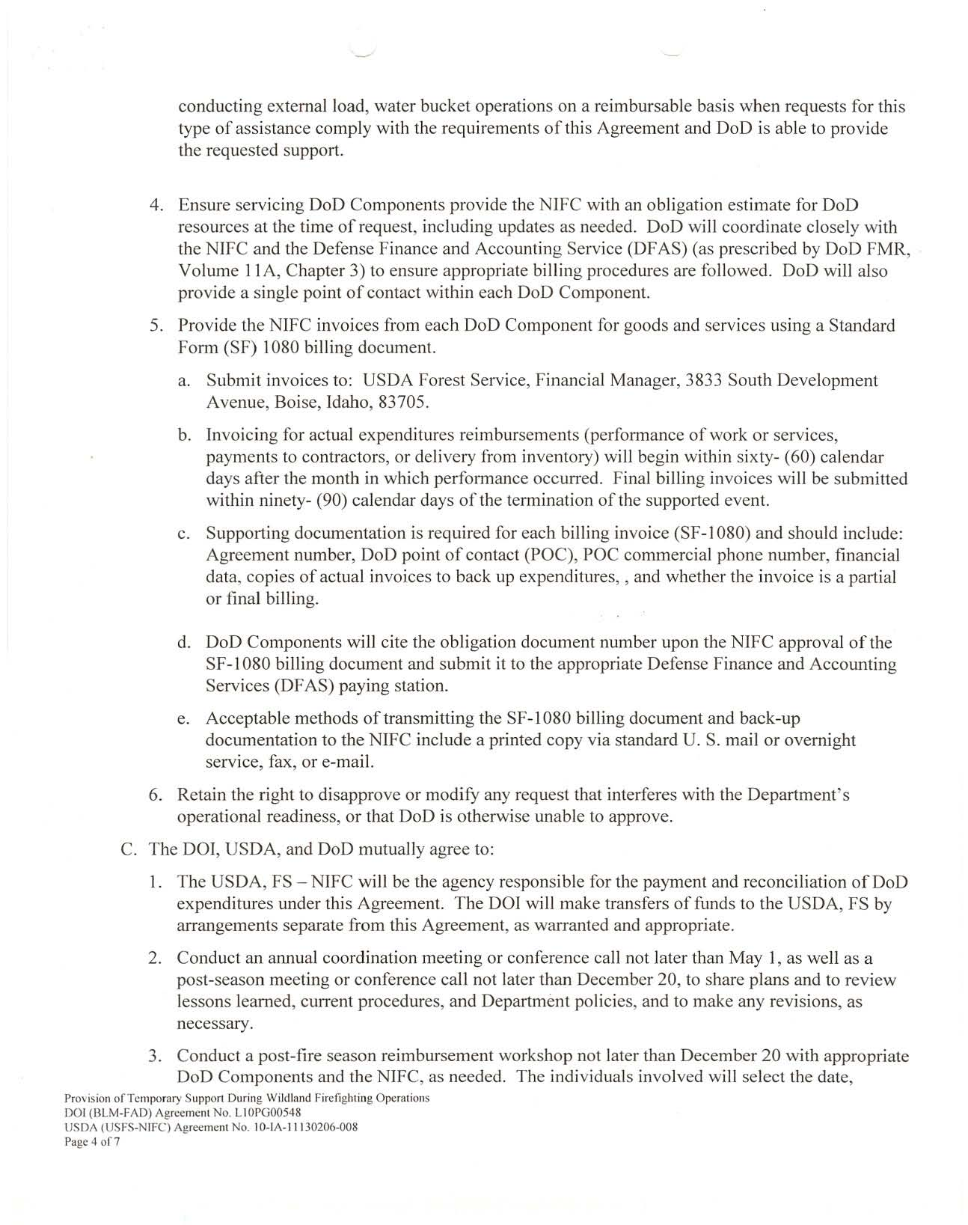

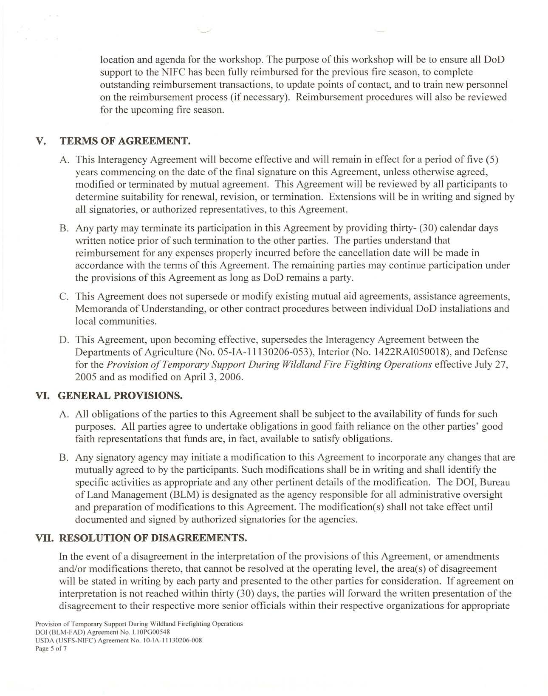

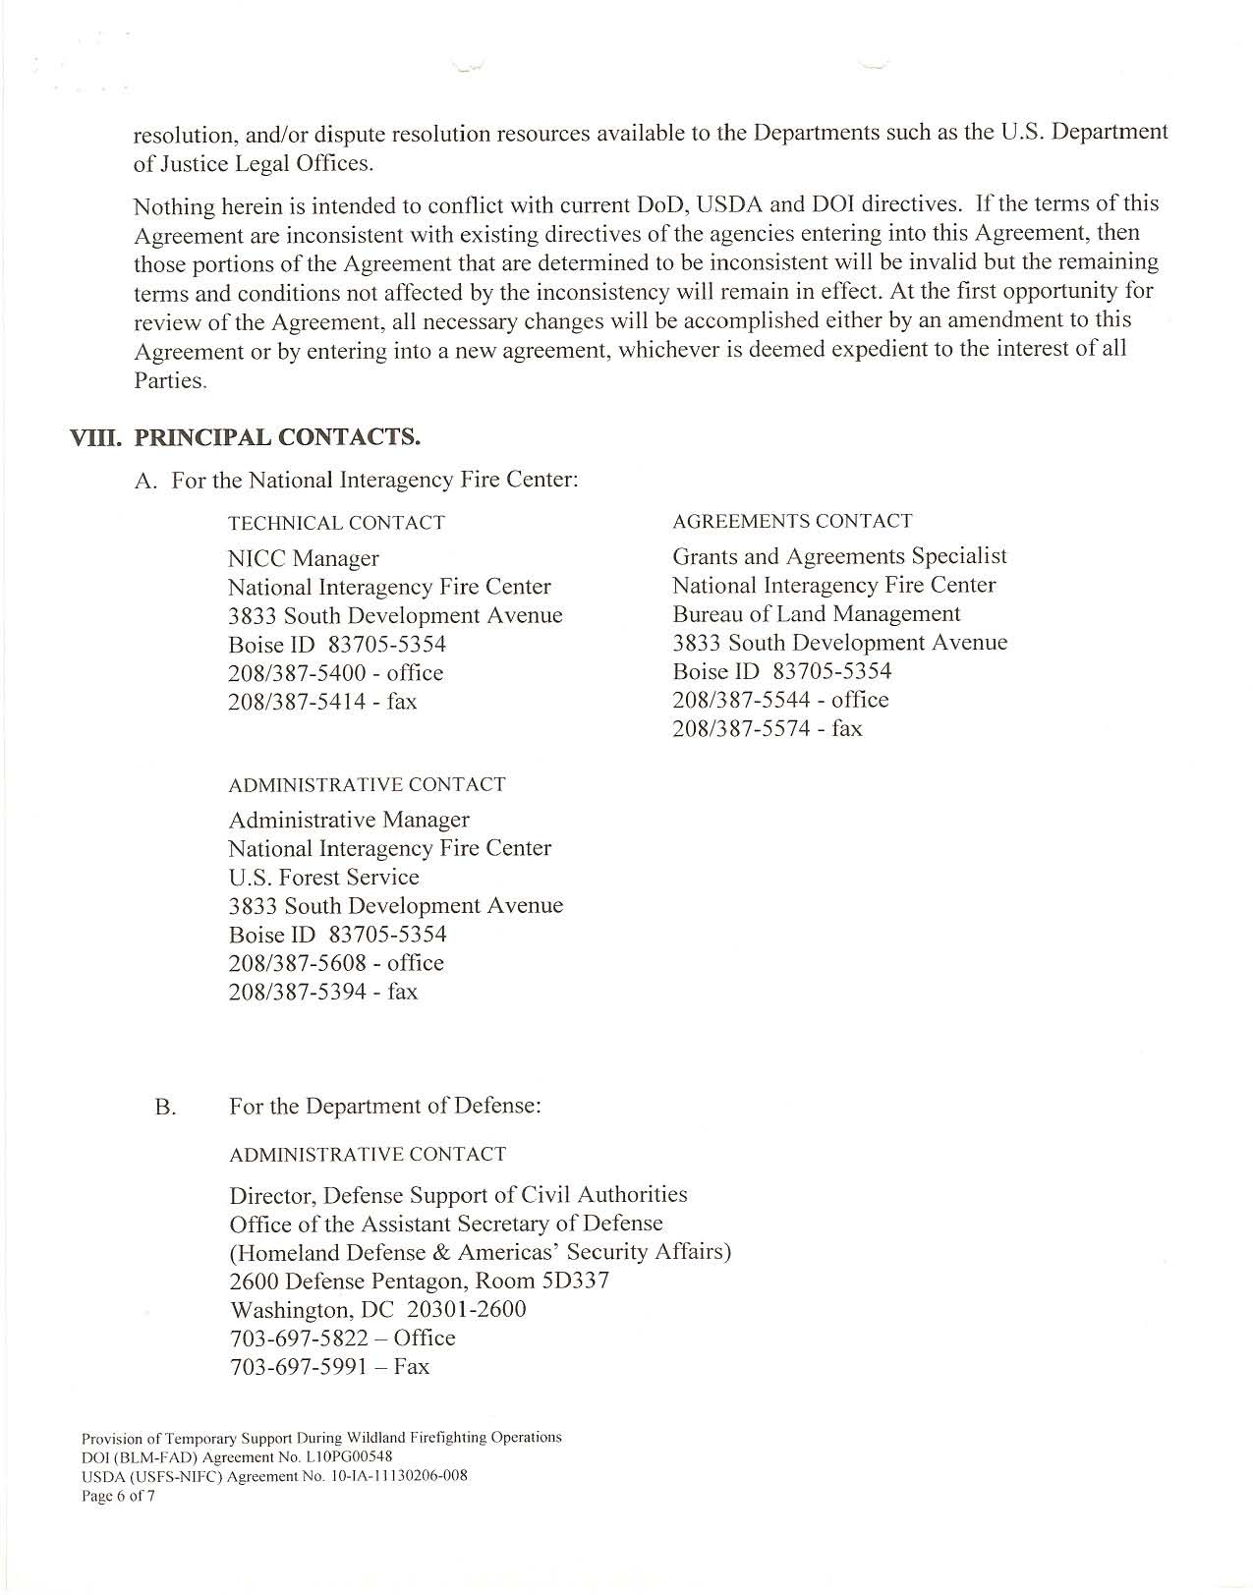

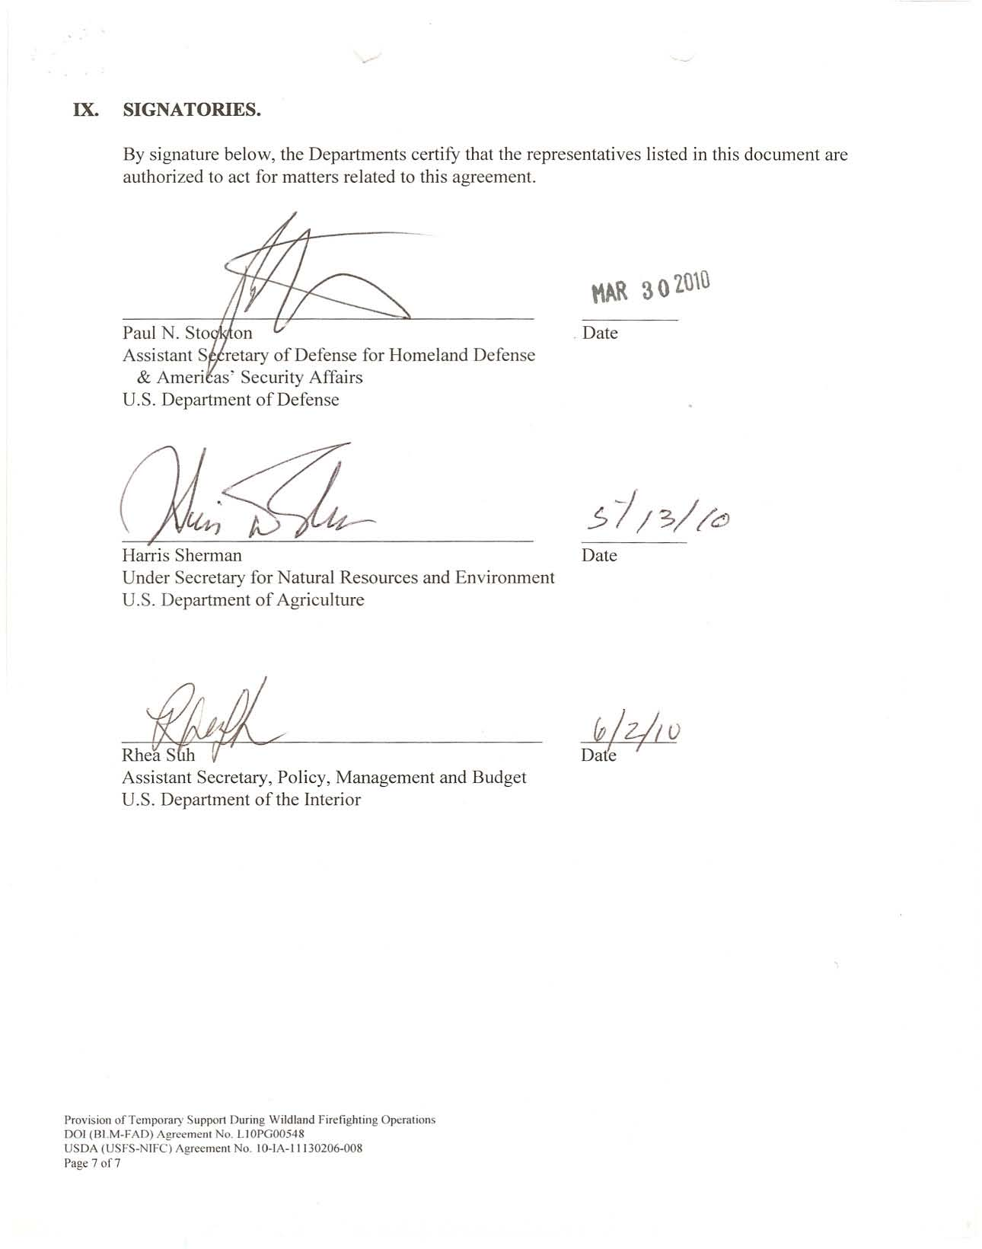

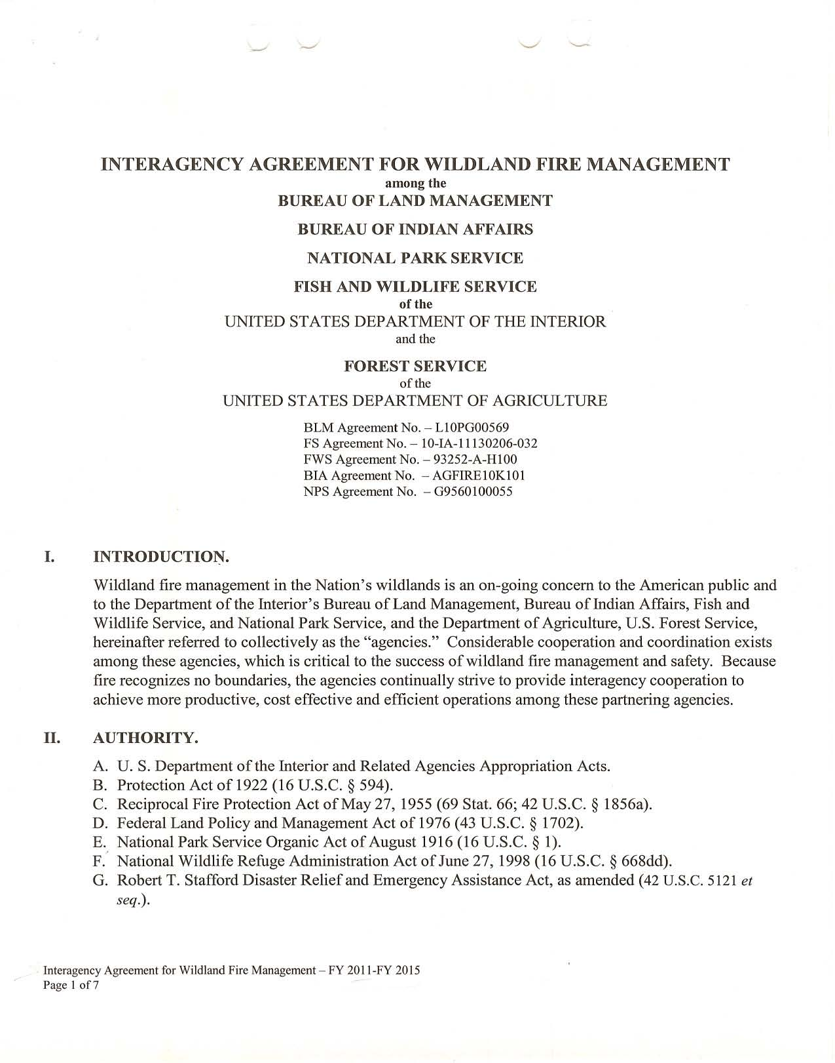

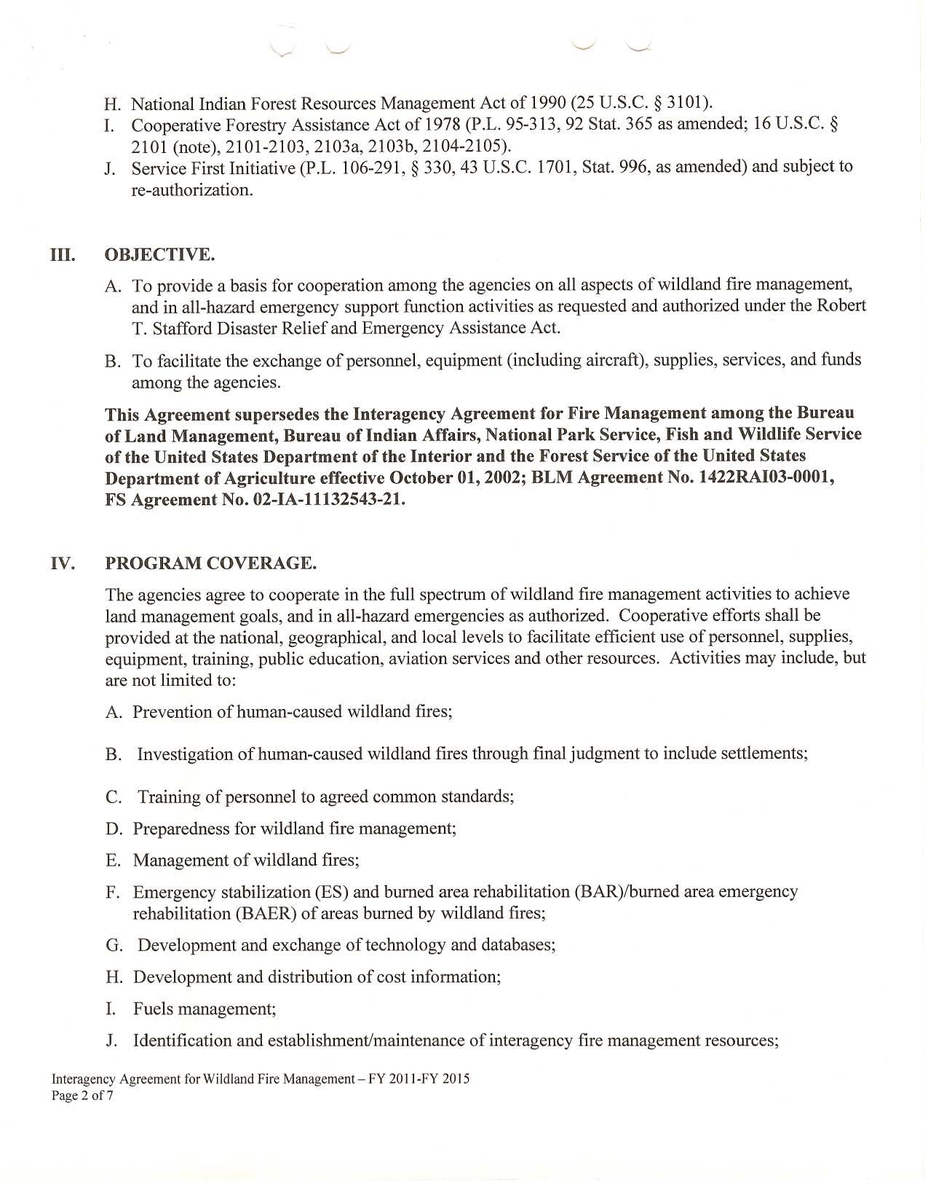

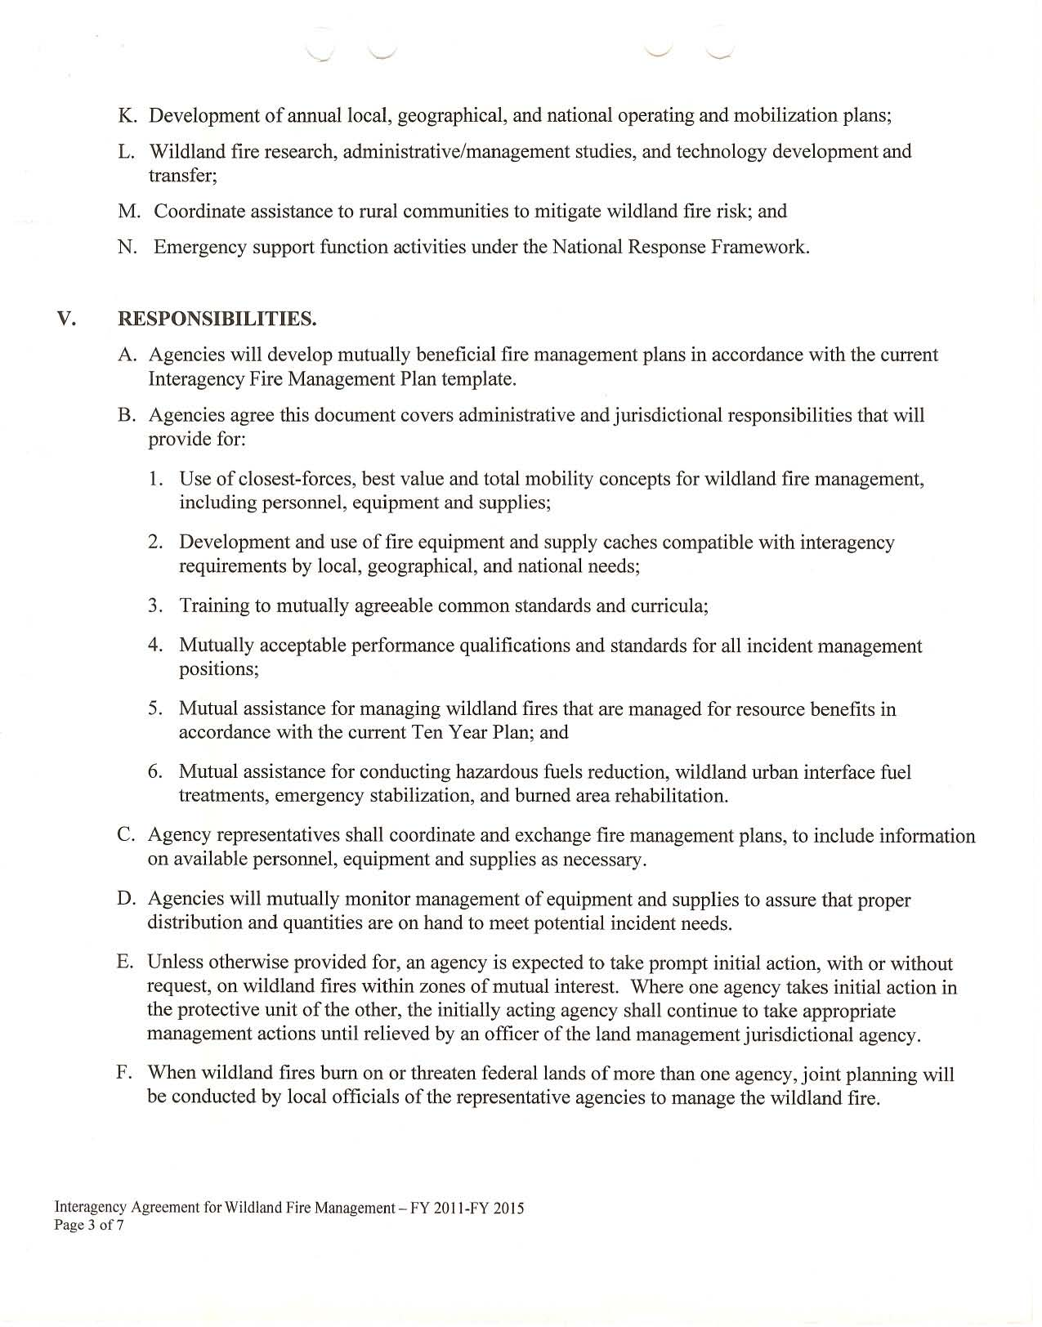

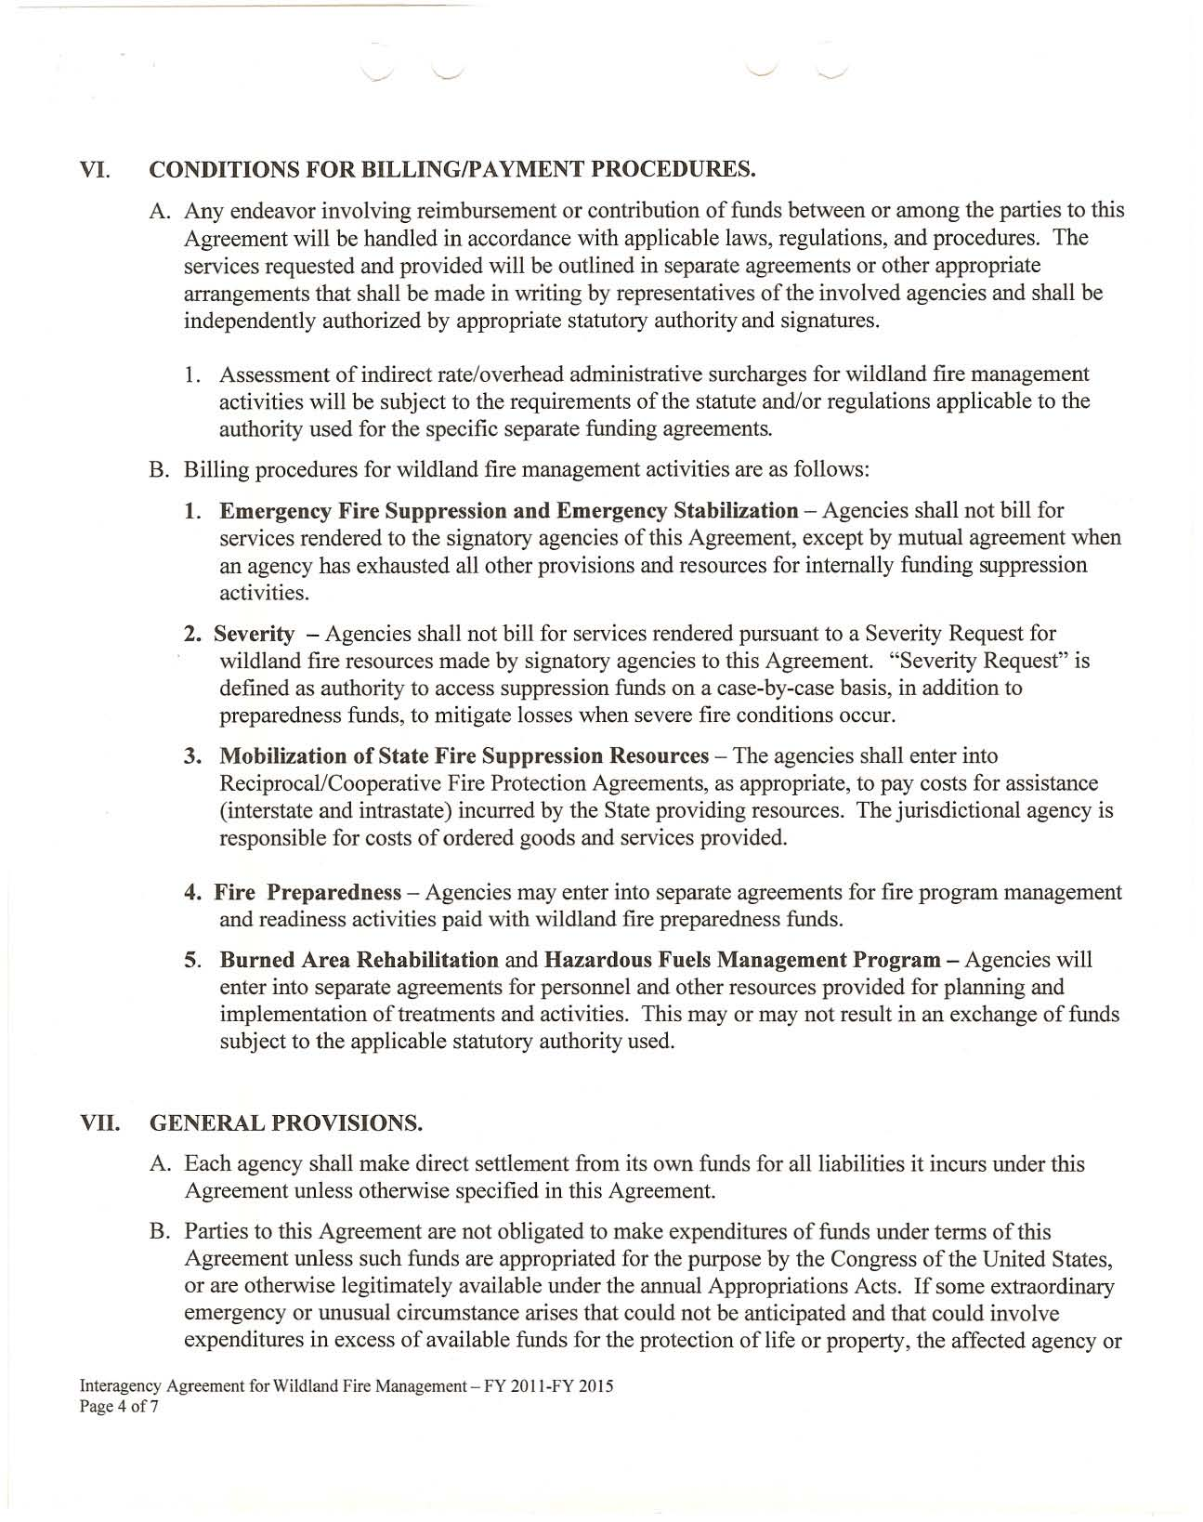

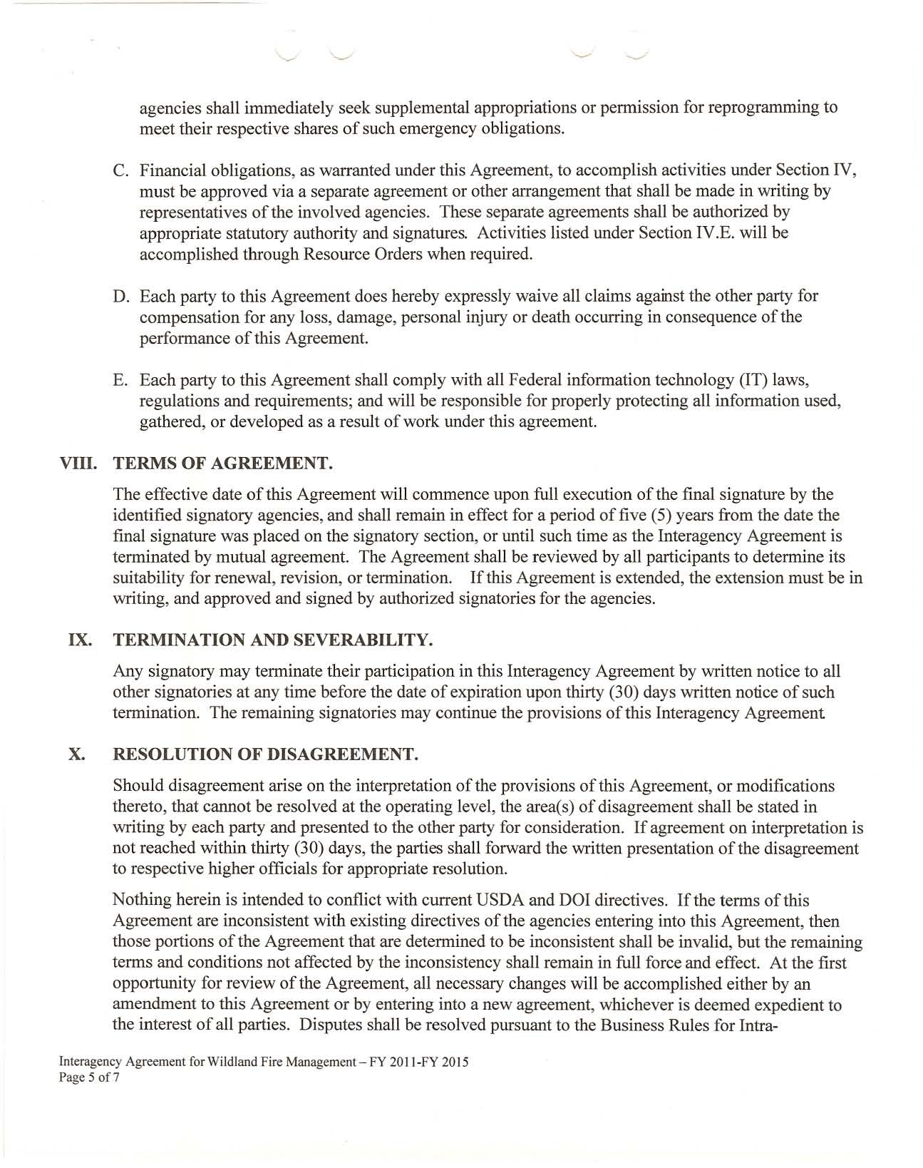

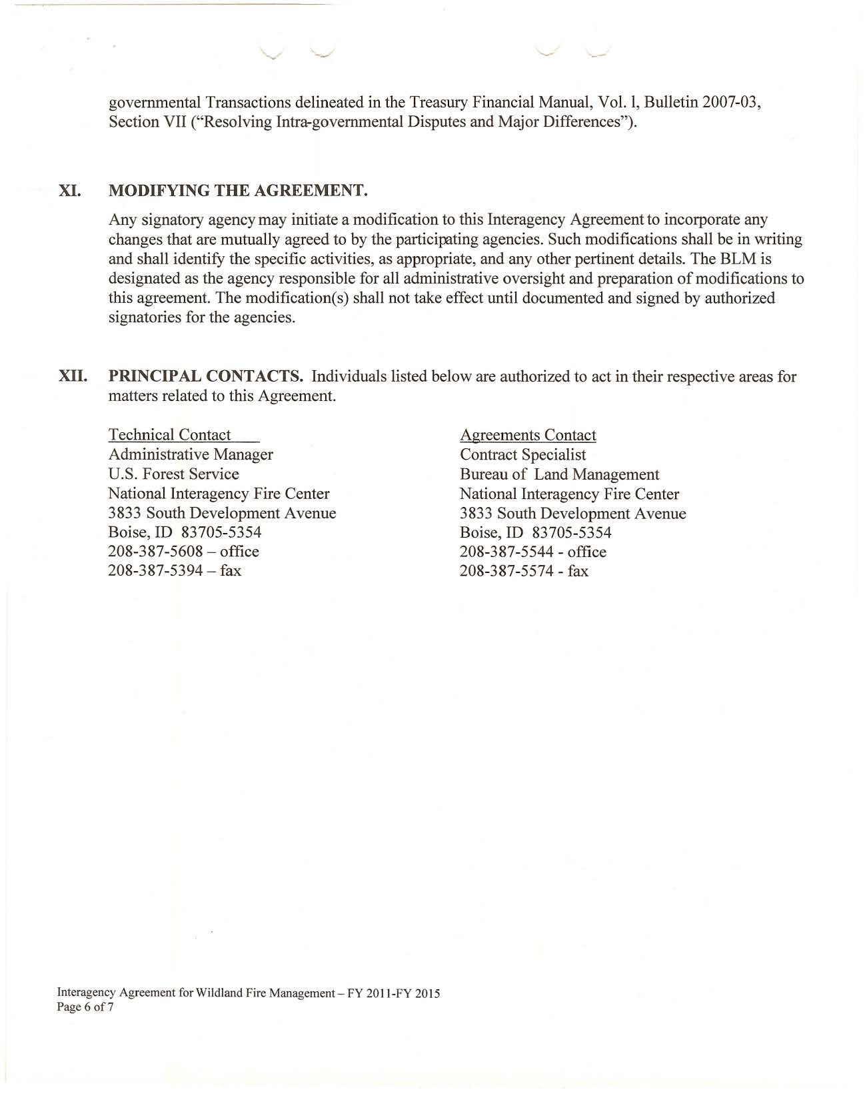

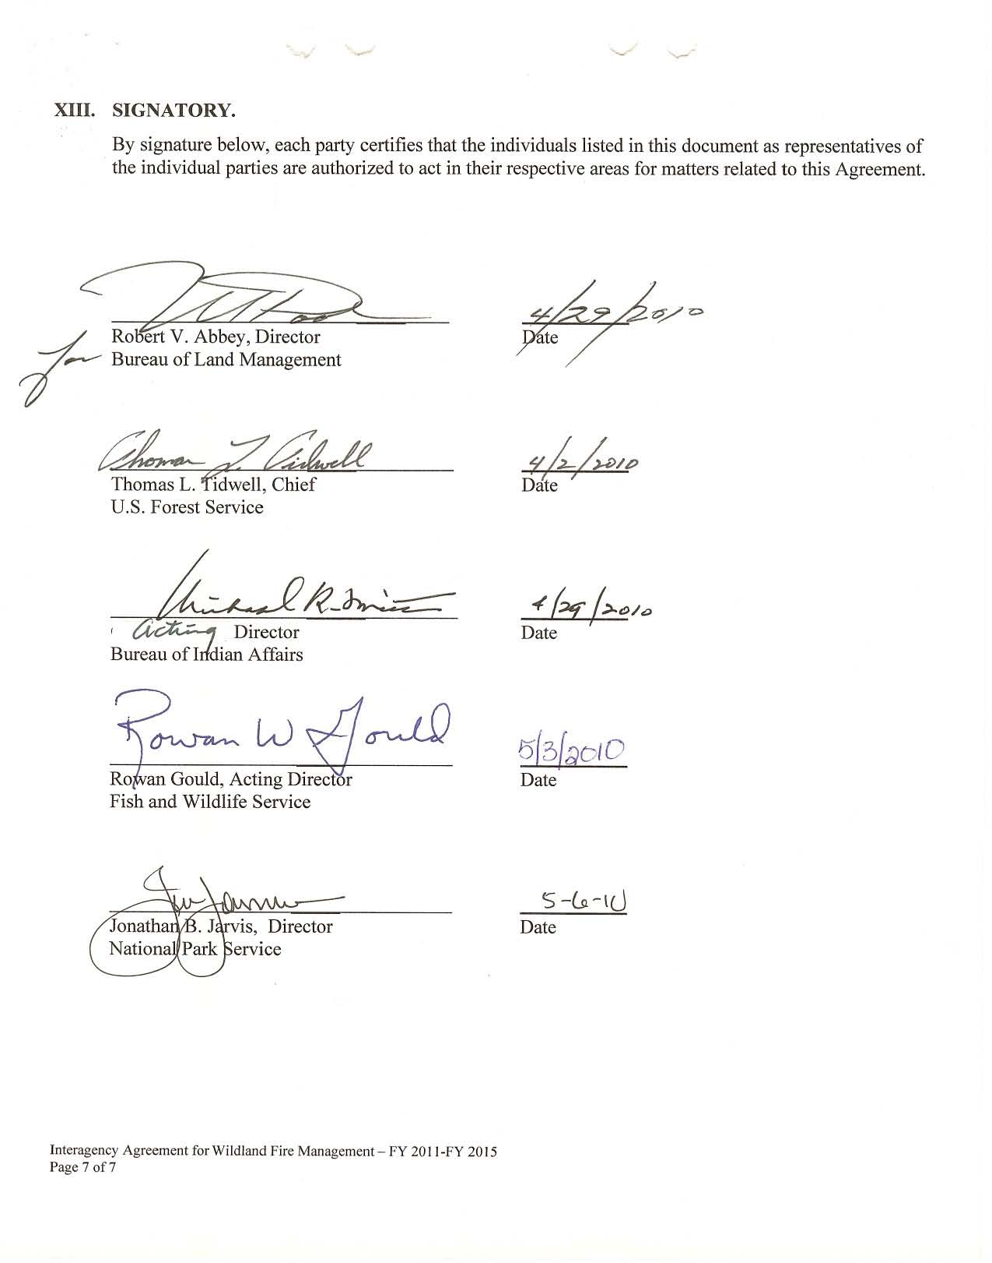

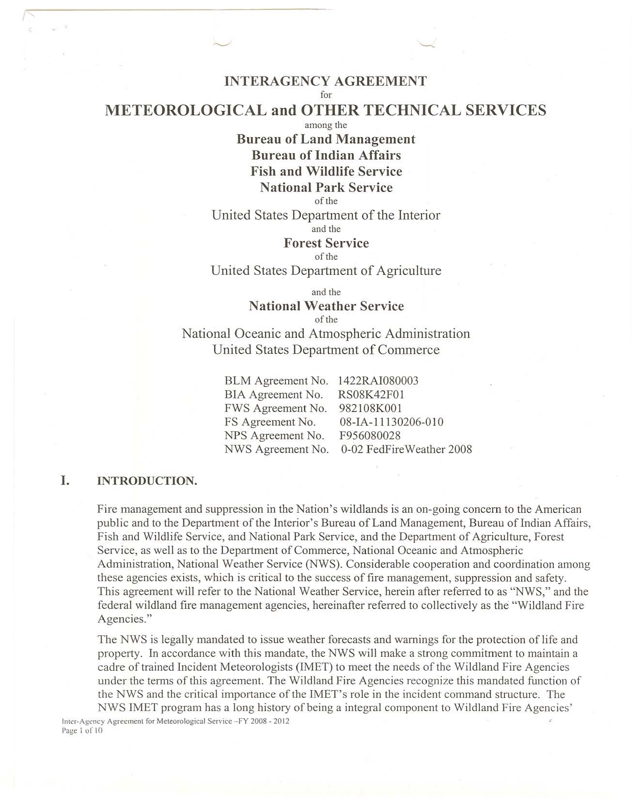

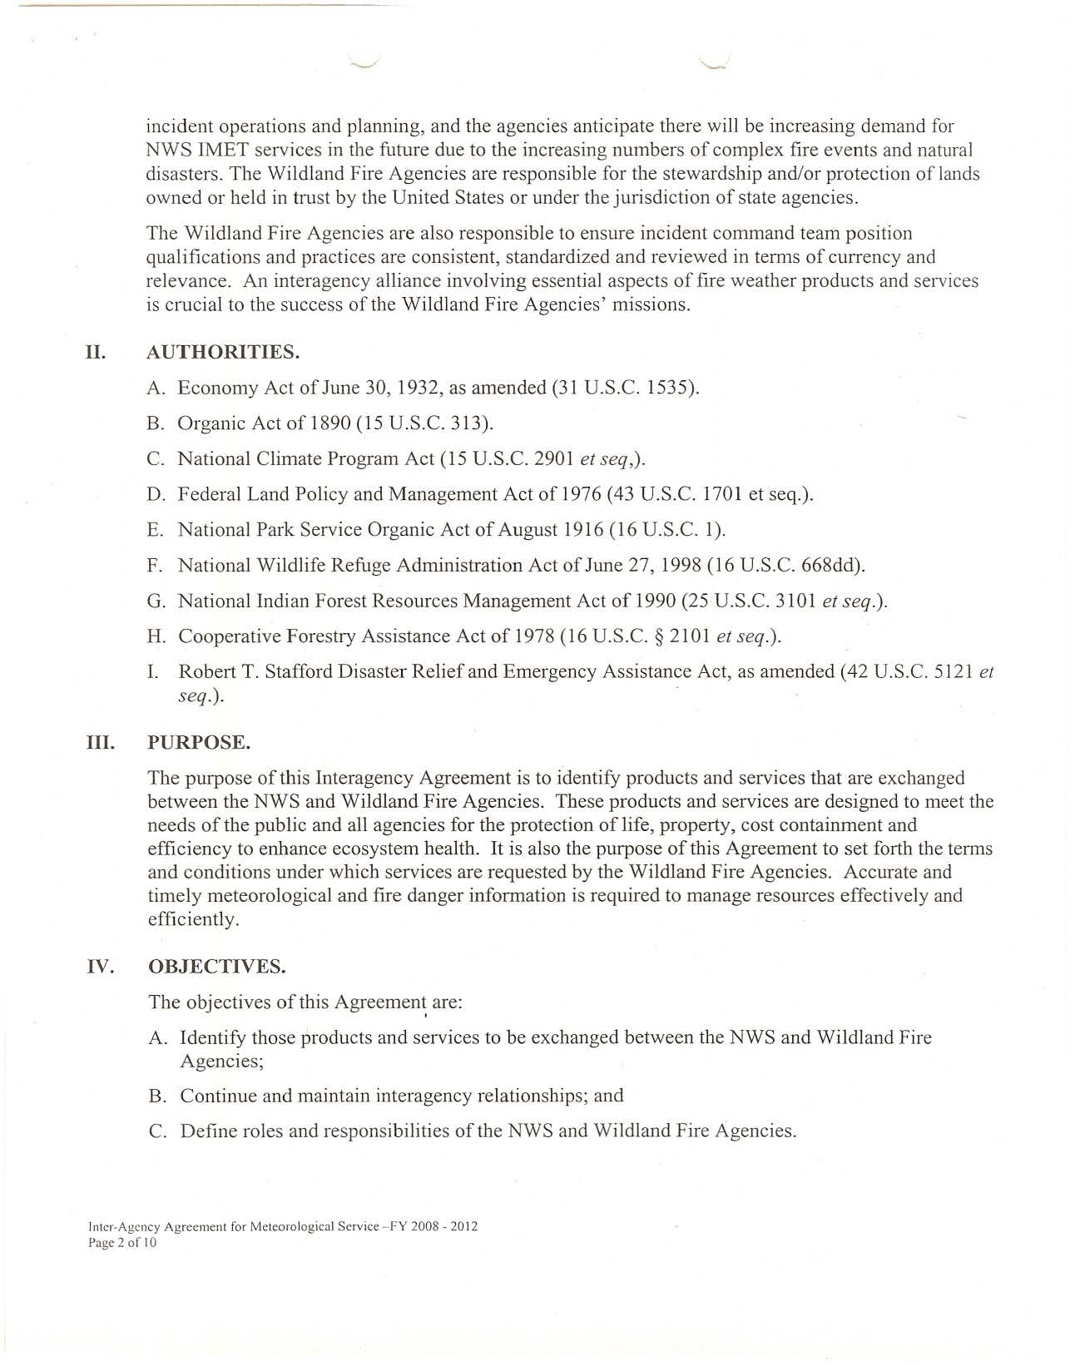

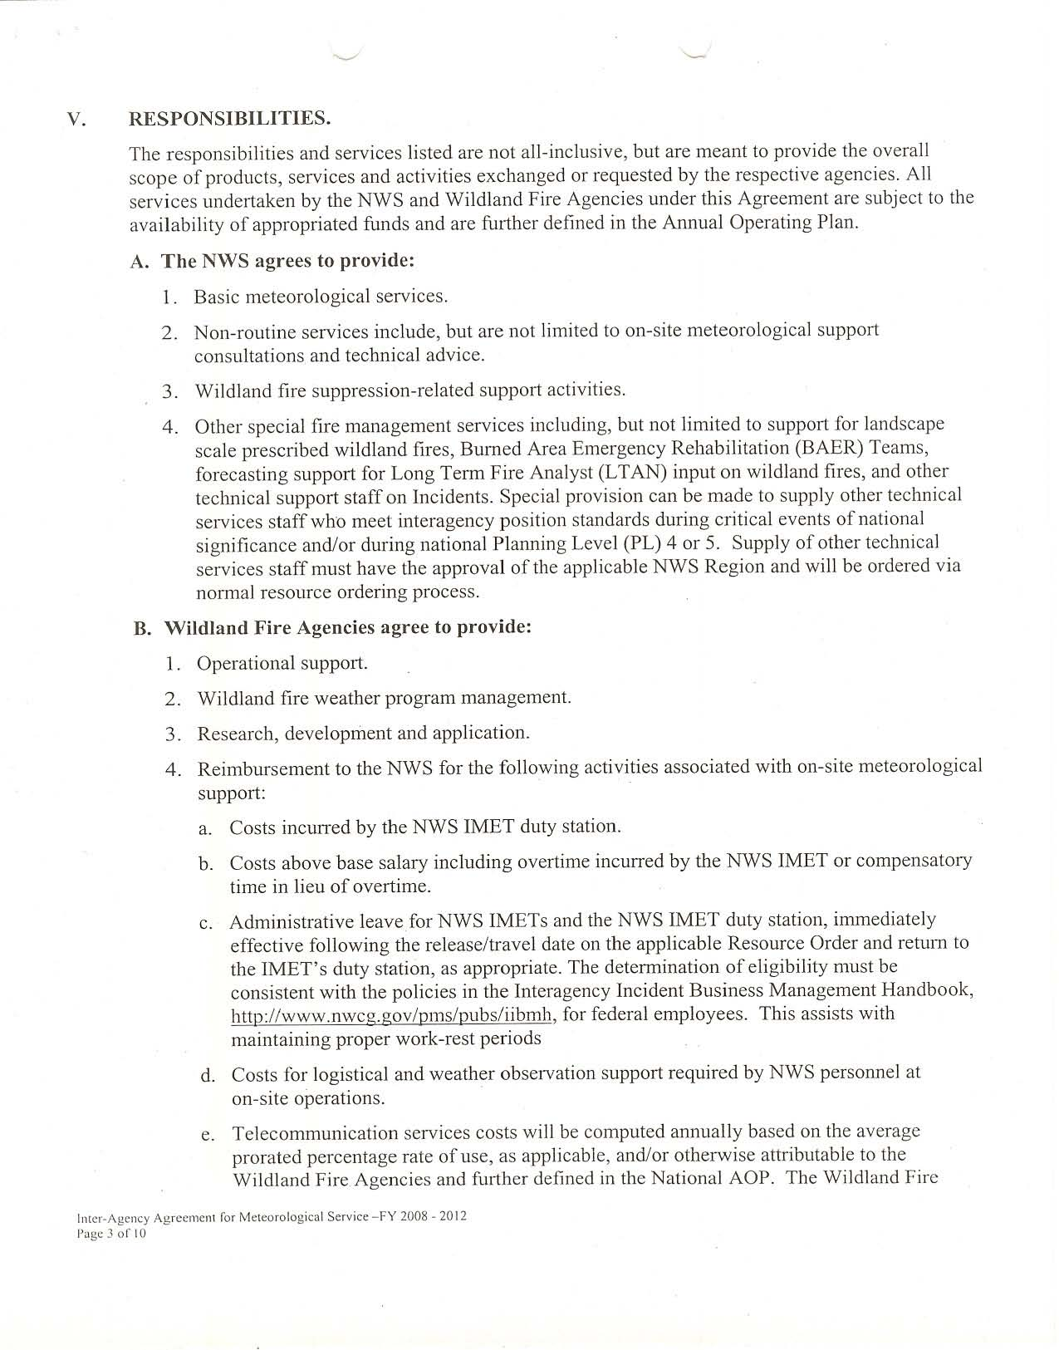

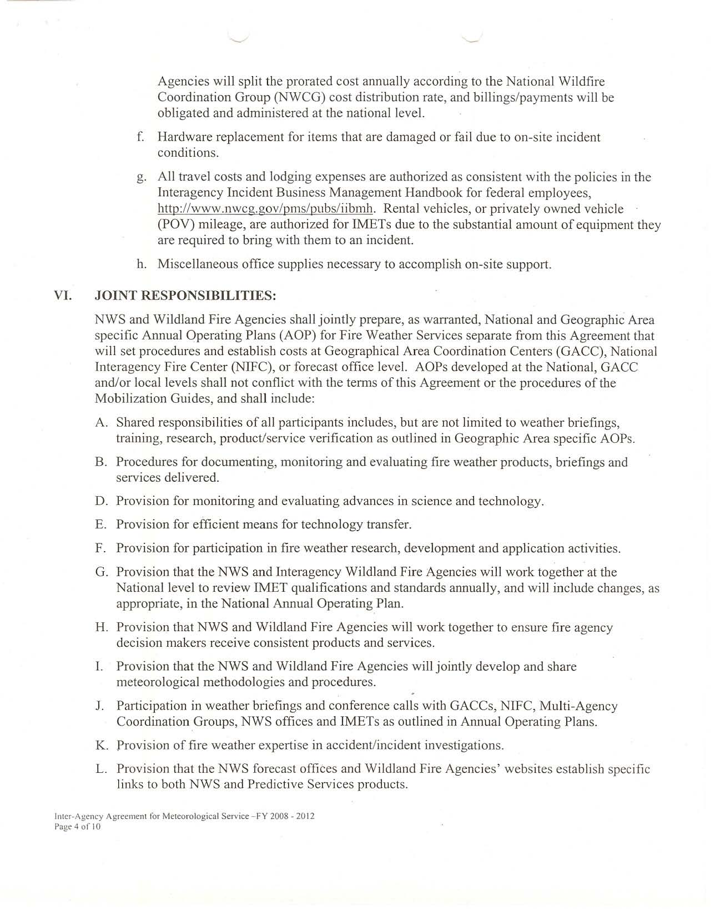

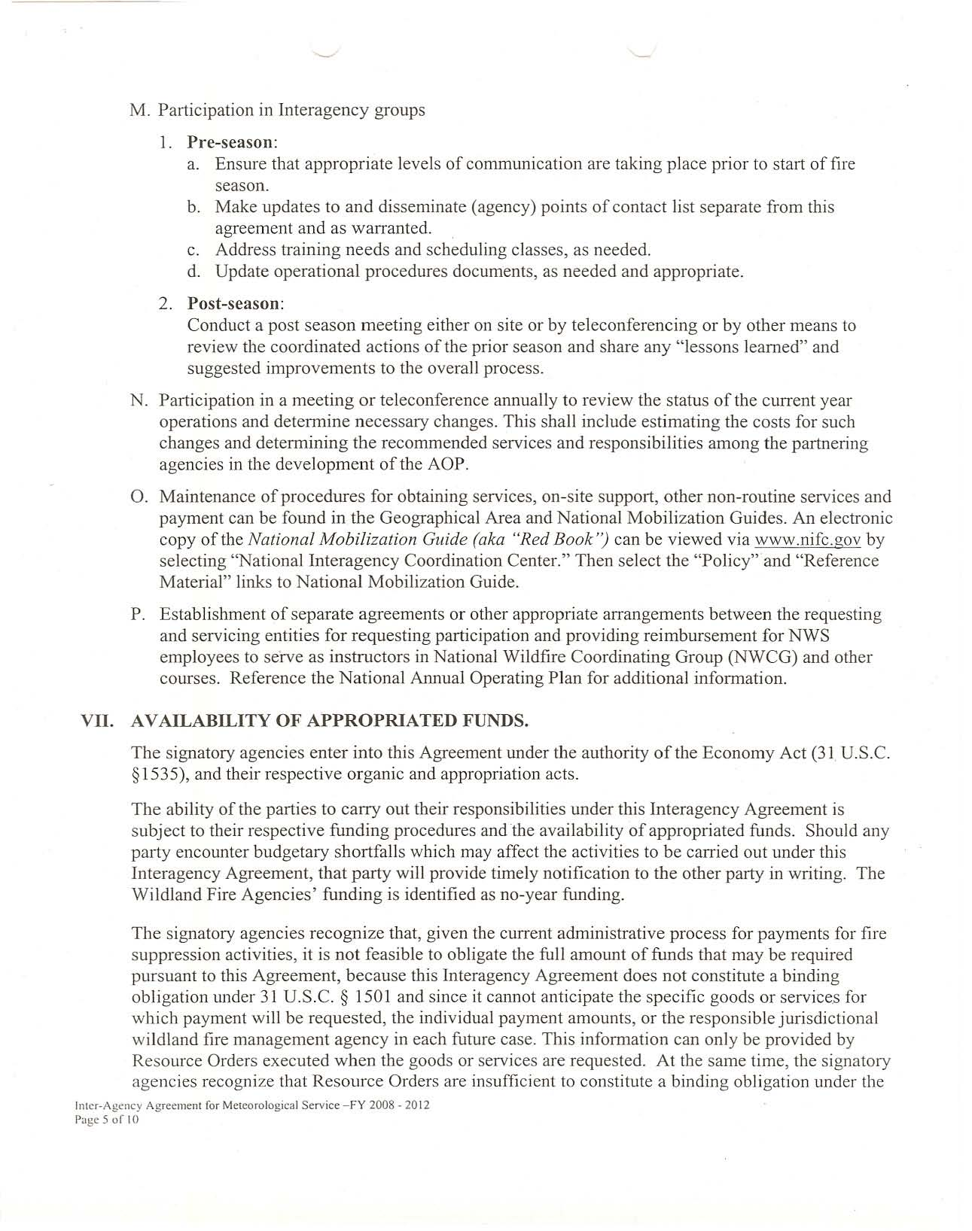

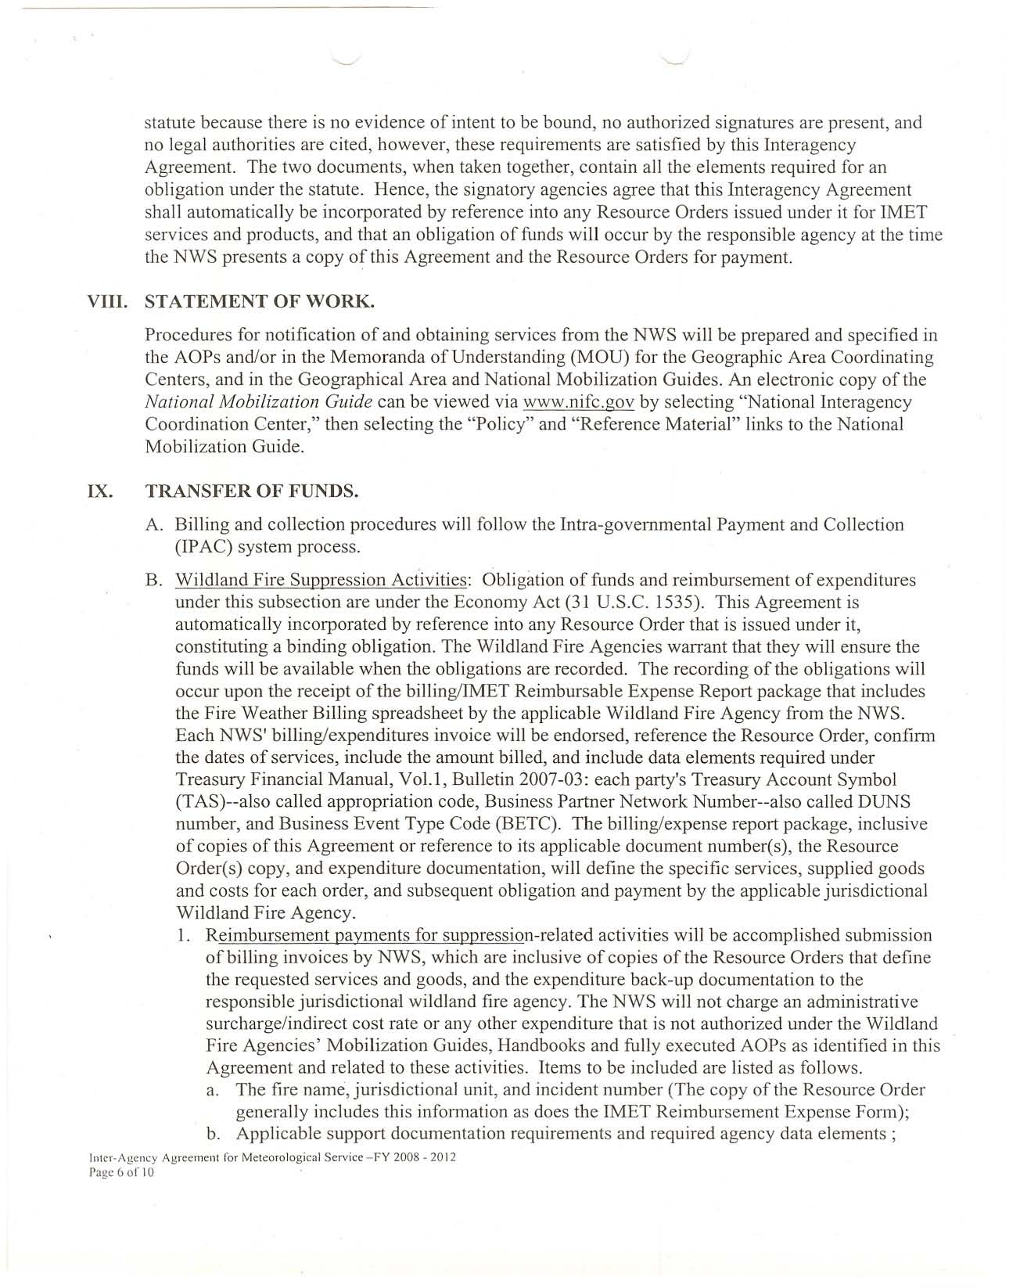

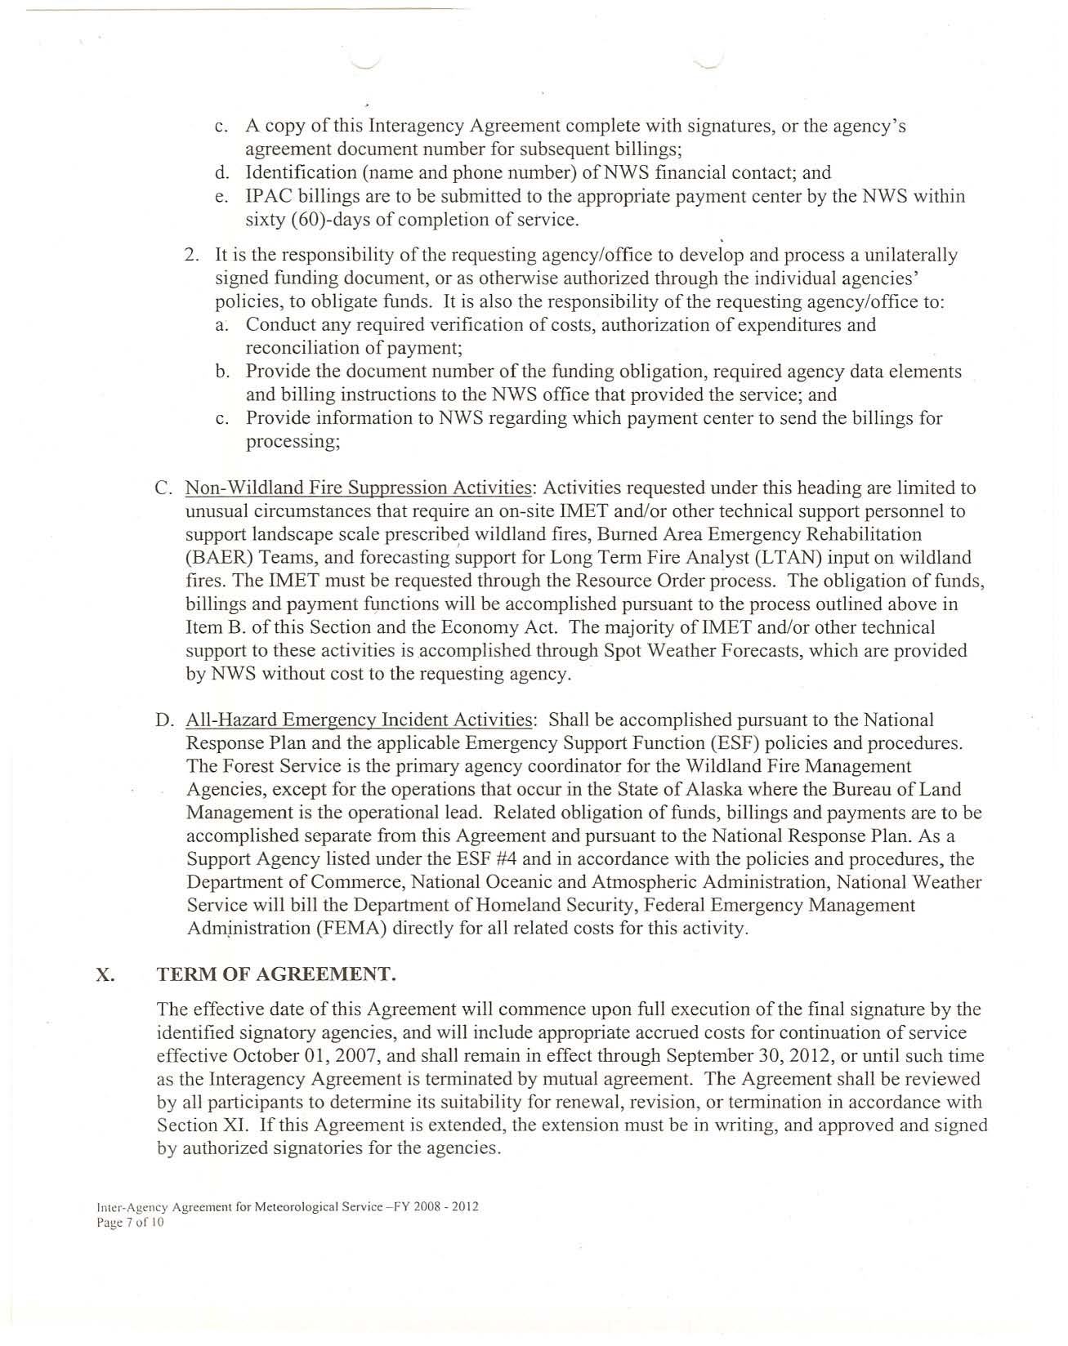

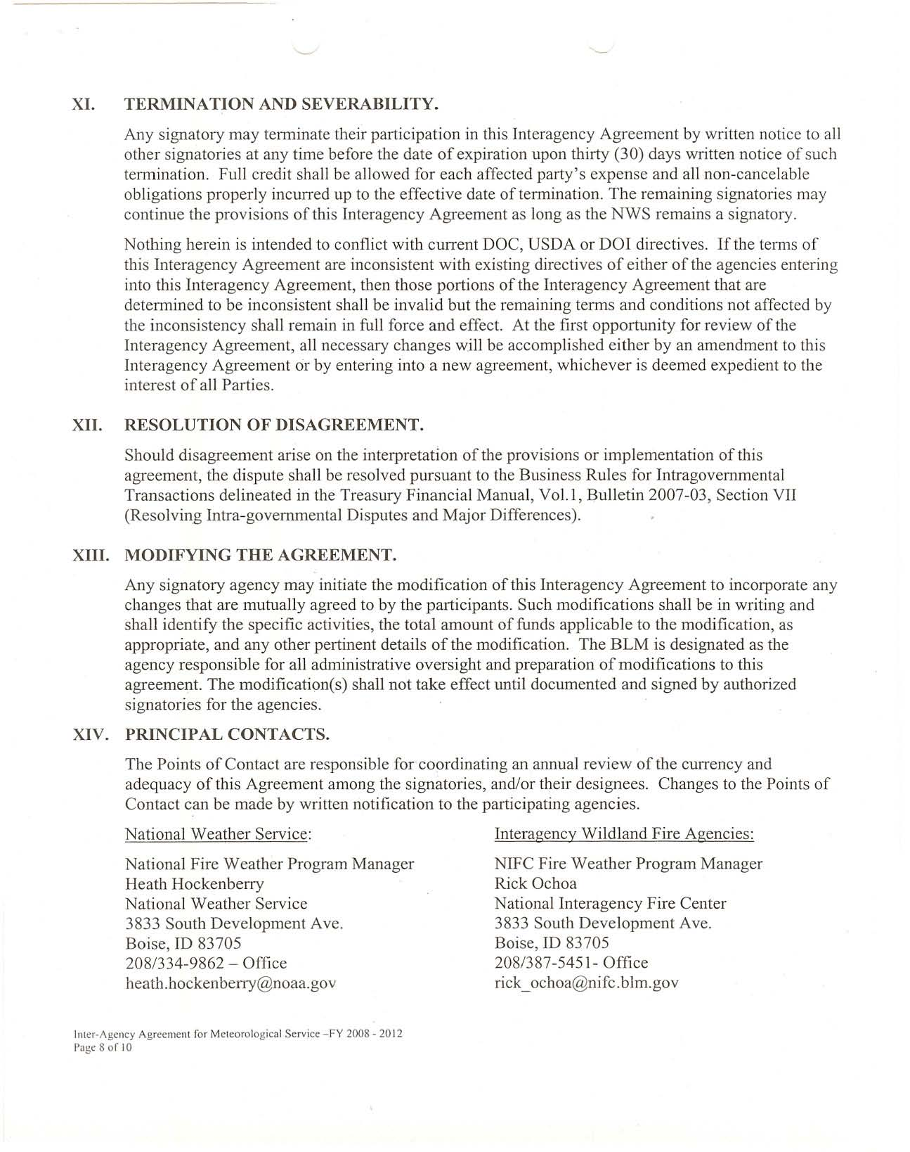

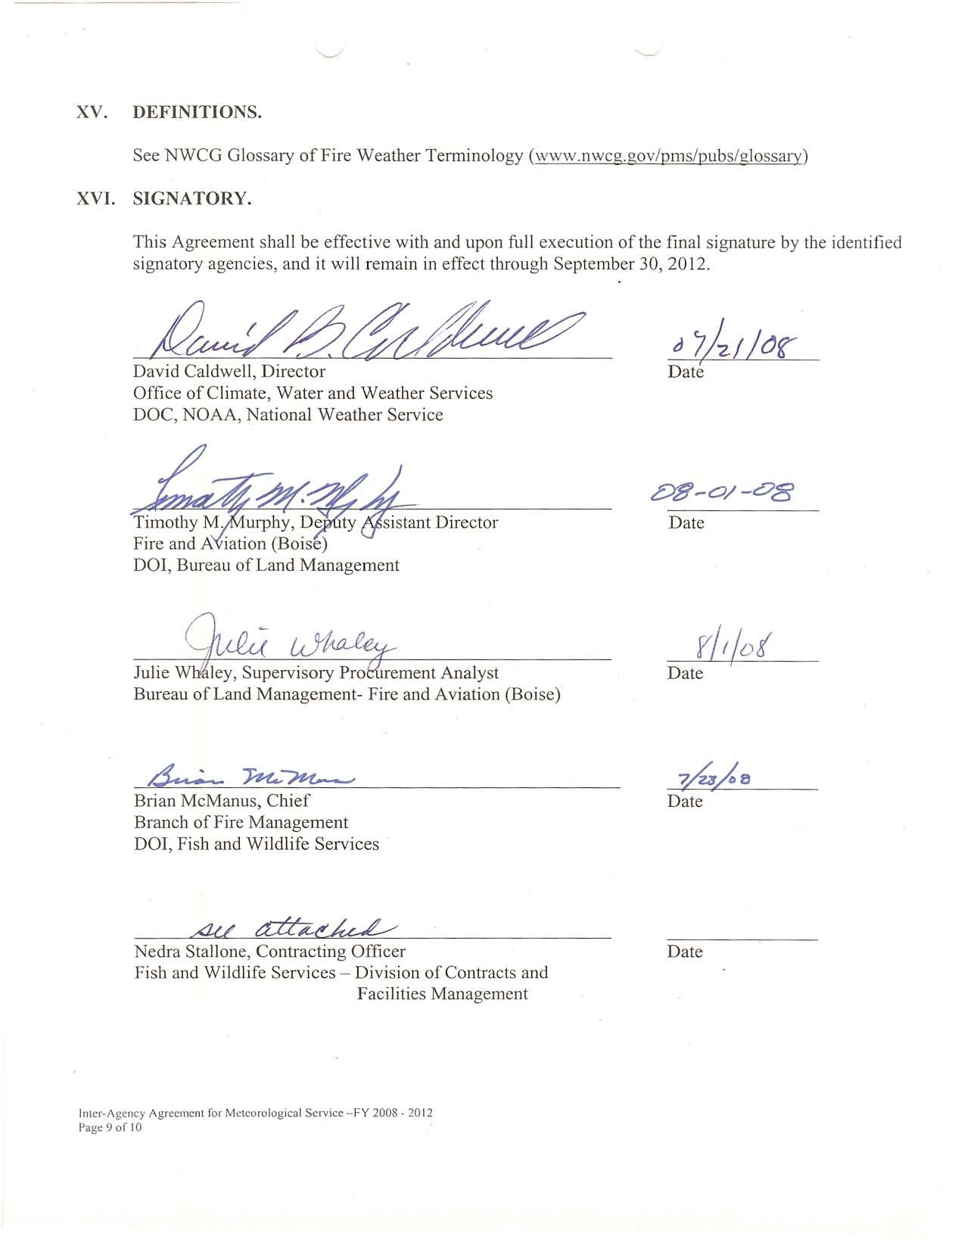

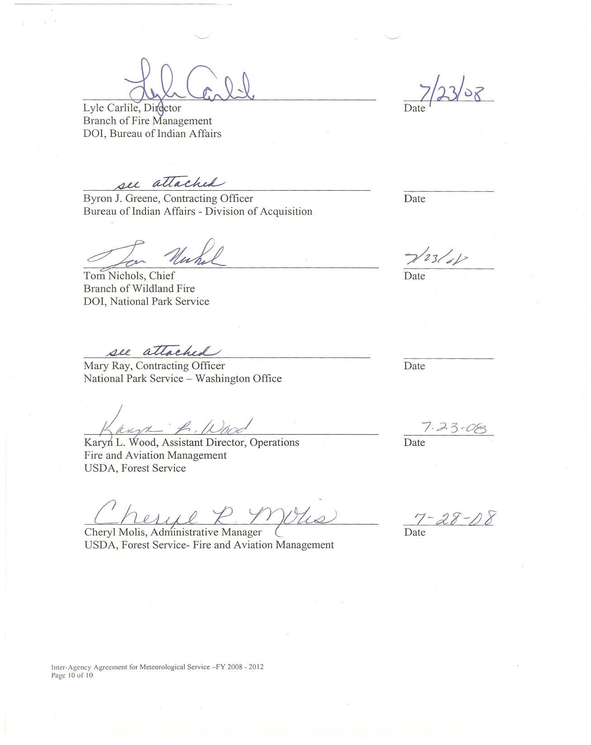

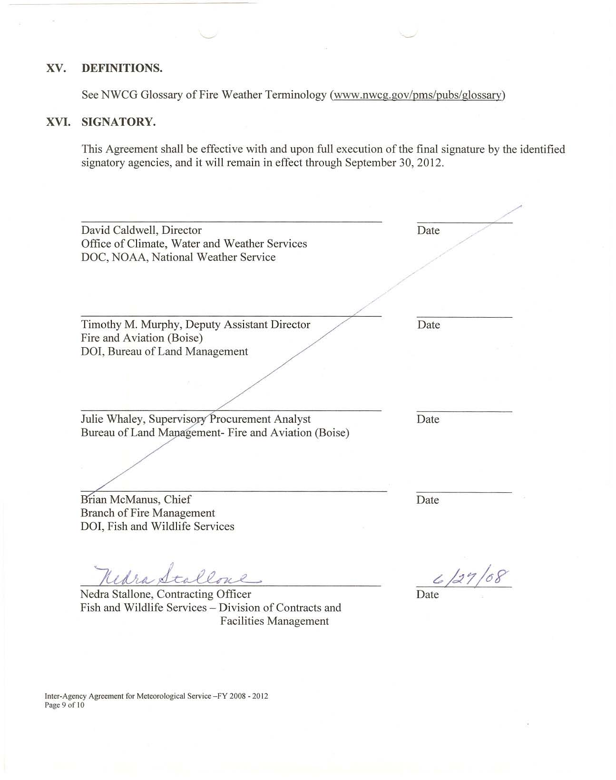

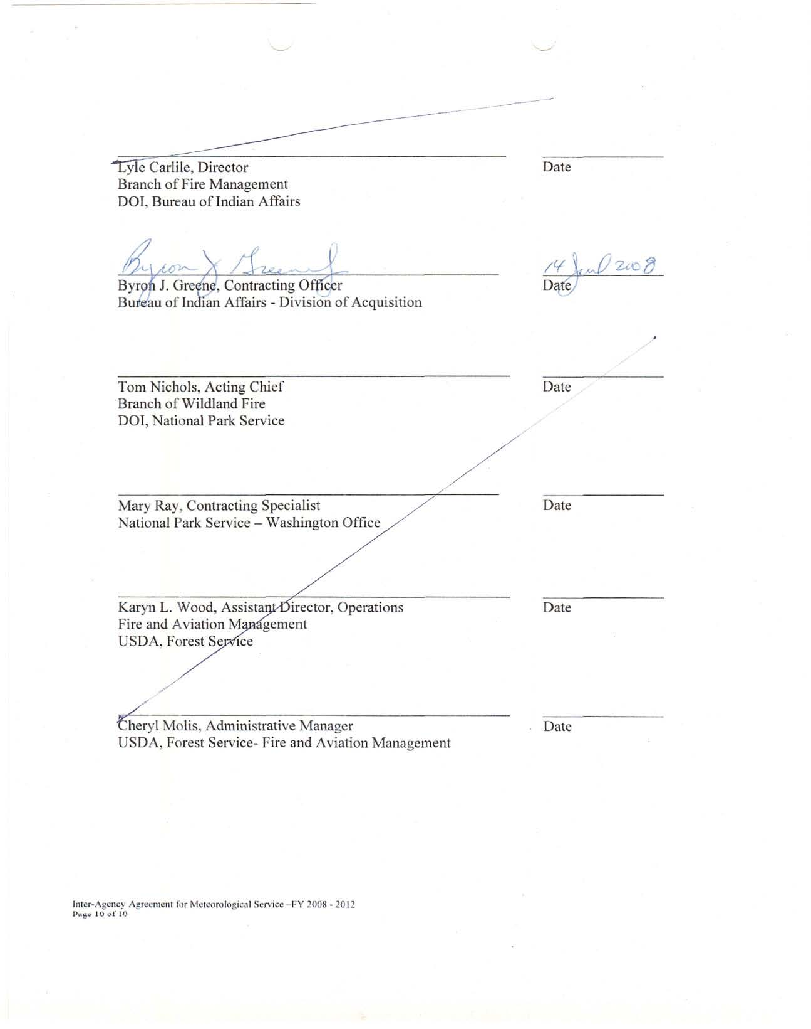

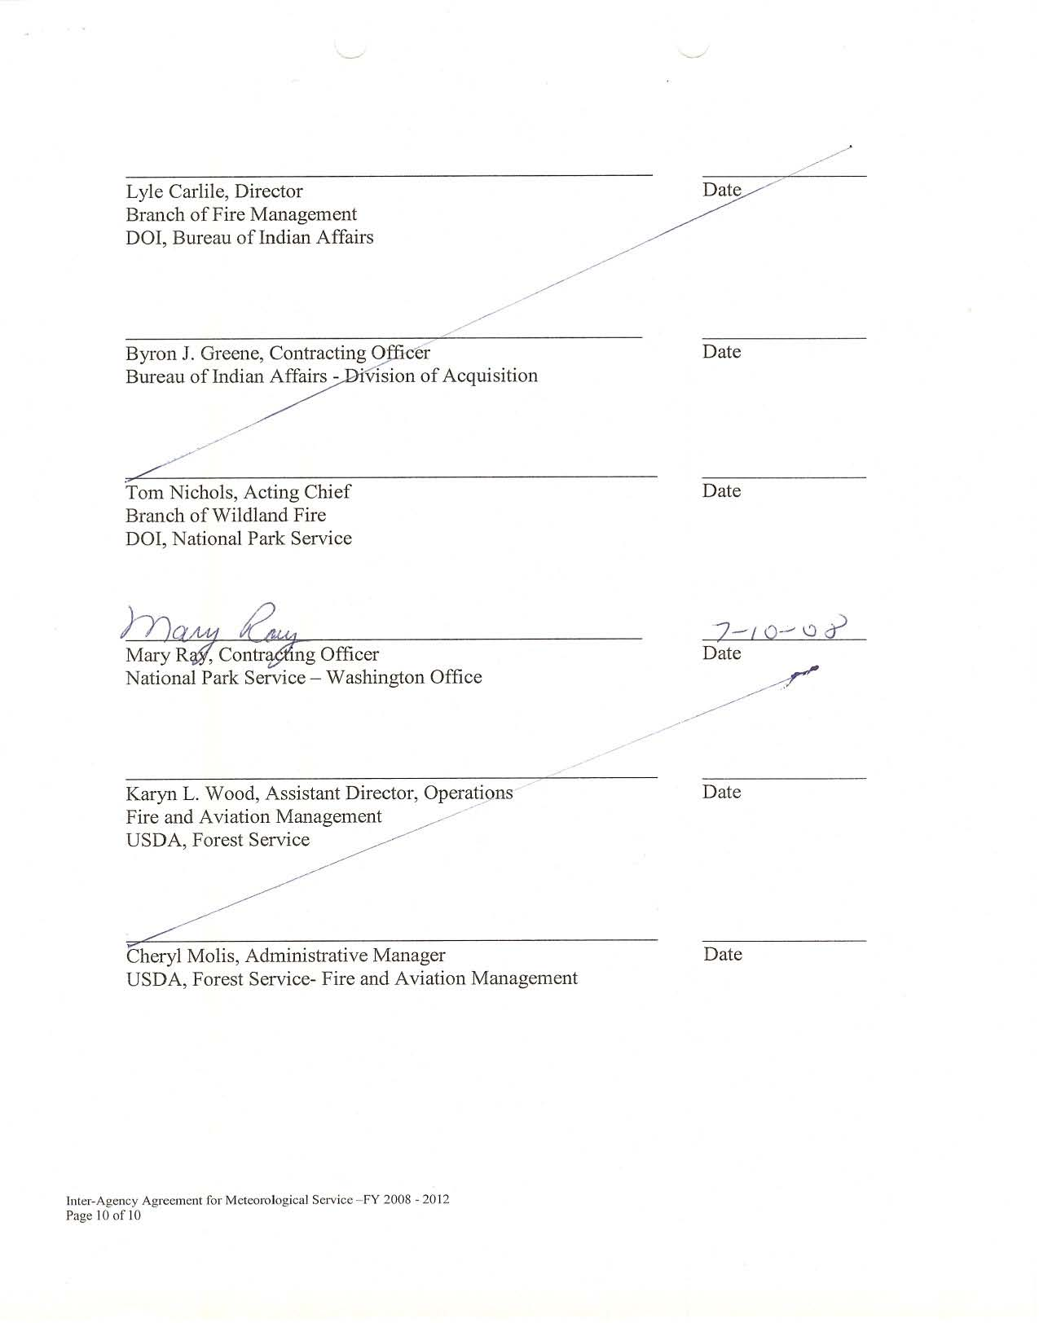

Memorandum of Understanding between the United States Department of Agriculture Forest Service and the United States Department of the Interior – Bureau of Land Management, Bureau of Indian Affairs, National Park Service, Fish and Wildlife Service, and Bureau of Reclamation (Law Enforcement)

MEMORANDUM OF UNDERSTANDING
BETWEEN THE
UNITED STATES DEPARTMENT OF AGRICULTURE
FOREST SERVICE
AND THE
UNITED STATES DEPARTMENT OF THE INTERIOR
BUREAU OF LAND MANAGEMENT
BUREAU OF INDIAN AFFAIRS
NATIONAL PARK SERVICE
FISH AND WILDLIFE SERVICE
BUREAU OF RECLAMATION (LAW ENFORCEMENT)

1. Background and Policy. Pursuant to the Memorandum of Agreement (Master Agreement) signed by the Secretaries of Agriculture and Interior (the Secretaries), dated February 27, 1990, and Titles 16 U.S.C. 1a-6, 43 U.S.C. 1733, 16 U.S.C. 7421(b), 25 U.S.C. Chapter 30, Section 2804 and 16 U.S.C. 559d(4), 559d , and 559g, it has been determined by all parties that the cross-designation of law enforcement officers will increase protection of the natural and cultural resources on public lands administered by the Secretaries, and is mutually beneficial, economical, and advantageous to the public interest. Accordingly, this Memorandum of Understanding (MOU) will service as the implementation document as directed by the Master Agreement. The Secretaries have determined that if cases where a specific need for law enforcement assistance and investigative support has been identified or where a law enforcement emergency or a violation in progress exists, it shall be mutually beneficial, economical, and advantageous to the public interest to cross-designate law enforcement officials within both Departments. In such instances, the procedures set out in this MOU shall apply for the cross-designation of authority between agencies.

2. Cross-Designation Defined. Cross-designation of law enforcement personnel means the vesting in a law enforcement office of one agency the full extent of law enforcement authority of another agency.

3. Scope of Law Enforcement Authority This Memorandum of Understanding shall authorize the cross-designation of law enforcement authority of the signatory agencies. Cross-designation of law enforcement officers under this MOU may take place across the range of, but may not exceed each agency’s law enforcement responsibilities. Nothing in this MOU is intended to expand, limit, or in any way restrict the law enforcement authorities or any agency. Officers so designated shall have the law enforcement authority of the agency charged with administering the lands or territory for which the designation is made and shall be subject to all applicable limitations on that authority. This authority shall last until he/she is released from the detail. Requests for cross-designation shall be consistent with the requesting agency’s internal procedures and subject to the following.

4. Procedures.

A. Investigative Support and Law Enforcement Assistance

1. Except as provided in Paragraphs 2 and 3 below, requests for cross-designation for investigative support and law enforcement assistance will be made by the Manager-In-Charge of the requesting unit to the Manager-In-Charge of the responding unit; e.g., Forest Supervisor to Park Superintendent, or Area Director to Regional Forester. This authority may be delegated by the Manager-In-Charge.

2. The request may be oral, and arrangements for determining reimbursement for expenses of the responding unit shall be agreed to in advance, or a case-by-case basis, by the agencies involved. An oral request will, in all cases, be followed by a written request and shall include arrangements for reimbursement of expenses under the Economy Act, 31 U.S.C. 1535.

3. No investigation, surveillance, or covert activity will be conducted independently by one agency on the lands administered by another agency without the concurrence of the Manager-In-Charge of the land in question, except when directed by a representative of the U.S. Attorney General or when authorized by statute.

4. Each agency may support another in conducting criminal, civil, and administrative investigations, as requested. The investigations may be pursuant to laws or regulations pertaining only to the requesting agency. When deemed necessary by the participating agencies, credentials may be issued to officers of other agencies which are party to this Agreement.

5. The agencies may loan and share communications equipment, frequencies, and other law enforcement equipment if such sharing is mutually determined to be necessary to effect efficient law enforcement operations and to ensure officer safety.

6. To the extent allowed by law, the agencies may cooperate in the establishment and operation of an interagency communications center. The extent of agency participation and the operating procedures of the center will be determined and set forth in a specific agreement.

B. Law Enforcement Emergencies

Any law enforcement officer/agent of a signatory agency may respond to an emergency request for assistance from another signatory agency and shall have the law enforcement authority of the requesting agency until the incident is over or the individual is relieved of the authority, unless continued assistance is required under the Investigative Support Section of this MOU. Emergency requests may be made officer-to-officer, in person, by radio, telephone, or through incident command systems. Request should be communicated to immediate supervisors as soon as possible. For the purpose of this MOU, the term “emergency” will mean an immediate threat to persons, property, or resources.

C. Violations in Progress

In many instances, such as when signatory agencies occupy neighboring jurisdictions, law enforcement personnel may encounter violations in progress on land administered by other signatory agencies. Accordingly, pursuant to local written supplemental agreements, a unit’s Manager-In-Charge may authorize the officers/agents of another agency to take initial action on violations in progress or render assistance on such incidents when such actions are in the best interest of the public and/or the government and meet the criteria for which this MOU is executed. This authorization shall be in written form and shall detail the reasons for the authorization and the names or positions of the law enforcement personnel so designated. Appropriate limitations regarding the scope of authority of the designated personnel also must be included in this authorization.

D. Applicable to All Cross-Designations

1. In all cases, it shall be requesting agency’s responsibility to supervise the exercise of authority by the officers/agents of the responding agency. It shall also be the requesting agency’s responsibility to ensure that the officers/agents of the responding agencies adhere to the requesting agency’s authority and standards and are familiar with how that authority is to be exercised.

2. Reimbursements

(a) Cross-designation of law enforcement personnel pursuant to this MOU generally shall be accomplished through reimbursable transactions under the Economy Act, 31 U.S.C. 1535. The details of all cross-designations shall be recorded in written document maintained by the requesting agency.

(b) Where cross-designation serves as an objective of all parties to the cross-designation, reimbursement under the Economy Act is not appropriate.

3. Any agency that is a party to this MOU may decline to provide assistance on a case-by-case basis.

4. This MOU shall remain in effect indefinitely.

5. Amendments to this MOU must be in writing and shall become effective upon written approval by all parties. Any agency wishing to terminate participation in the MOU shall provide all the signatory agencies with a written letter of their intent signed by the Agency head and stating a specific date of termination.

/s/ David Unger /s/ SIGNATURE UNKNOWN
Chief, U.S.D.A. Forest Service Director, National Park Service

Date: 4/05/94 Date: 1/06/93

/s/ Jim Baca /s/ Mollie H. Beattie
Director, Bureau of Land Management Director, U.S. Fish and Wildlife Service

Date: 1/04/94 Date: 3/14/94

/s/ Carol A. Bacon /s/ Daniel Beard
Acting Deputy Commissioner Commissioner
Bureau of Indian Affairs Bureau of Reclamation

Date: 12/28/93 Date: 12/20/93

/s/ SIGNATURE UNKNOWN
Director of Operations

Date: 12/13/93

ADDENDUM

This MOU shall not restrict the investigative activities conducted by the U.S. Fish and Wildlife Service (Service), Division of Law Enforcement (Division), within the scope of its existing legislative authority. Unlike other Department of Interior Bureaus, the jurisdiction and responsibility of the Service’s Division encompasses all lands and waters of the United States and its territories. The Division utilizes covert techniques to investigate and apprehend individuals involved in violation of wildlife law. Many of these covert investigations continue for several months or years before completion. For purposes of safety and security, Service investigations, particularly covert operations, will be conducted on a need-to-know basis only.

International Emergency Assistance Response Process – Operating Plan for USDA Forest Service

INTERNATIONAL EMERGENCY
ASSISTANCE RESPONSE PROCESS
AN OPERATING PLAN FOR
USDA FOREST SERVICE

Introduction

A 1985 Agreement between the U.S. Agency for International Development/Office of U.S. Foreign Disaster Assistance (OFDA) and USDA/Foreign Agricultural Service/International Cooperation and Development (FAS/ICD) established the Disaster Assistance Support Program (DASP) within the Forest Service’s International Programs Staff. DASP provides direct support to OFDA in the areas of disaster response, technical assistance, training, preparedness planning, and operational backing.

The purpose of this Operating Plan is to define the emergency response process whereby decisions are made and individuals and/or equipment and supplies are mobilized to assist OFDA on international disasters. It is important that roles and responsibilities are clearly understood so that the right people are informed in a timely manner, ensuring an effective, efficient response.

Decision Criteria

The decision to support or not support an international disaster emergency assistance request from OFDA will be made by the DASP. The following criteria will help guide the extent of the Forest Service involvement in international disaster assistance:

1. Is the emergency assignment to a potentially violent or unstable area? Is there adequate security?
2. Will the international mobilization adversely affect the Forest Service’s ability to respond to a domestic emergency?
3. Will the type of disaster involve significant health and safety threats to FS personnel?
4. Will large numbers of personnel be requested for a long duration?

Decision Process for Fire and Aviation Management Resources

When the emergency assistance requested by DASP through OFDA is for Fire and Aviation Management resources (F&AM personnel or NIFC supplies/equipment), the procedure for approval is to contact only one of the following individuals in prioritizing order, and to provide that person with a situation report. DASP personnel will make this initial contact through the following call list:

1. NICC Coordinator (208) 387-5400
2. Alice Forbes (208) 387-5605
3. Dale Dague (202) 205-1500
4. John Schulte (505) 842-3252 (w) (505) 362-7014 (c)

NICC will contact others on the list or the WO Duty Officer, who will notify the Director F&AM of the request, the proposed response, and obtain a decision on Fire and Aviation Management involvement.

Deployment Procedures for Disaster Assistance Response Teams (DART)

A request for disaster response personnel typically follows the steps below:

1. DASP receives a request from OFDA for specific assistance on a DART or assessment team. The decision on the degree of FS participation is made by DASP. (Deputy Chief, State and Private Forestry decides for F&AM resources.)

2. If equipment or supplies are being requested, DASP prepares and provides a situation status report that includes a summary of personnel, equipment, and/or supplies being requested to F&AM. If the requested items come through NIFC, F&AM transmits the initial request to NIFC.

3. Identification of potential DART members who will be asked to respond to an international disaster is accomplished in several ways, depending on the nature of the assignment:

A. Selection of DASP personnel to participate on the assignment.

B. From the disaster responder database roster maintained by DASP. This includes identified individuals who have been trained by DASP who have appropriate skills for the particular function requested, such as logistics, communications, aerial operations, landslide hazards, etc.

C. On a case-by-case basis, DASP may name request an individual from the Regions or NIFC based on a roster search, requirements for bilingual skills, prior international or country specific experience, or specialized skills or training.

4. Request for personnel is normally accomplished through the Regional Forester or F&AM (for F&AM resources).

5. DASP through FS/International Programs starts the official paperwork related to deployment (FAS/ICD is the back-up mechanism), including preparation of a DASP funded Travel Authorization (AD-202) for the employee’s round-trip travel from home unit to the affected country, and sending cables and telegrams to foreign field offices for clearances. DASP contacts the employee concerning travel arrangements and to work out details related to deployment.

6. DASP contact International Programs’ travel staff to secure Official Passports for travelers.

7. The base salary cost of an assignment will be negotiated.

8. Authorized and verified overtime on disaster response will be paid by OFDA through DASP. Overtime must specifically be authorized and approved by the DART Team Leader or USAID staff in the affected country and the Assistant Director for DASP. The Team Leader approves overtime on time sheets.

9. DASP and/or OFDA will maintain information on the location and status of personnel on disaster assignments and pass this information to the home units.

10. Monitoring and evaluating the disaster response and the changing conditions associated with the disaster concerning FS involvement is the responsibility of DASP.
11. A briefing in Washington, DC prior to departure will normally be scheduled. A debriefing in Washington may also be scheduled as necessary and determined by OFDA or DASP.

12. Reimbursement to the home unit of authorized employee overtime on the assignment is done by DASP through a job code upon receipt of overtime costs calculations from the home unit following the assignment.

13. Completed Travel Vouchers are submitted to DASP upon return from the assignment.

14. On rare occasions, FS employees may be deployed under a Travel Authorization issued by OFDA or FS directly. In that instance, DASP will issue a non-funded Travel Authorization.

15. The decision on an employee’s availability ultimately rests with employee’s home unit.

Bureau of Land Management, Assistant Directorate – Resource Use & Protection, Office of Fire and Aviation Management, International Program

BUREAU OF LAND MANAGEMENT
ASSISTANT DIRECTORATE – RESOURCE USE & PROTECTION
OFFICE OF FIRE AND AVIATION MANAGEMENT

INTERNATIONAL PROGRAM

Request for International Assistance Operating Plan

Introduction

A 1985 Agreement between the U.S. Agency for International Development (USAID) and USDA’s Foreign Agricultural Service/International Cooperation and Development (FAS/ICD) established a Disaster Assistance Support Program (DASP) within the Forest Service’s International Programs Staff. DASP provides direct support to USAID’s Office of Foreign Disaster Assistance (OFDA) in terms of disaster prevention, preparedness, technical assistance, and emergency relief. The Bureau has provided support to OFDA through DASP as an extension of the domestic Fire and Aviation programs and within the intent of the Joint USDI Agencies and USDA Forest Service Interagency Fire Agreement, No. 83-SIE-001, (WO-187).

The purpose of this Operating Plan is to define the request process for BLM employees to be mobilized to assist OFDA through DASP on international disasters. This Operating Plan is not meant to define the ordering and mobilization of resources for requests received by NICC from DASP to respond to international wildland fire disasters.

Notification Process for International Disaster Assistance Request

When BLM assistance for an international disaster is requested through DASP to meet an OFDA request, the procedure to implement BLM involvement will be for DASP to contact Tom Frey, International Program (IP) Coordinator for the National Office of Fire and Aviation, or Connie Lewis, International Program Specialist.

1. Tom Frey: (208) 387-5167, FAX (208) 387-5914, Cell Phone (208) 863-6216.
2. Connie Lewis: (208) 387-5354, FAX (208) 387-5914.

Decision Criteria

The decision to accept the request will be made by the Director, National Office, Fire & Aviation Management, with input from IP. The following questions will help guide the extent of the Bureau’s involvement in international disaster assistance:

1. Will the international mobilization adversely affect the Bureau’s ability to respond to a domestic emergency?
2. Will the type of natural disaster involve significant health and safety threats to Bureau personnel?

Disaster Assistance Procedures

A request for assistance from BLM will typically be handled in the following manner:
1. The request for Bureau assistance that includes a summary of the personnel, equipment, and/or supplies being requested will be transmitted from DASP to IP. The decision criteria will be evaluated, and if met, the individual(s), supplies/equipment will be identified, requested, and mobilized by IP. With all such requests, the ultimate commitment to such an assignment rests with the individual’s home unit. The information concerning the individual(s) or supplies/equipment requested will be passed on to the NIFC Budget and Evaluation Office for tracking of reimbursable expenses. A reimbursable account with DASP is renewed yearly.

2. IP will continue direct communication with DASP as the mobilization process continues.

3. The nature of the assignment will define the selection criteria for individuals:

a. Personnel who have completed Disaster Assistance Response Team (DART) Training.
b. Selection of individuals based on requested skills, requirements for bilingual skills, prior international experience, or specialized training.

4. The mobilization process will involve IP, the individuals being mobilized, and the home unit. The home unit is responsible for issuing the travel authorization. All expenses associated with travel for this assignment are reimbursable.

5. IP will inform the mobilized individual of the name and phone number of the DASP and OFDA contact person.

6. DASP/OFDA will track the location and status of personnel who have been dispatched to an emergency assignment.

7. Monitoring and evaluating the disaster response and the changing conditions associated with the disaster will be a responsibility of OFDA/DASP with feedback to IP.

Interagency Memorandum of Agreement between U.S. Department of Agriculture – Forest Service, U.S. Department of the Interior – Bureau of Land Management, and United States Army – Special Operations Command

INTERAGENCY MEMORANDUM OF AGREEMENT
BETWEEN
U.S. DEPARTMENT OF AGRICULTURE FOREST SERVICE
U.S. DEPARTMENT OF THE INTERIOR
BUREAU OF LAND MANAGEMENT
AND
UNITED STATES ARMY SPECIAL OPERATIONS COMMAND

Subject: Interagency Airborne Operations, Rough Terrain Parachute Training, and Technical Exchange

1. Purpose. This Interagency Memorandum of Agreement sets forth responsibilities of the United States Army Special Operations Command (USASOC), the United States Department of Agriculture Forest Service, and the U.S. Department of the Interior, Bureau of Land Management (BLM) enabling the Forest Service and BLM pilots and aircraft to conduct operations and training with USASOC personnel; and promotes the exchange of technical information and support between the Forest Service Missoula Technology Development Center (MTDC) and the USASOC. This single Agreement will consolidate all previous agreements entered into between the Forest Service, BLM, and USASOC and their subordinate organizations.

2. Reference. This Agreement is in accordance with the provisions of Section 601 of Economy Act of June 30, 1932 (32 U.S.C. 1535). It includes and supersedes all existing agreements between USASOC, its subordinate units, and the Forest Service regarding combined training and technical exchange.

3. Situation. The Forest Service has participated with USASOC units in training exercises and also provided rough terrain parachute training through its Smokejumper Program. This involvement has been ad hoc and administered by individual agreements between subordinate Forest Service and USASOC organizations. The continuing increase of USASOC’s need for rough terrain parachute training and also aircraft to perform a variety of tactical training tasks requires centralized prioritizing and scheduling of these activities at the headquarters level. It also provides an opportunity to exchange technical information and support in these common areas. Forest Service and BLM aerial attack operations are consistent with and compatible to USASOC operations. Technical requirements for modifying aircraft and equipping personnel for rough terrain parachute operations for these organizations are also compatible and overlap in many areas. Forest Service, BLM, and USASOC will benefit from an exchange of technical information and support in these common areas.

4. Scope. This Memorandum outlines the points of contact, routines, formats, responsibilities, and authority for conducting operations, rough terrain parachute training, and the exchange of technical information. This Agreement does not constitute a commitment by either agency to provide any support, except in those instances mutually agreed to by both parties. When USASOC interacts with either Forest Service or BLM, it will be in accordance with this Agreement.

5. Understandings, Agreements, Support, and Resource Requirements for Airborne Operations.

a. General.

(1) All operations will be conducted in accordance with USASOC Regulation 350-2, Airborne Operations, and the appropriate Forest Service or BLM Aviation
directives. When these directives are in conflict, operations will comply with the more restrictive application or as supplemented by the “User’s Guide.”

(2) Single points of contact for coordination and scheduling of all training activities will be USASOC AOOP-TP and the Boise Interagency Fire Center (BIFC).

(3) Forest Service and BLM retain control of all Aviation assets and may withdraw them without prior notice from any and all training activities to fulfill their fire suppression commitments.

(4) USASOC accepts Forest Service and BLM aircraft as is and without modification. Forest Service and BLM are not liable for injuries occurring to USASOC personnel while using Forest Service or BLM aircraft.

b. United States Army Special Operations Command will:

(1) Develop and maintain “User’s Guide” containing procedures and operational restrictions for aircraft operations with the Forest Service and BLM.

(2) Coordinate all airfield, airspace, drop zone, and aircraft servicing requirements to support operations to include airdrop airspace/NOTAMS, landing rights, and aircraft parking/storage for Forest Service and BLM aircraft.

(3) Coordinate messing, billeting, and ground transportation for Forest Service and BLM personnel supporting airborne operations.

(4) Investigate all accidents/incidents directly related to training and coordinate investigation with Forest Service and BLM.

(5) Reimburse Forest Service or BLM for all aircraft operating costs to include positioning/de-positioning aircraft, operations, aircraft servicing not provided by USASOC, Forest Service, and BLM personnel per diem, lodging, and travel costs in support training.

(6) Reimburse Forest Service and BLM for aircraft damage directly related to training and the negligent acts of USASOC personnel. Forest Service and BLM will retain complete ownership of such damaged aircraft.

(7) Reimburse Forest Service and BLM through their respective national centers for all accountable activities at the end of each fiscal year.

c. Forest Service and BLM will:

(1) Support USASOC in developing and maintaining the “User’s Guide.”

(2) Provide USASOC with a comprehensive billing rate schedule for all reimbursable items as an attachment to this Agreement.

(3) Provide USASOC a complete and detailed list of charges for activity within 90 days of completion.

(4) Cooperate as required by USASOC in accident/incident investigations.

6. Understandings, Agreements, Support, and Resource Requirements for Rough Terrain Parachute Training.

a. General

(1) Rough terrain parachute training may be conducted by residences at an accredited Smokejumper Training Facility or by Forest Service and BLM mobile training teams at an approved USASOC Training Facility.

(2) Points of contact for scheduling and coordination are USASOC AOOP-TP and the Boise Interagency Fire Center.

b. United States Army Special Operations Command will:

(1) Reimburse Forest Service and BLM for all messing, billeting, ground transportation, and flight hours used during training in residence at a Smokejumper Training Facility.

(2) Provide Forest Service and BLM mobile training team personnel messing, billeting, and ground transportation.

(3) Coordinate training facilities, aircraft, drop zones, and drop zone personnel for Forest Service and BLM training teams.

(4) Reimburse Forest Service and BLM for per diem, lodging, and travel costs incurred by mobile training team personnel.

(5) Provide all parachutes, air items, and rigger support for training activities at USASOC sites.

(6) Investigate all accidents/incidents.

(7) Accept all Forest Service and BLM equipment as is and reimburse these agencies for any equipment damaged, lost, or destroyed by negligence.

c. Forest Service and BLM will:

(1) Coordinate aircraft support, training facilities, transportation, messing, billeting, and instructor support for USASOC personnel in residence.

(2) Provide parachute loft facilities and rough terrain parachuting gear (except parachutes and air items) for USASOC students in residence.

(3) Provide instruction in aircraft exit and parachute landing techniques using rough terrain gear; tree climbing and letdown procedures; spotting techniques; and general principles of rough terrain parachute operations.

(4) Provide USASOC with a comprehensive billing rate schedule for all reimbursable items as an attachment to this Agreement.
(5) Provide USASOC a complete and detailed list of charges for each activity within 90 days of completion.

(6) Cooperate as required by USASOC in accident investigations.

7. Understandings, Agreements, Support, and Resource Requirements for Technical Exchange.

a. General

(1) Points of contact for the exchange of technical information and support are the United States Army John F. Kennedy Special Warfare Center and School Combat Developments directorate and the Missoula Technology Development Center.

(2) Points of contact are authorized to cooperate in research, development, acquisition, and test of mutual requirements.

(3) Points of contact are authorized to provide technical assistance, exchange technical publications, and participate in each other’s technical conferences upon invitation.

(4) Points of contact will protect classified and proprietary information.

8. Resolution of Disagreements. When disputes or unique situations create stalemates, USASOC and the BIFC will submit joint-signed statements of disagreement to the USASOC Executive Agent for determination and resolution.

9. Effective Date. This Interagency Agreement is effective upon signature by all parties. It will be updated biennially, on its anniversary date, and is subject to revision to termination at any time by the mutual consent of all parties.

/s/ Colonel Anthony Normand
Chief of Staff
United States Army Special Operations Command Date: 9/03/92

/s/ L.A. Amicarella
Director, Fire and Aviation Management
United States Department of Agriculture Date: 3/23/92

/s/ Roger L. Trimble
Director, Boise Interagency Fire Center
United States Department of the Interior
Bureau of Land Management Date: 4/16/92

Smokejumper Agreement

Interagency Agreement between the U.S. Department of Interior – Bureau of Land Management, and U.S. Department of Agriculture – Forest Service, for the Joint Operation of Smokejumper Resources

INTERAGENCY AGREEMENT
BETWEEN THE
U.S. DEPARTMENT OF THE INTERIOR
BUREAU OF LAND MANAGEMENT
AND
U.S. DEPARTMENT OF AGRICULTURE
FOREST SERVICE
AND
JOINT OPERATION OF SMOKEJUMPER RESOURCES

I. PURPOSE

To establish the interagency guidelines covering present and future operations of smokejumpers to assure efficient and effective us of these resources for the agencies.

II. AUTHORITY

A. Interagency Agreement between the United States Department of the Interior and the United States Department of Agriculture, dated October 1, 1982.
B. Economy Act of June 30, 1932, as amended (31 U.S.C. 1535).
C. Specific authorities of the Forest Service to engage in aviation and fire suppression activities or to cooperate with others in this regard include: 16 U.S.C. 572 (c), 578, 579 (a), 579 (b), 580, 580 (a).
D. Specific authorities for the Bureau of Land Management to engage in aviation and fire suppression activities with other include:

1. Protection Act of 1922 (42 Stat. 857, 26 U.S.C. 594).
2. Reciprocal Fire Protection Agreement Act of 1955 (69 Stat. 66, 42 U.S.C. 1856 (a) (b)).
3. Public Land Administration Act of 1960 (74 Stat. 506, 43 U.S.C. 1361).
4. Federal Land Policy and Management Act of 1976 (43 U.S.C. 1737-1738).

III. AGREEMENT

Whereas the Forest Service and the Bureau of Land Management have similar purpose and mission requirements, and the need to share smokejumper resources in fire suppression activities and other land management practices, they agree to the following:

A. An Annual Operating Plan will be developed and approved by the agencies’ designated representatives prior to December the first annually. This Plan must contain exchange arrangements, equipment needed, administrative and operational requirements, and fiscal provisions. This Plan becomes a part of this signed Agreement.

B. Each agency will, upon request, furnish specific fire suppression cost information for billing to third parties. Billings will be initiated by performing units. Forest Service units will send billing to BLM Denver Service Center, D-515, Building 50, Denver, CO. 80225. BLM units will send billing to appropriate Forest Service Regional Office.

C. Nothing in this Agreement shall be construed to limit either party in requesting additional smokejumpers from the other on an emergency basis at any time period. This type fire order is based upon availability at the time of the order. Release of these smokejumpers is based upon the end of the fire emergency and/or request by the supplying agency.

D. This Agreement, which establishes interagency smokejumpers operations, becomes effective upon signature by the respective agencies. This Agreement may be changed any time by mutual agreement of the respective agencies, except during the period April 1 through September 30 annually.

DEPARTMENT OF THE INTERIOR DEPARTMENT OF AGRICULTURE

/s/ Arnold E. Petty /s/ Gary E. Cargill
Bureau of Land Management Forest Service

Date: 4/10/85 Date: 4/12/85

Modular Airborne Firefighting System Agreements

Agreement between North Carolina Department of Natural Resources and Community Development, Division of Forest Resources, and Forest Service – United States Department of Agriculture

AGREEMENT
BETWEEN
NORTH CAROLINA DEPARTMENT OF NATURAL RESOURCES
AND COMMUNITY DEVELOPMENT
DIVISION OF FOREST RESOURCES
AND
FOREST SERVICE
UNITED STATES DEPARTMENT OF AGRICULTURE

WITNESSETH:

WHEREAS, the Forest Service maintains Modular Airborne Fire Fighting System (MAFFS) equipment for use in fire suppression, and

WHEREAS, the State desires to utilize the Modular Airborne Fire Fighting System equipment and services of the Forest Service in emergency situations, and

WHEREAS, it is the desire of both parties to minimize response time in the employment of the Modular Airborne Fire Fighting System equipment.

NOW THEREFORE, in consideration of the above premises, the parties hereto agree as follows:

THE FOREST SERVICE SHALL:

1. Provide two Modular Airborne Fire Fighting Systems for temporary use by the State in wildfire emergency situations. When the Forest Service has need of the Modular Airborne Fire Fighting System for its own use, the Forest Service will redirect it to Federal service.

2. Furnish qualified Modular Airborne Fire Fighting System liaison officers for each activation request by the State.

3. Furnish qualified Air Tanker Coordinators to the State at each activation request. Air Tanker Coordinator will be Forest Service Lead Plane Pilot, if available. If no Forest Service Lead Plane Pilot is available, a State Air Tanker Coordinator will be assigned to the Modular Airborne Fire Fighting System units.

4. Bill the State for salaries and expenses of the Air Tanker Coordinators and the expenses of the Forest Service Liaison Officer.

5. Retain ownership of the two Modular Airborne Fire Fighting Systems.

THE STATE SHALL:

1. Notify the Forest Service, Region 8 Aviation and Fire, Atlanta, Georgia, immediately upon activation of the Modular Airborne Fire Fighting System.

2. Use only Forest Service approved retardants.

3. Acquire updated communications (radios and harness) to meet joint Forest Service/State air tanker radio communication requirements.

4. Return the Modular Airborne Fire Fighting System units to the Forest Service in the same condition as received. All maintenance and operating costs will be paid by the State.

5. Upon presentation of a Bill for Collection, reimburse the Forest Service for salaries and expenses, including overhead, of the Air Tanker Coordinators and the expenses of the Liaison Officer. Reimbursement to the Forest Service shall be made payable to the USDA Forest Service, for deposit to the appropriation originally obligated. Mail to: Collection Officer, USDA Forest Service, Room 890, 1720 Peachtree Road, NW, Atlanta, GA 30367.

IT IS MUTUALLY AGREED:

1. Forest Service/State will jointly determine what suitable and available aircraft located within two hours of the Raleigh, North Carolina area.

2. When multiple structures are involved or immediately threatened and all local areas (2 hour timeframe) airtankers are committed and other contract aircraft (outside local area) cannot be moved into the local area within 2 hours, the Governor of North Carolina (State Forester), through the Division of Emergency Management, may order the North Carolina National Guard C-130’s at Charlotte, North Carolina, activated for air tanker assignment under the State Mutual Air Agreement. Forest Service agrees that when this activation takes place, the two Modular Airborne Fire Fighting System units assigned and located at Charlotte, North Carolina, will be included in the activation order.

3. The Raleigh, North Carolina, Division of Forestry Headquarters will be the principle unit to approve the activation request after they assure themselves that the contract air tanker fleet (State and Forest Service) is committed and/or unavailable.

4. Any additional Modular Airborne Fire Fighting System requests will come through normal channels and be requested from National Interagency Fire Coordination Center (NICC).

5. Modular Airborne Fire Fighting System liaison will be established during all activation.

6. North Carolina Air Guard (Charlotte) will train and hold periodic exercises so they can meet the 2-hour activation period. During long periods of inactivity, the State may conduct occasional one-mission exercises on their fires to test response time.

7. The State will look into a retardant reload capability at Charlotte, North Carolina. Initial dispatch will be to activate and load Modular Airborne Fire Fighting System unit, fly to Kinston, North Carolina, or other approved State tanker base, and fill with retardant.

MISCELLANEOUS CONDITIONS:

1. No member of, or delegate to, Congress or Resident Commissioner shall be admitted to any share or part of this Agreement, or to any benefit that may arise therefrom; but this provision shall not be construed to extend to this Agreement if made with a corporation for this general benefit.

2. Either party may terminate the Agreement by providing 30 days written notice. Unless terminated by written notice, this Agreement will remain in force indefinitely.

3. The United States of America shall not be liable for any damage incident to the performance of work under this Agreement, and the State expressly waives any and all claims against the United States of America for any loss, damage, personal injury, or death occurring in consequence of the performance of this Agreement.

IN WITNESS WHEREOF, the parties hereto have executed this Agreement as of the last date written below.

/s/ Harry Layman
State Forester
Division of Forest Resources

Date: 7/13/88

/s/ LeRoy Jones
Regional Forester
Southern Region

Date: 7/28/88

Agreement between California – Department of Forestry, the National Guard, and USDA – Forest Service, Pacific Southwest Region

AGREEMENT
BETWEEN
CALIFORNIA – DEPARTMENT OF FORESTRY,
NATIONAL GUARD,
AND
USDA – FOREST SERVICE, PACIFIC SOUTHWEST REGION

This Agreement, made and entered into by and between the USDA, Forest Service, Pacific Southwest Region, hereinafter referred to as the Forest Service, and California Department of Forestry, California National Guard, hereinafter referred to as the State, under the provisions of the Act of April 24, 1950 (16 U.S.C. 572 and 580), and Memorandums of Understanding between the Department of Defense and Departments of Agriculture and Interior.

WITNESSETH:

WHEREAS, the Forest Service maintains Modular Airborne Fire Fighting System equipment (MAFFS) for use in fire suppression and is willing to make available to assist the State in its fire suppression efforts, and

WHEREAS, the State desires to utilize the Modular Airborne Fire Fighting System equipment and services of the Forest Service in emergency situations, and

WHEREAS, it is the desire of both parties to minimize response time in the employment of the Modular Airborne Fire Fighting System equipment.

NOW THEREFORE, in consideration of the above premises, the parties hereto agree as follows:

A. THE FOREST SERVICE SHALL:

1. Loan the two (2) Van Nuys Modular Airborne Fire Fighting Systems to the State in emergency situations. When the Forest Service has need of the Modular Airborne Fire Fighting System for its own use, the Forest Service will redirect it to Federal service through the National Mobilization Plan.

2. Furnish qualified MAFFS liaison officers for each activation request by the State, until the State can provide qualified personnel.

3. Furnish qualified Air Tanker Coordinators to the State at each activation request. Air Tanker Coordinator will be Forest Service Lead Plane Pilot, if available. If no Lead Plane Pilot is available, a State Air Tanker Coordinator (non-pilot) will be assigned to the (MAFFS) coordination until a qualified Air Tanker Coordinator is available. The Forest Service Air Tanker Coordinator positions are highest priority and will be activated as soon as possible.

4. Bill the State for all costs, including overhead, related to its providing the services of the Air Tanker Coordinators, the Forest Service Liaison Officer, and any maintenance service requested in accordance with Provisions B. 5. of the Agreement.

B. THE STATE SHALL:

1. Upon presentation of a Bill for Collection, reimburse the Forest Service for all costs defined in A. 4. above. Reimbursement to the Forest Service shall be made payable to the United States Department of Agriculture Forest Service for deposit to the appropriation originally obligated. Mail to:

Collection Officer
United States Department of Agriculture, Forest Service
630 Sansome Street
San Francisco, CA 94111

2. Use only Forest Service approved retardants.

3. Return the Modular Airborne Fire Fighting System units to the Forest Service in the same condition as received. All maintenance and operating costs incurred during California Department of Forestry operations will be paid by the State.

4. Notify the Forest Service through South Zone OCC immediately upon activation. South Zone will notify Region 5 Aviation and Fire Management and the National Interagency Fire Coordination Center.

5. Provide maintenance service during operation through use of Forest Service maintenance contractors or Forest Service approved personnel.

6. Be liable for the cost of repair or depreciated value of either MAFFS unit lost, damaged, or destroyed while in the possession or under the control of the State unless such loss, damage, or destruction is the result of an intentional tort by the Forest Service employee.

C. IT IS MUTUALLY AGREED THAT:

1. State will study what suitable and available aircraft are located within two (2) hours of the Van Nuys, California area.

2. When multiple structures are involved or immediately threatened and all local area (2 hour timeframe) airtankers are committed and other contract aircraft (outside local areas cannot be moved into the local area within 2 hours), the Governor of California (Director of Forestry) can order the California National Guard C-130’s at Van Nuys activated for air tanker assignment under the State Mutual Aid Agreement. Forest Service agrees that when this activation takes place, the two Modular Airborne Fire Fighting System units assigned and located at Van Nuys, California, also be included in the activation order.

3. The State’s Department of Forestry Headquarters (Sacramento) will be the principle unit to approve the activation request after they assure themselves that the contract air tanker fleet (State and Forest Service) is committed and /or unavailable.

4. Any additional Modular Airborne Fire Fighting System requests will come through normal channels and requested from the National Interagency Coordination Center.
5. Media releases will be jointly issued by the State and Forest Service during the activation.

6. In the event a Modular Airborne Fire Fighting System unit becomes inoperative and a replacement is needed, the State will request the Assistant Regional Forester for Aviation and Fire Management to provide a replacement unit.

7. If the fire situation continues to worsen after State activation, the State may request National Mobilization of Modular Airborne Fire Fighting System at which time the program will be operated as a Federal activity.

8. An Annual Operation Plan will be developed by the State/Forest Service/California National Guard and signed prior to May 15th. The Plan will include this Agreement, a list of qualified personnel, an activities checklist, and a list of bases approved for operation. (See attached.)

9. The State and the California National Guard may use Modular Airborne Fire Fighting System units for training purposes upon notification of South Zone Operations Coordination Center.

10. The State will assign an Air Tanker Base Manager to the operation upon activation.

11. An operational Command Center will be identified for the Modular Airborne Fire Fighting System operation (Regional Office Emergency Command Center).

12. The Forest Service will provide an Agency Representative during activation.

13. Only personnel essential to the mission will be transported aboard aircraft during the fire mission.

14. The assigned qualified Modular Airborne Fire Fighting System Liaison Officer is the person in charge of the Modular Airborne Fire Fighting System operation.

MISCELLANEOUS CONDITIONS:

1. No member or delegate to Congress, or Resident Commissioner shall be admitted to any share or part of this Agreement, or to any benefit that may arise therefrom; but the provision shall not be construed to extend to this Agreement if made with a corporation for its general benefit.

2. Either party may terminate the Agreement by providing 30 days written notice. Unless terminated by written notice, this Agreement will remain in force indefinitely.

3. The United States of America shall not be liable for any damage incident to the performance of work under this Agreement to the State or any landowners for any damage, personal injury, or death occurring in consequence of the performance of this Agreement, and to the extent

authorized by law, the State agrees to defend and hold harmless the United States of America from any claims arising as a result of this Agreement.

IN WITNESS WHEREOF, the parties hereto have executed this Agreement as of the last date written below.

/s/ Willard Shank
Adjutant General
California National Guard Date: 7/07/86

/s/ Jerry Partan
Director
California Department of Forestry Date: 7/07/86

/s/ Richard E. Montaque
for Regional Forester
Pacific Southwest Region Date: 12/05/86

Collection Agreement between Wyoming State Forestry Division and the Forest Service – United States Department of Agriculture

COLLECTION AGREEMENT
BETWEEN
WYOMING STATE FORESTRY DIVISION
AND
FOREST SERVICE
UNITED STATES DEPARTMENT OF AGRICULTURE

This Collection Agreement is made and entered into by and between the Wyoming State Forestry Division, hereinafter referred to as the State, and the Forest Service, United States Department of Agriculture, hereinafter referred to as the Forest Service, under the provisions of the Department of Agriculture Organic Act of 1944 (16 U.S.C. 580) and ACC Operations Order 36-95, Coronet Forest.

The Forest Service previously entered into an Interagency Cooperative Fire Protection Agreement (#1102-0005-96-013, April 9, 1996) with the State of Wyoming in accordance with Acts of Congress and Wyoming Revised Statutes. That Agreement remains in effect.

I. PURPOSE

The purpose of this instrument is to initiate an agreement whereby the Forest Service will make available its Modular Airborne Fire Fighting System (MAFFS) to the State Air National Guard unit.

Both the State and the Forest Service have a strong interest in the control of wildfire emergency situations. Both parties wish to minimize response time in the deployment of the MAFFS equipment. The State desires to utilize the MAFFS equipment and the services of Forest Service personnel in support of MAFFS equipment in emergency situations.

II. THE STATE SHALL:

1. Notify the Forest Service, Fire and Aviation at the National Interagency Fire Center (NIFC), to request activation of the MAFFS.

2. Use only Forest Service approved retardants.

3. Maintain up-to-date communication equipment (radios and harness) to meet joint Forest Service/State air tanker radio communication requirements.

4. Return the MAFFS units to the Forest Service in the same condition as received. All maintenance and operating costs will be paid by the State, to include salary and expenses of MAFFS maintenance personnel. The point of return will be the base from which the stored MAFFS units were mobilized.

5. Upon presentation of a Bill for Collection, reimburse the Forest Service for salaries and expenses, including overhead, of the Liaison Officer, maintenance personnel, and, when applicable, Air Tanker Coordinators, support staff, and Air Tanker Base Manager. Reimbursement to the Forest Service shall be made payable to the USDA, Forest Service, for deposit to the appropriation originally obligated. Mail to: Collection Officer, USDA, Forest Service, Rocky Mountain Fiscal Officer, P.O. Box 25127, Lakewood, CO 80225. Any Forest Service bills for collection will be sent to the State Forester at the address listed under Part IV, Number 15, Principal Contacts.

6. Ensure that the MAFFS Operating Plan is followed.

7. Operate the MAFFS under all conditions outlined in the ACCOPORD 36-95 Coronet Forest, 12/95 or as updated by the MAFFS Operating Plan.

8. Use only qualified maintenance personnel identified in the USDA, Forest Service MAFFS Operating Plan prepared by the NIFC.

9. Designate a State Forestry Division representative to coordinate with Mission Commander and MAFFS Liaison at base of operations.

10. Hold Harmless. The State hereby agrees to defend and hold harmless the USDA, Forest Service, its representatives, or employees from any damage incident to the performance of the work resulting from, related to, or arising from this instrument.

III. THE FOREST SERVICE SHALL:

1. Upon receipt of a request through the NIFC, provide two MAFFS for temporary use by the State in Wyoming in wildfire emergency situations. When the Forest Service has need of the MAFFs for other emergency uses, the Forest Service will redirect to Federal Service through established channels.

2. Furnish qualified MAFFS Liaison Officers and Air Tanker Base Managers for each activation requested by the State. The State may provide qualified Air Tanker Base Managers.

3. Upon request, furnish qualified Air Tanker Coordinators to the State for each activation. A qualified State Air Tanker Coordinator may be assigned to the MAFFS units.

4. Retain ownership of the MAFFS.

5. Bill the State for reimbursement of salaries and expenses of the Forest Service Liaison Officer and, when assigned, Air Tanker Coordinator (lead plane pilot and aircraft), Air Tanker Base Manager, maintenance personnel, and other assigned staff as outlined in the Operating Plan ordering procedures.

IV. IT IS MUTUALLLY AGREED AND UNDERSTOOD BY AND BETWEEN THE PARTIES THAT:

1. This Agreement can only be activated when multiple structures are involved or immediately threatened and all local area (2 hour timeframe) airtankers are committed and other aircraft (outside local areas) cannot be moved in to the local area within 2 hours. In these circumstances, the Governor of Wyoming through Wyoming’s Emergency Management may order the Wyoming National Guard C-130’s at Cheyenne, Wyoming, activated for air tanker assignment under the current Memorandum of Understanding. Forest Service agrees that when this activation takes place, the two MAFFS units assigned and located at Cheyenne, Wyoming, may be included in the activation order.

2. Forest Service at the NIFC in coordination with the State will jointly determine what suitable and available aircraft are located within two hours of the Cheyenne, Wyoming area.

3. The State Forestry Division Headquarters will be the principle unit to approve the activation request after they assure themselves that the contract air tanker fleet (State and Forest Service) is committed and/or unavailable.

4. Any additional MAFFS request will come through normal channels and be requested from the NIFC.

5. All media releases involving MAFFS will be jointly issued by the State and Forest Service during or prior to activation.

6. MAFFS liaisons will be established during all activations.

7. The State and the Wyoming Air National Guard may use the MAFFS units for non-fire training exercises upon request and approval of the Forest Service Director at the NIFC.

8. Only Aerial Combat Command personnel and Forest Service authorized personnel essential to the mission will be transported aboard the aircraft during training or fire missions.

9. In accordance with the MAFFS Operating Plan, use of a MAFFS qualified Air Tanker Coordinator (lead plane) is required for all fire operations.

10. MODIFICATION. Modifications within the scope of the instrument shall be made by mutual consent of the parties by the issuance of a written modification, signed and dated by both parties, prior to any changes being performed. The Forest Service is not obligated to fund any changes not properly approved in advance.

11. ACCESS TO RECORDS. Give the Forest Service or Comptroller General, through any authorized representative, access to and the right to examine all books, papers, or documents related to this instrument.

12. PARTICIPATION IN SIMILAR ACTIVITIES. This instrument in no way restricts the Forest Service or the Cooperator(s) from participating in similar activities with other public or private agencies, organizations, and individuals.

13. RESTRICTION FOR DELEGATES. Pursuant to Section 22, Title 41, United States Code, no member of or delegate to Congress shall be admitted to any share or part of this instrument or any benefits that may arise therefore.

14. COMPLETION DATE. This instrument is executed as of the last date shown below and expires on April 1, 2002, at which time it will be subject to review, renewal, or expiration.

15. PRINCIPAL CONTACTS. The principal contacts for this instrument are:

National MAFFS Liaison Officer State Forester
USDA Forest Service Wyoming State Forestry Division
National Interagency Fire Center 1100 West 22nd Street
3833 S. Development Avenue Cheyenne, Wyoming 82002
Boise, Idaho 83705-5354 (307) 777-7586
(208) 387-5604

16. REFUNDS. Contributions authorized for use by the Forest Service, which are not spent or obligated for project(s) approved under this instrument, will be refunded to the cooperator or authorized for use for new projects by the cooperator.

17. TERMINATION. Either party(s), in writing, may terminate this instrument in whole, or in part, at any time before the date of expiration. The Forest Service shall not incur any new obligations for the terminated portion of the instrument after the effective date and shall cancel as many obligations as is possible. Full credit shall be allowed for Forest Service expenses and all noncancellable obligations properly incurred up to the effective date of termination. Excess funds shall be refunded within 60 days after the effective date of termination.

IN WITNESS WHEREOF, the parties hereto have executed this Agreement as of the last date written below.

/s/ Dennis W. Pendleton Date: 4/21/97
National MAFFS Liaison Officer
USDA, Forest Service

/s/ Thomas Ostermann Date: 4/25/97
Wyoming State Forestry Division

