**CHAPTER 20**

**ADMINISTRATIVE PROCEDURES**

Ordering Channels/Cost Coding

All agencies have designated ordering procedures for incident and wildland fire support and services. These established ordering channels provide for: rapid movement of requests, agency review, efficient utilization of resources, and cost effectiveness.

Geographic Area Coordination Centers (GACCs)

The GACCs act as focal points for internal and external requests not filled at the local level. GACCs are located in the following Areas:

**EASTERN – Milwaukee, Wisconsin:**

Connecticut, Delaware, Illinois, Indiana, Iowa, Maine, Maryland, Massachusetts, Michigan, Minnesota, Missouri, New Hampshire, New Jersey, New York, Ohio, Pennsylvania, Rhode Island, Vermont, West Virginia, and Wisconsin.

**SOUTHERN – Atlanta, Georgia:**

Alabama, Arkansas, District of Columbia, East Texas (plus Texas State Forest Service in West Texas), Florida, Georgia, Kentucky, Louisiana, Mississippi, North Carolina, Oklahoma, South Carolina, Tennessee, Virginia, Puerto Rico, and the Virgin Islands.

**SOUTHWEST – Albuquerque, New Mexico:**

Arizona, New Mexico, and West Texas (west of the 100th Meridian).

**ROCKY MOUNTAIN – Lakewood, Colorado:**

Colorado, Kansas, Eastern Wyoming, Nebraska, and South Dakota.

**NORTHERN ROCKIES – Missoula, Montana:**

Montana, North Dakota, Northern Idaho, and Yellowstone National Park, Wyoming.

**ALASKA – Fort Wainwright, Alaska:**

Alaska.

**NORTHWEST – Portland, Oregon:**

Oregon and Washington.

**NORTHERN CALIFORNIA OPERATIONS – Redding, California:**

Northern California and Hawaii.

**SOUTHERN CALIFORNIA OPERATIONS – Riverside, California:**

Southern California and USA Pacific Islands.

**EASTERN GREAT BASIN – Salt Lake City, Utah:**

Southern Idaho, Western Wyoming, Utah, and a portion of Arizona north of the Colorado River.

**WESTERN GREAT BASIN – Reno, Nevada:**

Nevada and a portion of California southeast of Lake Tahoe.

Ordering Procedures

Resource order requests will be processed using the Resource Ordering and Status System (ROSS). Resource order requests as the result of an incident, preparedness, severity, and wildland and prescribed fire will follow the established ordering channel displayed below.

At the point in this flow when an order can be filled, reverse the process to insure proper notification back to the incident or requesting office. Local agency dispatch offices should use mutual aid agreements with cooperators whenever possible.

**INCIDENT**

**DISPATCH CENTER**

**GEOGRAPHIC AREA COORDINATION CENTER**

**NATIONAL INTERAGENCY COORDINATION CENTER**

**GEOGRAPHIC AREA COORDINATION CENTER**

**DISPATCH CENTER**

**SENDING AGENCY**

Support to Border Fires

Border fires are defined as a wildfire that has crossed the boundary from one (1) Geographic Area into another or where the fire is expected to cross the boundary within two (2) burning periods.

Whereas both Geographic Areas have a vested interest and authority to provide resource support to the incident, they may order directly from each other in support of the incident. The following protocols apply:

* A single ordering point will be designated to ensure proper assignment and demobilization of resources. The incident will remain with the originating unit for situation reporting and prioritization.
* The dispatch organization designated as the single ordering point may place orders to either GACC using established ordering channels, however only the GACC of the originating unit expanded dispatch is authorized to place orders with NICC.
* Prior to initiating border fire support operations, concurrence and agreement must occur between the two GACCs and NICC. In order to maintain effective coordination and ensure that the appropriate resources are mobilized, daily conference calls will be conducted between both GACCs and the expanded dispatch organization for the duration of the incident.

Mobilization and Demobilization Information

Travel information for resources will be transmitted by using the ROSS Travel function. Each travel segment will identify mode of travel, carriers name with flight numbers, departure and

arrival locations with estimated departure time and estimated arrival time (ETD/ETA) using the local time and time zone.

Non-Incident Related Ordering

Resource acquisition not related to an incident, preparedness, severity, and wildland fire may also follow these ordering procedures. The use of appropriate cost coding procedures is required. Procedures for National Interagency Support Cache ordering are located within Chapter 20.

Cost Coding

Interagency Fire and Severity Activities

The five (5) Federal agencies with Wildland Fire Management funds (BLM, BIA, NPS, FWS, and USFS) have an Interagency Agreement for Fire Management which provides a basis for cooperation on all aspects of wildland fire activities. Included in this agreement is the direction to NOT bill for services rendered for emergency fire suppression, including severity activities.

All fire suppression orders are to have an interagency FireCode assigned by the ordering office. The BLM, FWS, NPS and BIA will use a four (4) digit interagency FireCode to track and compile costs for all severity activities; the ordering office must include the word “severity” within the resource order incident name. (Information on the interagency FireCode can be found at: <https://www.firecode.gov/help/User_Guide.pdf>)

All fire suppression orders are to have a four (4) digit interagency FireCode assigned by the ordering office. Interagency dispatch procedures have been established to incorporate assigning one FireCode per fire for use by all federal wildland fire agencies.

Orders processed through NICC must have at least one of the following federal agency cost codes assigned by the ordering office. Financial codes should be consistent with the Incident Type.

Bureau of Land Management (BLM)

The BLM wildland fire management cost coding is divided into eleven (11) activities:

* Wildland Fire Preparedness LF1000000
* Fire Facilities LF3300000
* Suppression Operations LF2000000
* Severity LF2100000
* Emergency Stabilization LF2200000
* Reimbursables: Fire LF6900000, All Risk LF6910000
* Hazardous Fuels: LF3100000
* State Assist: Suppression LF5610000, Preparedness LF5710000
* Rural Fire Assistance LF3500000
* Burned Area Rehab LF3200000
* Joint Fire Science Program LF3400000
* Fire Trespass L53200000
* Training Publications LF5810000

As with all BLM fire operations activities (suppression, rehabilitation and fuels), a project number is required regardless of the subactivity code being used. The standard fund coding guidelines used for suppression, rehabilitation, and fuels activities apply. Also, note that the standard severity coding procedure of converting from the severity number to a fire number applies when dispatched to a specific fire. All fire severity numbers have been assigned under program LF2000000.HT0000.

Bureau of Indian Affairs (BIA)

The BIA wildland fire management funding is divided into seven (7) activities and various sub-actitivites:

* Wildland Fire Preparedness 92200

Preparedness 92120

Interagency Fair Share 92130

National Programs 92140

Self governance 92900

Wildland Fire Preparedness 92T00

Interagency Hotshot Crew 92U00

Fire Ready Reserve 92V00

* Construction & Deferred Maintenance 92400
* Emergency Suppression 92500

Suppression 92310

Emergency Stabilization 92320

Severity 92350

* Hazardous Fuels Reduction Operations 92H00
* Burned Area Rehabilitation 92B00
* Rural Fire Assistance 92R00
* Reimbursable – Wildland Fire Management 9FIRE

Preparedness 9F100

Emergency Operations 9F200

Burned Area Rehabilitation 9F300

Haz. Fuels Reduction Operations 9F400

All Risk Assistance 9F600

Proceed Sales – Property/Equip 9F700

All cost codes require a six digit organization code, four digit fiscal year, then sub-activity and finally the interagency FireCode or project number [when applicable]. The interagency FireCode will be used with the 92500 and 92B00 activities. The use of 92200, 92400, 92H00, 92R00, and 9FIRE activities may require a project number.

Bureau of Indian Affairs personnel will use FireCode to assign one code annually for all severity assistance provided to the Forest Service.

The interagency FireCode will be used by the Bureau of Indian Affairs for tracking and compiling costs for wildland fire suppression and for severity activities.

National Park Service (NPS)

The NPS wildland fire management cost coding is divided into seven (8) activities and twenty-five (27) sub-activities:

* Wildland Fire Preparedness 8500

Readiness P11

Fire Research P13

Fire Management Planning P14

Base-8 for Preparedness Personnel while engaged P21

in Suppression Activities

* Facilities Construction & Maintenance 8505

Facilities Construction & Maintenance D12

* Fire Suppression Operations 8530

Wildland Fire Suppression E11

Emergency Stabilization E13

Severity/Step-Up E14

* Burned Area Rehabilitation 8540

Burned Area Rehabilitation B11

Burned Area Monitoring B14

* Hazardous Fuels Reduction – Non-WUI 8550

Fuels Management – Non-WUI H11

Hazardous Fuels Projects – Prescribed Fire H12

Hazardous Fuels Compliance H13

Hazardous Fuels Monitoring H14

Hazardous Fuels Projects – Mechanical H22

Hazardous Fuels Projects – Other H32

* Wildland Urban Interface - WUI 8560

Wildland Urban Interface Management W11

Wildland Urban Interface Projects – Prescribed Fire W12

Wildland Urban Interface Compliance W13

Wildland Urban Interface Monitoring W14

Wildland Urban Interface Community Assistance W15

Wildland Urban Interface Project – Mechanical W22

Wildland Urban Interface Projects – Other W32

* Rural Fire Assistance 8570

Rural Fire Assistance R11

* Fire Protection Assistance 8520

National Income Account F11

Expenditure Account – Preparedness F12

Expenditure Account – Operations F13

The interagency FireCode will be used by the National Park Service for tracking and compiling costs for wildland fire suppression and for severity activities.

Fish and Wildlife Service (FWS)

The FWS wildland fire management cost coding is divided into five (5) activities:

* Wildland fire Preparedness FF.F10000##ZZZZ0.XX
* Suppression Operations FF.F20000##ZZZZ0.XX
* Severity FF.F21000##ZZZZ0.XX
* Emergency Stabilization FF.F22000##ZZZZ0.XX
* Burned Area Rehabilitation FF.F32000##ZZZZ0.XX
* Hazardous Fuels Reduction Operations FF.F31000##NZZZZ.XX
* Wildland Urban Interface Projects FF.F31000##WZZZZ.XX
* Rural Fire Assistance FF.F35000##ZZZZ0.XX

*## = agency specific coding*

*ZZZZ = project assigned code/FireCode*

*XX = ABC Code*

All cost codes require a ten-digit cost center, , then the Work Break down Structure (WBS), which includes the interagency FireCode or project number. The interagency FireCode will be used with the suppression WBS. All fire operations activities require a project number.

The interagency FireCode will be used by the Fish and Wildlife Service for tracking and compiling costs for wildland fire suppression and for severity activities.

Forest Service (FS)

The interagency FireCode Program will be used to generate a four (4) character code that will be used to track and compile costs.

* “P” codes represent wildland fires.
* “S” codes represent severity requests. Each Region/Forest will have two S-codes for severity. One code for Washington Office (National) approved severity and a second code for Regional Office approved severity. Region/Unit overrides will be used.

S (region number) 1111-Short duration severity, approved at the Regional level. Each Region/Forest should use their own override.

S (region number) 9999-Longer duration, approved at the National level. Each Region/Forest should use their own override.

FS Severity Assistance to DOI will use the following codes by DOI Bureau.

S70001 1502 -FS resource used on **BIA** severity orders

S70002 1502 -FS resource used on **BLM** severity orders

S70003 1502 -FS resource used on **FWS** severity orders

S70004 1502 -FS resource used on **NPS** severity orders

“F” codes indicate FEMA supported incidents. An “F” code will be assigned by the Forest Service Regional Office that is within the affected FEMA Region. Individual resources ordered to a FEMA incident will charge to the appropriate “F” code. Units providing support to a FEMA incident will charge to the “F” code in accordance with the FS annual incident job code guidance. Under the National Response Framework (NRF), overtime, travel, and per diem are reimbursable. Base salary of all employees on assignment to a FEMA incident will be charged to the appropriate “F” code and paid from the Emergency Operations (WFSU) account.

Overhead/Crews

Personnel must be requested by the description found in the Fireline Handbook, NWCG Handbook 3, PMS 410-1, NFES 000065 (March 2004) and in the National Interagency Incident Management System (NIIMS) Wildland Fire Qualification System Guide, PMS 310-1, NFES 001414 (May 2008). All requests will be in one of these categories:

* C = Crews by type
* O = Overhead by position title
* IA = Initial Attack Rappelers andSmokejumpers

Overhead Mobilization and Demobilization

Units filling requests for personnel are responsible for ensuring all performance criteria are met. Requests will be processed as "fully qualified" unless "Trainee Acceptable" is selected as an inclusion in ROSS. The sending unit must designate a Flight Manager when two (2) or more personnel travel together to the same incident via non-commercial air transport. Refer to Chapter 60 for Flight Manager responsibilities.

Supplemental Fire Department Resources are overhead tied to a local fire department by general agreements that are mobilized primarily for response to incidents/wildland fires outside of their district or mutual aid zone. They are not a permanent part of the local fire organization and are not required to attend scheduled training, meetings, etc. of the department staff.

When mobilizing Supplemental Fire Department Resources outside of the fire district or mutual aid zone the following will apply:

Mobilization will follow established ordering procedures as identified in National, Geographic, and Local Mobilization Guides. Resources will be mobilized from the Host Dispatch Zone in which the department is located. Personnel will be provided a copy of the resource order request after confirmation of availability and prior to departure from their home jurisdiction. Resource orders shall clearly indicate incident assignment, incident location, expected incident arrival time, and any additional special needs or equipment authorizations, e.g. cellular phones, laptops, and rental vehicles.

NICC will not accept requests for clerical, driver, or laborer positions. It is not cost effective to hire and transport such personnel when they are normally available from local sources.

If a request requires individuals to be self-sufficient for the duration of the assignment, they must be able to procure food, lodging, and local transportation.

**Name requests for suppression or all-hazard incidents should be rare and are appropriate only for highly specialized positions or to meet specific agency objectives (for example, name requests between state agencies)**. The ordering unit must confirm availability for the individual being requested prior to placing the request.

Severity requests often involve strategic movement of resources from areas withlower fire potential. In these cases, name requests may be appropriate and are typically directed by agency managers.

Name requests charged to budgeted/programmed, non-suppression funds are acceptable and will be processed without delay.

All name requests not filled by the sending unit will be returned to the requesting unit by NICC as UTF.

Unless specifically excluded, ADs and private contractors will be accepted for suppression and severity orders.

During demobilization of resources, emphasis will be placed on having personnel home no later than 2200 hours local time. Occasionally, the availability of large transport aircraft will dictate timeframes during demobilization.

Crews

Crews will be ordered by a standard type. Three (3) types exist for National or interagency assignments. They are; Type 1, Type 2, and Type 2 with IA (initial attack) capability. Refer to Chapter 60 for minimum crew standards for national mobilization.

NIFC Forest Service has contracted nationally for T-2IA Crews (National Contract Resources, or NCR). National Contract Resources (NCR) are hosted by local units (Host Unit Coordination Centers, or HUCC) which are contractually required to utilize dispatch priorities when mobilizing crews, as outlined in section C.7 of the National Type-2IA Firefighter Crew Contract. See the following web-site for further details:

<http://www.fs.fed.us/fire/contracting/crews/crews.htm>

Type 1 Crews:

Crews that meet minimum standards identified within the Fireline Handbook, NWCG Handbook 3, PMS 410-1, NFES 000065 (March 2004). Interagency Hotshot Crews (IHC) are a Type 1 Crew that exceeds the Type 1 Standards as required by the National IHC Operations Guide (revised 2011). Interagency Hotshot Crews require appropriate Federal or State agency sponsorship and a recommendation by their respective Geographic Area Coordinating Group for inclusion into the National Interagency Mobilization Guide. NICC will maintain availability status of Type 1 Crews, but will not recognize internal Geographic Area rotations of these crews.

Type 1 Crews attempting to transport chain saws on other than NIFC contract jets should be prepared to ship their chain saws via an alternative method should loading be refused. Type 1 Crews normally come equipped with hand tools. There may be occasions when Type 1 Crews transported by air do not arrive with hand tools. If tools are needed, they should be ordered separately as supply items.

When Type 1 Crews are transported by aircraft, the receiving unit should be prepared to provide the following:

* Crew transportation.
* Vehicle to transport saws, fuel, and hand tools separate from crew transportation.
* Fire equipment (minimum two (2) cases of fuses).
* Chain saws (four (4) kits).
* Saw fuel (ten (10) gallons, unmixed).
* Bar oil (five (5) gallons).

Type 2 and Type 2 IA Crews:

Crews that meet minimum standards identified within the Fireline Handbook, NWCG Handbook 3, PMS 410-1, NFES 000065 (March 2004). Type 2 Crews will be ordered as Type 2 or Type 2 IA. In addition to the Type 2 minimum standards, Type 2 IA Crews can be broken up into squads and have three (3) qualified sawyers.

Type 2 and Type 2IA Crews ordered through NICC **DO NOT** come with chain saws or hand tools when transported by air. If chain saws or hand tools are needed, they should be ordered separately as supply items.

Units sending Type 2 and Type 2 IA Crews will determine the ratio of crews to Crew Representatives (CREP) needed for a given assignment. Depending on the assignment, ratios of 1:1 to 1:4 may be appropriate. These responsibilities can be met by an Interagency Resource Representative (IARR) as well. A CREP assigned to Type 2 or Type 2 IA Crew will remain with the crew from the initial dispatch until the crew is released to home unit. CREPs are not required for agency regular crews.

Standard crew size is twenty (20) people maximum and eighteen (18) people minimum (including Crew Boss, Crew Representative, and trainees).

All equipment will be inspected and weighed at time of mobilization to ensure adherence to safe transportation procedures.

All crew personnel mobilized and demobilized outside the local unit through NICC will be identified on a crew manifest form. Crew supervisors or will maintain a minimum of four (4) accurate copies of this form at all times. Crew weights will be manifested separate from personal gear and equipment weights. The crew supervisor or CREP will ensure compliance with weight limitations. (See Chapter 10 for standard weight and gear policy)

Anytime a Geographic Area or State has committed four (4) or more crews, an Interagency Resource Representative (IARR) can be sent by the sending unit or the receiving unit can request them. For each IARR sent, it is the responsibility of the sending GACC to mobilize, demobilize, and ensure proper notification is made to the receiving GACC. An IARR mobilized to incident assignments away from their home unit should have the ability to be fiscally self-sufficient. If the IARR is not self-sufficient, the receiving unit must be notified in advance so they can be prepared to support them.

Interagency Wildland Fire Modules

Orders for Interagency Wildland Fire Modules will be placed through established ordering channels in ROSS using an Overhead Group Request (Module, Wildland Fire) and configured according to Chapter 60.

Interagency Wildland Fire Modules provide skilled and mobile personnel for prescribed fire management and wildfires managed for resource or ecological benefit in the areas of planning, fire behavior monitoring, ignition, and holding. Secondary priorities follow in the order below:

* Support burn unit preparation.
* Support mechanical hazardous fuel reduction projects.
* Assist with fire effects plot work.

Smokejumpers

Smokejumpers primary mission is initial attack. While most effective at providing rapid initial response, smokejumpers are well equipped to respond to extended attack incidents and short-term critical need missions on large fires. Smokejumpers are normally configured by planeload, with each load ranging from 2 to 20 smokejumpers depending on aircraft type and smokejumper availability. Smokejumpers may be configured as crews (hand crew, engine crew, or helitack crew) or as single-resource overhead for Incident Command System positions. Concurrence with NICC must be obtained prior to configuring smokejumpers as crews or modules for extended attack operations.

NICC must be notified when a Geographic Area has internally committed or mobilized 50% of their smokejumpers. Geographic Areas will inform NICC of the establishment of smokejumper spike bases.

There are two primary methods for ordering smokejumpers. The type of order should be predicated on immediate need or augmentation.

**Initial Attack Load**

When smokejumpers are needed jump-ready for initial attack with aircraft, they are to be requested in ROSS as “Load, Smokejumper, Initial Attack” on an Aircraft request. Specifying the delivery system is not permitted. The sending unit will fill the request with a roster in ROSS or by forwarding a manifest form, with name and agency identification, through the established ordering channels. This information can be acquired after the jumpship is airborne. Any intent to retain Smokejumpers which have not been utilized as an IA load will be negotiated between the GACCs and NICC. GACCs pre-positioning smokejumpers when multiple starts are occurring or predicted will specify the anticipated duration. If not deployed during this period, smokejumpers will be made available for higher priorities, unless longer duration is negotiated between the GACCs and NICC.

Smokejumpers held as boosters after release from the first IA assignment will be placed on an Overhead order using individual “O” requests. Smokejumpers recovered and mobilized to another assignment, internally or across Geographic Area boundaries, will also be placed on an Overhead order.

Aircraft delivering Initial Attack smokejumpers will return to the sending base or a designated airport before the end of the pilot’s daily flight or duty limitations. Any intent or necessity to retain the aircraft will be negotiated between NICC and the GACCs. If the aircraft is retained past the first operational period, it will be placed on an Aircraft request through established ordering channels.

**Booster Load/ Individual Smokejumper Pre-position**

Boosters may be ordered from one individual base or could be filled by individuals from multiple bases. When requesting a booster or pre-positioning individual smokejumpers they will be ordered by individual Overhead requests. Requests may specify a desired delivery system (round or square parachutes). Smokejumper aircraft must be ordered separately if the aircraft is needed beyond delivery of the smokejumpers. Booster Load/Individuals may be kept up to 14 days. NICC, GACCs, and local dispatch center should communicate with the hosting and potential sending smokejumper base(s) before the order(s) are placed and filled.

Helicopter Module

Call-When-Needed (CWN) helicopters will be managed by a qualified Helicopter Manager (HMGB) and qualified Helicopter Crew Members (HECM); when combined they function as a helicopter module.

|  |  |  |  |
| --- | --- | --- | --- |
| **TYPE**  **HELICOPTER** | **FAA STANDARD / TRANSPORT**  **CATEGORY** | **FAA Standard Category Temporarily Designated for Limited Use** | **FAA Standard Category Permanently Designated for Limited Use or FAA Restricted Category** |
| 1 | Manager plus Four (4) Helicopter Crewmembers | Manager only | Manager only |
| 2 | Manager plus Three (3) Helicopter Crewmembers | Manager only | Manager only |
| 3 | Manager plus Two (2) Helicopter Crewmembers | Manager only | Manager only |
| CWN Helicopter and Module must meet up away from Incident(s) or Fire Operations. The minimum required staffing levels must be filled with fully qualified personnel. Trainees may be ordered in addition to the standard module configuration. | | | |

Units requesting helicopter modules for Call-When-Needed helicopters will do so using an Overhead (O) support request for each position. Helicopter module requests should be coordinated with anticipated helicopter delivery time and location. Ordering a helicopter module for a CWN helicopter is not automatic. Ordering units should attempt to fill helicopter module positions internally first.

If the intended use is for initial attack, the HMGB request must specify that a fitness level of arduous is required. Any other qualification requirements (ICT4, etc.) must also be specified.

If helicopter personnel/modules are required to arrive with special needed items (flight helmets, radios, etc.), it must be specified at the time of request.

**Helicopter Rappellers**

The USDA Forest Service operates 12 rappel bases nationally in Regions 1, 4, 5, and 6. Each base utilizes Bell medium helicopters, and generally operates from May through October.

Rappellers primary mission is initial attack. When rappellers are needed for initial attack with aircraft, they are to be requested in ROSS as “Load, Rappeller, Initial Attack” on an Aircraft request. Additional mission specific information should be documented on the resource order. When ordered for initial attack, rappellers will be self-sufficient for 36 hours after deployment on an incident and are assigned to the user unit until released.

Rappel boosters will be ordered by individual Overhead requests. Any additional support needs may be documented on the resource order. See Chapter 60 for additional information.

**Non-Standard Overhead Groups**

The generic overhead catalog items “module, fuels” or “module, suppression” will be used to order non-standard overhead groups and configured according to Chapter 60. All requests for these catalog items will be placed through established ordering channels using an Overhead Group Request. Length of assignment rules apply to all non-standard overhead groups.

Communications Coordinator (COMC)

A Communications Coordinator must be assigned when a second 4390 Starter System is assigned to any incident within a one hundred (100) mile radius of the first assigned 4390 Starter System. The Communications Coordinator should be requested as a name requested position. The GACC will coordinate filling the request with the National Incident Radio Support Cache (NIRSC) in Boise, ID by calling the National Communications Duty Officer (CDO) at 208-387-5644. Rental vehicle, lap top computer and cellular phone should be authorized when placing the request.

It is important that this position be ordered as early as possible to alleviate the possibility of frequency conflicts during multi-incident situations. See Chapter 60 for additional information.

Incident Meteorologist (IMET)

Whenever a Geographic Area mobilizes a Type 1 Interagency Incident Management Team, the Geographic Area will provide an IMET who will be assigned to the incident. Certain situations could develop where an IMET is not needed for each incident, such as when two (2) or more incidents are in close proximity to each other. In these cases, one (1) or more IMETs could be shared by the incidents.

IMET status will be maintained by the respective Geographic Area in ROSS. Status will include updated contact information, the home jetport, individual qualifications, and current availability.

When an IMET is needed for an incident, the request will be placed with the local National Weather Service (NWS) Forecast Office within the local fire weather district in which the incident is located.

If the IMET request is not filled by the NWS Forecast Office or if the National Preparedness Level is at 4 or higher, the request will be placed up to the GACC. The GACC will contact the NWS National Fire Weather Operations Coordinator (NFWOC) (Larry Van Bussum, or acting) in Boise, Idaho by calling the NWS Incident Response Desk at 877-323-IMET (4638).

The NFWOC will then identify the name and location of the available IMET to fill the ordering incidents IMET request. If the available IMET is located within the Geographic Area where the incident is located, the IMET will be ordered by name request and internally mobilized using established procedures. If the available IMET is located in another Geographic Area, the IMET request will be placed to the National Interagency Coordination Center (NICC) as a name request using established procedures. NICC will place the IMET request to the appropriate Geographic Area to be filled.

When the NWS cannot provide transportation, the sending dispatch office is responsible for arranging and providing mobilization needed for the IMET and any required equipment to the incident. The incident or incidents host agency is responsible for arranging and providing demobilization needed for the release of the IMET and required equipment back to the home unit.

The IMET is a single resource covered under a reimbursable agreement between the Wildland Fire Agencies and the Department of Commerce, NOAA-NWS. Standard NWS equipment that is essential to on-site meteorological support is mobilized with each IMET, no additional resource order requests are necessary. Standard NWS equipment does not require additional ordering by the incident. Basic standard NWS equipment includes:

* Laptop computer
* Printer
* Mobile satellite setup and setup tools
* Cellular telephone
* Agency or rental vehicle appropriate for off-pavement use
* Miscellaneous office supply

Reimbursement of costs associated with utilization of Standard NWS equipment such as cell phone usage charges, satellite communication charges, and four-wheel drive SUV, pickup or similar rental vehicle to travel to incident locations with their equipment (including remote locations) is authorized under section V., part B item 4 of the Interagency Agreement for Meteorological and Other Technical Services. Damages, failure, and daily wear incurred to standard equipment during an assignment are also eligible for reimbursement.

Cache Support Positions

These positions are available to assist fire caches during periods of high activity or when shortages of locally trained personnel hinder cache operations.

National Incident Management Teams

Interagency Incident Management Teams (IMTs)

Incident Management Teams will be ordered by type (Type 1, Type 2 and NIMO). National Type 1 IMTs will be mobilized according to the National call-out procedures from the National rotation managed by NICC. Geographic Area Type 2 IMTs will be mobilized according to Geographic Area policy, with the following exception: Geographic Area Type 2 IMTs that have been ordered through NICC for staging within a Geographic Area will be prioritized and assigned to any new Federal Type 2 incident within that Area, or when a replacement team is needed within that Area.

IMTs will be requested through established ordering channels configured as identified in Chapter 60. Incident Commanders shall make notification to the receiving Geographic Area through established ordering channels of any position shortages, or when their team configuration differs from the standard configuration.

The primary mission of IMTs is wildfire incident management. IMTs may respond to all-hazard incidents under the following guidelines:

* Planned events should be managed internally by the respective agency.
* The planned length of assignment should not exceed fourteen (14) days without negotiated approval from the sending Geographic Area and NICC.

A Federal Emergency Management Agency (FEMA) mobilization under the National Response Framework (NRF) will be accomplished according to the National call-out procedures identified in Chapter 60. For additional information on the NRF, see Chapter 10.

* The standard length of assignment of fourteen (14) days may be extended up to thirty (30) days after negotiated approval between the Incident Commander and FEMA.
* Base hours for Federal employees, in most cases, are not reimbursed by FEMA. Overtime, premium pay, and travel expenses may be paid by FEMA.

National Area Command Team

National Area Command Teams will be mobilized according to the National call-out procedures from the National Area Command Team rotation managed by NICC. Orders for National Area Command Teams will be placed through established ordering channels using an Overhead Group Request to NICC, configured as identified in Chapter 60.

**National Incident Management Organization Teams (NIMO)**

Orders for National Incident Management Organization Teams will be placed through established ordering channels using an Overhead Group Request and configured as identified in Chapter 60.

Incident Support Teams

National Interagency Buying Teams (BUYT)

National Interagency Buying Teams will be mobilized according to the National call-out procedures from the National Interagency BUYT Rotation managed by NICC. Orders for BUYTs will be placed through established ordering channels using an Overhead Group Request and configured as identified in Chapter 60.

The primary mission of a BUYT is to support the local administrative staff with incident acquisition. In addition, the BUYT Leader has the responsibility for coordinating property accountability with the Supply Unit Leader. Responsibilities and coordination of BUYTs can be found in the Interagency Incident Business Management Handbook in Chapter 20 and Chapter 40.

BUYTs should not be utilized as defacto payment teams. Incident host agencies should order an Administrative Payment Team if the situation warrants.

BUYTs are ordered by the incident host agency and report to the agency administrator or designated position, and work with the local administrative staff to support the incident acquisition effort. Geographic Areas will internally mobilize their National Buying Teams, local Geographic Area buying teams, or ad-hoc buying teams before requesting a National Interagency Buying Team from NICC. National BUYTs are mobilized according to National Call-Out Procedures. (See Chapter 60)

Administrative Payment Teams (APTs)

The National Park Service provides Administrative Payment Teams for incident support. The purpose of the APT is to expedite payment of financial obligations incurred as a result of an emergency incident and relieve the local administrative unit of additional work generated by the

incident. After receiving written delegation of authority from the agency administrator, the team is responsible for payment of all financial obligations incurred during the incident.

Requests for APTs will be placed through established ordering channels using an Overhead Group Request to NICC, configured according to Chapter 60. APTs will be mobilized according to the National call-out procedures from the APTs Rotation managed by NICC.

APTs can make a full range of vendor payments. The following should be considered before requesting an APT:

* Is the incident expected to last for more than fourteen (14) days?
* The incident host agency is unable to process the payments during and after the incident due to regular workload demands.
* The community near the incident is providing support and cannot replenish stock without financial hardship and must be reimbursed fairly quickly.

Burned Area Emergency Response Team (BAER)

Burned Area Emergency Response is an integral part of wildfire incidents. All wildland fire management agencies are responsible for taking immediate and effective post wildfire site and resource stabilization actions designed to protect life and property and prevent further natural and cultural resource degradation while ensuring all environmental and legal mandates are met.

The Department of the Interior (DOI) maintains two (2) National BAER Teams to assist field units plan for immediate post wildfire site emergency stabilization. National BAER Teams are dispatched to more complex BAER incidents involving risks to human life and critical Federal assets. Potential floods, mud and debris flows, watershed/municipal water supplies, urban interface, and complex and multiple jurisdictions are the dispatch prioritization criteria issues factored into the mobilization decision. Bureaus maintain rosters of BAER personnel for less complex incidents and are available through the National Coordinators listed in Chapter 60.

BAER team personnel meet training and PPE standards necessary to make non-escorted IC approved fireline visits. Orders for BAER teams will be placed through established ordering channels in ROSS using an Overhead Group Request and configured according to Chapter 60.

National Fire Prevention and Education Teams (NFPET)

Requests for National Fire Prevention and Education Teams will be placed through established ordering channels in ROSS using an Overhead Group Request to NICC and configured according to Chapter 60.

NFPETs provide skilled and mobile personnel for fire prevention and education activities. They can be ordered to support a variety of situations affecting a large or small area. Teams are effective with the reduction of unwanted human-caused wildland ignitions, when wildland fire severity conditions are imminent, when unusually high fire occurrence is anticipated due to human activity, weather conditions, or hazardous fuels, and when an above normal incidence of human caused fires exists. NFPETs are designed to supplement local prevention and education program efforts on a short term basis. Working with local agencies and resources, NFPETs are equipped to complete on-site prevention assessments and plans, initiate the implementation of the plans, and begin immediate public outreach and information dissemination. Ordering teams for normal, routine, or project work should be discouraged. See Chapter 60 for additional information.

Wildland Fire and Aviation Safety Teams (FAST)

Wildland Fire and Aviation Safety Teams assist Agency Administrators during periods of high fire activity by assessing policy, rules, regulations, and management oversight relating to operational issues. They can also provide the following:

* Guidance to ensure fire and aviation programs are conducted safely.
* Review compliance with Occupational Safety and Health Administration (OSHA) abatement plans, reports, reviews, and evaluations.
* Review compliance with Interagency Standards for Fire and Aviation Operations.

Wildland FASTs can be requested to conduct reviews at the local, state, and geographical levels. If a more comprehensive review is required, a National FAST can be ordered through established ordering channels to NICC using an Overhead Group request and configured according to Chapter 60.

Wildland FASTs will be chartered by their respective Geographic Area Multi-Agency Coordinating Group (GMAC), with a delegation of authority, and report back to the GMAC.

The team’s report includes an executive summary, purpose, objectives, methods and procedures, findings, recommendations, follow-up actions (immediate, long-term, and national issues), and a letter delegating authority for the review. As follow-up, the team will gather and review all reports prior to the end of the calendar year to ensure identified corrective actions have been taken. FAST reports should be submitted to the Geographic Area, with a copy to the Federal Fire and Aviation Safety Team (FFAST) within thirty (30) days.

Aviation Safety Assistance Team (ASAT)

Aviation Safety Assistance Teams enhance safe, efficient, and effective aviation operations. An ASAT provides assistance to unit and aviation managers, flight crews, and incident management teams for increasing, ongoing or declining incident aviation activity.

If an ASAT cannot be filled internally, the request may be placed with NICC through established ordering channels using individual overhead requests configured according to Chapter 60. ASATs receive an assignment briefing with management concerns and/or issues identified in a letter delegating authority, which establishes the roles of the team and its expectations. The teams will provide daily feedback to the person(s) identified in the delegation of authority. Teams will conduct an exit briefing and will provide a written report prior to demobilization.

Equipment/Supplies

All Equipment and Supply Orders will follow established ordering procedures (Type 1, 2, 3 incidents), except for the redistribution of supplies within the National Fire Equipment System (NFES). Redistribution of excess supply items will be coordinated by the designated NFES Cache Manager(s). Cache orders will be filled to meet timeframes specified, using the most economical service. All NFES cache items are shipped ready for fireline use.

Equipment/Supplies Mobilization

Contracted resources awarded under a competitive solicitation process shall be mobilized using established dispatch procedures before at-incident agreements are issued.

Examples of Equipment resources are:

* National Contract Mobile Food Services (Caterers).
* National Contract Mobile Shower Facilities.
* Rolling Stock – engines, water tenders, dozers, etc.

Supplies are identified as materials or goods not defined in any other resource or service category.

Examples of Supplies resources are:

* NFES items.
* Mobile Cache Vans.
* Local Purchase.

Equipment/Supplies Demobilization

When demobilizing contracted equipment, vendors awarded Incident Blanket Purchase Agreements (I-BPAs) as a result of competitive solicitations, shall be given priority to remain on the incident over resources with at-incident agreements, unless the Incident Commander determines it necessary to deviate based on a specific incident need or objective.

Release information for equipment and accountable supply items must be promptly relayed through ROSS.

**National Interagency Support Cache Ordering Procedures**

• The NISCC can be activated at PL3 due to significant circumstances and is an automatic activation at PL4.

• Orders for cache restock will be placed directly between National Interagency Support Caches until the National Interagency Supply Cache Coordinator (NISCC) position is activated at NICC. • When the NISCC is activated at NICC, all cache restock orders from National Interagency Support Caches will be placed with the NISCC. Based on national priorities, the NISCC will forward requests to the appropriate National Interagency Support Cache(s) for processing.

• The Cache to Cache Restock process should be utilized before large replacement supply orders are procured through GSA or other sources. Large replacement supply orders will be coordinated by a representative from the NFES at all planning levels to avoid overstocking the system.

NFES Items in Short Supply

• NICC, in cooperation with NFES, will advise all incident support agencies of those items in high demand with limited quantities and will distribute this information through the NFES Managed Items List.

• Identified items on the NFES Managed Items List will be requested through established ordering channels and will be coordinated through the NFES Representative at NIFC.

Field Office Replenishment During Fire Season

Agencies will place orders to their servicing National Interagency Support Cache. Replenishment orders must be the result of fire management activities and must be accompanied with the appropriate cost code.

Field Office Replenishment Outside of Fire Season

Whenever possible, field offices must order directly from GSA for those items stocked in the Federal Supply System.

All other items will be ordered directly from suppliers unless individual agency instructions prevail.

Incident Replacement of NFES Items

Prior to release from an incident, personnel may request replacement of equipment and supplies that were lost, consumed, or worn out during the incident.

IMTs will approve all requests for replacement of equipment and supplies. If the requested equipment and supplies are not available at the incident, the Supply Unit Leader may forward requests to their servicing cache through established ordering channels. Replacement items will be shipped to the Supply Unit at the incident. If there is insufficient time for the Supply Unit to obtain replacement requests before demobilization of the resource, an Incident Replacement Requisition (NFES 001300) will be completed and forwarded to the servicing cache, who will then forward it to the requesting unit’s servicing cache for processing. Replacement items will be filled and shipped to the requestor’s home unit.

Local Unit Incident Replacement: Type 3 and Type 4 Incidents

The hosting units’ Agency Administrator or authorized representative must approve all replacement requests. Follow procedures for incident replacement, Chapter 20.

Incident to Incident Transfer of Equipment and Supplies

Transfer of equipment and supplies between incidents, including those operating under Area Command authority, may occur only with proper documentation so accountability is maintained. Transfer of communications equipment creates safety concerns by increasing the risk of frequency conflict and the possibility of damaged equipment or equipment not tuned being utilized. This may only be done with approval of the NIRSC Communications Duty Officer (CDO).

National Incident Radio Support Cache (NIRSC)

NIRSC is a National Resource composed of multi-channel radio systems and kits available for complex incident communications. The priority use of NIRSC radio systems and kits are for active incidents. All radio systems and kits must be returned to NIRSC as soon as the incident has demobilized. A National Communications Duty Officer (CDO) is available at NIRSC throughout the year. Geographic Area Frequency Managers, Communication Coordinators (COMC), and Incident Communication Unit Leaders (COML) will coordinate with NICC, the Geographic Area, and the NIRSC CDO on all telecommunication issues.

NIRSC stocks NFES 004390 Starter Systems, which will provide the initial Command/Tactical, Air Operations, and Logistical communications requirements of a single incident. Individual kits are available to supplement Starter Systems or to provide support for smaller incidents. The NIRSC CDO can provide assistance in determining a specific incident’s communication requirements.

NIRSC radios are synthesized and contain both FS and DOI frequencies. FS and DOI frequencies are not “cleared” nationally. Other agencies use these frequencies and, in some cases, in very critical and sensitive areas. All frequencies must be approved for the areas where they will be used. Any of the national frequencies (FS or DOI) are not to be used without prior coordination with the NIRSC CDO.

NIRSC issues dedicated FM frequencies in conjunction with communication equipment assigned to incidents. NIRSC will order additional FM frequencies from DOI and FS – WO as conditions

warrant. Government users may not use Family Radio Service (FRS) for communications on any planned or ongoing incident.

Radio Mobilization

Requests for NIRSC radio systems and kits will be placed with NICC through established ordering channels. **To insure proper frequency coordination, the ordering office must include the Latitude and Longitude of the incident on the resource order.** Radios will be used as received without modification. Defective radio equipment will be immediately returned to NIRSC for maintenance. To maintain quality and quantity for the field, each Starter System or kit will be returned to NIRSC for rehabilitation immediately after each assignment. The incident or unit charged with custody of the radio equipment is responsible for a complete inventory of that equipment upon return from the incident.

Each Geographic Area may order up to four (4) Starter Systems for preposition during their established fire season. The NIRSC CDO must be contacted at 208-387-5644 when an order for a Starter System is received for an incident. The CDO will identify which prepositioned Starter System will be assigned to the incident. A replacement Starter System may be requested after commitment of a prepositioned Starter System. Replacement Starter Systems may not be filled where congestion of spectrum is an issue. In these instances, special frequency Starter Systems will be built on an as needed basis and shipped to the incident.

Typically, Starter Systems should remain intact. However, individual kits may be utilized for smaller incidents that do not require an entire Starter System. GACCs will notify the NIRSC CDO of the need for individual kits from a Starter System. If the NIRSC CDO authorizes the use of individual kits from the prepositioned Starter System, the GACC will place additional subordinate requests through normal ordering channels in order to complete the Starter System. Any kit committed or assigned to an incident that was originally prepositioned to a Geographic Area must follow the same transfer process as outlined above.

Prepositioned radio systems and kits will be returned to NIRSC as soon as the need has diminished or annually for preventative maintenance. Prepositioning NIRSC radio systems and kits longer than six (6) months requires NIRSC approval.

Radio Demobilization

NIRSC radio systems and kits should be inventoried, sealed, and returned promptly to NIRSC/NIFC. **Do not stockpile kits**. Spare seals are supplied in each box. Incidents are responsible for ensuring all radio systems or kits are returned or accounted for on a Property Loss Statement.

Incident Remote Automatic Weather Stations, (IRAWS) NFES 005869

Requests for IRAWS will be placed with NICC through established ordering channels. Any necessary IRAWS technicians, vehicles, or air transportation required for mobilization and demobilization will be coordinated through NIFC. RAWS Technicians will accompany the IRAWS when mobilized and do not require a separate Overhead request to be tracked. Upon release from the incident, the IRWS will be returned to NIFC via the most expeditious method available (next day air cargo preferred).

Project Remote Automatic Weather Stations, (PRAWS) NFES 005870

Requests for PRAWs will be placed with NICC through established ordering channels. PRAWS will be configured for the specific project prior to the mobilization. The requesting agency must contact the NIFC Remote Sensing Fire Weather Support Office at (208) 387-5726 prior to ordering to determine the PRAWS configuration. Any necessary PRAWS technicians, vehicles, or air transportation required for mobilization and demobilization will be coordinated through NIFC. Upon release from the project, the PRWS will be returned to NIFC via the most expeditious method available (next day air cargo preferred).

National Contract Mobile Food Services and National Contract Mobile Shower Facilities

National Contract Mobile Food Service Units

Any time mobile food services are needed for federal wildland fire incidents in the western United States, the Federal Wildland Fire Agencies are obligated to order services from the National Mobile Food Services Unit (MFSU) Contractors any time (1) the number of people to be fed is at or above 150 persons per meal and (2) the headcount is estimated to remain at those numbers, or greater, for at least 72 hours from when the headcount first reaches 150 per meal, provided that the Contractors can reasonably meet the incident’s needs and required time frames. MFSU Contractors will be given the opportunity to provide three meals per day unless other arrangements are mutually agreed to with the FDUL or the needs of the incident require different meal options such as Meals Ready to Eat (MRE).

MFSU also may be ordered for other types of incidents at the Government’s option. State and other federal cooperators may also utilize this contract at their option. However, the ordering procedures at Section C.2 of the National Mobile Food Services Contract will be followed for all orders. For additional information, refer to the National Mobile Food Services Contract publication or the on the web at: <http://www.fs.fed.us/fire/contracting/food/food.htm>

National Contract Mobile Shower Facilities Units

Any time mobile Shower Facilities are needed for federal wildland fire incidents in the western United States, the Federal Wildland Fire Agencies (see Section J.10, National Mobile Shower Facilities Contract), are obligated to order services from the National Mobile Shower Facilities Contractors, provided that the Contactors can reasonably meet the incident’s needs and required time frames (See Section C.2, 2.2, National Mobile Shower Facilities Contract). Mobile Shower Facility Units also may be ordered for other types of incidents, at the Government’s option. State and other federal cooperators may also utilize this contract at their option. However, the ordering procedures at Section C.2 will be followed for all orders. For additional contract information, refer to the National Mobile Shower Facilities Contract publication or on the web at: <http://www.fs.fed.us/fire/contracting/shower/shower.htm>

National Contract Mobile Food Services and Shower Facilities Mobilization

All National Contract and CWN (Call When Needed) Mobile Food Service Units and Mobile Shower Facility Units in the lower 48 States are ordered through and mobilized by NICC through established ordering channels.

* Mobile Food Service Unit requests require a completed Food Service Request Form at the time of request. (See Chapter 20)
* Shower Facilities requests require the approximate number of personnel to service, estimated duration, and date and time theshowering is to begin.

If an incident has a need for additional mobile food service units or shower facilities units, the request will be placed with NICC through established ordering channels. NICC will determine and assign the appropriate units to all Federal wildland fire incidents.

When necessary, as determined by the incident, a Contracting Officer’s Technical Representative (COTR) may be ordered through the appropriate Geographic Area. If the Geographic Area is unable to provide a COTR, the order will be placed through NICC. Once the unit is operating smoothly, the COTR may be demobilized from the incident through the appropriate dispatch channels.

National Contract Mobile Food Services and Shower Facilities Reassignments

All requests to reassign National Contract Mobile Food Services or Shower Facilities units will be placed with NICC through established ordering channels. All reassignments of National Contract Mobile Food Services and Shower Facilities units will be communicated to the vendor by NICC.

National Contract Mobile Food Services and Shower Facilities Demobilization

All release information will be entered into ROSS within fifteen (15) minutes of demobilization. Contractors may take twenty-four (24) hours to rest and replenish supplies within the local area after release. After 24 hours, contractors must return to the unit’s designated dispatch point.

Aircraft

NICC is the sole source for large transport aircraft holding Federal Aviation Regulations (FAR) Part 121 Certificates and for Type 1 and 2 Call-When-Needed (CWN) Helicopters (See Chapter 20).

Cooperator aircraft (State contracted, State owned, State managed National Guard aircraft, county, city, or other) may be used on federal fires under the following conditions:

* The pilot and aircraft have been approved in writing for the aircraft and the mission by either the FS or the Aviation Management Directorate (AMD).
* There exists a written MOU (Memorandum of Understanding), Interagency Agreement, or other document that authorizes this use and payment for this use.
* The cooperator aircraft will be operated within any limits on its use established in the written approval.
* The cooperator aircraft will be used only in situations where federal aircraft are not reasonably available.
* The cooperator aircraft will be released when federal aircraft become reasonably available.
* Use of cooperator-owned aircraft prior to exhausting contracted resources must involve a “significant and imminent threat to life or property.”

Aircraft Mobilization

When a Geographic Area has depleted local and available aircraft resources, request(s) will be placed with NICC. Aircraft assigned will become the receiving Area’s resource until released. The following terminology will be used when requesting aircraft through NICC:

* Knots (kts) will be the standard term used to reference airspeed.
* VORs (Very High Frequency Omni-directional Range) will be used to reference direction.
* Latitude and longitude must be provided in degrees and minutes.
* Aircraft registration numbers will be used when referencing helicopters, lead planes, and air attack aircraft. Airtankers and SEAT’s will be referenced by the airtanker number; e.g., T-00.

The following selection factors will be used when ordering aircraft:

* Airtankers: Loaded or empty (two (2) hour maximum flight when loaded, except for the VLAT’s).
* Timeliness.
* Cost effectiveness.
* Performance specifications for density/high altitude operations.
* Appropriately carded.
* Special applications such as special-use flights, tundra pads, float, etc.

Aircraft Demobilization

Flight Following will be performed on all Government or exclusive use contract aircraft being demobilized. NICC will release charter and CWN aircraft to the vendor without flight following provided no Government personnel or cargo is on board. All aircraft release information will be entered in to ROSS.

Flight Management Procedures

**Types of flights:**

* **Point-to-Point.** Point-to-point flights originate at one developed airport or permanent helibase, with a direct flight to another developed airport or permanent helibase. These types of flights are often referred to as "administrative"flights. These flights require point-to-point approved pilots and aircraft. A point-to-point flight is conducted higher than 500 feet above ground level (AGL) except for takeoff and landing.
* **Mission Flights.** Mission flights are those flights that do not meet the definition of a point-to-point flight. These types of flights are often referred to as “tactical” flights. A mission flight requires work to be performed in the air (such as retardant or water delivery, reconnaissance, smokejumper delivery, sketch mapping), or through a combination of ground and aerial work (such as delivery of personnel and/or cargo from a helibase to an unimproved landing site, rappelling, cargo let-down, or wild horse herding). The pilot and aircraft must be agency approved (carded) for the mission being performed.

**Flight Plans and Flight Following.** Agency flight plans are the responsibility of the originating dispatch office and are documented on a Flight Request/Flight Schedule or an Aircraft Resource order for mission flights. Flight following is the responsibility of the originating dispatch office and will remain so until transferred through a documented, positive handoff. The flight following dispatch office shall be continually staffed while an aircraft is airborne. Confirmation of an aircraft’s arrival at a specified destination is required to ensure that a flight has been completed safely. It is the pilot’s responsibility to close out a flight plan. If an aircraft is overdue, it is the receiving dispatcher’s responsibility to initiate aircraft search and rescue actions. Flight following problems are documented through the SAFECOM system.

* **FAA Flight Plans and Flight Following.**  All flights conducted under FAA Instrument Flight Rules (IFR) are automatically provided FAA flight following. Administrative flights conducted under Visual Flight Rules (VFR) flight plans require the pilot to file a flight plan with the appropriate FAA facility. The pilot must request FAA flight following. Air Traffic Control (ATC) may or may not provide it. It is the pilot’s responsibility to confirm with dispatch which type of FAA flight plan will be used. The pilot shall close out the flight plan with the FAA once the flight is completed. FAA flight plans and flight following are generally used for point-to-point flights and the pilot or flight manager will contact dispatch with an estimated time of departure, estimated time en route and close out with dispatch once the aircraft is on the ground to accomplish resource tracking.
* **Agency Flight Plans and Flight Following.** For mission flights, there are two types of Agency flight following: **Automated Flight Following (AFF), and Radio Check-in.**  AFF is the preferred method of agency flight following. If the aircraft and flight following office have AFF capability, it shall be utilized. Periodic radio transmissions are acceptable when utilizing AFF. (See AFF procedures section, for more detailed information) **Radio Check-in/Check-out** flight following requires verbal communication via radio every 15 minutes. The dispatcher will log the aircraft call sign, latitude, longitude and heading. Agency flight following is used for all mission flights. **Helicopters conducting Mission Flights shall check-in prior to and immediately after each takeoff/landing per IHOG 4.II.E.2.**

For point-to-point flights,AFF flight following may be used as well. The pilot or flight manager will, as a minimum, contact dispatch prior to the flight with an estimated time of departure, estimated time en route, souls and fuel on board and will close out with dispatch once the aircraft is on the ground.

NICC will Resource Track all aircraft crossing Geographic Area boundaries, which have been ordered through NICC, on:

* Aircraft Orders.
* Flight Requests.
* IA Smokejumper Orders.

Notification of the commitment of National Resources applies to non-tactical flights.

SENDING UNIT – The Sending Unit is the dispatch unit which sends the aircraft from the vendor or Government aviation unit.

RECEIVING UNIT – The Receiving Unit is the dispatch unit which is receiving the resource.

* Responsibilities of the Sending Unit:
* Obtain actual time of departure (ATD) and estimated time of arrival (ETA) from the initial departure airport from pilot/vendor.
* Relay the ATD, ETA, and method of Flight Following (agency or FAA) to the Sending Unit’s GACC via established ordering channels.
* Notify the GACC of any route changes, and of any delay or advances of a flight plan exceeding thirty (30) minutes.
* Assist with search procedures for overdue aircraft. Utilize agency aircraft search/rescue guides, as appropriate.
* On any flight requiring stops en route to a destination, instruct the Pilot-In-Command or Flight Manager to contact NICC at (800) 994-6312. Aircraft support vehicles should contact NICC at fuel stops. (Flight Manager Responsibilities are located in Chapter 60)
* Responsibilities of Sending GACC:
* Sending GACC will relay the flight itinerary to NICC via email or fax.
* Notify NICC of any route changes, and of any delay or advances of a flight plan exceeding thirty (30) minutes.
* Assist with search procedures for overdue aircraft. Utilize agency aircraft search and rescue guides, as appropriate.
* Responsibilities of NICC:
* Relay flight itinerary to the receiving GACC by email or fax.
* Notify receiving GACC of any route changes, and of any delay or advances of a flight plan exceeding thirty (30) minutes.
* Resource track tactical aircraft to specified destinations.
* Monitor flight plans for additional utilization.
* Responsibilities of Receiving GACC:
* Relay flight itinerary to the Receiving Unit by email or fax.
* Notify Receiving Unit of known delays/advances of a flight plan exceeding thirty (30) minutes.
* Confirm arrival of all tactical aircraft to NICC by telephone; notify NICC of any aircraft overdue by more than thirty (30) minutes.
* Assist with search procedures for overdue aircraft. Utilize agency aircraft search and rescue guides, as appropriate.
* Responsibilities of Receiving Unit:
* Confirm arrival of all tactical aircraft by telephone to Receiving GACC.
* Notify Receiving GACC of any delays of a flight plan exceeding thirty (30) minutes; notify receiving GACC of any aircraft overdue by more than thirty (30) minutes.
* Initiate/assist with search procedures for overdue aircraft. Utilize agency aircraft search and rescue guides, as appropriate.

**Automated Flight Following (AFF) Requirements and Procedures**

AFF reduces the requirement to “check in” via radio every 15 minutes, and provides the dispatcher with a wide range of information on the flight, airspace, and other data that may be pertinent to the flight. This reduces pilot workload, clears congested radio frequencies, and provides the dispatcher with much greater detail and accuracy on aircraft location and flight history.

* Requirements to Utilize AFF:
* Automated flight following does **NOT** reduce or eliminate the requirement for aircraft on mission flights to have FM radio capability, and for the aircraft to be monitoring appropriate radio frequencies during the flight.
* Procedures for flight requests, ordering aircraft, requirement for a Flight Manager, etc., are the same as radio check-in procedures.
* The aircraft must be equipped with the necessary hardware (transmitter and antenna).
* The dispatch office responsible for the flight following must have a computer connected to the Internet immediately available to them in the dispatch office. Dispatch office(s) responsible for flight following shall be staffed for the duration of the flight.
* Training: The flight following dispatcher must have a working knowledge of the automated flight following program (Webtracker) and must have a current username and password for the automated flight following system.
* Procedures for Utilizing AFF:
* When an aircraft is ordered, or a user requests flight following from a dispatch office, and the above listed requirements are met automated flight following shall be utilized.
* The dispatch office will log on to the automated flight following web site, verify that the aircraft icon is visible on the screen, and be able to quickly monitor this page at any time during the flight.
* The dispatch office will provide the pilot with FM frequencies and tones that will be monitored for the duration of the flight.
* The pilot will relay the flight itinerary, ETD, ETA and fuel on board to the dispatch center.
* When aircraft is initially airborne, and outside of sterile cockpit environment, the pilot will contact the dispatch office via radio stating “Nxxxx off (airport or helibase name), ATD, SOB, FOB and ETE on AFF”. Dispatch office shall respond “Nxxxx, (dispatch call sign) AFF.” This is required to positively verify that both the aircraft and the dispatch office are utilizing AFF, radios are operational, and that the dispatcher can “see” the aircraft on the computer screen. If there is a problem at this point, change to radio 15-minute check-in procedures until the problem is resolved.

If radio contact cannot be established the pilot will abort the mission and return to the airport/helibase.

* If there is a deviation from the planned and briefed flight route, the pilot will contact the dispatch office via radio with the changed information.
* The dispatch office will keep the AFF system running on a computer for the entire flight and will set a 15-minute timer and monitor the computer at a minimum and document, for the duration of the flight.
* If the aircraft icon turns RED, it means the signal has been lost. Immediately attempt contact with the aircraft via radio and follow normal lost communication, missing aircraft, or downed aircraft procedures as appropriate. If radio contact is made after a lost signal, flight may continue utilizing 15-minute radio check-ins for flight following. (During tactical operations below 500’ a periodic red indication is normal and does not necessitate an ‘immediate’ contact especially if flight following has been established with the incident. This should be addressed during the pre-flight briefing.)
* When the aircraft has completed the flight and landed, the pilot or flight manager (passenger, observer, Flight Manager, ATGS, etc.) shall contact the dispatch office via radio or telephone informing them that they are on the ground.
* If the flight will cross “traditional dispatch boundaries,” the originating dispatch office must coordinate with affected units, and establish if the aircraft will be flight followed for the duration of the flight from the originating office or handed off when the border is crossed. Either option is acceptable but must be communicated and understood between dispatch offices and pilots/flight managers.

Additional information about AFF can be found at: <https://www.aff.gov/>

Airborne Thermal Infrared (IR) Fire Mapping

Infrared equipment and aircraft are National Resources. All requests for infrared flights will be placed with NICC through established ordering channels no later than 1530 Mountain. All requests for infrared services will be on a ROSS aircraft request. Infrared Scanner Request Forms for infrared flights will be created at the National Infrared Operations (NIROPS) website at: <http://nirops.fs.fed.us/rcr/scanner/index.php>. User accounts can be requested by contacting NIROPS directly. If the website is unavailable, a faxed Infrared Aircraft Scanner Request Form (See Chapter 20) will be submitted for each request. A qualified Infrared Interpreter (IRIN) must be confirmed or in place at the time of the infrared flight.

NICC may assign these resources to a Geographic Area during lower Preparedness Levels (PL). When assigned to a Geographic Area, the GACC will provide a qualified IR Coordinator and provide for Flight Following of assigned aircraft. NICC will flight follow between Geographic Areas.

NICC will maintain the flight scheduling and priority setting for national infrared resources when competition exists.

Flight crews, when assigned to a Geographic Area, will coordinate with the using agency’s IR Liaison and IR Coordinator. The IR Coordinator will keep informed of mission priorities, flight times, etc.

Users of Infrared Services should be familiar with the contents of the Infrared (IR) Thermal Mapping Operations Manual, available from the Infrared Operations Specialist at NIFC, (208) 387-5647.

The objectives of the Infrared Program are:

* Primary: Provide infrared support and services to all agencies engaged in wildland fire activities.
* Secondary: Provide infrared support for other resource projects as priorities, time, and capabilities allow.

Lead Planes

Lead Planes are National Resources. Areas administering these aircraft will make them available for wildland fire assignments when ordered by NICC, if not currently committed to fires. Requests for lead planes may be filled with an ASM1. (See Chapter 20)

Aerial Supervision Modules (ASM1)

The ASM1 is a fixed wing platform that utilizes two (2) crew members to perform the functions of traditional air attack and low-level lead operations. The ASM1 requires both crew members to be trained to work as a team, utilizing Crew Resource Management (CRM) skills and techniques to enhance safety, efficiency, and effectiveness. ASM1s are National Resources.

Areas administering these aircraft will make them available for wildland fire assignments when ordered by NICC.

Tactical and Reconnaissance Aircraft

Air attack and reconnaissance aircraft are on Call-When-Needed (CWN) and Exclusive Use Contracts solicited and inspected by the AMD and other federal agencies. They are available for

Interagency use and will be requested through established ordering channels. The ordering office may request the aircraft with specific avionics equipment. (See Chapter 80)

Large Transport Aircraft

Large transport aircraft are National Resources and will be requested through NICC.

* Scheduling: Large transport aircraft arranged by NICC are requested on a per mission basis. Flight Following ATD/ETE will be relayed by the NICC Aircraft Desk for each flight leg.
* Requests for Large Transport: When requesting a large transport aircraft, the following information is required:
* Number of passengers and/or cargo weight per destination, and combined total weight for the flight.
* Pick-up point at jetport and time passengers and/or cargo are available to load. NICC requires 48 hour lead time to plan and schedule aircraft for demobilization flights.
* Pick-up point at the jetport is the Fixed Base Operator (FBO) or gate at the airport terminal where the aircraft will park.
* Passengers must be weighed and manifested prior to boarding the aircraft.
* Government or contractor support available at each airport, including contact person and telephone number.
* All personnel listed on the manifest and flight crew members should be provided at least one sack lunch.

Helicopters: Call-When-Needed (CWN)

* Type 3 helicopters are solicited and inspected by the AMD and FS Regional Aviation Officers.
* Type 1 and 2 helicopters are solicited and inspected by NIFC. With the exception of Alaska, all Type 1 and 2 helicopters will be dispatched by NICC.

There are two (2) categories of helicopters:

* Limited: No passenger or internal cargo transport, lift only. See Interagency Helicopter Operations Guide, NFES 001885 for additional information.
* Standard: Passenger and cargo hauling.
* Helicopter Modules

When processing requests for helicopters, NICC will inform the requesting GACC of the contract type of the assigned resource: Exclusive Use or CWN. Exclusive Use Contract helicopters are mobilized complete with an assigned module. If the request is filled with a CWN helicopter, the requesting Area must provide a module or order a module through NICC. A helicopter manager must be identified and confirmed in the Special Needs block before NICC assigns a CWN helicopter, with the exception of Alaska, due to the extended mobilization time of the aircraft from the Lower 48 to Alaska. CWN helicopter managers and/or modules will meet with their assigned helicopter off-site from the incident prior to performing work. The specific reporting location should be identified on the Resource Order, such as a Fixed Base Operator (FBO) or other easily located site. For information regarding mobilization of helicopter modules, see Chapter 20.

* GACCs will obtain approval from NICC prior to reassigning Type 1 or 2 Helicopters to another incident.

Exclusive Use Contract Helicopters

* All FS Exclusive Use Type 1 and 2 Helicopters are contracted by NIFC.
* Most FS Exclusive Use Type 3 and 4 Helicopters are contracted by NIFC.
* All Exclusive Use Contract Helicopters for DOI Agencies are solicited, inspected, and contracted by AMD.
* Exclusive Use Contract Helicopters are dispatched locally by the Administrative Unit.

Periodically, Forest Service Type 1 and Type 2 Exclusive Use Helicopters not within their Mandatory Availability Period (MAP) are hired under their Exclusive Use Contract for optional use periods for incidents or projects. A modification to the Exclusive Use Contract is required for the duration of the incident assignment. The Exclusive Use Contract designates the COR and the Exclusive Use Helicopter Manager. If, the designated FS Exclusive Use Helicopter Manager is not immediately available, the requesting Geographic Area will assign an available Exclusive Use Helicopter Manager to the helicopter until the designated Exclusive Use Helicopter Manager arrives at the incident. The designated Helicopter Manager will then manage the helicopter thereafter. The COR will be notified that the Exclusive Use Helicopter is being dispatched.

Airtankers

Airtankers are National Resources. Geographic Areas managing these aircraft will make them available for wildland fire assignments when ordered by NICC. This will be accomplished by ensuring that all support functions (i.e. airtanker Bases and Local Dispatch Centers) that are required for the mobilization of national assets (i.e. Large Airtankers, Lead Planes, ASM’s, and Type 1 and 2 Helicopters) are staffed and maintained to support mobilizations. When a Geographic Area has depleted available Large Airtanker (Type 1 or 2) resources, request(s) will be placed with NICC. Large Airtanker initial attack agreements between neighboring unit level dispatch centers are valid only where proximity allows the airtanker to respond loaded direct to the incident.

There are five (5) types of airtankers:

Type Capacity (Minimum)

VLAT 10,000 gallons

1 3,000 to 9,999 gallons

2 1,800 to 2,999 gallons

3 800 to 1,799 gallons

4 Up to 799 gallons

Airtanker Use In Optional and Post Season Periods

Post Season and Optional Use airtanker activations are processed by the Contracting Officer (CO), through the Designated Administrative Contracting Officers (ACO).

The following chart indicates the different contract periods

|  |  |  |  |
| --- | --- | --- | --- |
| Optional  Use | Mandatory  Availability (MAP) | 30 Day  Post-Season |  |

The following process is used to activate airtankers during the Post Season and Optional Use periods:

* The requesting GACC will place request(s) for airtankers with NICC.
* NICC will notify the CO or designated representative of request(s).
* The CO or designated representative and NICC will determine the availability of airtankers and will notify the national airtanker inspector(s), if needed. The CO or designated representative will notify the ACO of the contract item to be activated.
* NICC will notify the GACC of the airtanker activation.
* NICC will request the airtanker from the appropriate vendor.

Modular Airborne Firefighting Systems (MAFFS)

* Objectives

MAFFS provides emergency capability to supplement commercial airtankers on wildland fires.

* Policy

MAFFS are National Resources and are used as a reinforcement measure when contract airtankers are committed or not readily available. MAFFS will be made available to assist foreign governments when requested through the Department of State or other diplomatic Memorandum of Understanding (MOU).

* Responsibility

Geographic Areas are responsible for ascertaining all suitable commercial airtankers are assigned to wildland fires or committed to initial attack before placing a request for a MAFFS Mission to NIFC. For additional information, see the MAFFS Operating Plan.

* NIFC Responsibility

NIFC is responsible for ascertaining that all suitable commercial contract airtankers nationally are committed to wildland fires, initial attack, or cannot meet timeframes of requesting units. When this occurs, the Duty Coordinator will notify the FS Director, NIFC. The FS Director, NIFC, or in his/her absence, the FS National Aviation Officer, or their Acting is responsible for initiating a MAFFS mission. Once approval is given, the NICC Manager activates the request through proper DOD channels.

After the initial contact has been made, the NICC will submit a Request for Assistance (RFA) to the DOD Liaison at NIFC. The Governors of California, Wyoming, and North Carolina may activate their respective Air National Guard Units having MAFFS equipment and qualified crews for State-controlled fires. Approval for use of MAFFS equipment must be obtained from the FS Director, NIFC, prior to this activation.

When MAFFS are activated by a governor, the FS Regional Office for that State will assign an accounting code for the incident.

* Ordering Criteria
* FS domestic requests will be placed through established ordering channels to NICC.
* NICC will place a Request for Assistance (RFA) to the NIFC Defense Coordinating Officer (DCO). The DCO places the RFA concurrently with the US Northern Command and the Joint Directorate of Military Support for approvals.
* The requesting Geographic Area needs to order the following support:
* 1 each MAFFS Liaison Officer (MLO aka MAFF) and 1 each MLO trainee
* 1 each MAFFS Base Station Radio Kit (no NFES number assigned)
* 1 each NIICD FAA Certified Avionics Technician (THSP)
* 1 each Assistant MAFFS Liaison Officer.
* 1 each MAFFS Airtanker Base Manager (MABM) and 1 each MABM trainee
* Logistics, Finance, and Information personnel
* MAFFS Operations must also include a MAFFs qualified Lead Plane.

The Receiving Unit must be prepared to provide administrative support (procurement, motel rooms, phones, office space, clerical and timekeeping support, transportation) to accommodate as many as 26 people per two (2) aircraft. Refer to the current MAFFS Operating Plan for specifics.

Single Engine Airtankers (SEATs)

Single Engine Airtankers (SEATs) under an On-Call, Variable Term, or an Exclusive Use

Contract and are solicited and inspected by the AMD and other federal agencies. The SEAT module includes a support vehicle with batch mixing capability for wet and dry retardant. They are available for interagency use and will be requested through established ordering channels. If the ordering office cannot provide a SEAT Manager for a SEAT, the SEAT Manager will be requested on an Overhead order. For additional information, see the Interagency SEAT Operations Guide (ISOG), NFES 001844.

Temporary Flight Restrictions, FAR 91.137 (TFR)

Temporary airspace restrictions will be established when incident related Aviation activities present potential conflict with other Aviation activities. The FAA requires that latitude/longitude information for TFRs (Temporary Flight Restrictions) must be provided in degrees, minutes, and seconds, including reference to north latitude and west longitude. If seconds’ information is not available, add two (2) zeros to the description. Do not use spaces, commas, or other symbols in the description. Example: ddmmssN/dddmmssW or 450700N/1175005W. The corner points should be listed in a clockwise sequence around the requested TFR to avoid “bow tie” depictions. The Interagency Airspace Coordination Guide describes further how flight restrictions are requested and implemented.

Military Training Routes and Special Use Airspace

Military Training Routes and Special Use Airspace presenting conflicts with incident related Aviation activities will be identified by local units. The source for this information is AP-1B, Flight Information Publication, “Military Training Routes” and the AP/1A FLIP, “Special Use Airspace.” Each office should maintain a current edition of these documents. Special Use Airspace information should be organized for easy and rapid utilization; i.e., displayed on dispatching maps, with conversions for legal description to latitude/longitude prepared. Further direction may be obtained in the Interagency Airspace Coordination Guide.

Airspace Conflicts

Consult the Interagency Airspace Coordination Guide.

FAA Temporary Control Tower Operations

The FAA may be requested to provide air traffic control support **(consisting of two (2) FAA Air Traffic Controllers)** when Air Operations in support of an incident becomes complex or unsafe at uncontrolled airports. FAA Temporary Control Towers are ordered on an Aircraft Order. A lead time of eight (8) hours is desirable when ordering. **If the FAA cannot supply radios, the incident COML will order radios as an Equipment Request through established ordering channels.**

The FAA has requested additional information be provided when requesting FAA Temporary Control Towers. (See FAA Temporary Tower Request Form, Chapter 20) This form, in addition to the Checklist Form in Chapter 11 of the Interagency Airspace Coordination Guide, must accompany FAA Temporary Control Tower requests.

Dedicated Radio Frequencies

FM, VHF, and UHF Frequencies:

NIRSC issues dedicated FM frequencies in conjunction with communication equipment assigned to incidents. NIRSC will order additional FM frequencies from DOI and FS, Washington Office, as conditions warrant. **To insure proper frequency coordination, the ordering office must include the Latitude and Longitude of the incident on the resource order.**

AM Frequencies:

Initial attack AM air-to-air frequencies will be assigned by the NIFC Communications Duty Officer (CDO) after annual coordination with the FAA. The primary AM assignment is published at the beginning of the fire season. The secondary assignment for the zone, if pre-engineered, will reside under the control of the GACC. The secondary assignment can be quickly authorized for use by the zone through a request to the GACC. The tertiary assignment, if applicable, will remain with the CDO and its use authorized as conditions warrant. VHF AM assignments are used for air to air communications and are authorized only within the zone to which assigned. **IA assignments are not dedicated to project fires.**

FM air-to-ground frequencies will be facilitated and coordinated by the NIFC CDO in cooperation with the agency frequency managers with the intent to create permanent assignments. Both AM and FM assignments will be used on an interagency basis and a master record of the assignments are maintained by the NIFC CDO. Updated frequency information for initial attack air to air, and air to ground is coordinated annually with the GACCs.

Incident requests for the use of dedicated Air-to-Air and Air-to-Ground frequencies will be made through established ordering channels to NICC and are filled by the NIRSC CDO. The CDO coordinates all National Cache FS and DOI frequencies as well as any additional frequencies released by other agencies for wildland fire support. Aviation frequencies are to be ordered on an Aircraft order as an “A” request.

Airtanker bases will monitor 123.975 VHF AM for aircraft contact. *(Airtanker bases in the Southwest and Southern Geographic Areas may be assigned alternate frequencies. Please reference local supplements for current frequency assignments.)* These frequencies are for National Airtanker Ramp use and not to be used for tactical or Flight Following purposes.

Predictive Services

Predictive Services provides decision-support to the federal, state and local wildland fire agencies for operational management of and strategic planning for firefighting resources. This is accomplished through the collection, analysis and dissemination of information about fire activity, resource status, weather and fuels, and assessments of fire danger and fire potential.

The Predictive Services Handbook and the Predictive Services Operating Principles and Guidelines provide guidance and direction to the National Interagency Coordination Center (NICC) and the Geographic Area Coordination Centers (GACC) Predictive Services units. These documents detail:

• Program management and organization

• Roles and responsibilities

• Products and services

• Communication, training, and support requirements

These documents are to be the standard by which the Predictive Services program operates.

The Predictive Services Handbook can be viewed or downloaded at:

<http://www.predictiveservices.nifc.gov/NPSG/npsg_pdf/PSHandbook_2009Update.pdf>

The Predictive Services Operating Principles and Guidelines can be viewed or downloaded at:

http://www.predictiveservices.nifc.gov/NPSG/npsg_pdf/PS_Oper_Princ_Guidelines.pdf

Incident Status Summary (ICS-209)

The Incident Status Summary (ICS-209) submitted to the GACC is used to report large wildland fires and other significant events on lands under federal protection or federal ownership. Lands administered by states and other federal cooperators may also report in this manner.

The ICS-209 program is a Fire and Aviation Management Web (FAMWEB) application referred to as the “209 Program.” The ICS-209 is submitted by the agency that has protection responsibility for the incident regardless of who administers the land. If the protection agency is non-federal and chooses not to meet federal reporting standards, then the federal agency which has administrative jurisdiction will submit the incident ICS-209. Geographic Area Coordination Centers will ensure that their dispatch centers submit complete and accurate ICS-209 reports for any wildland fire meeting requirements specified in the “When to Report Wildland Fire Incidents with an ICS-209” flowchart shown below (available at <http://www.predictiveservices.nifc.gov/intelligence/intelligence.htm>), or as set in their Mobilization Guide, if more frequent. The ICS-209 form can be found in the appendix of this chapter. Specific instructions for entering ICS-209 information using the 209 Program are located in the User’s Guide at: <http://www.fs.fed.us/fire/planning/nist/209.htm>. The ICS-209 Program and electronic ICS-209 form is located at: <http://fam.nwcg.gov/fam-web/>.

* Reporting Wildland Fires

All wildland fires will be reported based on: Incident Management Team and national resources being assigned; significant events having occurred or forecast to occur; acres burned (>100 in timber, >300 in grass/brush fuels); incident strategy (Full Suppression, Point/Zone Protection, Confine, and Monitor); and time since detection (see “When to Report Wildland Fire Incidents with an ICS-209” flowchart below.)

* Wildfires managed for Complete Perimeter Control (Full Suppression) will submit an ICS-209 daily when that fire meets large fire criteria. The National Interagency Coordination Center classifies large fires as 100 acres or larger in timber fuel types, 300 acres or larger in grass or brush fuel types, or when a Type 1 or 2 IMT is assigned. For fires being managed under this strategy an ICS-209 will be submitted daily until the incident is contained. Refer to the GACC Mobilization Guide or agency policy for reporting requirements once containment is achieved.
* Wildfires managed under a Monitor, Confine, or Point Zone management strategy will submit an ICS-209 following the guidelines outlined in the “When to Report Wildland Fire Incidents with an ICS-209” flowchart below. Detailed guidelines and examples are in the “When to Report Wildland Fire Incidents” document on the National Intelligence web page: <http://www.predictiveservices.nifc.gov/intelligence/intelligence.htm>. The minimum ICS-209 requirements for these types of fires are:
* Create an initial ICS-209; complete blocks 1 through 15 and block 42 (Remarks).
* Complete blocks 45 through 47, Approval Information.
* If national resources are committed to the incident, complete block 43, Committed Resources.
* Additional reporting blocks can be completed to meet the needs of the incident or GACC.
* Wildfires within a complex should be aggregated and included on one ICS-209. A complex is two or more individual incidents located in the same general proximity, which are assigned to a single incident commander or unified command. Individual large incidents within a complex should be listed in block 42 (Remarks) along with name, suppression strategy, acreage and percent contained. Smaller fires may be aggregated under one generic name (e.g. “Miscellaneous,” “ABC Misc,” etc.), along with cumulative information in Remarks.
* Prescribed fires will be reported following the requirements outlined in the “When to Report Wildland Fire Incidents with an ICS-209” flowchart below.
* Other Incidents (Non-Fire)

An ICS-209 will be submitted for other events in which a significant commitment of wildland fire resources has occurred, or when a Type 1 or 2 Interagency Incident Management Team has been assigned.

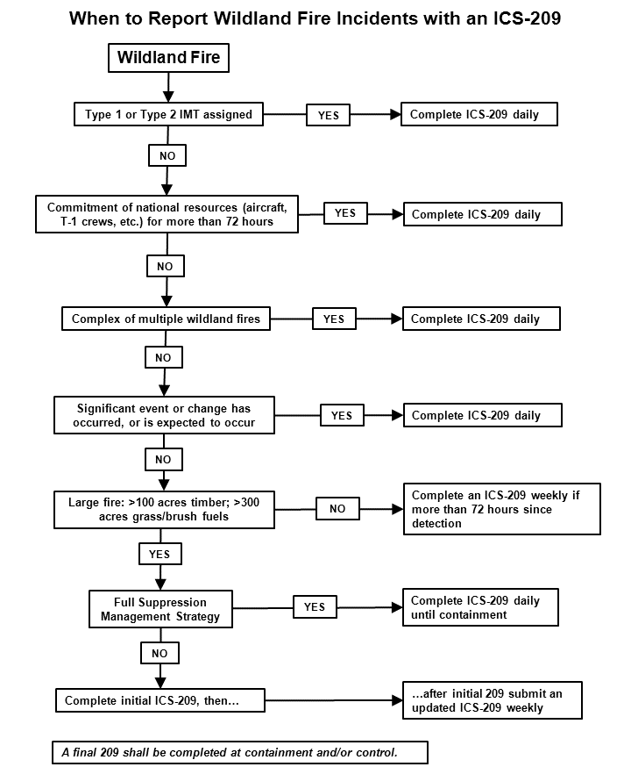

**Definitions:**

Significant number of resources is defined as non-local resources that are required to manage an incident that exceed the capacity of the local unit.

Significant commitment of national resources is defined as one or more Type 1 crews, one or more fixed wing or rotor wing aircraft.

**Monitor** is the systematic process of observing, collecting and recording of fire-related data, particularly with regards to fuels, topography, weather, fire behavior, fire effects, smoke, and fire location. This may be done onsite, from a nearby or distant vantage point in person or using a sensor, or through remote sensing (aircraft or satellite).

**Confine** is to restrict a wildfire to a defined area, using a combination of natural and constructed barriers that will stop the spread of the fire under the prevailing and forecasted weather conditions until out. This means, “some action is or has been taken” (line construction, bucket drops, etc.) to suppress portions of the fire perimeter.

**Point or Zone Protection** involves protecting specific points from the fire while not actively trying to line the entire fire edge. Points being protected may be communities, individual homes, communication sites, areas of high resource value, etc.

**Full Suppression** implies a strategy to "put the fire out” as efficiently and effectively as possible, while providing for firefighter and public safety. To complete a fireline around a fire to halt fire spread, and cool down all hot spots that are immediate threat to control line or outside the perimeter, until the lines can reasonably be expected to hold under foreseeable conditions. Synonymous with “Full Perimeter Containment” and “Control.”

For more information refer to “When to Report Wildland Fire Incidents” document on the web at: <http://www.predictiveservices.nifc.gov/intelligence/intelligence.htm>.

Interagency Situation Report

Daily: At national Preparedness Level 2 and above, whenever significant wildland fire activity occurs, or when the following condition is met: All fires that meet large fire criteria, including prescribed fires, and when an incident or event experiences significant commitment of wildland fire resources.

The Interagency Situation Report is a (FAMWEB) application known as the Sit Report Program. GACCs will ensure that all of their dispatch centers have submitted completed Situation Reports as outlined above, and as outlined in each GACC’s Mobilization Guide. The reporting period for this report is 0001 to 2400. NICC will retrieve situation reports from FAMWEB by 0200 Mountain Time. Fires and acres shall be reported by ownership. Reporting is required for all prescribed fire activity along the same schedule as wildfires. The Interagency Situation Report application is divided into seven (7) sections:

* Daily Fire Statistics
* Resource Information
* Planned Prescribed Fires
* Remarks
* Year-to-Date Statistics
* ICS-209 Entry
* Large Incident Priority

The Sit Report Program shares certain incident information with the 209 Program for summaries and reports. Specific reporting requirements and program instructions are located in the Sit Report User’s Guide located at: [http://www.fs.fed.us/fire/planning/nist/sit.htm](http://www.fs.fed.us/fire/planning/nist/sit.html).

The Sit Report Program is located at <http://fam.nwcg.gov/fam-web/>.

Incident Management Situation Report

Daily: At national Preparedness Level 2 and above, or when significant activity occurs.

Weekly: At national Preparedness Level 1.

The Incident Management Situation Report (IMSR) is prepared by NICC Predictive Services from information and data derived from the Interagency Situation Report and 209 Program through the FAMWEB reporting system. A brief national weather/fire potential outlook will be prepared by a NICC meteorologist for inclusion in the Predictive Services Discussion section of the IMSR.

Large full suppression fires are typically reported in the IMSR until the incident is contained. Wildfires that are managed under a Monitor, Confine, or Point Zone strategy will initially be reported in the IMSR when the event exceeds 100 acres in timber fuel types, 300 acres in grass or brush fuel types, or has an IMT assigned. Such large, long duration fires will be reported in the IMSR until activity diminishes, and thereafter when significant activity occurs (such as acreage increase of 1,000 acres or more, significant resource commitment or resource loss) until the incident is contained.

7 Day Significant Fire Potential Outlook

The 7-day Significant Fire Potential Outlook provides a week-long projection of fuels dryness, weather, fire potential and firefighting resources information. It will be issued daily when a Geographic Area is at Preparedness Level 2 or higher (not including support-only periods). Each Geographic Area’s Predictive Services unit will determine whether to produce a morning or afternoon routine issuance. The outlook will be produced and disseminated using the 7-day Outlook Preparation System (7day OPS). This will facilitate producing the routinely issued product as well as unscheduled updates. It will also provide the ability for the Predictive Services units to provide service backup to one another. Issuance times for each Area’s outlook can be found in the Geographic Area Mobilization Guide and/or in its National Weather Service/Predictive Services Annual Operating Plan.

All the Geographic Area outlooks will be viewable from <http://psgeodata.fs.fed.us/7day/>. The outlooks produced by the 11 Geographic Area Predictive Services units will be consolidated into a National 7-day Significant Fire Potential map located at: <http://psgeodata.fs.fed.us/staticmap.html>.

National Wildland Significant Fire Potential Outlook

Monthly: Issued the first business day of the month.

The National Wildland Significant Fire Potential Outlook is prepared and distributed by NICC on the first business day of each month. This report consists of a national monthly map showing areas of below normal, normal, and above significant fire potential, as well as a seasonal map covering months two through four that shows trends from the previous month’s outlook plus areas of increasing to above normal or decreasing to below normal significant fire potential.

A brief synopsis of the current and predicted national situation is included in the report. National Wildland Significant Fire Potential Outlooks will utilize information from individual GACC Predictive Services units, as well as other sources of climate, weather and fire danger data. This product is updated and produced each month of the year as a collaborative effort by all personnel in the NICC Predictive Service unit.

GACC Monthly and Seasonal Wildland Significant Fire Potential Outlooks

GACC monthly and seasonal outlooks are optional but strongly encouraged as they provide greater detail than the national outlook issued by NICC. GACC monthly or seasonal outlook products will adhere to the following protocols:

* GACC and NICC outlooks must be geospatially equivalent.
* GACC websites are required to link to either Geographic Area or national outlooks.
* GACCs are required to provide draft forecast maps as well as narrative highlights (bullets) of monthly and seasonal significant fire potential to NICC three business days before the end of each month.
* GACC monthly and seasonal outlooks will be issued and posted to their websites on the first business day of each month. The monthly maps will delineate areas of below-normal, normal, and above-normal significant fire potential. Seasonal map covering months two through four will illustrate trends from the previous month. A discussion of fuel conditions, climate outlooks, and other pertinent information will be included in the outlooks.

Fuel and Fire Behavior Advisories

Predictive Services and Coordination staff at all levels should be involved with the issuance of any fuels/fire behavior advisories covering a large percentage of their Geographic Area(s) so they can carefully consider both the content and intended audience of the messages. When a situation arises that warrants an advisory message:

* Determine area of extent
* If local area only (single agency unit or county) – Local area should issue advisory or safety message (Use of Standard Template strongly recommended). No other GACC action needed.
* If geographic in scope (multiple units, counties, or significant portion of geographic area):
* Involve and coordinate with Predictive Services unit staff to get their input/feedback.
* Discuss message on 09:30 Coordinators call to determine if other GACCs are facing same issue.
* Review & tailor message for content, accuracy, suitability and distribution (Predictive Services staffs at Geographic and/or National levels, as appropriate, will coordinate to ensure message is appropriate for entire area of concern).
* Post advisory according to protocols listed below.

Posting Protocols

* Use Standard Template (available from NICC).
* Send completed advisory to NICC who will post to national page.
* Create a detailed map using available tools to draw affected area and to coordinate with neighboring units.
* NICC will post to a national map and archive messages.
* It is recommended that URLs and email messages posted or sent out by the GACCs informing users about the advisory contain a link to the NICC Fuels/Fire Behavior web page and national map (this will inform users about other fuels/fire behavior advisories that are posted across the country).
* GACC web pages should link to the NICC page for both advisory text and national map.
* GACCs will determine when the advisory message is no longer valid and contact NICC to remove the advisory link off the webpage and map.

Wildland Fire Entrapment/Fatality

Entrapment: A situation where personnel are unexpectedly caught in a fire behavior-related, life-threatening position, where planned escape routes or safety zones are absent, inadequate, or have been compromised. An entrapment may or may not include deployment of a fire shelter for its intended purpose. This situation may or may not result in injury. They include “near misses.”

In the event that a wildland fire entrapment or fatality occurs, it should be reported immediately to NICC. A Wildland Fire Entrapment/Fatality Initial Report should be completed and mailed to NICC electronically or by fax machine within twenty-four (24) hours. Submit this report even if some data is missing. (See Chapter 20) Form is located at the following web site: <http://www.nifc.gov/nicc/logistics/coord_forms.htm>. Subsequent to the Initial Report, the investigation and review shall be conducted following agency specific policies and NWCG Guidelines.

National Fire Preparedness Plan

National Preparedness Levels are established by the NMAC at NIFC throughout the calendar year. Preparedness Levels are dictated by burning conditions, fire activity, and resource availability. Resource availability is the area of most concern. Situations and activities described within the Preparedness Levels consider wildland fires and prescribed fires. At any preparedness level, NMAC may request that proposed new prescribed fire (Rx) applications be curtailed to meet national resource needs for emergency operations.

Why Preparedness Levels are Established

The purpose of established Preparedness Levels is:

* To identify the level of wildland fire activity, severity, and resource commitment nationally.
* To identify actions to be taken by NIFC and Geographic Areas to ensure an appropriate level of preparedness/readiness for the existing and potential situation.
* To guide and direct Geographic Area Fire Management activities when essential to ensure national preparedness or in response to the National situation.

The NICC Coordinator will monitor the national wildland fire activity and Geographic Area Preparedness Levels and will recommend to the NMAC a National Preparedness Level. Response and support to non-fire incidents requiring a significant commitment of resources may also affect National Preparedness Levels. National Preparedness Levels will be responsive to the Homeland Security Advisory System.

National Preparedness Levels are determined from the ground up and may influence resource allocations within Geographic Areas not experiencing significant activity to ensure sufficient resources are available for the national situation.

Geographic Area Preparedness Levels

Geographic Area Preparedness Plans should be prepared in accordance with Agency Directives. Copies of Geographic Area Plans should be forwarded to NICC.

Preparedness Level Descriptions

Preparedness Level 1

Description: Minimal large fire activity nationally. Most Geographic Areas have low to moderate fire danger. There is little or no commitment of National Resources.

* Management Direction/Consideration:

Agency/Geographic Areas will determine appropriate actions.

Responsibility:

Agency Administrators within Geographic Areas.

Preparedness Level 2

**Description:** Wildland fire activity is increasing, and large fires are occurring in one (1) or more Geographic Areas. Minimal mobilization of resources from other Geographic Areas is occurring. There is moderate commitment of National Resources with the potential to mobilize additional resources from other Geographic Areas. Significant fire potential is high or becoming high over the next seven (7) days in at least two (2) Geographic Areas.

* Management Direction/Consideration:

Agency/Geographic Areas will determine appropriate actions.

Responsibility:

Agency Administrators within Geographic Areas.

* Management Direction/Consideration:

Daily morning briefings conducted for the NIFC Directorate.

Responsibility:

NICC Coordinator.

* Management Direction/Consideration:

Monitor Geographic Area wildland and prescribed fire status, resource commitments, and preparedness levels.

Responsibility:

NICC Coordinator, Geographic Area Coordinators.

Preparedness Level 3

Description: Wildland fire activity is occurring in two (2) or more Geographic Areas that requires or may require a significant commitment of National Resources. Additional resources are being ordered and mobilized through NICC. Type 1 and 2 IMTs are committed in two (2) or more Geographic Areas and Type 1 and Type 2IA crew commitment nationally is at 50%. Significant fire potential is high or becoming high over the next seven (7) days in at least three (3) Geographic Areas.

* Management Direction/Consideration: Incident strategies must consider the short and long term resource requirements for all new and existing wildland fires (planned and unplanned), to ensure efficient resource utilization for identified priorities.

Responsibility:

Agency Administrators within Geographic Areas.

* Management Direction/Consideration:

Ensure agency fire qualified personnel are available for fire assignments.

Responsibility:

Agency Administrators within Geographic Areas.

* Management Direction/Consideration:

Daily morning briefings conducted for the NIFC Directorate.

Responsibility:

NICC Coordinator.

* Management Direction/Consideration:

Coordinate the prepositioning of National Resources, as appropriate.

Responsibility:

NICC Coordinator.

* Management Direction/Consideration:

Consider requesting Severity Funds to strengthen fire preparedness capability (scarce National Resources).

Responsibility:

NICC Coordinator.

* Management Direction/Consideration:

Assess resource availability from Canada.

Responsibility:

NMAC.

* Management Direction/Consideration:

Monitor critical Fire Cache Supply Inventories and provide appropriate direction to Geographic Areas.

Responsibility:

NMAC.

* Management Direction/Consideration:

Geographic Areas provide NICC with timely intelligence on existing and emerging situations.

Responsibility:

Geographic Area Coordinators.

* Management Direction/Consideration:

AMD and FS Aviation inspect all Type 1 and Type 2 Helicopters.

Responsibility:

National Aviation Officer, FS, and Director, AMD.

* Management Direction/Consideration:

Advise the military of the need for a Defense Coordinating Officer (DCO) to be assigned to NIFC.

Responsibility:

NICC Coordinator.

* Management Direction/Consideration:

Evaluate the need to activate the National Interagency Support Cache Coordinator at NICC.

Responsibility:

NICC Coordinator and National Interagency Support Cache Managers.

Preparedness Level 4

Type 1 and 2 IMTs are committed in three (3) or more Geographic Areas. Competition exists for resources between Geographic Areas. Nationally, 60% of Type 1 and 2IA crews are committed. Three (3) or more Geographic Areas have reached drawdown on tactical resources. Significant fire potential is high or becoming high over the next seven (7) days in at least three (3) Geographic Areas and ignition triggering events are likely in at least two (2) Geographic Areas.

Description:

* Management Direction/Consideration:

Establish MAC Group at NIFC and conduct MAC Group Meetings daily.

Responsibility:

NMAC.

* Management Direction/Consideration:

Prescribed fire application can be continued or be initiated if the proposed action is approved by an agency at the Regional or State Office level. This approval must be based on an assessment of risk, impacts of the proposed actions on Area resources and activities, and include feedback from the GMAC. The GMAC provides information or perspectives to agencies wishing to proceed with or implement a prescribed fire application. The final decision to implement resides with the implementing agency.

Agencies wishing to proceed with an incident strategy other than full suppression will consult with GMAC. The final decision to implement resides with the implementing agency.

If the agency decides to implement, incident strategies must consider the short and long term resource requirements for all new and existing wildland fires (planned and unplanned) to ensure efficient resource utilization for identified priorities.

Responsibility:

Agency Administrators and Regional and State Offices.

* Management Direction/Consideration:

Establish IR Coordinator position at NICC, as appropriate.

Responsibility:

NICC Coordinator.

* Management Direction/Consideration:

Allocate/preposition National Resources.

Responsibility:

NMAC.

* Management Direction/Consideration:

Train additional emergency firefighters as may be appropriate.

Responsibility: Agency Administrators within Geographic Areas.

* Management Direction/Consideration:

Coordinate “off-site” training of emergency firefighters with Geographic Areas.

Responsibility:

NMAC Coordinator.

* Management Direction/Consideration:

Encourage: (1) Assignment of Communications Frequency Managers and Aviation Specialists to all complex multiple incidents; and (2) Activation of MAC Group as may be appropriate.

Responsibility:

Agency Administrators within Geographic Areas.

* Management Direction/Consideration:

Geographic Areas provide NICC with fire priorities and other pertinent information at [0300 and 1700 daily].

Responsibility:

Agency Administrators within Geographic Areas.

* Management Direction/Consideration:

Implement Military Training Plan. Assemble Training Cadre for training military.

Responsibility:

NMAC Coordinator.

* Management Direction/Consideration:

AMD and FS Aviation contract, award, and inspect additional CWN Type 1 and Type 2 Helicopters.

Responsibility:

National Aviation Officer, FS.

* Management Direction/Consideration:

Activate the National Interagency Aviation Coordinator position.

Responsibility:

National Agency Aviation Offices – FS, BLM, and AMD.

* Management Direction/Consideration:

Activate the National Interagency Support Cache Coordinator position at NICC.

Responsibility:

NICC Coordinator.

Preparedness Level 5

Wildland fire or other incidents nationally have the potential to exhaust all agency fire resources. Eighty percent (80%) of Type 1 and Type 2IA crews are committed, as well as the majority of other National Resources. Significant fire potential is likely to remain high in at least three (3) Geographic Areas with no indication of improvement in the next seven (7) days.

Description:

* Management Direction/Consideration:

Continue with National Preparedness Level 4 activities.

Responsibility:

NMAC Coordinator.

* Management Direction/Consideration:

Request Canadian Liaison for the NMAC.

Responsibility:

NMAC Coordinator.

* Management Direction/Consideration:

Access the need for International assistance.

Responsibility:

NMAC.

* Management Direction/Consideration:

Add Coordinator position at NICC to coordinate military mobilizations.

Responsibility:

NMAC Coordinator.

* Management Direction/Consideration:

Rx applications can be initiated or continued if the proposed action is approved by an agency at the Regional or State Office level and local resources are available to carry out the application without additional outside resource needs. This approval must be based on an assessment of risk, impacts of the proposed actions on Area resources and activities, and include feedback from the GMAC. The GMAC provides information or perspectives to agencies wishing to proceed with or implement a Rx application.

For Rx applications to be initiated or continued that requires additional support of resources from outside the local unit or require resource ordering of an IMT or WFMT, a National MAC representative must assess risk and impacts of the proposed action and present to NMAC for review prior to proceeding. The final decision to implement resides with the implementing agency.

Agencies wishing to proceed with an incident strategy other than full suppression will consult with GMAC and their Geographic Area NMAC Representative. The final decision to implement resides with the implementing agency.

If the agency decides to implement, incident strategies must consider the short and long term resource requirements for all new and existing wildland fires (planned and unplanned) to ensure efficient resource utilization for identified priorities.

Responsibility:

Agency Administrators, Regional and State Office Fire Staff, NIFC Staff, and NMAC.

* Management Direction/Consideration:

Prepare Geographic Area evaluation/assessment of current and projected fire situation when requested by the NMAC.

Responsibility:

GMACs.

* Management Direction/Consideration:

When requested by the NMAC, make available and incorporate project equipment into the NFES Fire Cache System.

Responsibility:

GMACs.

**Preparedness Level 5 to 4**

Description: Competition for resources has significantly decreased. No critical fire weather is forecasted for the next three (3) to five (5) days.

**Preparedness Level 4 to 3**

Description: Significant demobilization is occurring. Crews are being released daily and sent to home units. Fifty percent (50%) of total crew capability is available for new fires. All ground DoD resources have been released. Moderating conditions are forecasted for the next twenty four (24) hours, and higher humidity and lower temperatures are forecasted for the major fire areas.

**Preparedness Level 3 to 2**

Description: The majority of large fires are contained. Initial attack resources are again available. Geographic Area Crew availability is at or above the 50% level. There is no competition for resources between Geographic Areas. Large fire areas are expected to receive precipitation, with associated higher humidity and lower temperatures.

National Multi-Agency Coordinating Group (NMAC) Decisions

All NMAC Decisions affecting Geographic Areas and/or providing management guidance will be documented on the NICC web page, located at the following web site: <http://www.nifc.gov/news/nmac2/index.html>. Additional information may be required from Geographic Areas and Coordinating Groups in order to effectively develop strategy.

Follow-Up Evaluation

The NMAC Coordinator will document decisions and their results and will report to the NMAC during subsequent meetings.

Mobilization Procedures for Military Assets

It is advisable that units and field level users intending to order and utilize military resources obtain copies of the Military Use Handbook, NFES 002175, located at the following web site: http://www.predictiveservices.nifc.gov/intelligence/military/Military_Use_Handbook_2006_2.pdf. The short term use of trained DOD assets should be considered until civilian or wildland fire agency resources become available to replace DOD assets. For long term use/assignments, the following process will be followed:

Established Resource Ordering Process

The established resource ordering process will be utilized, including standard resource order format.

* NICC will determine if all available civilian resources are committed.
* The Resource Order will be passed back to the Geographic Area indicating that military assets are the only available resources and estimated time frames for delivery.
* The Resource Order will be passed back from the Geographic Area to the ordering unit dispatch center, indicating military assets are the only available resources and estimated timeframes for delivery.
* The Resource Order will be passed back from the ordering unit dispatch center to the incident indicating military assets are the only available resource and estimate timeframes for delivery. It may be necessary for the unit dispatcher to redeploy civilian crews to insure military units are kept intact by deploying a minimum of one (1) battalion to the same incident.
* The incident must reorder the military assets on a Resource Order in the following manner:
* Crews: Will be ordered by battalion (25 crews). Each battalion will have one (1) “C” request number. Each battalion will initially be deployed to the same incident.
* Each Resource Order for crews will be accompanied by “O” requests for:
* One (1) Battalion Military Liaison (BNML).
* One (1) Deputy BNML.
* Four (4) Strike Team Leaders – Military (STLM).
* Twenty-eight (28) Military Crew Advisors (MCAD) (Minimum Crew Boss qualified).

Overhead personnel will remain committed throughout the assignment (30–33 days).

* 00The Resource Order will then be passed from the incident through established ordering channels to NICC. NICC will certify no civilian assets are available, and then forward the Resource Order to the appropriate Continental United States Military Headquarters.
* NICC will provide the following items:
* Air transportation, if needed, from installation to the jetport closest to the incident.
* Five (5) kits of programmable handheld radios, which will be mobilized with the battalion.
* The incident, on a separate request number, must order enough support equipment, caterers, showers, transportation, and hand tools to equip the military (500-600 firefighters and support personnel). The incident will need to supply diesel fuel for ground vehicles, and fuel for Aviation assets. All firefighting personnel will come equipped with PPE.
  + Aviation: Aviation support will be ordered by required missions. It should be noted that military Aviation resources, when compared to civilian resources, are restricted in mission capability.

Each group of missions will have its own “A” request number. Each Resource Order will specify the following information:

* Pounds of external cargo per day.
* Number of passengers (PAX) per day.
* Hours of water bucket missions per day.
* Pounds of internal cargo per day.
* Estimation of aircraft needed.
* Aviation communication needs.
* Helicopter Modules/Managers
* Refer to Military Use Handbook, NFES 002175, July 2006, Chapter 70.4.1.
* Vehicles: Vehicles will be ordered by required missions. Each group of missions will have its own “E” request number.

Each Resource Order will specify the following information:

* Number of passengers per day.
* Pounds of cargo per day.

Civilian Support

All other civilian support requested specifically by the military at the incident will follow the established ordering procedures.

Demobilization Procedures

Procedures will be reversed. However, a lead time of seventy-two (72) hours will be needed to release military firefighters. NICC will release assets to the military and normally provide air transport from the nearest airport. The incident should be prepared to provide ground transportation to the airport. All tools, PPE, and other firefighting issued equipment need to be collected at the incident prior to demobilization.

International Operations

Canada Support

Mobilizations involving the United States of America (USA) and Canada are governed and directed by the diplomatic note, Reciprocal Forest Fire Fighting Arrangement Operational Guidelines, and by local initial attack agreements. Requests to Canadian agencies will normally be made after USA resources are depleted, shortages are projected, or reasonable timeframes cannot be met. All requests for use of Canadian Resources must be ordered through NICC, except for local mutual aid that does not include provisions for any reimbursement. The USA may request airtankers from Canada only after all available contract, add-on, and MAFFS aircraft have been mobilized. The USA may request helicopters from Canada after all available contract and CWN helicopters have been mobilized.

Australia and New Zealand Support

Mobilizations involving the United States, Australia, and New Zealand are coordinated through NICC, and are defined in the Wildfire Arrangements between the Department of the Interior and Department of Agriculture of the United States and the Australian and New Zealand Participating Agencies and in the Annual Operating Plan for these Arrangements. Request to Australian and New Zealand Participating Agencies will normally be made after USA resources are depleted, shortages are projected, or reasonable timeframes cannot be met.

Mexico Support

Mobilizations involving the United States and Mexico for fires within ten (10) miles either side of the U.S. – Mexico border are defined in the Wildfire Protection Agreement between the Department of the Interior and the Department of Agriculture of the United States and the Secretariat of Environment, Natural Resources, and Fisheries of the United Mexican States for the Common Border.

Mobilizing USA resources for suppression assistance within Mexico beyond the ten (10) mile zone must be approved and coordinated by NICC, be authorized for reimbursement by the U.S. Agency for International Development’s Office of Foreign Disaster Assistance, and be received by NICC through a request from the U.S. Forest Service’s Disaster Assistance Support Program. (See Chapter 10)

Other Nations Support for Large Scale Mobilizations

Large scale mobilizations for reimbursable direct support to disasters (fires or all-hazard) in other nations are based on requests received through the Forest Service International Program’s Disaster Assistance Support Program (DASP). DASP responds to requests from the U.S. Agency for International Development’s Office of Foreign Disaster Assistance (OFDA). OFDA works closely with U.S. Ambassadors in foreign countries, who must determine if an incident in a foreign country warrants U.S. involvement. If the Ambassador does feel the incident is beyond the capability of the affected government, the affected government has requested the assistance, and it is in the best interest of the U.S. Government to assist, the Ambassador can “declare” a disaster. That declaration is the activation mechanism for U.S. support. If that support would include resources available through the land management agencies, OFDA would go to DASP, who would place requests through NICC.

Small scale requests for disaster assistance or technical assistance are coordinated directly by DASP through the home units of the requested individuals.

More information concerning the mission of OFDA and how it organizes and responds to international disasters can be found in OFDA’s Field Operations Guide for Disaster Assessment and Response (FOG). The FOG can be located at the following web site:

<http://www.usaid.gov/our_work/humanitarian_assistance/disaster_assistance/resources/pdf/fog_v4.pdf>

More information on DASP is located at: <http://www.fs.fed.us/global>.

Dispatch Forms

Resource Order Form

Mobile Food and Shower Service Request Form

Passenger and Cargo Manifest Form

Aircraft Flight Request/Schedule Form

Infrared Aircraft Scanner Request Form

FAA Temporary Tower Request Form

Preparedness/Detail Request Form

Incident Status Summary (ICS-209) Form

Monthly Wildland Fire Weather/Fire Danger Outlook Form

Wildland Fire Entrapment/Fatality Form

Documentation of Length of Assignment Extension Requirements Form

Resource Order Form

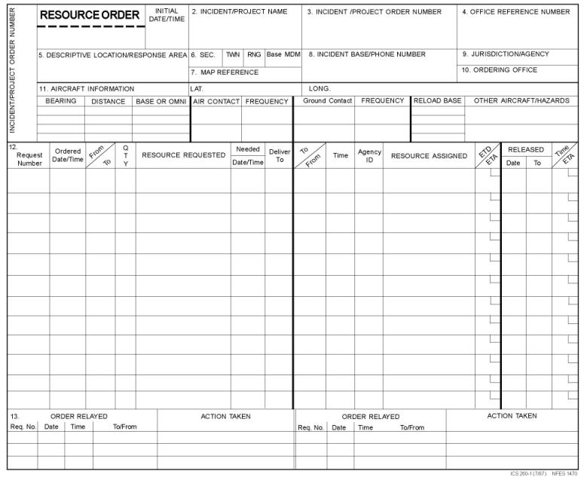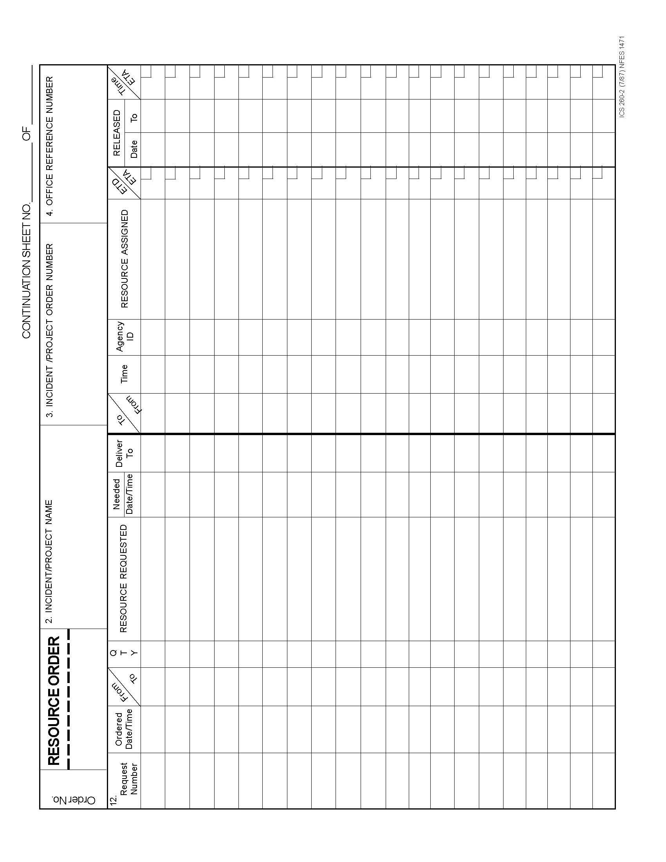

**MOBILE FOOD & SHOWER SERVICE REQUEST FORM**

Incident Name: Financial Code:

Resource Order #: Food Service Request E#:___________

Shower Unit Request E#:___________

**I. FOOD SERVICE: Requested Date, Time, Meal Types, and Number of Meals**

1. Date of first meal: Time of first meal:

2. Estimated number for the first three meals:

1st meal: [ ] Hot Breakfast [ ] Sack Lunch [ ] Dinner

2nd meal: [ ] Hot Breakfast [ ] Sack Lunch [ ] Dinner

3rd meal: [ ] Hot Breakfast [ ] Sack Lunch [ ] Dinner

This Block for National Interagency Coordination Center Use Only.

Actual agreed upon Date/Time first meals are to be served: Date: Time:

(Minimum guaranteed payment is based on these estimates, see Section G.2.2):

1st meal: [ ] Hot Breakfast [ ] Sack Lunches [ ] Dinner

2nd meal: [ ] Hot Breakfast [ ] Sack Lunches [ ] Dinner

3rd meal: [ ] Hot Breakfast [ ] Sack Lunches [ ] Dinner

**II. Location**

Reporting location:

Contact person at the Incident:

**III. Additional Information**

Spike Camps: Yes No Unknown

Estimated Duration of Incident____________ Estimated Personnel at Peak____________

Dispatch Contact: Telephone Number:

**IV. SHOWER SERVICE: Requested Date and Time Mobile Shower Unit is needed**

Date Requested_______________ Time Requested_______________

Mobile Shower Unit type ordered: Large (12+ stalls) [___] Small (4-11 stalls) [___ ]

This Block for National Interagency Coordination Center Use Only.

Actual agreed upon Date/Time Mobile Shower Unit to be operational: Date: Time:

**National Interagency Coordination Center – 208-387-5400**

Passenger and Cargo Manifest Form

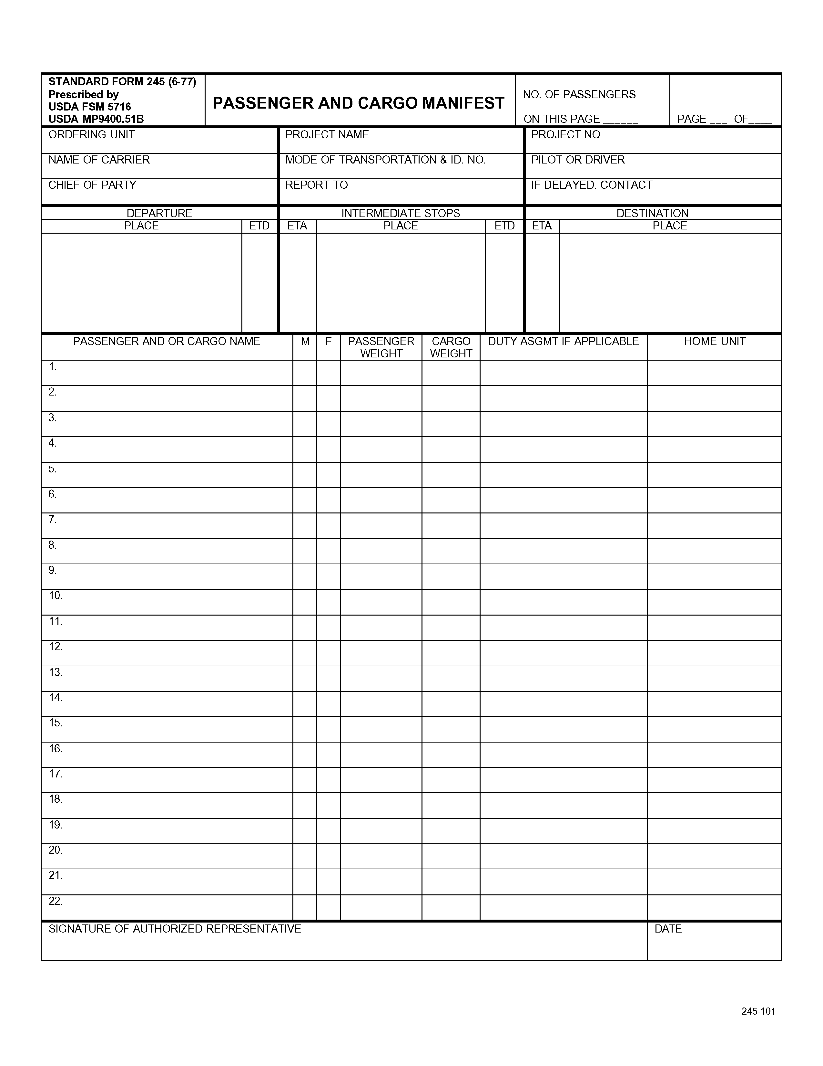

Aircraft Flight Request/Schedule Form

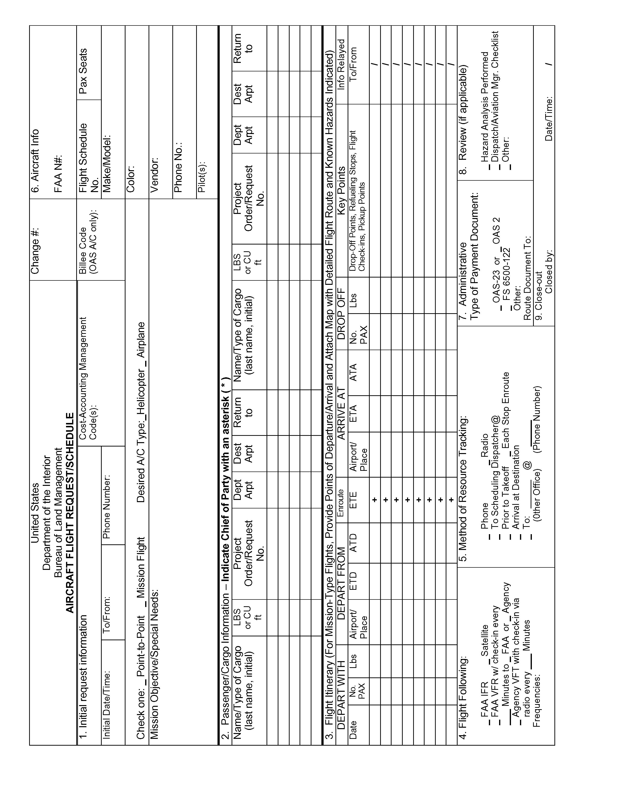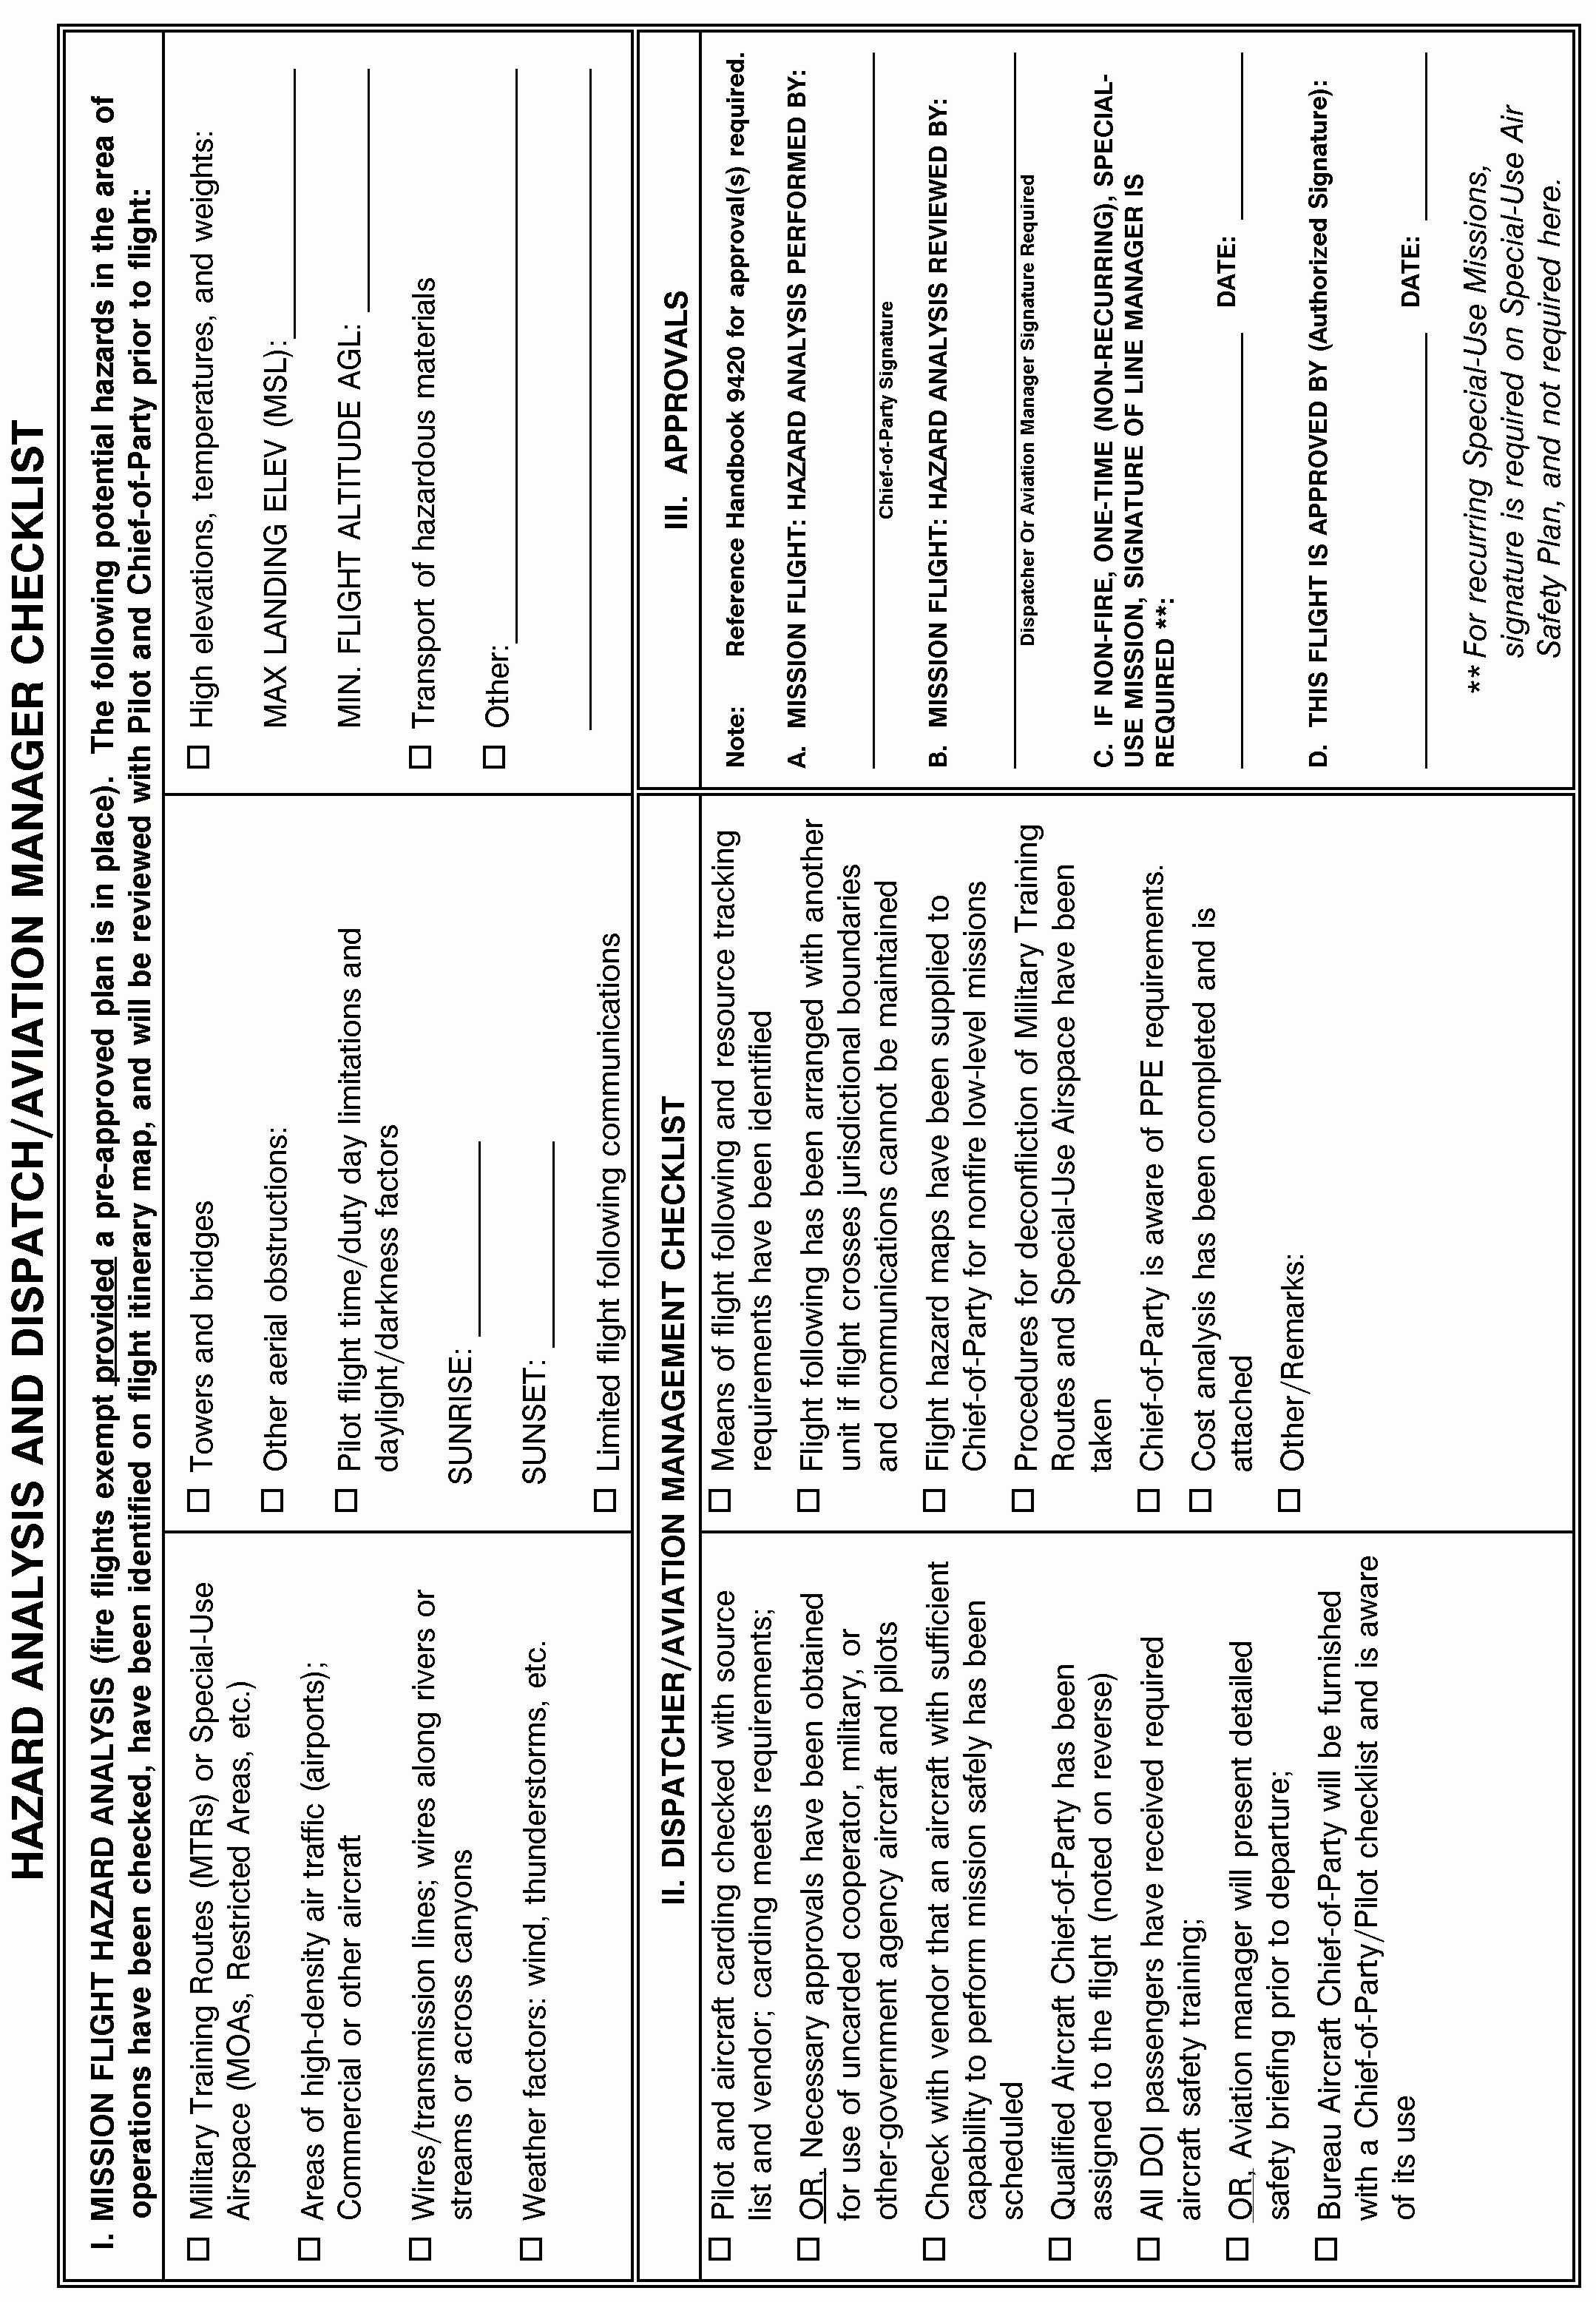

Infrared Aircraft Scanner Request Form

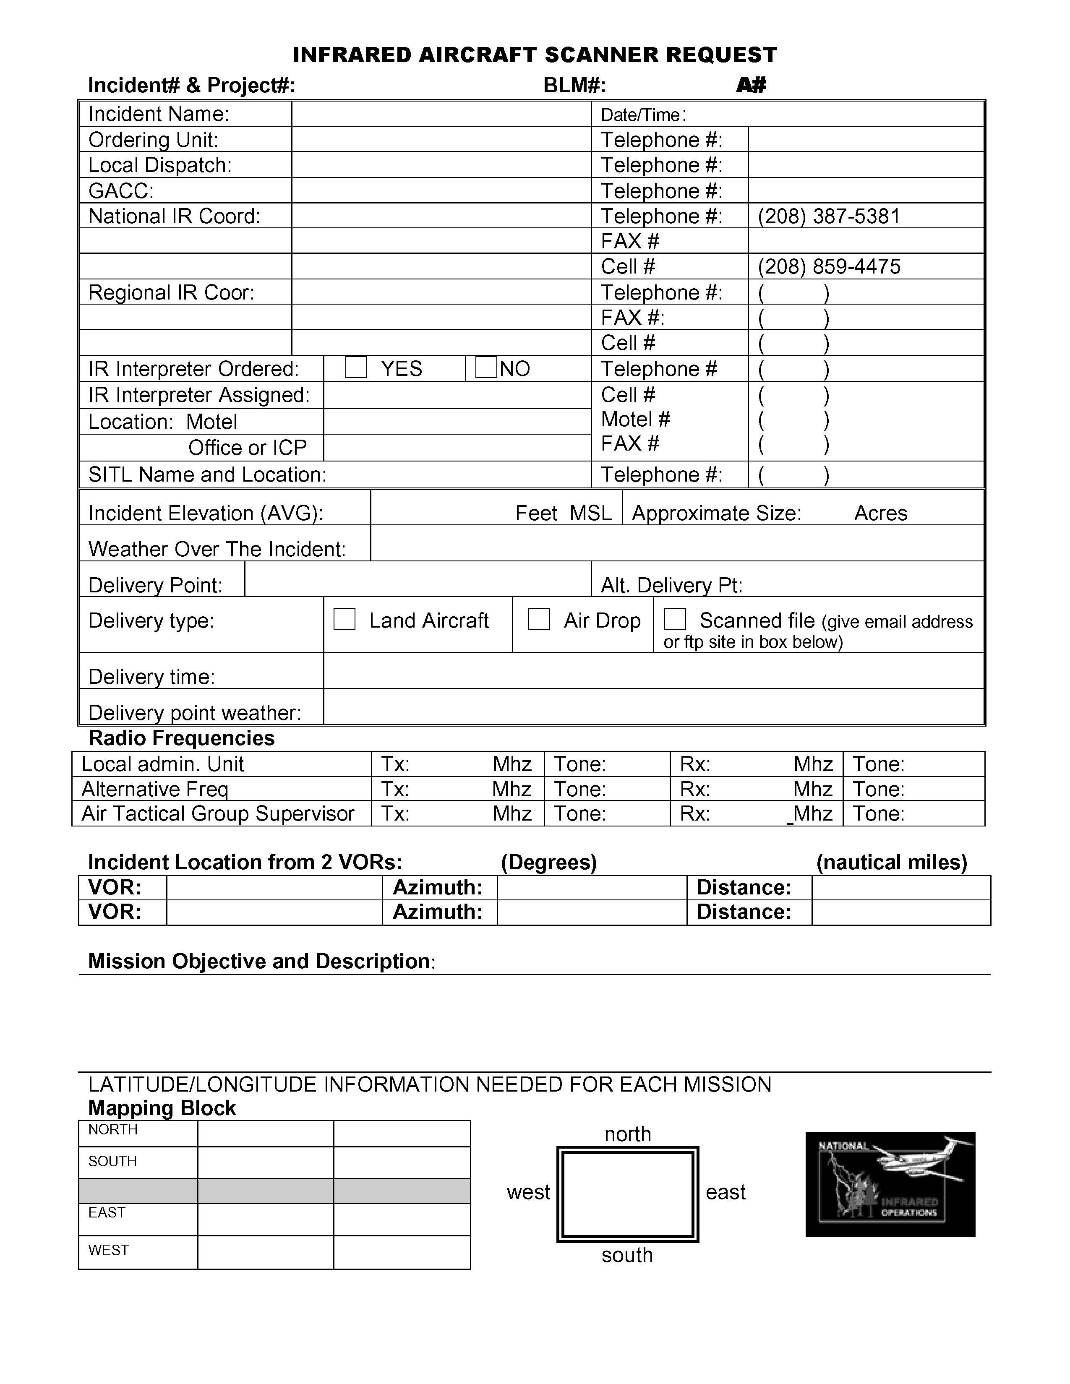

FAA Temporary Tower Request Form

**TEMPORARY TOWER REQUEST FORM**

(Note - this form should be used in conjunction with the checklists located in Chapter 11 of the Interagency Airspace Coordination Guide ([www.fs.fed.us/r6/fire/aviation/airspace](http://www.fs.fed.us/r6/fire/aviation/airspace))

Please attach this form to the Resource Order and forward both forms to the appropriate FAA Regional Operations Center (ROC),through established ordering channels*.*

**I.** **GENERAL INFORMATION**:

Incident Name ________________________ Management/Fiscal Code ____________________

Resource Order Number ________________ Request Number ________ Date_________________

**II. POINTS OF CONTACT**

Name/Agency Telephone

Ordering Unit __________________________________ ________________________

Air Ops/Air Support _____________________________ ________________________

Local or Expanded Dispatch _______________________ ________________________

Geographic Area Coordination Ctr__________________ ________________________

National Interagency Coordination Ctr_______________ ________________________

FAA POC at ROC ____________________________ ________________________

Name / Phone Number of Airport Owner / Operator ___________________________________

Has the Airport Owner been notified? YES NO

Requested Operational Hours: ____________________________

Estimated Length of Duration: ____________________________

**III.** **SUPPORT INFORMATION**

Closest City/Town ____________________________________ State ___________________

Where is the proposed location of the temporary tower (Select one or explain):

Airport Name & FAA Code__________________________ Helibase_______________

Incident Command Post ___________________________ Other__________________

Is a facility available on site for use as a tower (Select one or explain)?

FBO Site/Room rental/etc__________________ Rental Trailer ____________________

Facility to be built on site___________________ Other __________________________

Conditions to expect for overnight at site: Camp ________________ Hotel _________________

Is a vehicle (Gov’t or rental) available for tower personnel? YES NO

Please attach detailed driving directions to the reporting site

Note: Road closures, hazardous conditions, easiest route of travel, etc

**IV. EQUIPMENT SURVEY - Refer to Chapter 11 checklist / Interagency Airspace Coordination Guide**

What equipment do you currently have (radios, etc) for use by tower personnel?

_____________________________________________________________________________

_____________________________________________________________________________

What equipment do you need? (radios, etc)

__________________________________________________________________________________________________________________________________________________________

Have you completed an inventory of equipment?

_____________________________________________________________________________

Preparedness/Detail Request Form

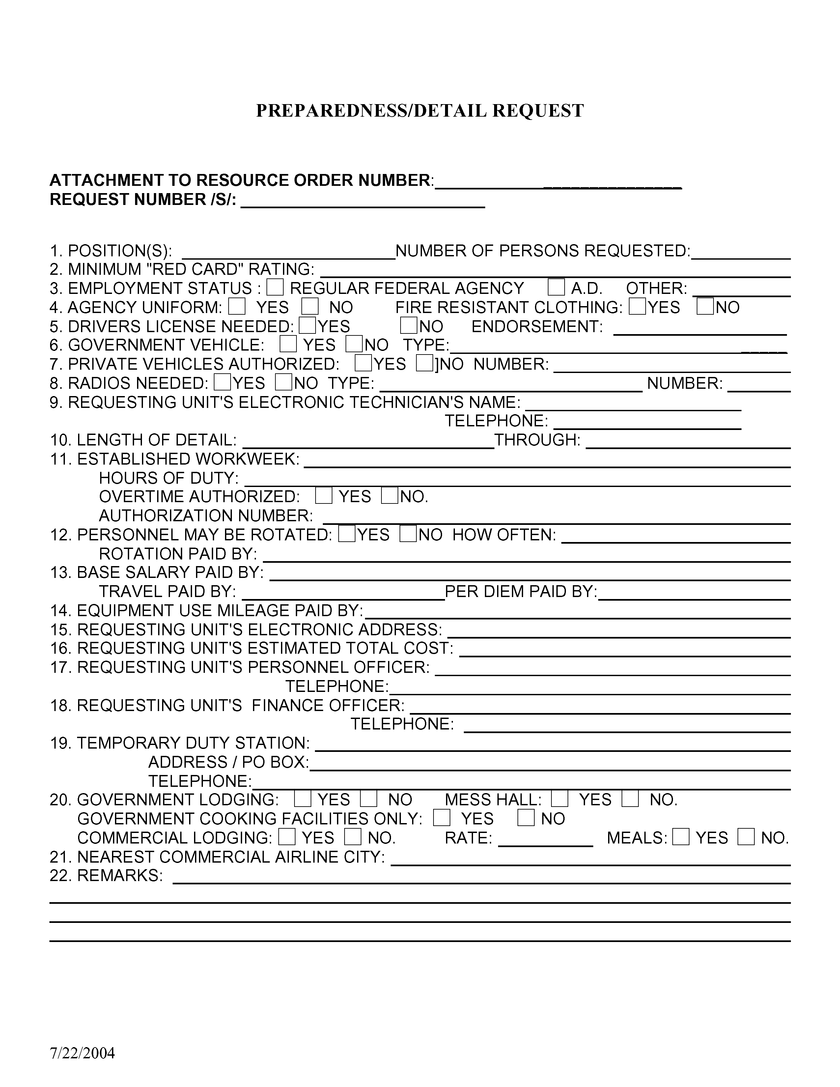

Incident Status Summary (ICS-209) Form

### Incident Status Summary (ICS-209)

|  |  |  |  |  |
| --- | --- | --- | --- | --- |
| 1: Date | 2: Time | 3: Initial   |   Update   |   Final           |              | | 4: Incident Number | 5: Incident Name |

|  |  |  |  |  |  |
| --- | --- | --- | --- | --- | --- |
| 6: Incident Kind/Strategy | 7: Start Date    Time | 8: Cause | 9: Incident Commander | 10: Incident Command Organization | 11: State-Unit |

|  |  |  |
| --- | --- | --- |
| 12: County | 13: Latitude and Longitude  Lat:  Long:  Ownership at Origin: | 14: Short Location Description (in reference to nearest town): |

|  |  |  |  |  |  |
| --- | --- | --- | --- | --- | --- |
| 15: Size/Area Involved | 16: % Contained or  MMA | 17: Expected Containment Date: | 18: Line to Build | 19: Estimated Costs to Date | 20: Declared Controlled Date:  Time: |

|  |  |  |  |  |  |  |
| --- | --- | --- | --- | --- | --- | --- |
| 21: Injuries this Reporting Period: | 22: Injuries to Date: | 23: Fatalities | 24: Structure Information | | | |
|  |  |  | Type of Structure | # Threatened | # Damaged | # Destroyed |
| 25: Threat to Human Life/Safety: Evacuation(s) in progress ----  No evacuation(s) imminent --  Potential future threat --------  No likely threat --------------- | | | Residence |  |  |  |
| Commercial Property |  |  |  |
| Outbuilding/Other |  |  |  |

|  |
| --- |
| 26: Projected incident movement/spread in 12, 24, 48 and 72 hour time frames:  12 hours:  24 hours:  48 hours:  72 hours: |

|  |
| --- |
| 27: Values at Risk: include communities, critical infrastructure, natural and cultural resources in 12, 24, 48 and  72 hour time frames:  12 hours:  24 hours:  48 hours:  72 hours: |

|  |
| --- |
| 28: Critical Resource Needs (amount, type, kind, and number of operational periods in priority order in 12, 24,  48 and 72 hour time frames): **ex. 3 CRW1 (4); 1 HEL1 (5);**  12 hours  24 hours:  48 hours:  72 hours: |

|  |
| --- |
| 29: Major problems and concerns (control problems, social/political/economic concerns or impacts, etc.) Relate critical resources needs identified above to the Incident Action Plan. |

|  |
| --- |
| 30: Observed Weather for current operational period: Wind Direction: Wind Speed (mph): Peak Gusts:  Max. Temperature:        Min. Relative Humidity: |

|  |
| --- |
| 31: Fuels/Materials Involved: A drop down box with the 13 Fire Behavior Fuel Models has been added. The incident would select the predominant fuel model with the option to include additional fuels information in the text box. |

|  |
| --- |
| 32: Today's observed fire behavior (leave blank for non-fire events): |

|  |
| --- |
| 33: Significant events today (closures, evacuations, significant progress made, etc.): |

|  |
| --- |
| 34: Forecasted Weather for next operational period:  Wind Speed (mph): Temperature:  Wind Direction: Relative Humidity: |

|  |  |  |
| --- | --- | --- |
| 35: Estimated Control Date and Time: | 36: Projected Final Size: | 37: Estimated Final Cost: |

|  |
| --- |
| 38: Actions planned for next operational period: |

|  |
| --- |
| 39: For fire incidents, describe resistance to control in terms of: |
| 1. Growth Potential - |
| 2. Difficulty of Terrain - |

|  |
| --- |
| 40: Given the current constraints, when will the chosen management strategy succeed? |

|  |
| --- |
| 41: Projected demobilization start date: |

|  |
| --- |
| 42: Remarks: |

|  |
| --- |
| 43: Committed Resources |

|  |  |  |  |  |  |  |  |  |  |  |  |  |  |  |  |
| --- | --- | --- | --- | --- | --- | --- | --- | --- | --- | --- | --- | --- | --- | --- | --- |
| Agency | CRW1 | | CRW2 | | HEL1 | HEL2 | HEL3 | ENGS | | DOZR | | WTDR | OVHD | Camp Crews | Total Personnel |
| SR | ST | SR | ST | SR | SR | SR | SR | ST | SR | ST | SR | SR |
|  |  |  |  |  |  |  |  |  |  |  |  |  |  |  |  |
|  |  |  |  |  |  |  |  |  |  |  |  |  |  |  |  |
| Total |  |  |  |  |  |  |  |  |  |  |  |  |  |  |  |

|  |
| --- |
| 44: Cooperating and Assisting Agencies Not Listed Above: |

|  |
| --- |
| Approval Information |

|  |  |  |
| --- | --- | --- |
| 45: Prepared by: | 46: Approved by: | 47: Sent to: By:  Date: Time: |

Monthly Wildland Fire Weather/Fire Danger Outlook Form

**MONTHLY WILDLAND FIRE WEATHER/FIRE DANGER OUTLOOK**

**1. Reporting Unit: _______________________________________________________**

**2. Date: ____________________________**

**3. Potential for Serious/Critical Fire Problems:**

|  |  |  |  |  |  |  |
| --- | --- | --- | --- | --- | --- | --- |
| **This Coming Month** | **Below Normal** |  | **Normal** |  | **Above Normal** |  |
| **This Season** | **Below Normal** |  | **Normal** |  | **Above Normal** |  |

**Comments: ___________________________________________________________________**

**4. Fire Weather Outlook: (Addresses the following factors)**

**Drought Conditions: ________________________________________________________**

**Precipitation Anomalies and Outlook: _________________________________________**

**Temperature Anomalies and Outlook: _________________________________________**

**5. Fuels:**

|  |  |  |  |  |  |  |
| --- | --- | --- | --- | --- | --- | --- |
| **Fine – Grass Stage** | **Green** |  | **Cured** |  |  |  |
| **New Growth** | **Sparse** |  | **Normal** |  | **Above Normal** |  |

**Live Fuel Moisture (sage, deciduous, conifer): ___________________________________**

**1000 Hour Dead Fuel Moisture: _______________________________________________**

**Normal/Average Fuel Moisture for this Time of Year: ____________________________**

**6. Average Fire Occurrence/Acres Burned (to date, 5 year average): ______________________________________________________________________________**

**7. Actual Occurrence/Acres Burned (to date, this year): ______________________________**

**8 Written Summary (The text from this summary will be used in the National Wildland Fire Outlook). (Attach to this form.)**

**9. Fire Outlook Map (Attach to this form.)**

**A Geographic Area outline map showing Areas of below normal, normal, and above normal fire potential shall be submitted, along with the Monthly Fire Weather/Fire Danger Outlook Report. The map template can be found at:**

http://www.nifc.gov/news/intell_predserv_forms/national_map.html

Wildland Fire Entrapment/Fatality Initial Report Form



Documentation of Length of Assignment Extension Requirements Form

