Unit 5: Working with Instructors

In this unit you will learn about:

- The Program Manager and the CERT Instructor. The roles of Program Manager and instructor.
- Recruitment. How to find and recruit instructors.
- Orientation. What you need to learn and what orientation is needed.
- Tracking. What information to track and why to track instructors.
- Management. The tasks involved in managing instructors.
- Retention. The importance of recognizing both paid and volunteer instructors.
- Termination. What to do if it is necessary to terminate an instructor.

[This page intentionally left blank]

Learning Objectives/ Performance Outcomes | At the conclusion of this unit, the participants will be able to:  - Establish a process for working with instructors.  - Describe how to recruit instructors.  - Describe how to orient instructors.  - Explain why to track instructors.  - Describe methods for managing instructors.  - Identify techniques for retaining instructors.  - Explain what to do when terminating an instructor.
Scope | The topics that will be discussed in this unit are:  - Unit Overview  - The Program Manager and the CERT Instructor  - Recruit Instructors  - Orient Instructors  - Track Instructors  - Manage Instructors  - Retain Instructors  - Terminate an Instructor  - Unit Summary
Estimated Completion Time | 1 hour

Training Methods | The instructor starts by providing an overview of the Program Manager’s role with instructors: the types of personnel needed, the importance of instructors to the program’s success, the elements of a competent instructor, and the instructor development plan.  Then the instructor conducts a guided discussion about who might be a good instructor for a CERT course. The class reviews factors to consider when recruiting instructors. Participants record recruitment ideas in their Draft Program Plan.  The instructor next discusses orienting instructors. The instructor explains that orientation includes learning about the instructor and providing information to the instructor. The instructor then provides a list of the information to include in orientation to reduce liability and to ensure that the instructor represents the program competently.  Then the instructor briefly addresses tracking instructors: what needs to be tracked and why tracking is important.  Following this, participants and instructor discuss the tasks in managing instructors, training them, monitoring their work, and finally evaluating them and providing feedback.  Next the instructor conducts a short guided discussion on the ways to provide instructor recognition, particularly to volunteer instructors.  Finally, the instructor briefly discusses terminating an instructor.  Throughout the unit participants record ideas in their Draft Program Plan.
Resources Required | - Community Emergency Response Team Program Manager Instructor Guide (for instructors)  - Community Emergency Response Team Program Manager Participant Manual (for participants)  - PowerPoint slides 5-1 to 5-38

Equipment | The following equipment is required for this unit:  - A computer with PowerPoint software  - A computer projector and screen  - Easel pad and easel or whiteboard  - Markers
Notes | A suggested time plan for this unit is as follows:  Unit Overview 1 minute  The Program Manager and the CERT Instructor 15 minutes  #1 Recruit Instructors 8 minutes  Draft Program Plan: Identify Recruitment Options 10 minutes  #2 Orient Instructors 10 minutes  #3 Track Instructors 1 minute  #4 Manage Instructors 10 minutes  #5 Retain Instructors 3 minutes  Terminate an Instructor 1 minute  Unit Summary 1 minute  Total Time: 1 hour
Remarks | While the initial training offered by a CERT program is the CERT Basic Training course, a program will quickly begin offering more training courses. Therefore this unit uses the generic term “CERT course” rather than referring to one particular course.  This unit is not about how to deliver CERT Basic Training. Remember that the audience for this unit is current and potential Program Managers; it is not CERT instructors. Sections of this unit reflect the content of the CERT Train-the-Trainer course but the emphasis in this unit is on managing instructors rather than training instructors.

Unit 5: Working with Instructors

Instructor Guidance | Content
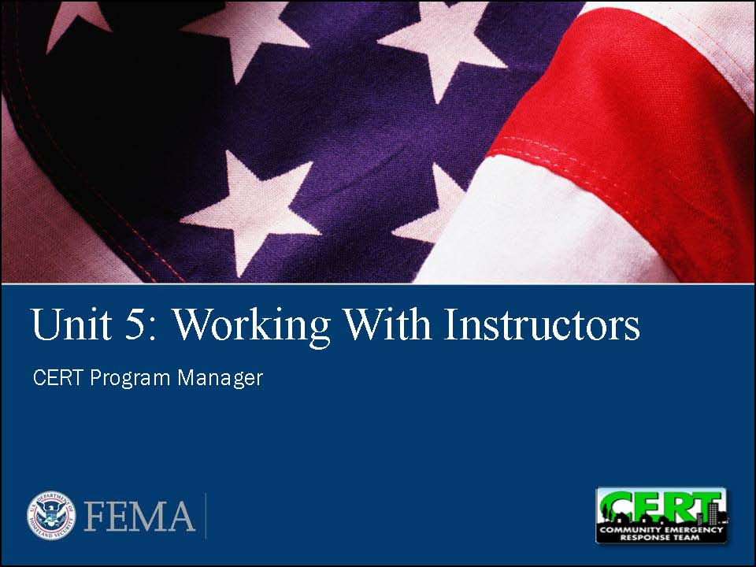  Display Slide 5-1 | Unit Overview  Say that this unit looks at how the Program Manager works with instructors:  - Recruitment  - Orientation  - Tracking  - Management  - Retention  - Termination
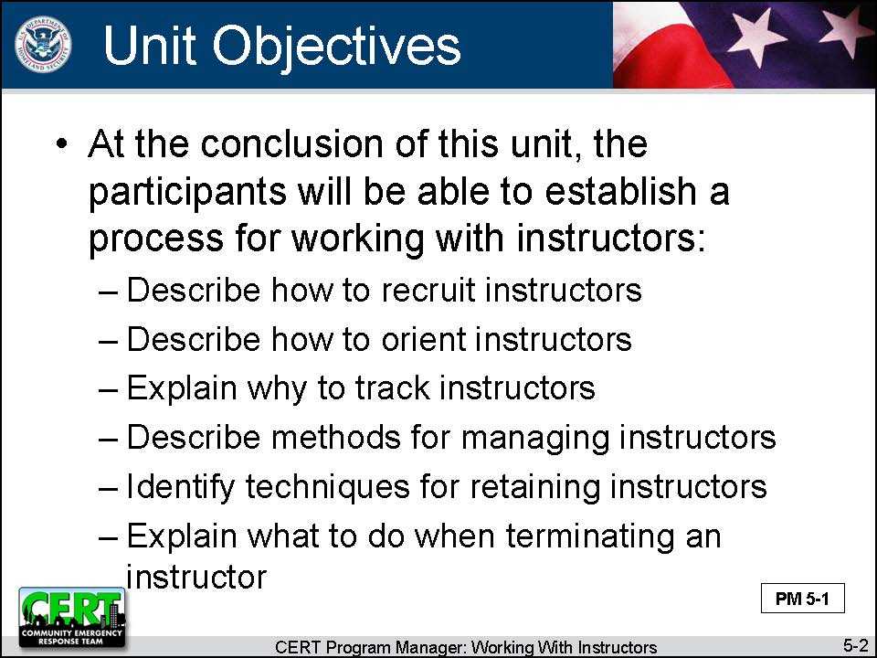  Display Slide 5-2 | Unit Objectives  Give the unit’s learning objectives.  At the conclusion of this unit, the participants will be able to establish a process for working with instructors:  - Describe how to recruit instructors.  - Describe how to orient instructors.  - Explain why to track instructors.  - Describe methods for managing instructors.  - Identify techniques for retaining instructors.  - Explain what to do when terminating an instructor.
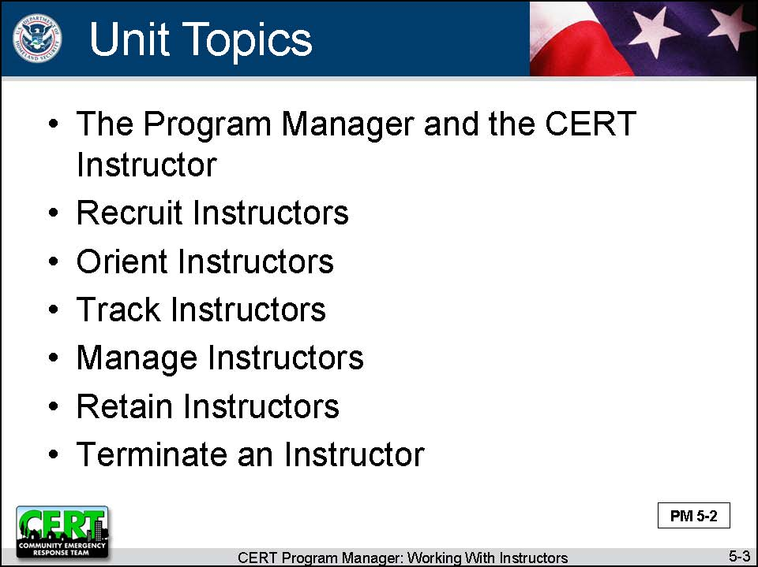  Display Slide 5-3 | Unit Topics  Say that the Program Manager does the same tasks with instructors that he or she does with volunteers. Therefore this unit will look at the following topics:  - The Program Manager and the CERT Instructor  - Recruit Instructors  - Orient Instructors  - Track Instructors  - Manage Instructors  - Retain Instructors  - Terminate an Instructor
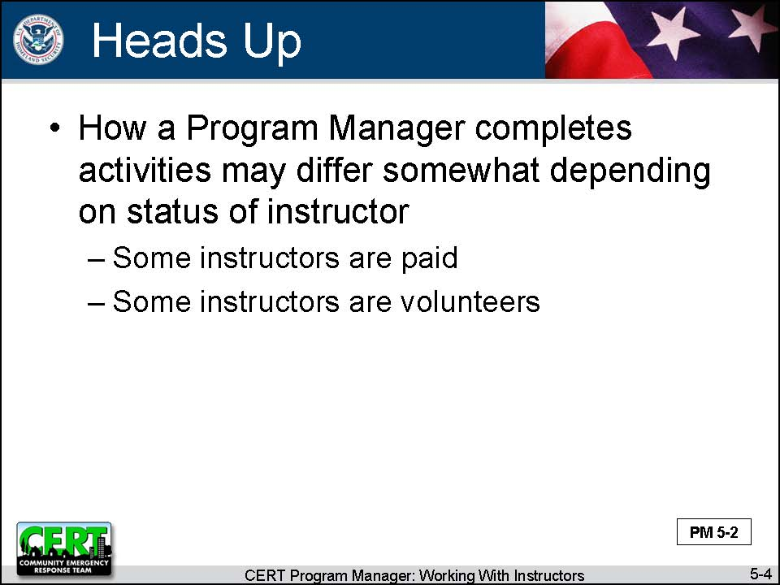  Display Slide 5-4 | Finally, tell participants that, since some instructors will be paid and some will be volunteers, how a Program Manager completes these activities may differ somewhat depending on the circumstance.
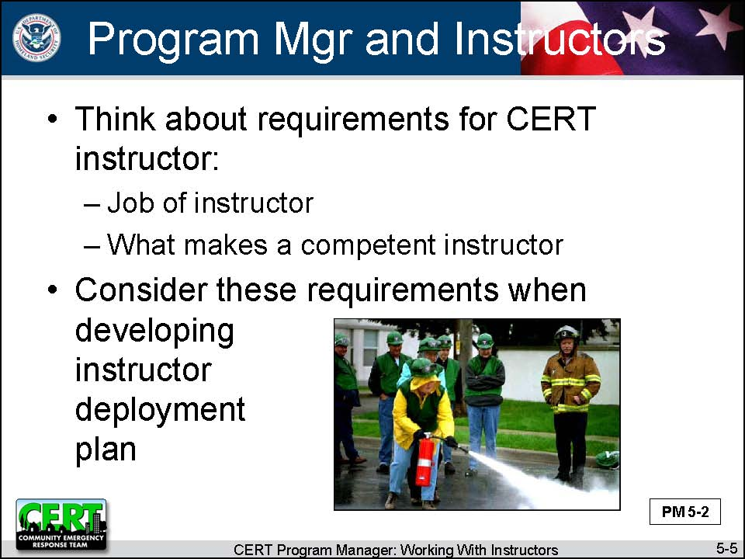  Display Slide 5-5 | The Program Manager and the CERT Instructor  Explain that, before talking about how to work with CERT instructors, it’s important to think about the requirements for a CERT instructor:  - The job of the instructor  - What makes a competent instructor  Say that a Program Manager needs to consider these requirements when determining how instructors will be used to support the program, called an instructor deployment plan.
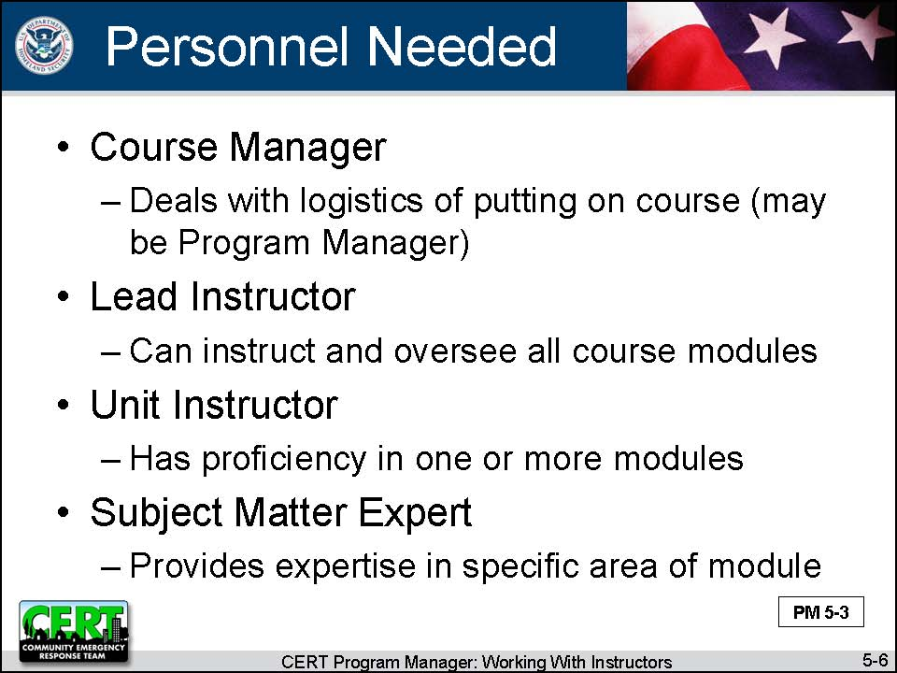  Display Slide 5-6 | Types of Personnel Needed  Say that, in order to put on a CERT Basic Training course, the CERT program generally needs these positions filled:  - Course Manager – Deals with the logistics of putting on the course (may be the Program Manager)  - Lead Instructor - Can instruct and oversee all course modules  - Unit Instructor – Has proficiency in the instruction of one or more specific modules  - Subject Matter Expert – Provides expertise in a specific area of a module
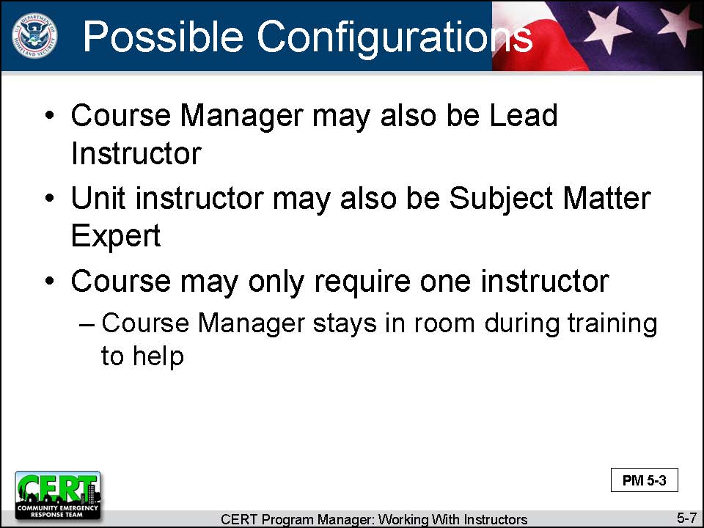  Display Slide 5-7 | Explain that CERT programs may vary in how they assign the positions:  - The Course Manager may also be the Lead Instructor.  - The Unit Instructor may also be a Subject Matter Expert.
Also explain other training courses, e.g., CERT supplemental modules, may be configured differently:
- Only one instructor
- Course Manager, who stays in the room during the training to help

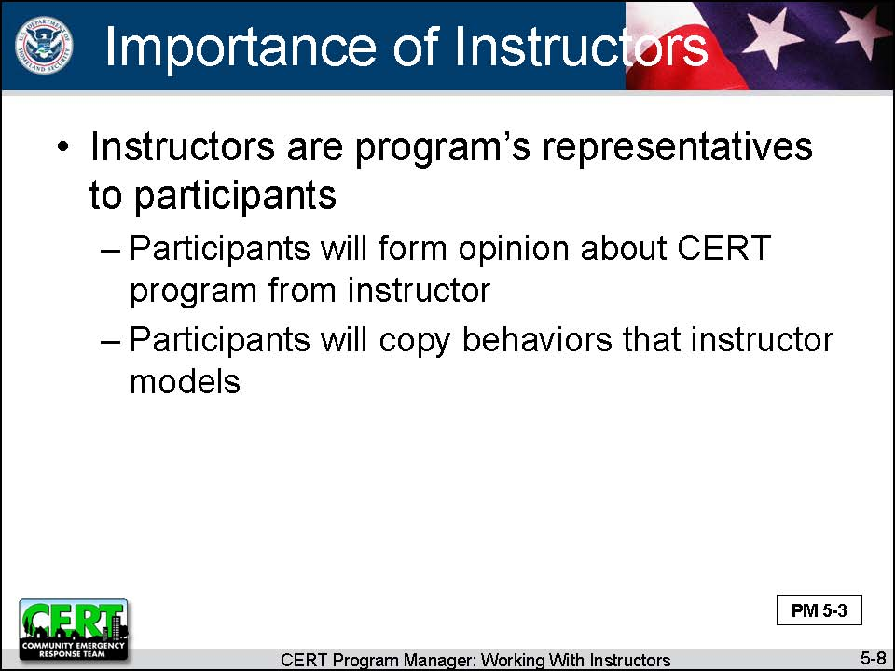  Display Slide 5-8 | The Importance of the Instructors  Say that, whatever the configuration, the instructors are the program’s representatives to the participants.  - Participants will form an opinion about the CERT program from the instructor.  - Participants will copy the behaviors that the instructor models.
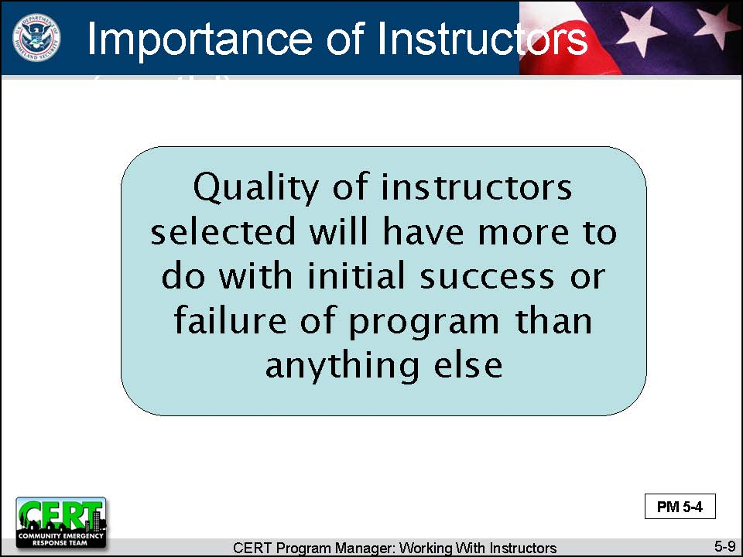  Display Slide 5-9 | Stress that the quality of the instructors selected will have more to do with the initial success or failure of the program than anything else.  - Participants regularly rate the quality of instruction as more important to meeting their overall learning goals than any other factor.  - Participants pay attention to the instructors more than to print materials or media.
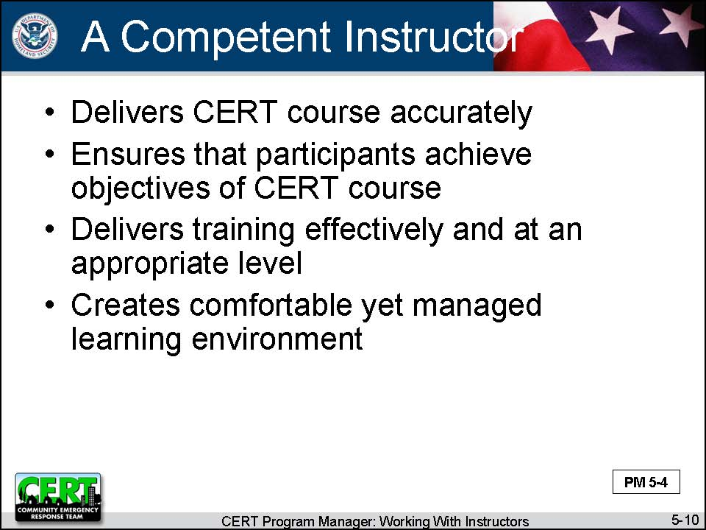  Display Slide 5-10 | A Competent Instructor  Reiterate that a program needs to select the instructor cadre carefully and train them so that they are able to present a training course in a way that relates to the participants.  Tell participants that a competent instructor accomplishes the following:  - Delivers the CERT course accurately, conveying the messages and intent of the CERT program (e.g., safety, teamwork, place in overall community emergency operations plan)  - Ensures that participants achieve the objectives of the CERT course  (continued)
- Delivers training effectively and at an appropriate level, thus enabling participants to learn and correctly apply skill sets
- Creates a comfortable yet managed learning environment
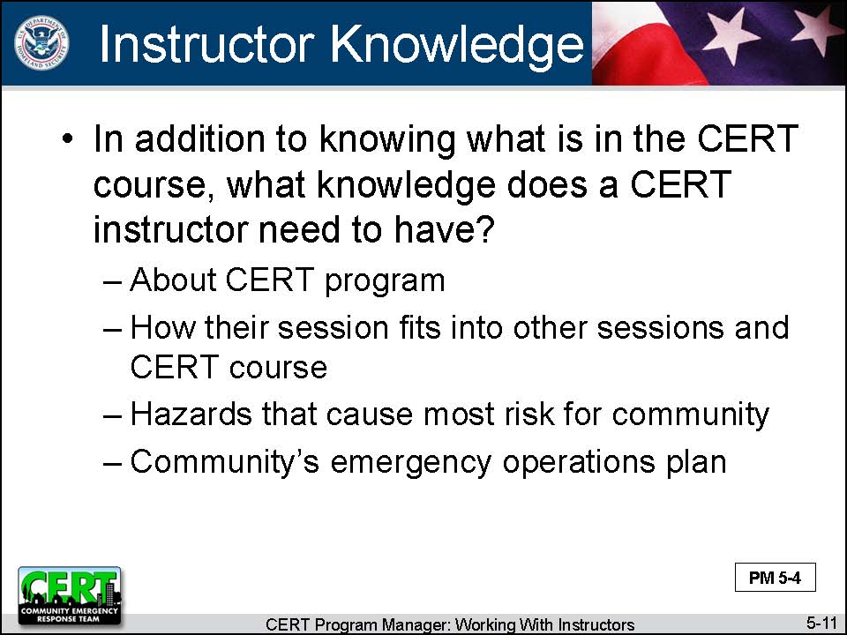  Display Slide 5-11  This slide is animated. The first click displays the question.  Conduct a class discussion by asking this question.  The second click displays the responses.  Before moving on, ask the participants if they have any questions. | Ask participants:  In addition to knowing what is in the CERT course, what knowledge does a CERT instructor need to have?  Summarize the discussion by listing the things a CERT instructor needs to know:  - About the CERT Program  - How their session fits into the other sessions and the CERT course  - The hazards that cause the most risk for the community  - The community’s emergency operations plan
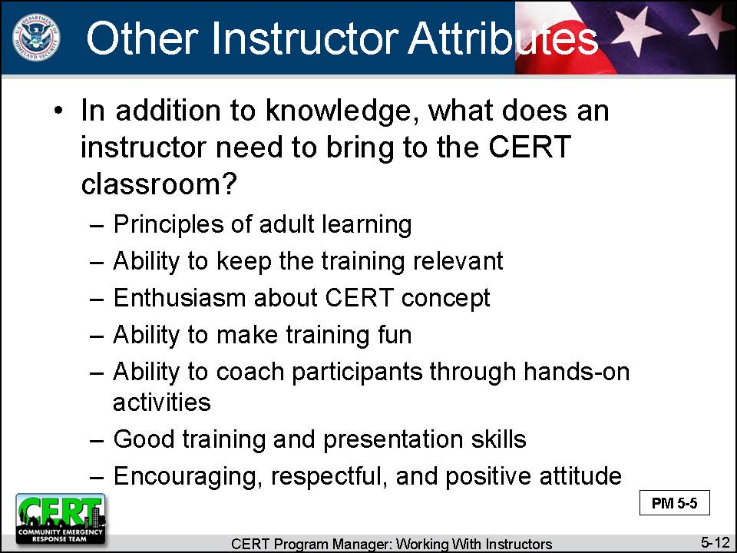  Display Slide 5-12  This slide is animated. The first click displays the question.  Conduct a class discussion by asking this question.  The second click displays the responses.  Before moving on, ask the participants if they have any questions. | Ask participants:  In addition to knowledge, what does an instructor need to bring to the CERT classroom?  Summarize the discussion by listing the things a CERT instructor needs to bring to the classroom:  - Principles of adult learning  - The ability to keep the training relevant  - Enthusiasm about the CERT concept  - The ability to make the training fun  - The ability to coach participants through hands-on activities  - Good training and presentation skills  - An encouraging, respectful, and positive attitude
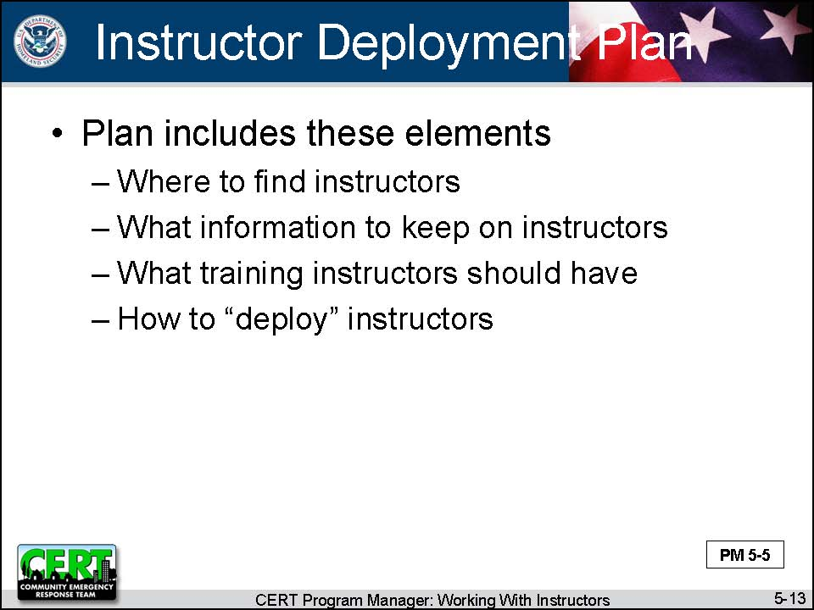  Display Slide 5-13 | The Instructor Deployment Plan  Explain that, given the requirements that the CERT Program has for its instructors, it is essential that a Program Manager plan how to work with his or her instructors. The instructor deployment plan should address:  - Where to find instructors (to be covered in Recruit Instructors)  - What information to keep on the instructors (to be covered in Orient Instructors)  - What training the instructors should have (to be covered in Orient Instructors)  - How to “deploy” the instructors (to be covered in Manage Instructors)
 | Do experienced Program Managers have anything to add about what has just been covered?
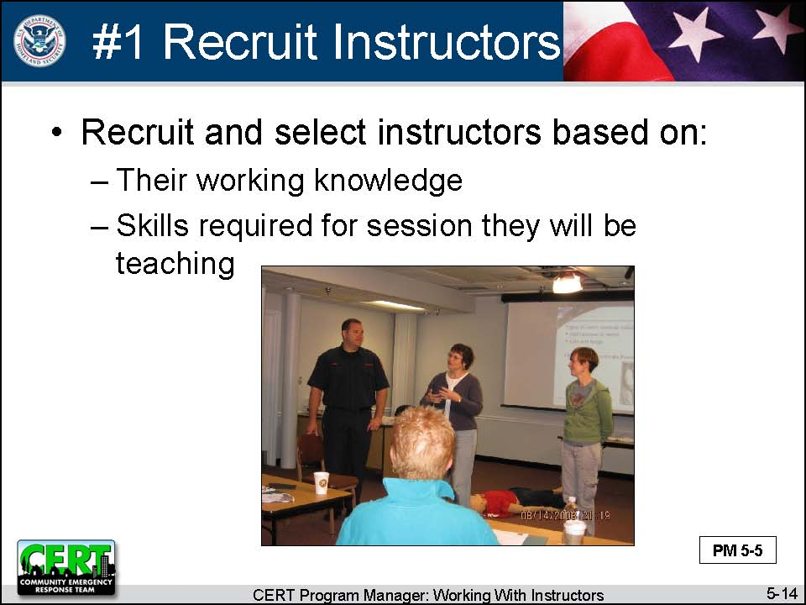  Display Slide 5-14 | #1 Recruit Instructors  Explain that you are now going to look more in depth at each of the activities a Program Manager undertakes when working with instructors. The first thing a Program Manager needs to do is to find instructors.  Say that instructors should be recruited and selected to conduct the CERT Basic Training course and other courses based on their working knowledge and the skills required for the session they will be teaching.
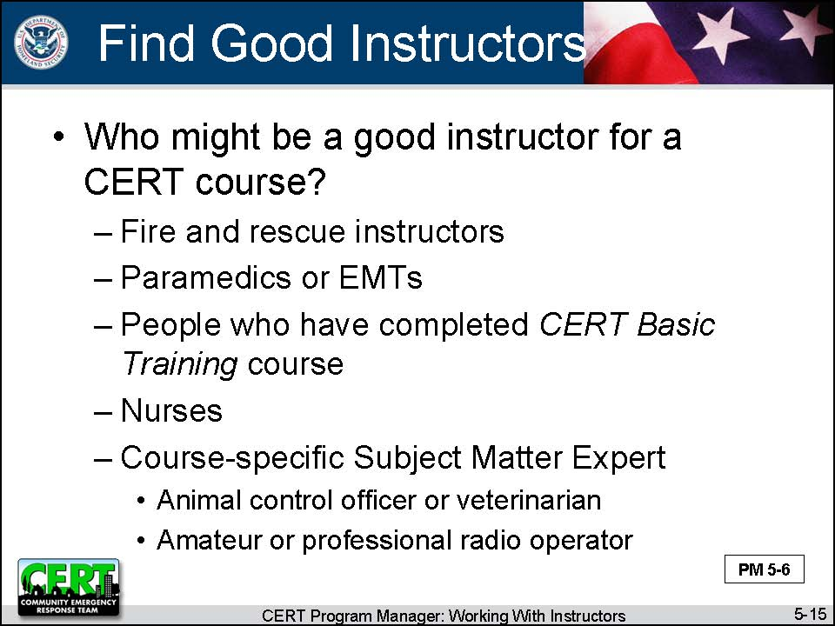  Display Slide 5-15  This slide is animated. The first click displays the question.  Conduct a class discussion by asking this question.  The second click displays the responses.  Before moving on, ask the participants if they have any questions. | Ask participants:  Who might be a good instructor for a CERT course?  Summarize the discussion by saying that the following people can make good CERT instructors:  - Fire and rescue instructors  - Particularly for CERT Basic Training Units 2 (Fire Safety) and 5 (Light Search and Rescue Operations)  - May also be skilled for CERT Basic Training Units 7 (Disaster Psychology) and 8 (Terrorism and CERT)  - Paramedics or emergency medical technicians  - For CERT Basic Training Units 3 (Disaster Medical Operations-Part 1) and 4 (Disaster Medical Operations-Part 2)  - People who have completed the CERT Basic Training course and have demonstrated they have the skills and expertise to deliver the training  - For CERT Basic Training Units 1 (Disaster Preparedness) and 6 (CERT Organization)  (continued)  - Nurses  - For CERT Basic Training Units 3 (Disaster Medical Operations-Part 1) and 4 (Disaster Medical Operations-Part 2)  - Animal control officer or veterinarian  - Animal Response I and II  - Amateur or professional radio operator  - CERT Emergency Communications
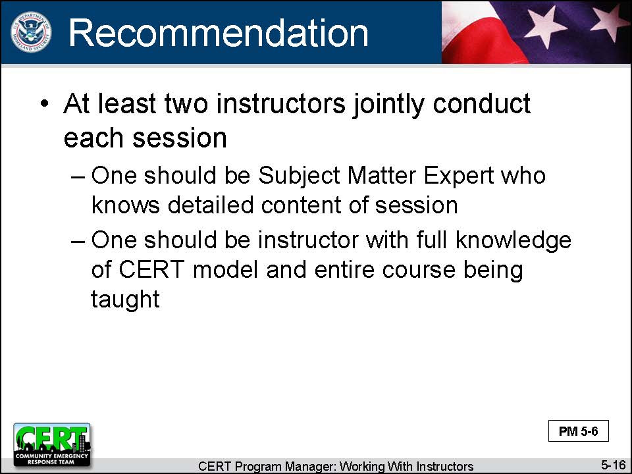  Display Slide 5-16 | Tell participants that it is recommended that at least two instructors jointly conduct each session:  - One should be a Subject Matter Expert who knows the detailed content of the session.  - One should be an instructor with a full knowledge of the CERT model and the entire course being taught.
PM, P. 5-7 | Refer participants to the Factors to Consider When Recruiting Instructors in the Participant Manual and on the following page in the Instructor Guide.  Review it with participants.

PM, P. 5-7 | Factors to Consider When Recruiting Instructors
Review the following lists of advantages and challenges to help you make decisions about the types of instructors to select.
Subject Matter Experts as CERT Instructors
Advantages |  | Challenges
- Often have first response experience  - May have training experience  - Are reliable  - Have a set work schedule  - Have credibility  - If they are first responders, foster a relationship between the participants and the department |  | - May be uncertain about the CERT model  - May not have training experience  - Cost more than CERT volunteers  - May tell "war" stories  - May go into too much detail for training objective
CERT Basic Training Graduates as Instructors
Advantages | Challenges
- Are familiar with CERT operations  - May have training experience  - Cost less than professional responders | - May not have the level of expertise that Subject Matter Experts do  - May not have training experience  - May cause issues with professional responders who feel that CERT graduates are taking their jobs  - May not have experience to answer “what if” questions  - Must fit CERT around work responsibilities

Instructor Guidance | Content
 | Do experienced Program Managers have anything to add about instructor recruitment?
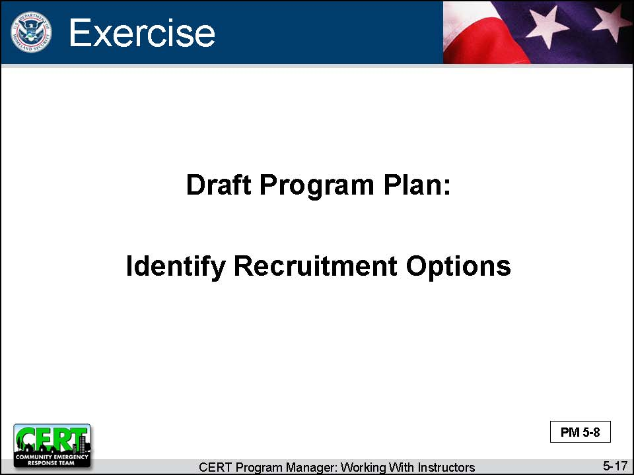  Display Slide 5-17 | Exercise: Draft Program Plan: Identify Recruitment Options  Purpose: This exercise allows Program Managers to identify avenues they would like to pursue for instructor recruitment.
Instructions: Follow the steps below to conduct the exercise.
- Refer participants to the Draft Program Plan in Unit 1 of the Participant Manual and the Instructor Guide.
- Ask participants to complete the first table of the fifth section, Working with Instructors, individually.

 | Debrief: Remind participants to always be alert for new possibilities for recruitment and to add them to the Draft Program Plan.
There are several additional sections in the Draft Program Plan where they may want to add ideas about:  - Orienting instructors  - Tracking instructors  - Managing instructors  - Retaining instructors | Tell participants that, as they go through the rest of the module, they should record their ideas for working with instructors in the Draft Program Plan.
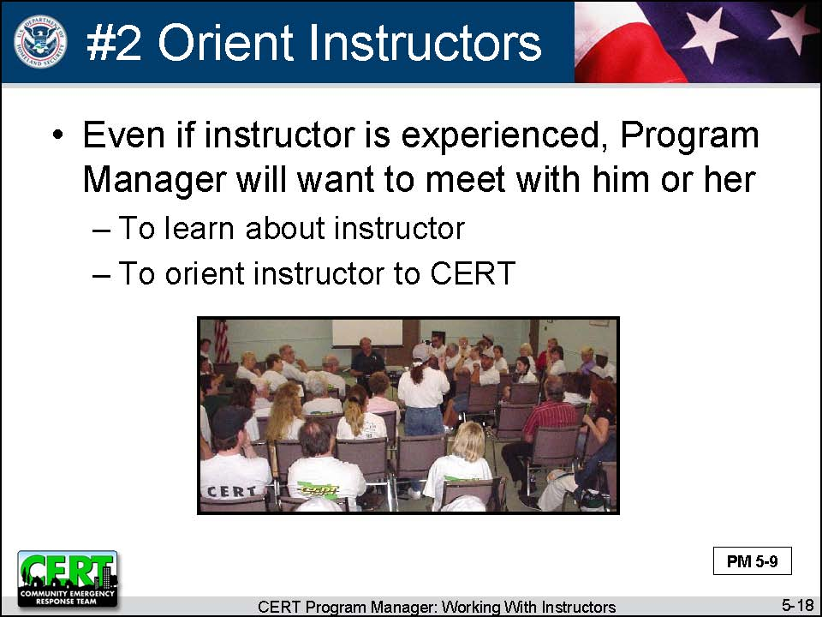  Display Slide 5-18 | #2 Orient Instructors  Explain that you are now going to discuss the second activity that Program Managers need to do with potential instructors. This activity is orientation.  Say that, even if the instructor selected is experienced, the Program Manager will want to meet with him or her. There are two reasons for the meeting:  - To learn about the instructor  - To orient the instructor to CERT
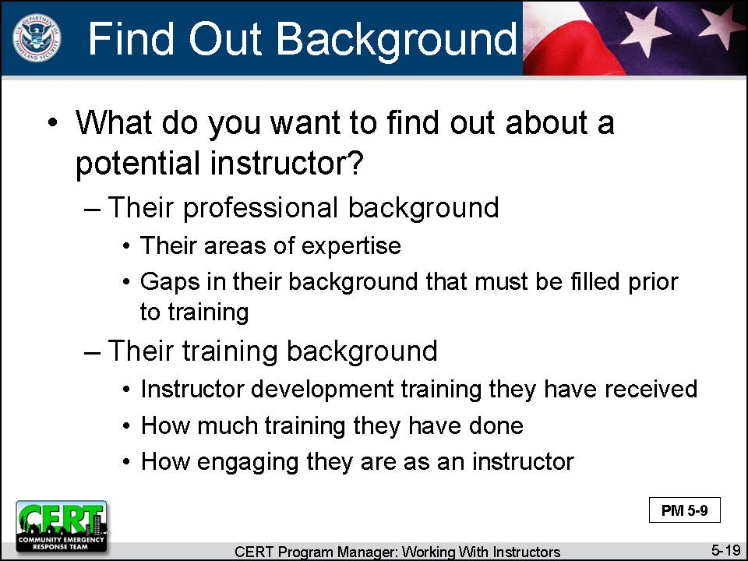  Display Slide 5-19  This slide is animated. The first click displays the question.  Conduct a class discussion by asking this question.  The second click displays the responses.  Before moving on, ask the participants if they have any questions. | What You Want to Learn  Ask participants:  What do you want to find out about a potential instructor?  Summarize the discussion by listing the things a CERT Program Manager needs to find out about a potential instructor:  - Their professional background  - What their areas of expertise are  - Gaps in their background that must be filled prior to training  - Their training background  - What instructor development training they have received  - How much training they have done  - How engaging they are as an instructor (ask for a sampling of evaluations)
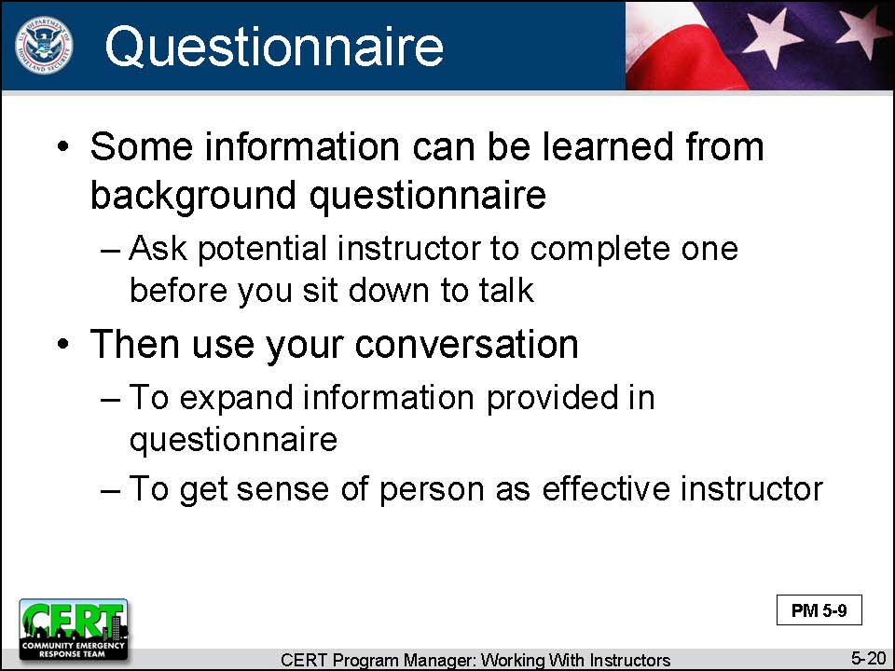  Display Slide 5-20 | Say that some of this can be learned by asking the potential instructor to complete a background questionnaire before you sit down to talk. Then you can use your conversation to expand the information provided and to get a sense of this person as an effective instructor.
PM, P. 5-10 and 5-11 | Refer participants to the Sample Instructor Background Questionnaire in the Participant Manual and on the following pages in the Instructor Guide.

PM, P. 5-10 and 5-11 | Sample Instructor Background Questionnaire

Name:
Address: | Work Phone:
Address: | Home Phone:
Address: | Mobile Phone:
Employer: | E-mail Address:
Place a check mark next to all areas in which you have experience:
CERT Program  Fire safety and fire suppression  Hazardous materials safety  Emergency medical triage and treatment  Search and rescue techniques and markings | Incident Command System (ICS) operations  Disaster psychology  Exercise controller  Other:
Describe your instructor development training:

List your past training presentation experience:

Place a check mark next to all areas for which you wish to be considered:
Lead Instructor for (name of course) ____________________________________________

Co-Instructor for: (these are all sessions in CERT Basic Training)
Disaster Preparedness
Fire Safety
Emergency Medical Operations
Light Search and Rescue
CERT Operations
Disaster Psychology
CERT and Terrorism
Exercise Safety Officer

Co-Instructor for (name of course) ____________________________________________
Your Signature: |  | Date:

Instructor Guidance | Content
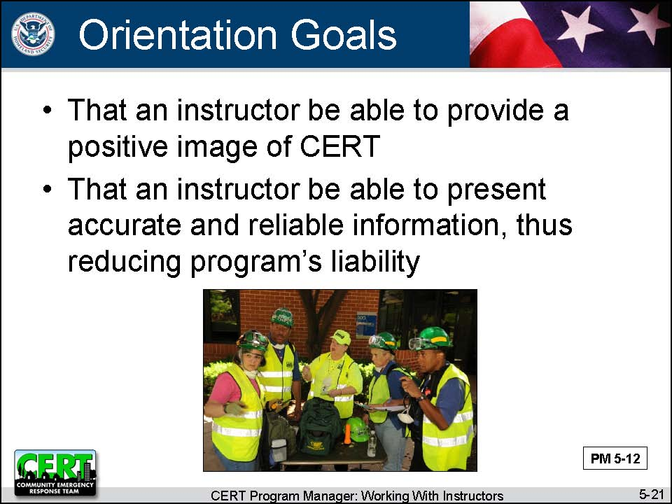  Display Slide 5-21 | What Orientation You Want to Provide  Remind the group that instructors are the program’s representatives to the participants. The way that CERT participants react to and judge the instructors directly impacts how participants feel about your CERT program. So one concern of Program Managers is that an instructor must provide a positive image of CERT.  Say that another concern of Program Managers is that an instructor presents accurate and reliable information, thus reducing a program’s liability.
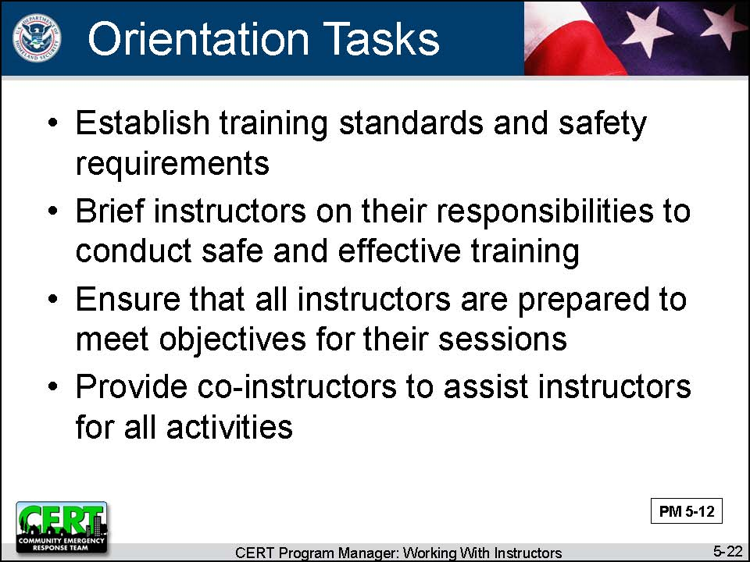  Display Slide 5-22 | Provide the six steps that Program Managers can take to ensure that instructors are an asset to the program and that they present reliable information:  - Establish training standards and safety requirements for the training.  - Brief all instructors on their responsibilities to conduct safe and effective training.  - Ensure that all instructors are prepared to meet the objectives for their sessions.  - Provide co-instructors to assist the instructors for all activities.
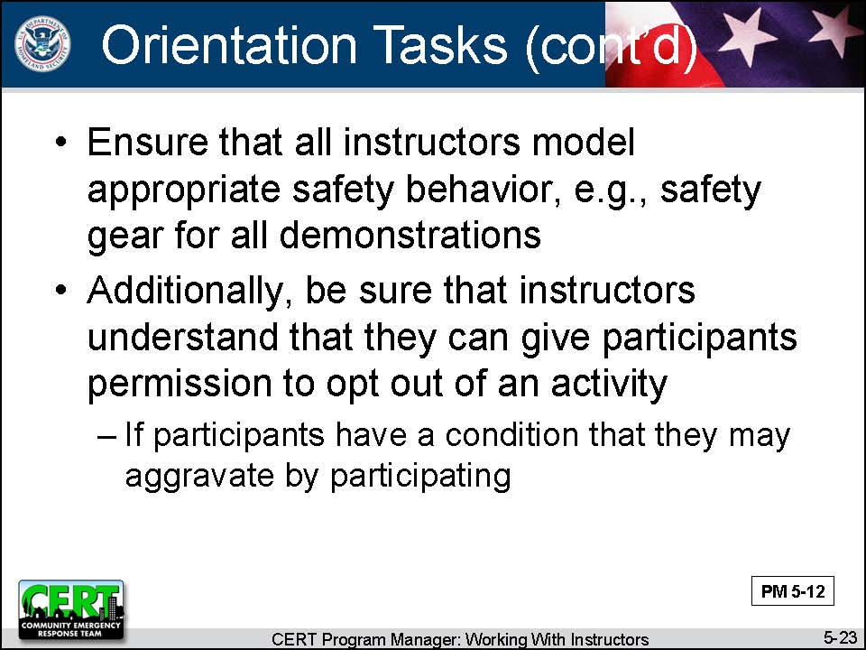  Display Slide 5-23 | - Ensure that all instructors model appropriate safety behavior, e.g., safety gear for all demonstrations.  - Additionally, be sure that instructors understand that they can give participants permission to opt out of an activity if they have a condition that they may aggravate by participating.
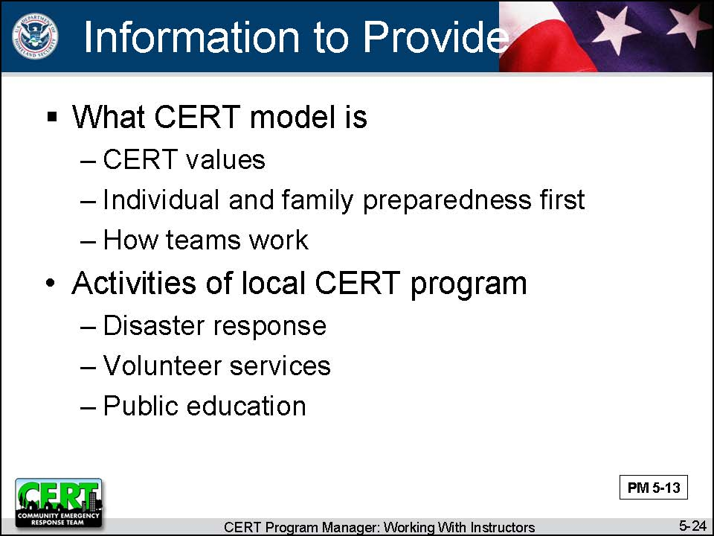  Display Slide 5-24 | Explain that this process starts at the orientation when the Program Manager provides the following information:  - What the CERT model is  - CERT values  - Individual and family preparedness first  - How teams work (organization, local activation protocol, team communication method)  - The standards that volunteers are held to  - The activities of the local CERT program  - Disaster response  - Volunteer services  - Public education
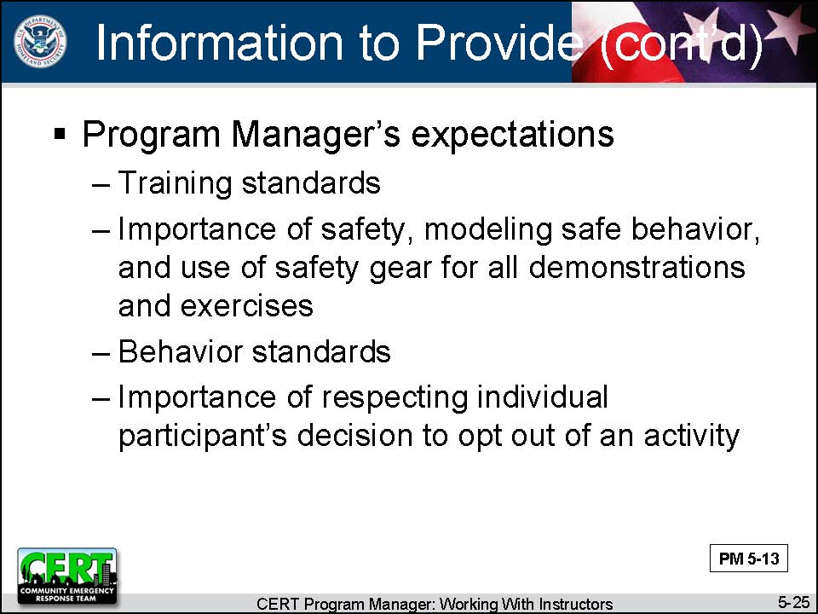  Display Slide 5-25 | - The Program Manager’s expectations  - Training standards, e.g., that the lesson plan will be followed  - The importance of safety, modeling safe behavior, and the use of safety gear for all demonstrations and exercises  - Behavior standards  - The importance of respecting an individual participant’s decision to opt out of an activity
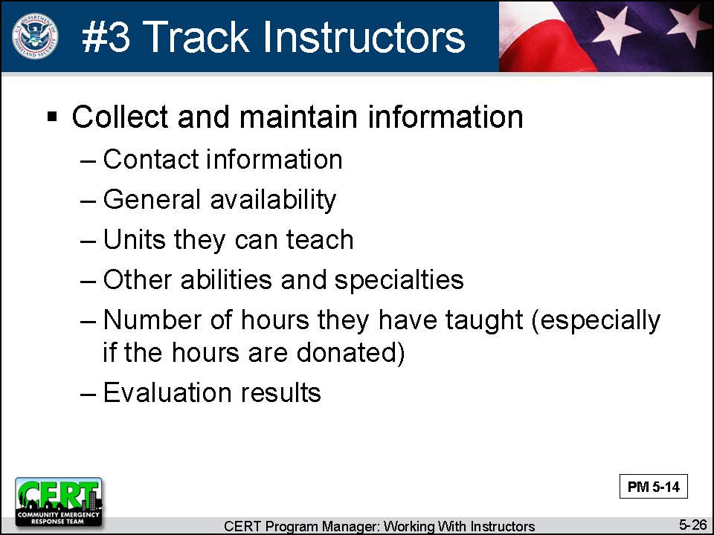  Display Slide 5-26 | #3 Track Instructors  Explain that tracking instructors is not much different from tracking volunteers. Program Managers must collect and maintain the following information:  - Contact information  - General availability  - Units they can teach  - Other abilities and specialties  - Number of hours they have taught (especially if the hours are donated)  - Evaluation results
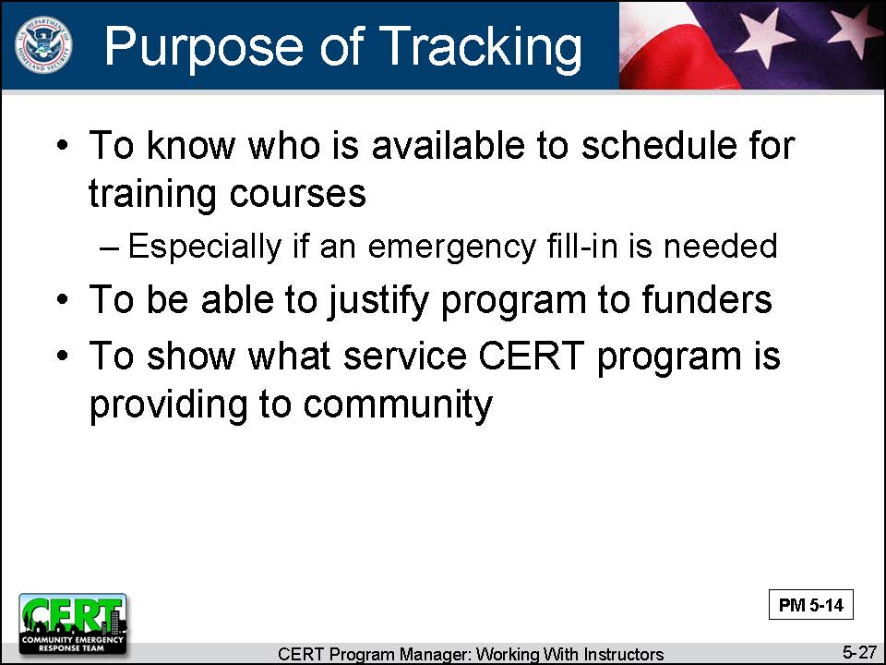  Display Slide 5-27  Refer participants to the information on justifying a program in the previous unit, Working with Volunteers. | Remind participants of the reasons for tracking this information:  - Need to know who is available to schedule for training courses, especially if an emergency fill-in is needed  - Need to be able to justify the program to funders  - To show what service the program is providing to the community
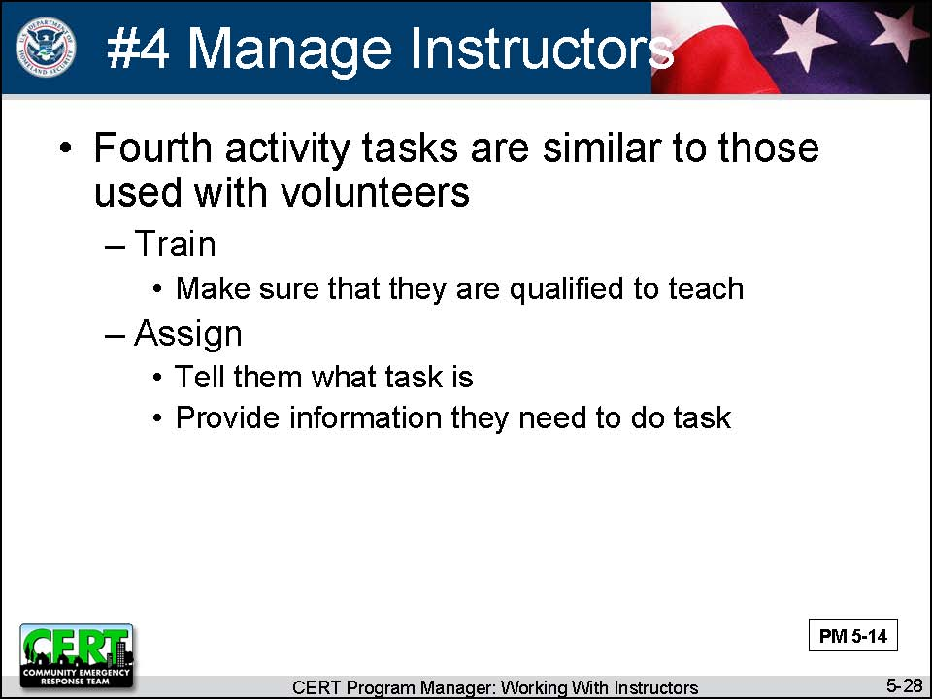  Display Slide 5-28 | #4 Manage Instructors  Explain that you are now going to discuss the fourth activity that Program Managers need to do with instructors. This activity is managing them.  Tell participants that the management tasks for instructors are similar to those used with volunteers. The tasks are:  - Training: making sure that they are qualified to teach  - Assigning: telling them what the task is and providing them the information they need to do the task
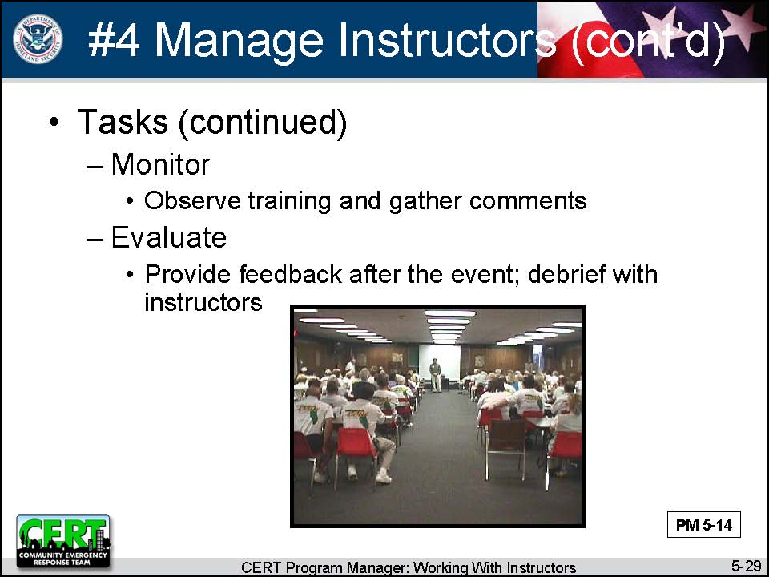  Display Slide 5-29 | - Monitoring: observing the training and gathering comments  - Evaluating: providing feedback after the event; debriefing with instructors
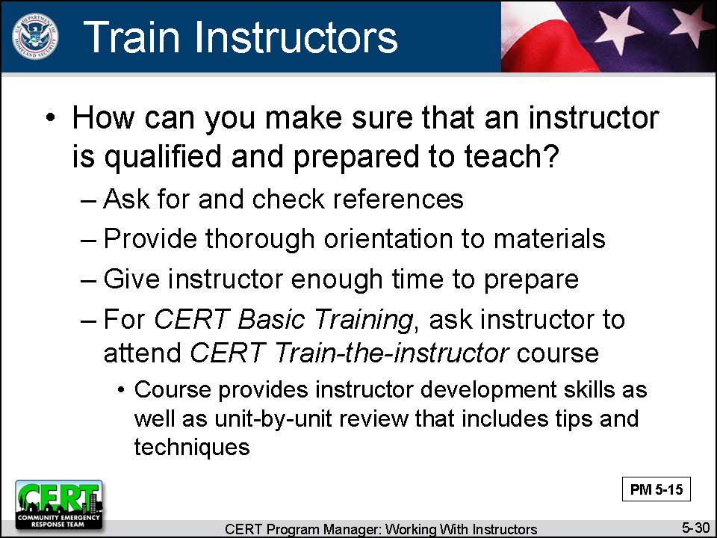  Display Slide 5-30  This slide is animated. The first click displays the question.  Conduct a class discussion by asking this question.  The second click displays the responses.  Before moving on, ask the participants if they have any questions. | Training  Ask participants:  How can you make sure that an instructor is qualified and prepared to teach?  Summarize the discussion:  - Ask for and check references.  - Provide a thorough orientation to the materials.  - Give the instructor enough time to prepare.  - For CERT Basic Training, ask the instructor to attend the CERT Train-the-Instructor course. This course provides instructor development skills as well as a unit-by-unit review that includes tips and techniques.
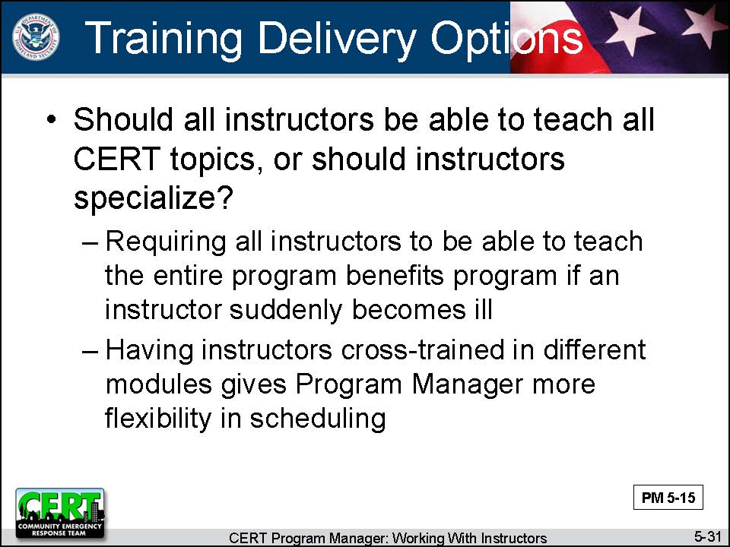  Display Slide 5-31 | Discuss how Program Managers may want to use instructors. Do they want all instructors to be able to teach all CERT topics, or do they want instructors to specialize?  - Requiring all instructors to be able to teach the entire program will be more difficult, but it may benefit the program if an instructor suddenly becomes ill.  - In addition, having instructors cross-trained in different modules gives a Program Manager more flexibility in scheduling.
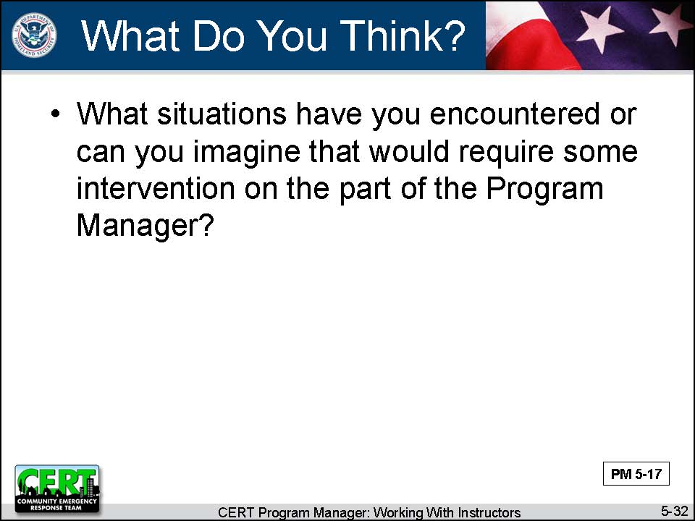  Display Slide 5-32  Record the responses on the easel pad. Don’t discuss solutions; just record situations. See possible responses below. | Monitoring  Think about the quality of training and the training skills of instructors who have worked with you.  Ask participants:  What situations have you encountered or can you imagine that would require some intervention on the part of the Program Manager?
- Covers material in too much depth
- Tells too many “war stories”
- Skips sections of the lesson plan
- Skips hands-on activities
- Only lectures; no interaction with participants
- Teaches the material wrong
- Does not use safety equipment during demonstrations and activities
Conduct a discussion about how to handle these situations. Responses may include preventive measures as well as reactive measures. | Ask participants:  What can you do about these situations?
PM, P. 5-16 | Refer participants to Working with Instructors in the Participant Manual and on the following page in the Instructor Guide.

PM, P. 5-16 | Working with Instructors

Experienced CERT Program Managers have been successful in training their instructors using the steps listed below.

- Step 1: Provide an orientation to the CERT program and to the training.
- Step 2: Allow new instructors time to review the materials carefully.
- Step 3: If the CERT program is just starting, do a dry run of the training.
- Step 4: Require new instructors to observe the training before they teach their first session.
- Step 5: Schedule a practice session for new instructors to present the session that they will teach to the Program Manager and other instructors.
- Step 6: Require new instructors to co-train with an experienced instructor.
- Step 7: Observe the actual training session.
- Step 8: Schedule a meeting after the training to debrief and to identify changes to make in future sessions.
- Step 9: Provide corrective feedback to instructors individually.

Instructor Guidance | Content
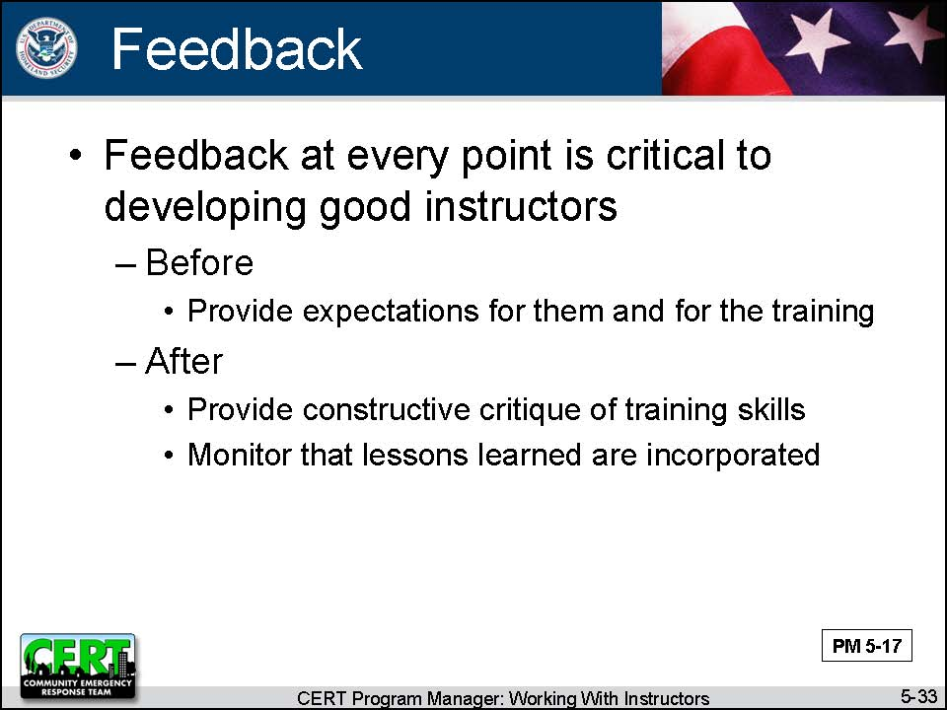  Display Slide 5-33 | Feedback  Explain that feedback at every point is critical to developing good instructors.  - Before: Be sure that all instructors are aware of the Program Manager’s expectations for them and for the training.  - After: Provide a constructive critique of training skills, and monitor to make sure that they incorporate the lessons learned into future classes.
 | Do experienced Program Managers have anything to add about managing instructors?
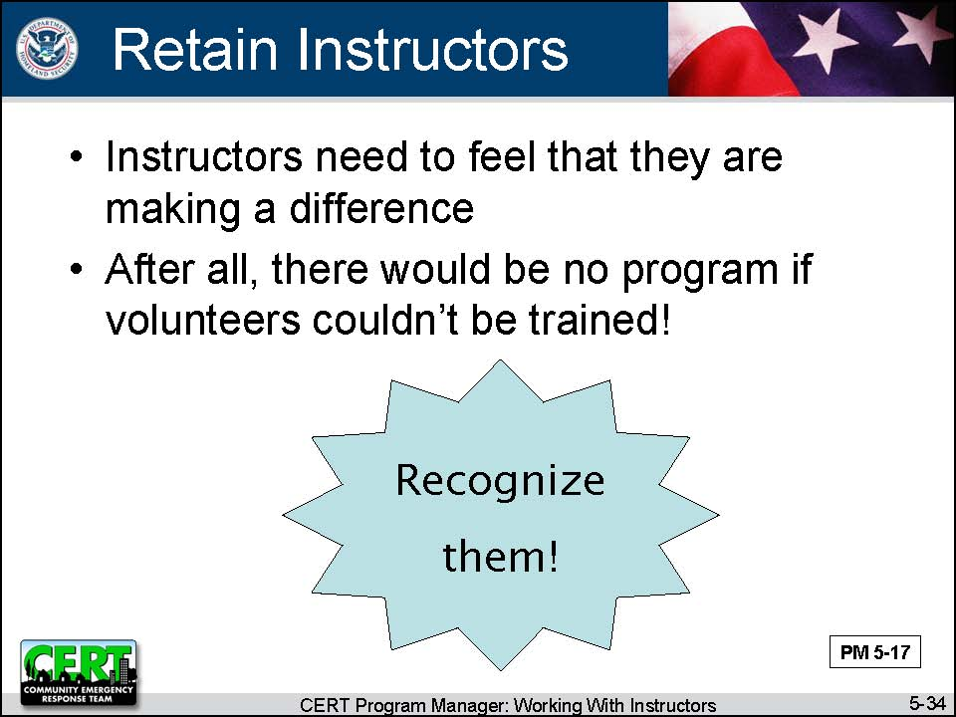  Display Slide 5-34 | #5 Retain Instructors  Explain that, whether they are paid or they are donating their time, instructors need to be recognized and appreciated just as volunteers do. Instructors need to feel that they are making a difference or they will go somewhere else. So keeping instructors involved is important. After all, there would be no program if the volunteers couldn’t be trained.
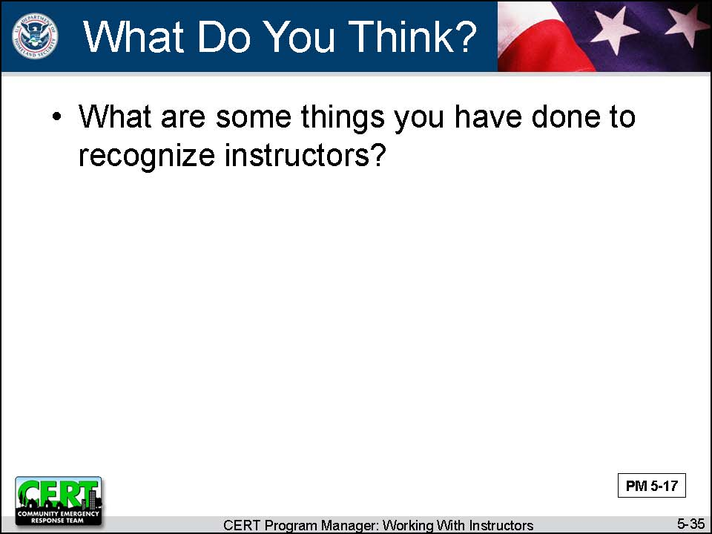  Display Slide 5-35  Conduct a class discussion by asking this question. | Ask experienced Program Managers:  What are some things you have done to recognize instructors?
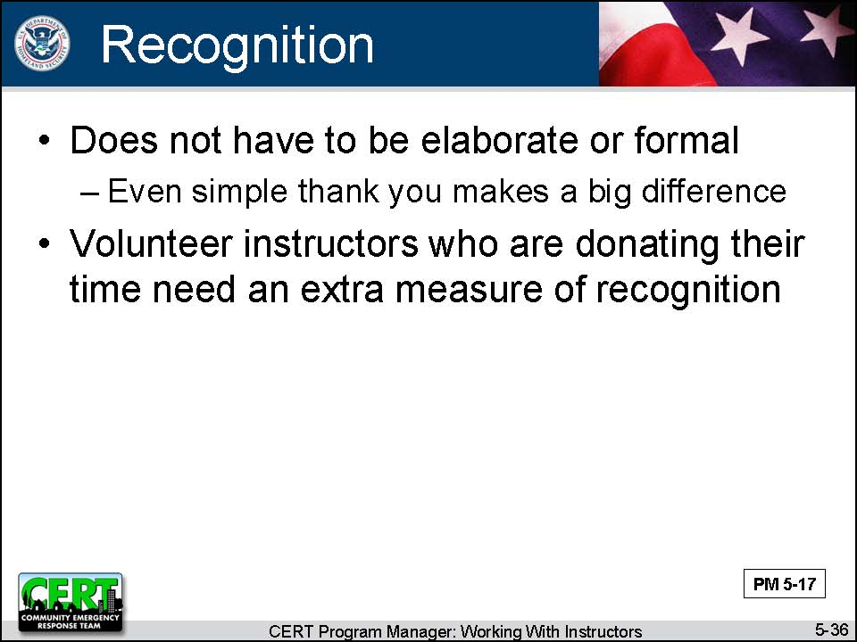  Display Slide 5-36 | Say that recognition does not have to be elaborate or formal. Even a simple thank you makes a big difference.  Tell participants that volunteer instructors who are donating their time need an extra measure of recognition. Many programs make a special point to have volunteer instructors receive an annual certificate presented by the Fire Chief or a key elected official.
 | Do experienced Program Managers have anything to add about instructor retention?
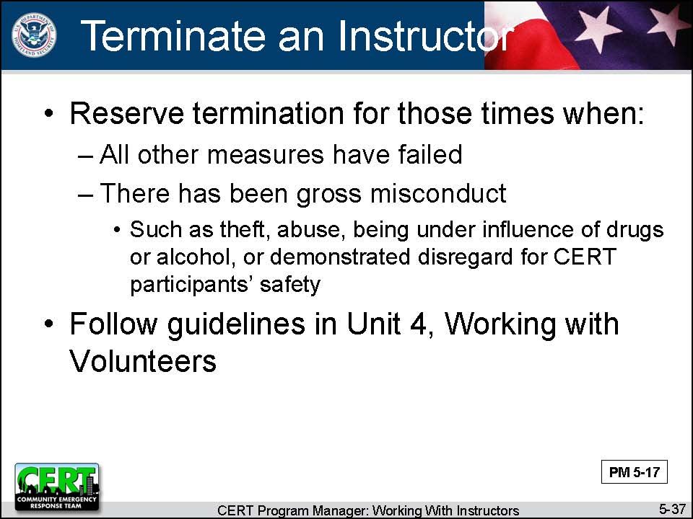  Display Slide 5-37 | Terminate an Instructor  Say that sometimes the Program Manager may decide that an instructor needs to be terminated. As with program volunteers, termination should be reserved for those times when:  - All other measures have failed.  - There has been gross misconduct such as theft, abuse, being under the influence of drugs or alcohol, or demonstrated disregard for CERT participants’ safety.
 | Remind participants that, from the beginning, instructors should be made aware of the disciplinary policy and the possibility of termination if they do not meet the expectations and standards set by the program.
 | Refer Program Managers to the guidelines in Unit 4, Working with Volunteers, should they have a situation that causes concern.
 | Do experienced Program Managers have anything to add about strategies they have used when terminating an instructor?

Instructor guidance | Content
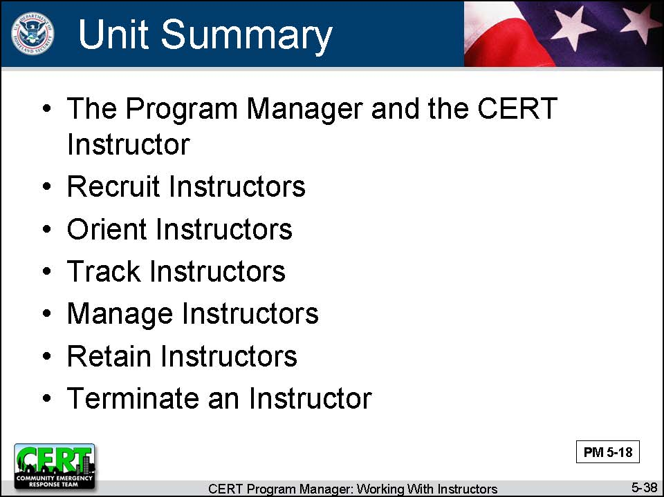  Display Slide 5-38 | Unit Summary  Tell participants that this unit has looked at working with instructors:  - The Program Manager and the CERT Instructor  - Recruit Instructors  - Orient Instructors  - Track Instructors  - Manage Instructors  - Retain Instructors  - Terminate an Instructor
 | Do you have any questions about anything covered in this unit?
Transition
The next unit will discuss how to procure and manage resources for your program.

[This page intentionally left blank]

