Unit 3: CERT Basic Training
Unit 1 Review

In this unit you will review the following information about CERT Basic Training Unit 1:

- Unit Purpose
- Unit Objectives
- Key Points to Be Made in the Unit
- Training Videos Relevant to the Unit
- The Hands-on Activities in the Unit and How to Conduct Them Correctly
- How This Unit Connects to the Other Units

[This page intentionally left blank]
Learning Objectives/ Performance Outcomes | At the conclusion of this unit, the participants will be able to demonstrate knowledge of the CERT Basic Training course Unit 1.
Scope | The topics that will be discussed in this unit are:  - T-T-T Unit Overview  - Unit 1 Purpose  - Unit 1 Learning Objectives  - Unit 1 Key Topics  - Training Videos in Unit 1  - Hands-On Activities in Unit 1  - Tips for Teaching Unit 1  - How Unit 1 Connects to Other Basic Training Units  - T-T-T Unit Summary
Estimated Completion Time | 45 minutes
Training Methods | The instructor begins by asking what the purpose and learning objectives of the Basic Training unit are. The instructor then asks participants to identify how the objectives are met in the unit.  Next the instructor reviews the key topics of the Basic Training unit and indicates what training videos are recommended for the unit.  The focus of this T-T-T unit is on the hands-on activities: their purpose, what latitude instructors have in conducting them, and the correct way to conduct them.  Finally the instructor reviews how the Basic Training unit is connected to the other units in the CERT Basic Training course.
 | Please be advised that, as a general rule, the instructor is encouraged to add pertinent information to this guide, but should never subtract material.
Resources Required | - Community Emergency Response Team Train-the-Trainer Instructor Guide (for Train-the-Trainer instructors)  - Community Emergency Response Team Train-the-Trainer Participant Manual (for all participants)  - Community Emergency Response Team Basic Training Instructor Guide (for all participants)  - PowerPoint slides 3-1 to 3-9
Equipment | The following additional equipment is required for this unit:  - A computer with PowerPoint software  - A computer projector and screen
Preparation | None required.
Notes | A suggested time plan for this unit is as follows:  T-T-T Unit Overview 1 minute  Unit 1 Purpose 1 minute  Unit 1 Learning Objectives 5 minutes  Unit 1 Key Topics 2 minutes  Training Videos in Unit 1 5 minutes  Hands-On Activities in Unit 1 20 minutes  Tips for Teaching Unit 1 5 minutes  How Unit 1 Connects to Other Basic Training Units 5 minutes  T-T-T Unit Summary 1 minute  Total Time: 45 minutes

Unit 3: CERT Basic Training Unit 1 Review

Instructor Guidance | Content
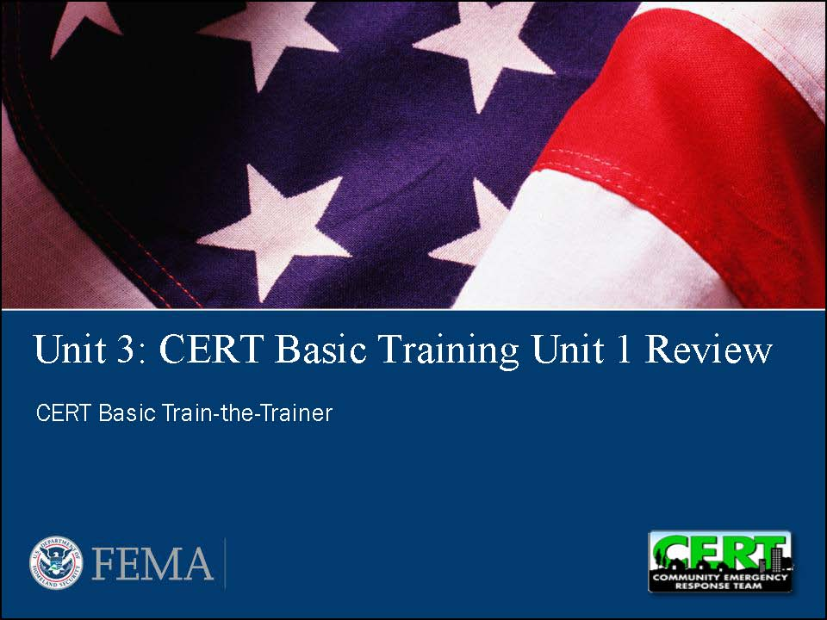  Display Slide 3-1 | T-T-T Unit Overview  Explain that this unit reviews the content and activities in CERT Basic Training Unit 1. It also looks at how Unit 1 connects to the other units in the CERT Basic Training course.
Encourage participants to use the CERT Basic Training Instructor Guide to find the answers to the questions. | Unit 1 Purpose
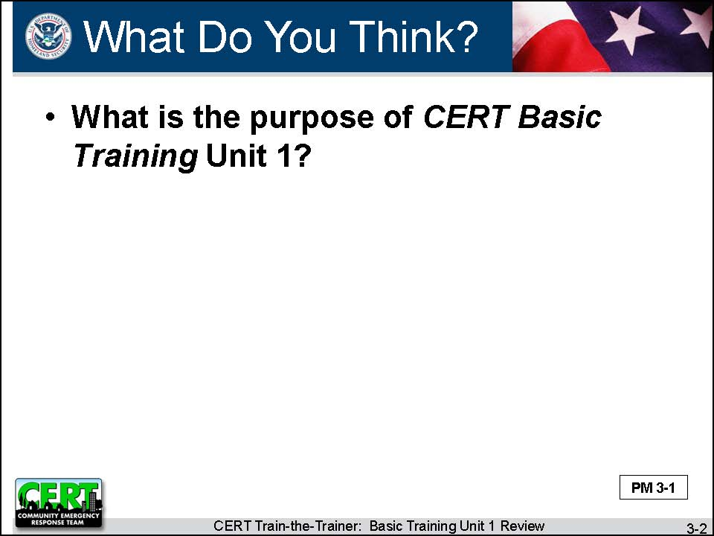  Display Slide 3-2  Conduct a class discussion based on this question. | What is the purpose of CERT Basic Training Unit 1?
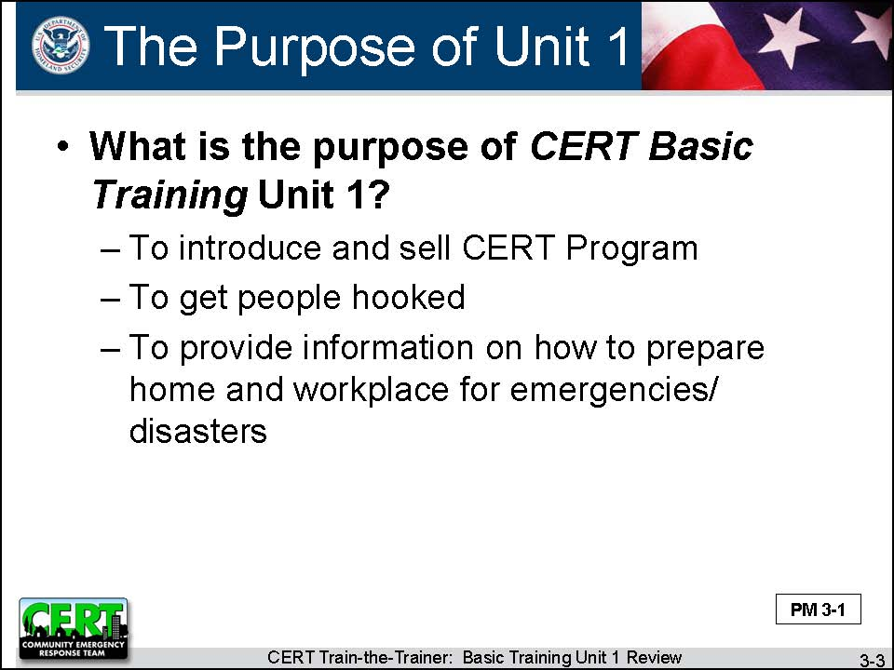  Display Slide 3-3 | Summarize the discussion by reviewing the slide.  The purpose of CERT Basic Training Unit 1 is:  - To introduce and sell the CERT Program  - To get people hooked  - To provide information on how to prepare home and workplace for emergencies/disasters
 | Emphasize that the instructor for this unit should be the best one that the program has. This instructor needs to inspire the participants to become active CERT members or, at the very least, to promote the CERT concept with friends and family and in their neighborhoods and workplaces.
 | Unit 1 Learning Objectives
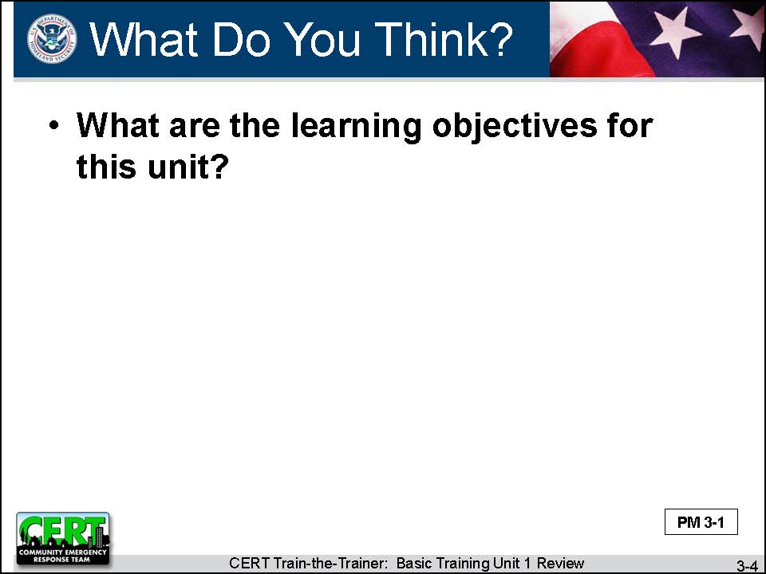  Display Slide 3-4  Conduct a class discussion based on this question. | What are the learning objectives for this unit?
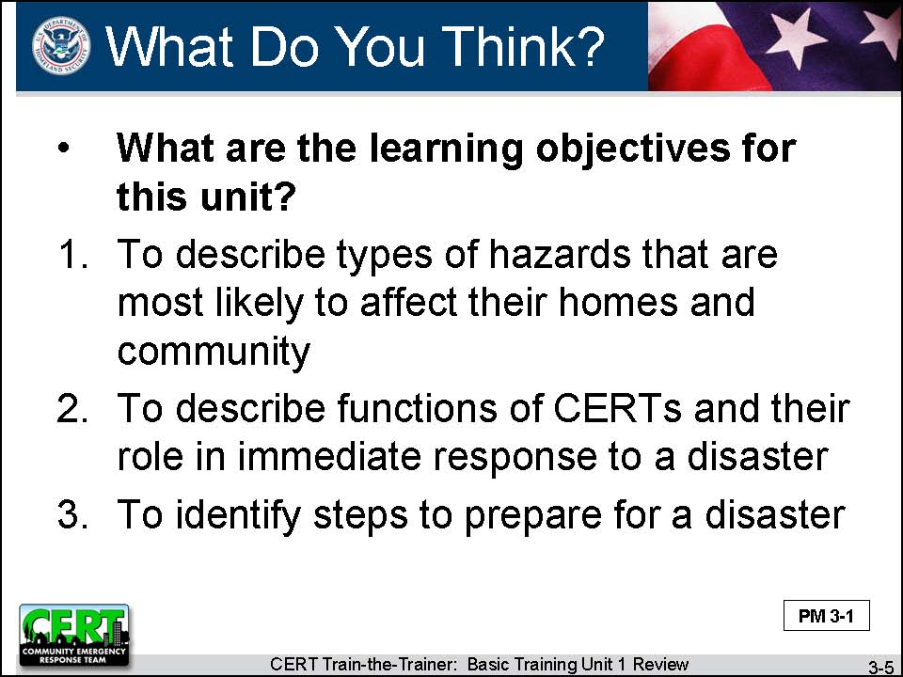  Display Slide 3-5 | Summarize the discussion by reviewing the slide.  Give the learning objectives for this unit:  - To describe the types of hazards that are most likely to affect their homes and community  - To describe the functions of CERTs and their role in the immediate response to a disaster  - To identify steps to prepare for a disaster
 | Unit 1 Key Topics
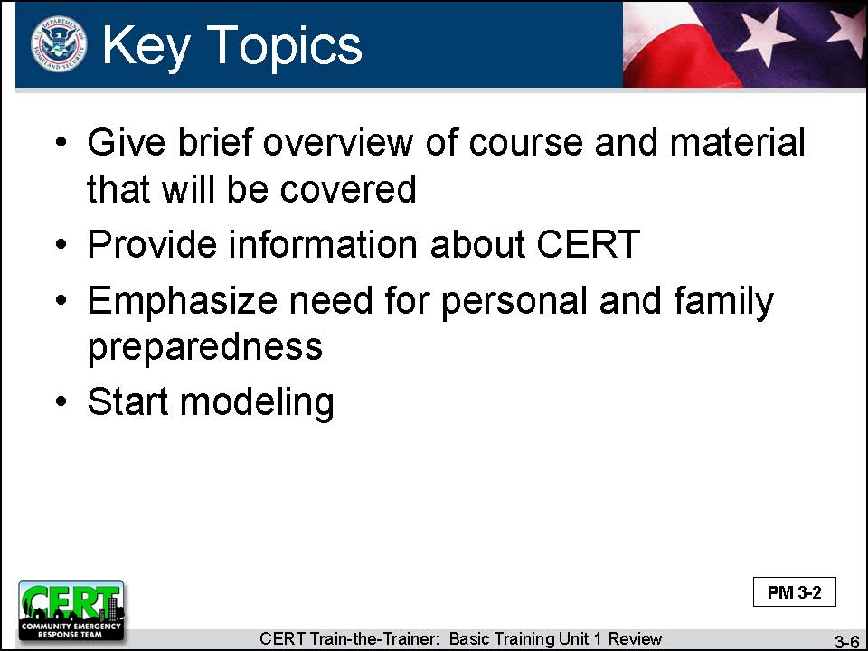  Display Slide 3-6 | Explain that in this unit, the instructor needs to do the following:  - Give a brief overview of the course and the material that will be covered.  - Provide information about CERT:  - History, especially of the successful deployments of CERTs  - Role of CERT in disasters and non-disasters  - How CERTs fit into the emergency operations plan  - Emphasize the need for personal and family preparedness:  - Disaster kits  - Evacuation plans
- Start modeling:
- Personal protective equipment (PPE) demonstration
- Personal and family safety comes first
- Team building
- Emphasize the motto: Do the greatest good for the greatest number in the shortest amount of time.
- “What If” scenarios: What would you do if the ground started shaking, if the fire alarm went off, etc.?

Training Videos for Unit 1
The 19-minute video CERT In Action is recommended for Unit 6 to show neighborhood CERT activation, Incident Command System (ICS), and operations. However, if time permits, instructors may choose to show all or part of the video during Unit 1 to help illustrate the concept of CERT. The video could be shown again during Unit 6, when participants will have a more knowledgeable perspective on CERT operations.

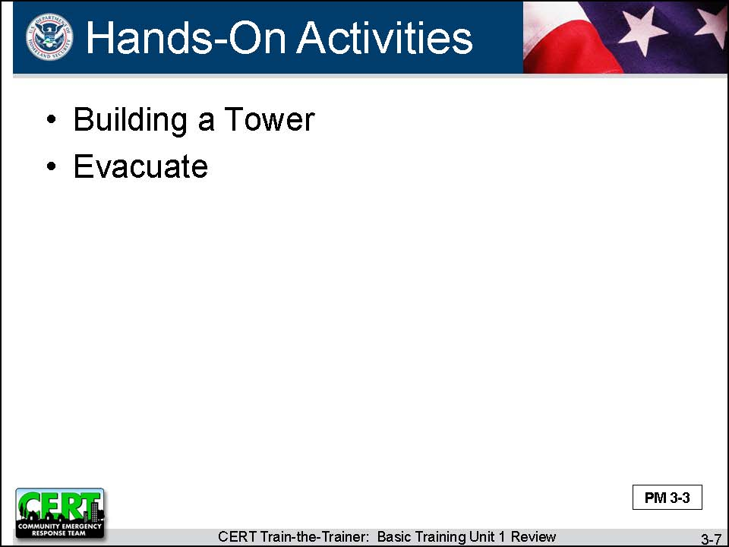  Display Slide 3-7 | Hands-on Activities in Unit 1  Building a Tower (Basic Training IG p. 1-9)  Purpose  Team building  Latitude to Adapt  - Give each group 5 minutes to discuss how they will build the tower and then don’t allow them to talk until it is completed.  - Develop a different team-building activity.
 | How to Do the Activity Correctly
- Refer to the groups as “teams.”
- Ensure that the groups do not begin the tower construction during the first 5 minutes. They may only discuss and plan during that period.
- Allow the groups to talk during the second 5 minutes as they construct the tower.
 | - During the debriefing, emphasize that the exercise was not just an “ice-breaker.” The exercise also demonstrates how unfamiliar people can work on an unfamiliar problem under unfamiliar conditions and in a time-compressed environment to reach a common goal. These are the conditions under which CERTs will need to work to reach desired outcomes.
 | Evacuate (Basic Training IG p. 1-33)
Purpose
To get people thinking about preparing for a disaster
Latitude to Adapt
Conduct the activity as it is written.

How to Do the Activity Correctly
- When a volunteer reports on his or her list and mentions an item that some or all other participants should have on their lists (e.g., pet supplies, prescription medications, insurance policy numbers), ask other participants if they remembered it.
- If a participant mentions an item that is incorrect (e.g., open all windows before the tornado hits), immediately provide correct information to the group.

 | Tips for Teaching Unit 1
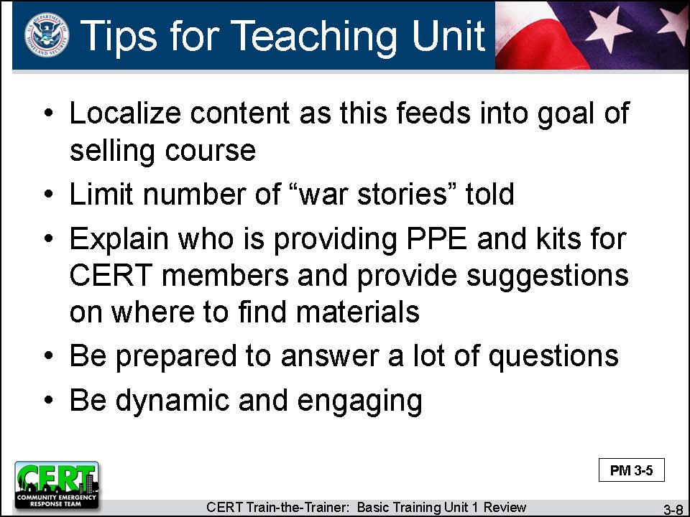  Display Slide 3-8 | - Localize the content, as this feeds into the goal of selling the course.  - Talk about locally specific potential disasters/hazards and keep talk about other disasters to a minimum.  - Limit the number of “war stories” told in Unit 1.  - Explain who is providing the PPE and kits for CERT members and provide suggestions on where to find materials if CERT members will assemble their own kits.  - Be prepared to answer a lot of questions in this unit. Know the organization of the CERT Basic Training course.  - The most effective instructor for the first class is dynamic and engaging in order to keep participants coming back.
  Conduct brief discussion. | Do you have any other tips?
 | How Unit 1 Connects to Other CERT Basic Training Units
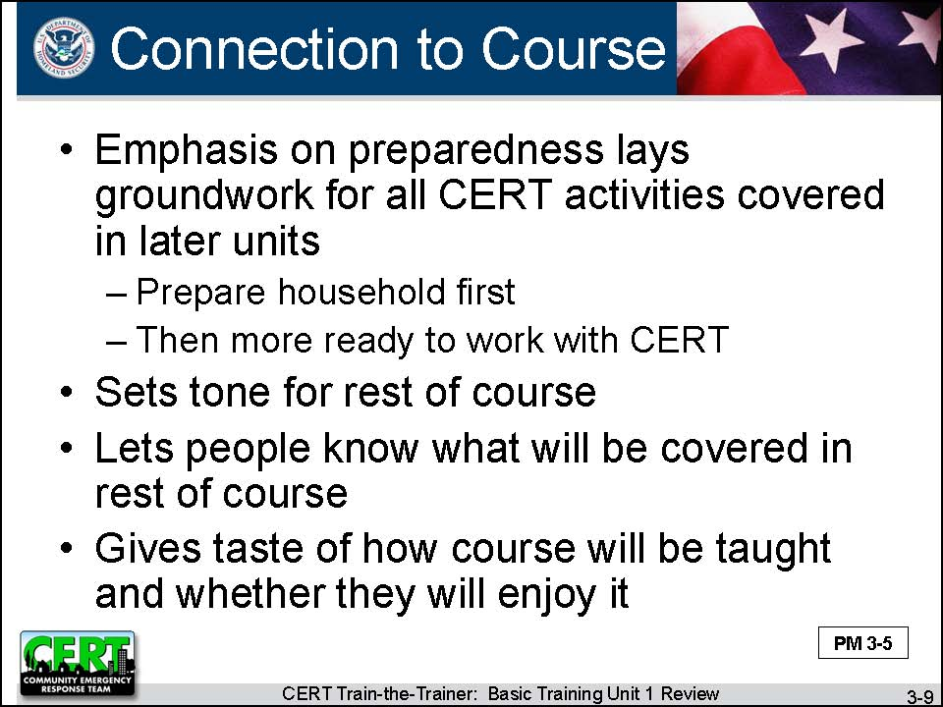  Display Slide 3-9 | - The emphasis on preparedness in this unit lays the groundwork for all CERT activities to be covered in later units. A CERT member’s responsibility is to prepare their household. If the household is prepared for an emergency, a member will also be more ready and able to go to work with their CERT whenever needed.  - This unit also sets the tone for the course. It lets people know what will be covered in the rest of the course. It gives them a taste of how it will be taught and whether they will enjoy it.

T-T-T Unit Summary
This unit has provided information on CERT Basic Training Unit 1.

 | Do you have any questions about anything covered in this unit?

Transition
The next unit will review Unit 2 of the CERT Basic Training course.

[This page intentionally left blank]

