Unit 2: Setting a Program Vision

In this unit you will learn about:

- The Importance of Setting Goals. Why you should set goals and objectives for your local program.
- What Are Program Goals and Objectives. The difference between goals and objectives.
- The Goal Setting Process. How to develop goals and objectives that are appropriate for your local program.

[This page intentionally left blank]

Learning Objectives/ Performance Outcomes | At the conclusion of this unit, the participants will be able to:  - Use strategic planning to define the mission and goals for a local CERT program.  - Explain why a CERT program must have clearly defined goals and objectives.  - Establish draft goals and objectives for a CERT program.
Scope | The topics that will be discussed in this unit are:  - The Importance of Setting Goals  - What Are Program Goals and Objectives?  - The Goal Setting Process
Estimated Completion Time | 2 hours
Training Methods | The instructor begins by discussing the importance of goal setting and explaining that successful programs have a clear vision of where they are headed.  The instructor then leads a brainstorming session to list possible goals for a CERT program.  Next the instructor explains the difference between an overall program goal and objectives. The instructor guides participants through the list previously developed to identify which are goals and which are objectives.  The instructor will discuss the criteria that make an objective effective. It is SMART: simple, measurable, achievable, realistic, and timely. As a group, participants evaluate some examples of program objectives and determine whether they are effective.
Training Methods  (continued) | The instructor discusses each of the five steps in the goal setting process:  - Identify community needs and sponsor needs.  - Develop draft goal and objectives.  - Test the goals and objectives with sponsors and stakeholders.  - Periodically evaluate progress toward achieving objectives and appropriateness of objectives.  - Develop new goal/objectives as needed.  Between Steps 3 and 4, participants begin to work on their Draft Program Plan, introduced in Unit 1, by developing draft goal and objectives for their program.  New Program Managers will identify a draft overall goal and 1-2 draft objectives for their program. They will list people that they want to involve in the goal development process.  Established Program Managers will review their current program goal and objectives and see if the objectives are achievable and appropriate and how the objectives might be revised. They will list others who should review the updated goals.  In Step 4, Periodically Evaluate Progress, two tools are discussed to use for strategic planning: Questions to Get You Started and SWOT Analysis.
Resources Required | - Community Emergency Response Team Program Manager Instructor Guide (for instructors)  - Community Emergency Response Team Program Manager Participant Manual (for participants)  - PowerPoint slides 2-1 to 2-27

Equipment | The following additional equipment is required for this unit:  - A computer with PowerPoint software  - A computer projector and screen  - Easel pad and easel or whiteboard  - Markers
Notes | A suggested time plan for this unit is as follows:  Unit Overview 5 minutes  The Importance of Setting Goals 5 minutes  What Are Program Goals and Objectives 20 minutes  The Goal Setting Process 60 minutes  Draft Program Plan: Develop Program Goal and Objectives  25 minutes  Unit Summary 5 minutes  Total Time: 2 hours
Remarks | When talking about goals, terminology often gets murky. The literature on strategic planning uses a variety of terms: plans, policies, mission statements, goals, objectives, strategies, tactics, and actions.  For this unit, the terms goal and objectives are used.

Unit 2: Setting a Program Vision

Instructor Guidance | Content
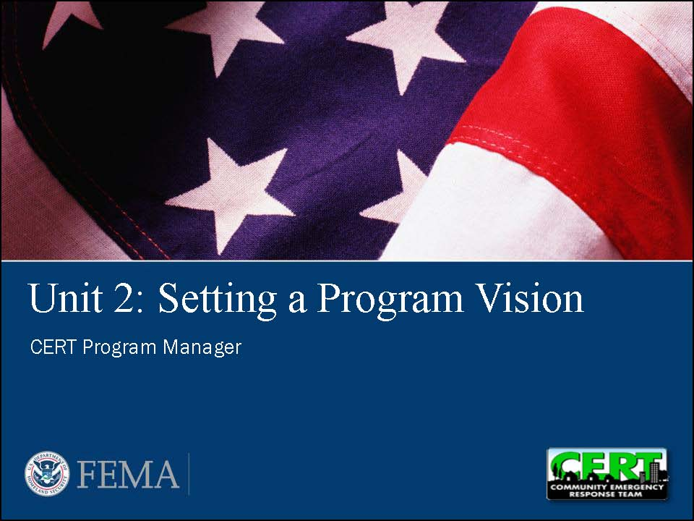  Display Slide 2-1 | Unit Overview  Say that this unit looks at program goals and objectives and how they are developed.
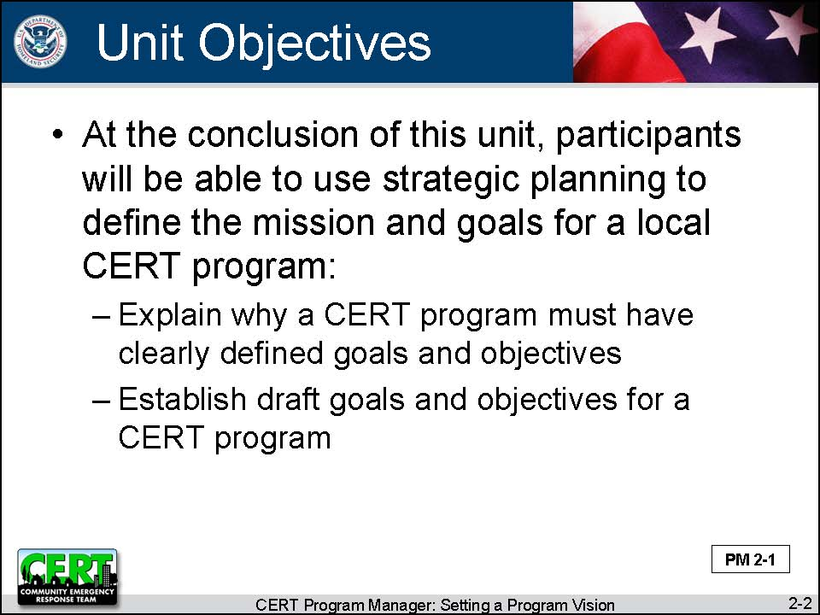  Display Slide 2-2 | Unit Objectives  Give the unit’s learning objectives.  At the conclusion of this unit, the participants will be able to use strategic planning to define the mission and goals for a local CERT program:  - Explain why a CERT program must have clearly defined goals and objectives.  - Establish draft goals and objectives for a CERT program.
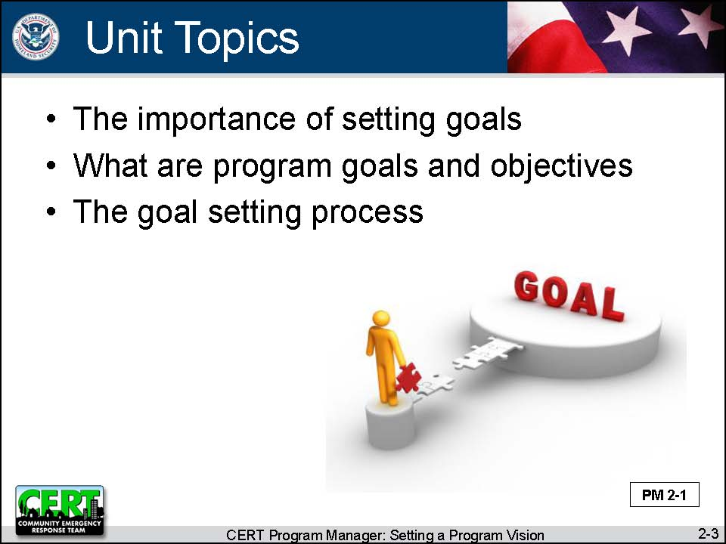  Display Slide 2-3 | Unit Topics  Say that, to accomplish those objectives, this unit will look at:  - The importance of setting goals  - What are program goals and objectives  - The goal setting process
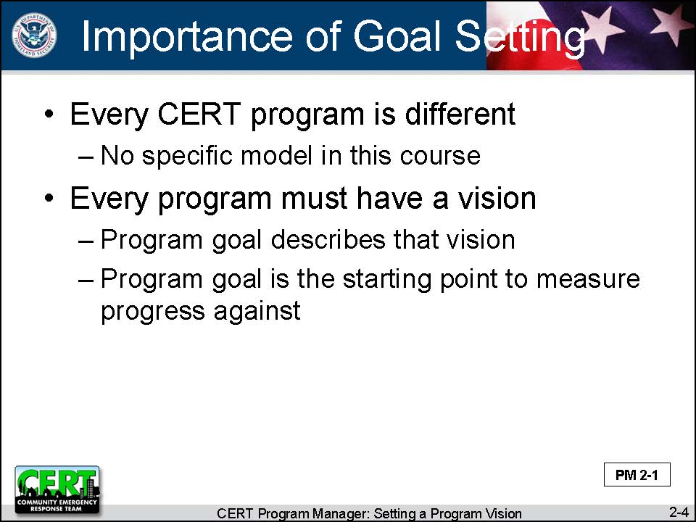  Display Slide 2-4 | The Importance of Setting Goals  Tell participants that an effective CERT program will look very different from one community to another. Therefore, this course will not provide a specific model for operating a program.  Say that, even though this course will not provide a model, in order to choose an operating structure, every CERT program must have a clear vision of what that CERT program will be.  Explain that the way that we describe our program vision is by creating a goal for the program. We have to have that goal as a starting point so we can later determine whether we have made any progress.
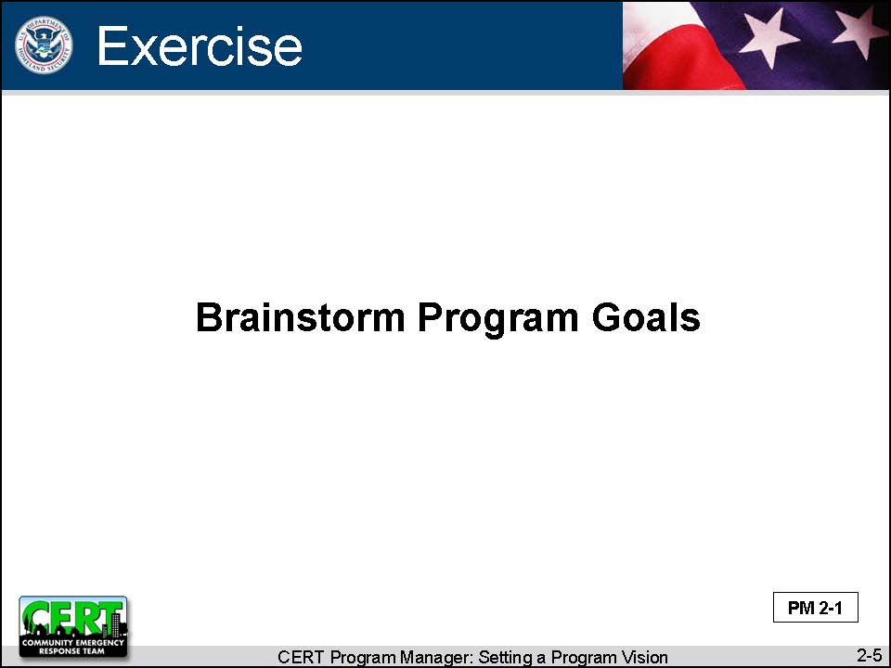  Display Slide 2-5 | Exercise: Brainstorm Program Goals  Purpose: This exercise generates a list of possible program goals.
Instructions: Follow the steps below to conduct the exercise.
- Ask participants: What might be a possible goal for a CERT program?
- Record the list on the easel pad.
- If there is more than one page of ideas, post the pages because you will return to the list.

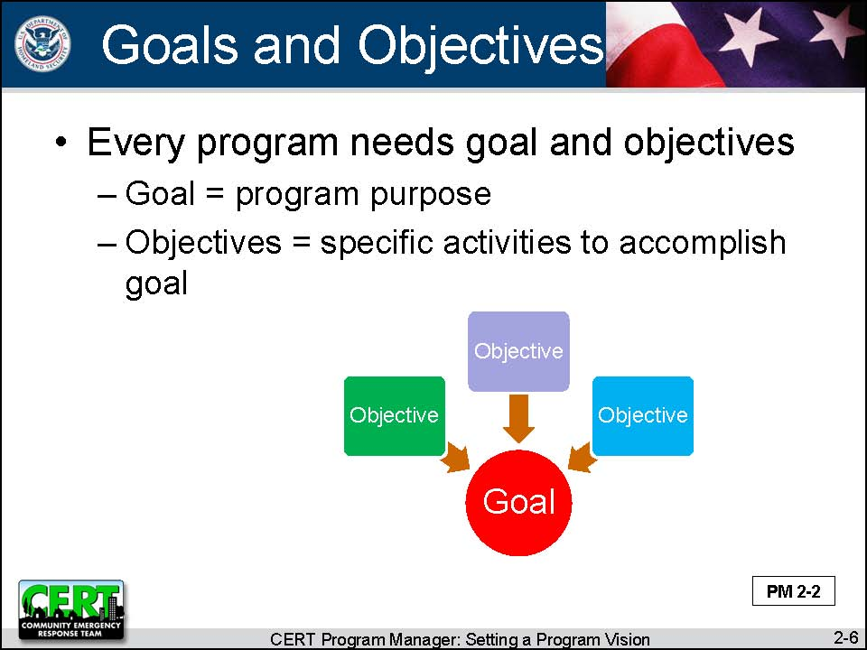  Display Slide 2-6 | What Are Program Goals and Objectives?  Make the distinction between a goal and an objective.  - The program goal is a clear and succinct statement about the program’s purpose for existence.  - Objectives are specific activities that the program will undertake to accomplish the goal.
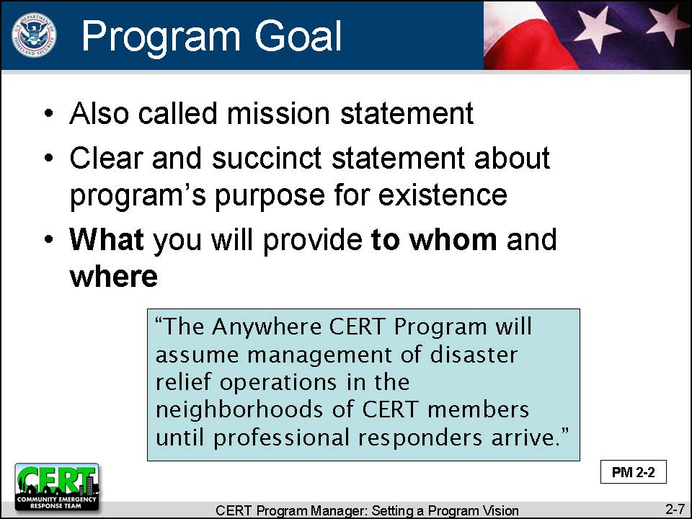  Display Slide 2-7 | Provide these details about program goals.  - Sometimes a goal is called a mission statement.  - It will probably describe what you will provide to whom and in what geographic area.  - Example: “The Anywhere CERT Program will assume management of disaster relief operations in the neighborhoods of CERT members until professional responders arrive.”  - Example: “To do the greatest good for the most people in the least amount of time” (CERT Program)
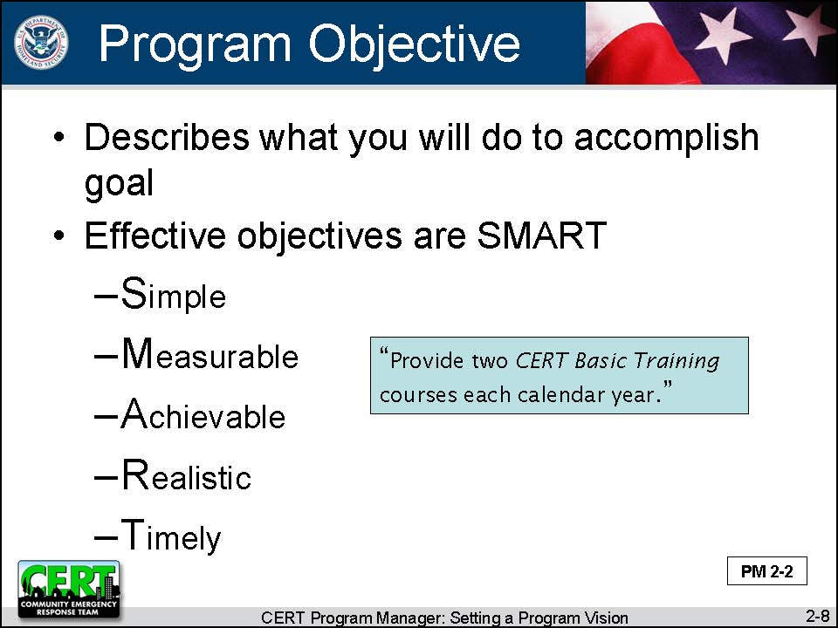  Display Slide 2-8 | Explain that objectives describe your intended future results – specific things that you will accomplish.
Say that to be effective an objective must be SMART.
- Simple (or specific): It is clear and well-defined
- Measurable: There is a way to measure progress toward achieving that goal.
- Achievable: The resources available to accomplish the objective.
- Realistic: The goal can be accomplished within reasonable parameters (e.g., time, cost, resource expenditure).
- Timely: The objective includes a due date or a time when it will be accomplished.
The objective does meet the SMART criteria. | Ask participants if the objective on the slide is SMART.
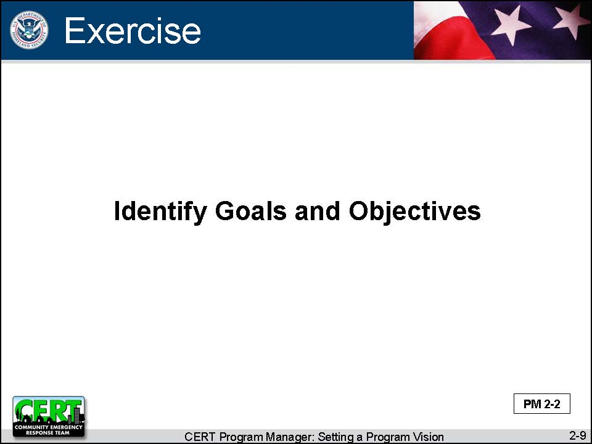  Display Slide 2-9 | Exercise: Identify Goals and Objectives  Purpose: This exercise allows participants to practice distinguishing between program goals and program objectives.
Instructions: Follow the steps below to conduct the exercise.
- Say to participants: Let’s look at the list we just created. Which goals are goals, and which are objectives?
- Mark goals with a “G” and objectives with an “O.”
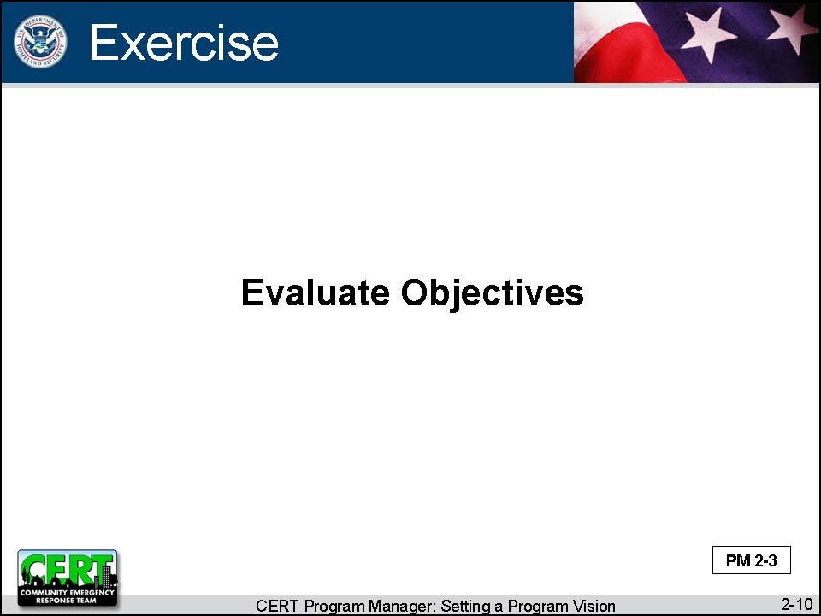  Display Slide 2-10 | Exercise: Evaluate Objectives  Purpose: This exercise allows participants to identify effective objectives.
PM, P. 2-4 to 2-7  The correct responses are provided in the Instructor Guide. | Instructions: Follow the steps below to conduct the exercise.  - Say to participants: Let’s look at some objectives and evaluate them to see if they are effective.  - Refer participants to Examples of Program Objectives in the Participant Manual and on the following page in the Instructor Guide.  - Ask participants to complete the worksheet individually.  - Explain that for each objective, participants should answer Yes or No to the questions by checking the appropriate box.  - Is the objective simple?  - Is the objective measurable?  - Is the objective achievable?  - Is the objective realistic?  - Is the objective timely?  - Review the worksheet with participants. Discuss their responses.  - After reviewing all seven examples, ask participants which objectives are effective. The correct answers are 4 and 7.
 | Debrief: Remind participants that to be effective an objective must meet all five criteria: smart, measurable, achievable, realistic, and timely.

PM, P. 2-4 to 2-7 | Examples of Program Objectives

Instructions:
For each goal answer Yes or No to the questions by checking the appropriate box.

- To have enough instructors available so that whenever a group of 15 or more people is interested in having a CERT class we can provide it for them
 | Yes | No
Is the objective simple?
Is the objective measurable?
Is the objective achievable?
Is the objective realistic?
Is the objective timely?

Answer: Simple, measurable, achievable, realistic

- To improve community preparedness by training community volunteers to provide emergency care until first responders arrive
 | Yes | No
Is the objective simple?
Is the objective measurable?
Is the objective achievable?
Is the objective realistic?
Is the objective timely?

Answer: Measurable, achievable, realistic

- To see Teen CERT in every high school in our county
 | Yes | No
Is the objective simple?
Is the objective measurable?
Is the objective achievable?
Is the objective realistic?
Is the objective timely?

Answer: Simple, measurable, achievable

- To support a community’s public safety efforts (e.g., installing smoke alarms or staffing first aid booths at community events) by providing CERT members whenever requested
 | Yes | No
Is the objective simple?
Is the objective measurable?
Is the objective achievable?
Is the objective realistic?
Is the objective timely?

Answer: Simple, measurable, achievable, realistic (depending on a CERT program’s resources), timely

- To locate a cadre of experts that will assist in providing CERT Basic Training to all 170,000 county residents and to do annual refresher training
 | Yes | No
Is the objective simple?
Is the objective measurable?
Is the objective achievable?
Is the objective realistic?
Is the objective timely?

Answer: Measurable, achievable

- To assist and support the work of the Office of Emergency Management
 | Yes | No
Is the objective simple?
Is the objective measurable?
Is the objective achievable?
Is the objective realistic?
Is the objective timely?

Answer: Achievable, realistic

- To host an outdoor search and rescue class and then to form a search and rescue team
 | Yes | No
Is the objective simple?
Is the objective measurable?
Is the objective achievable?
Is the objective realistic?
Is the objective timely?

Answer: Simple, measurable, achievable, realistic, timely

Instructor Guidance | Content
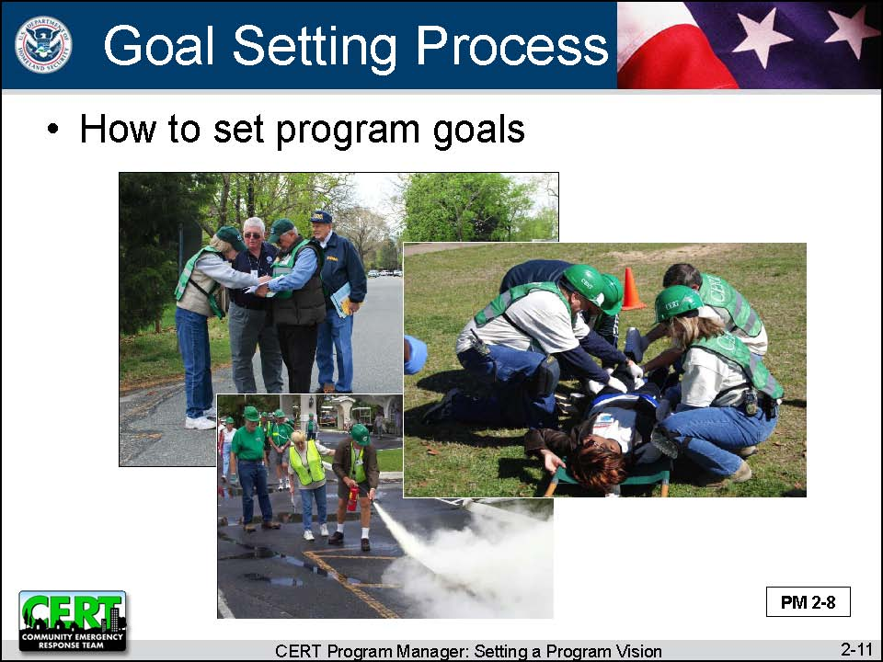  Display Slide 2-11 | The Goal Setting Process  Say that now participants understand what a goal is and what a goal must include to be effective. The next thing to talk about is how to set program goals.
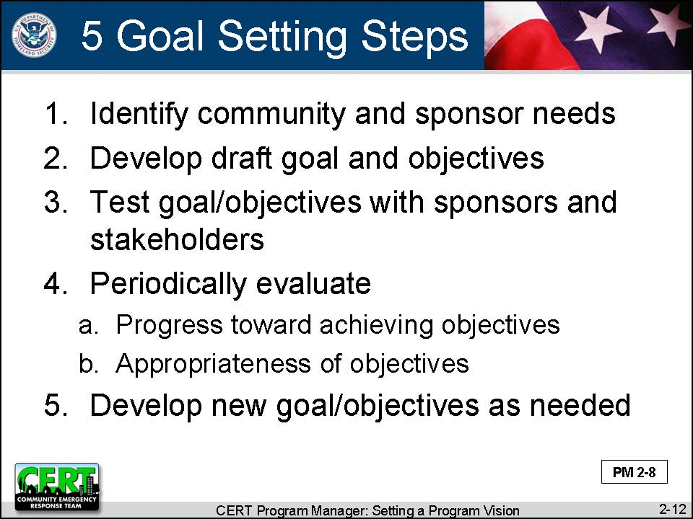  Display Slide 2-12 | The Five Steps in the Goal Setting Process  Describe the five steps in the goal setting process:  - Identify community needs and sponsor needs  - Develop draft goal and objectives  - Test the goal and objectives with sponsors and stakeholders  - Periodically evaluate:  - Progress toward achieving objectives  - Appropriateness of objectives  - Develop new goal and objectives as needed  Explain that this slide is an overview and each step will be covered in more detail.
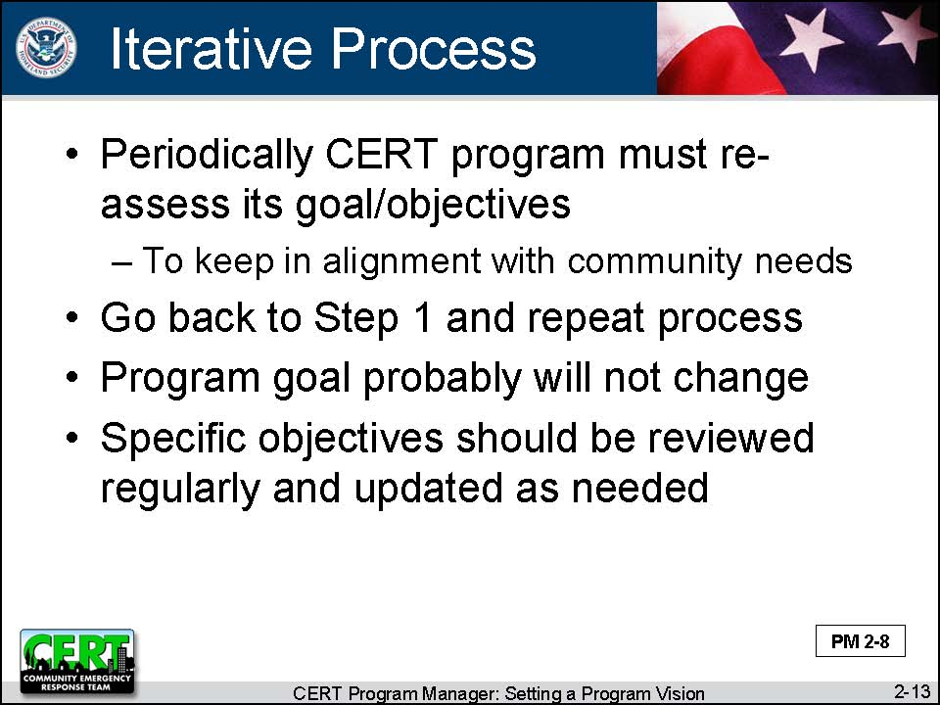  Display Slide 2-13 | Explain that this is an iterative process. Periodically the CERT program must re-assess its goals to ensure that they are kept in alignment with the needs of the community. That means going back to Step 1 and repeating the goal setting process. The overall program goal probably will not change, but specific goals should be reviewed regularly and updated as needed.
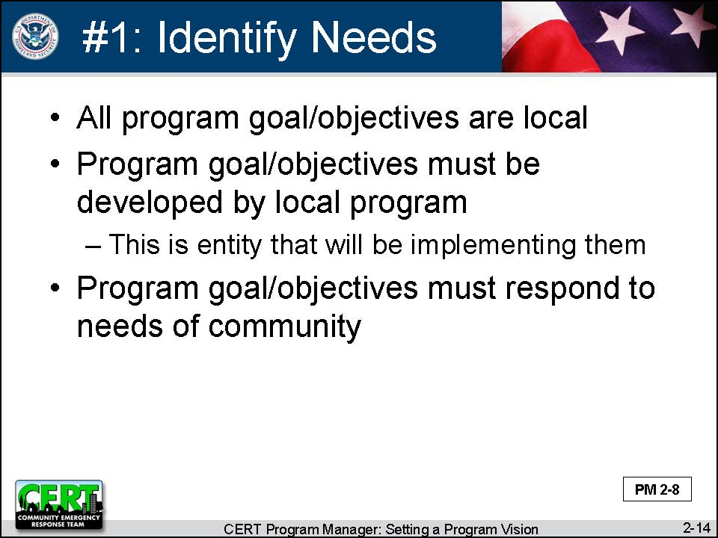  Display Slide 2-14 | Step #1: Identify Community Needs and Potential Sponsor Needs  Explain that all program goal and objectives are local.  - They must be developed by the local program as this is the entity that will be implementing them.  - They must respond to the needs of the community.
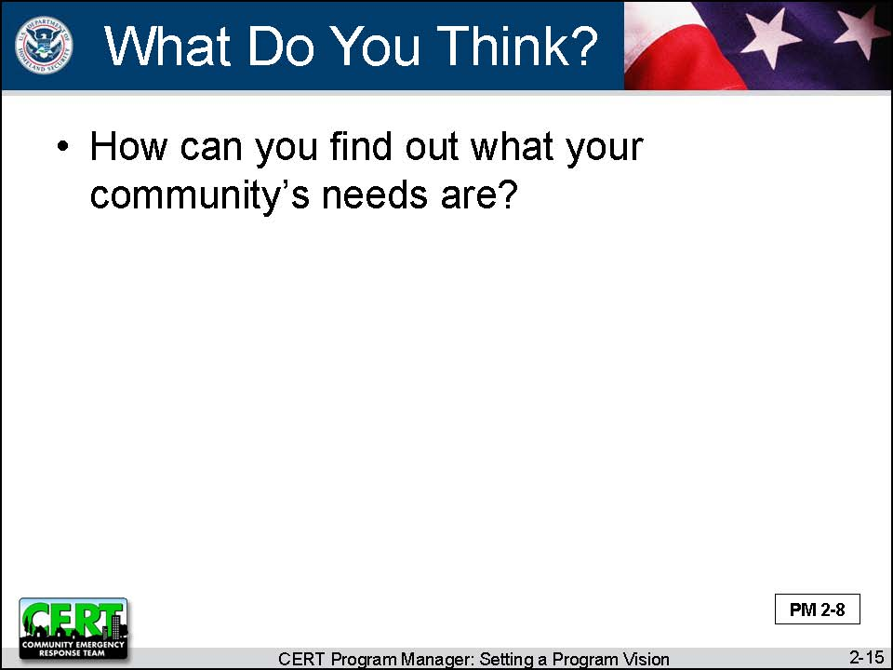  Display Slide 2-15  The answer is very simple: You ask. | Ask participants:  How can you find out what your community’s needs are?
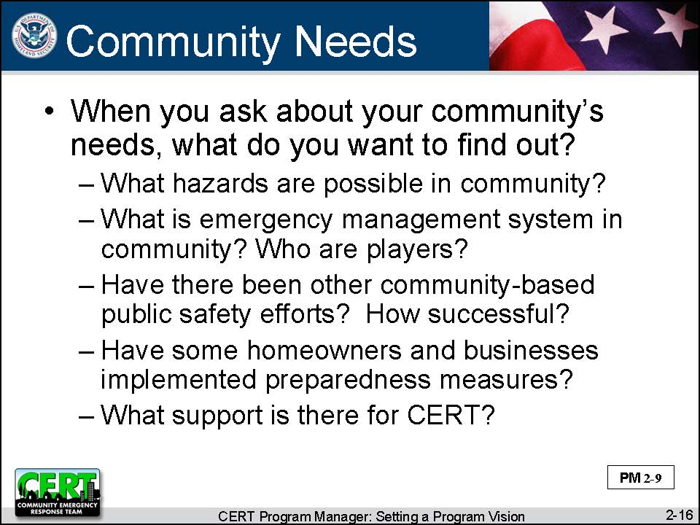  Display Slide 2-16  This slide is animated. The first click displays the question.  Conduct a class discussion by asking this question.  The second click displays the responses.  Before moving on, ask the participants if they have any questions. | Ask participants:  When you ask about your community’s needs, what do you want to find out?  Summarize the discussion by reviewing some of the things you want to find out:  - What hazards are possible in the community?  - What is the emergency management system (EMS) in the community and who are the players?  - Have there been other community-based public safety efforts? How successful were they?  - Have some homeowners and businesses implemented preparedness measures?  - What support is there for CERT?
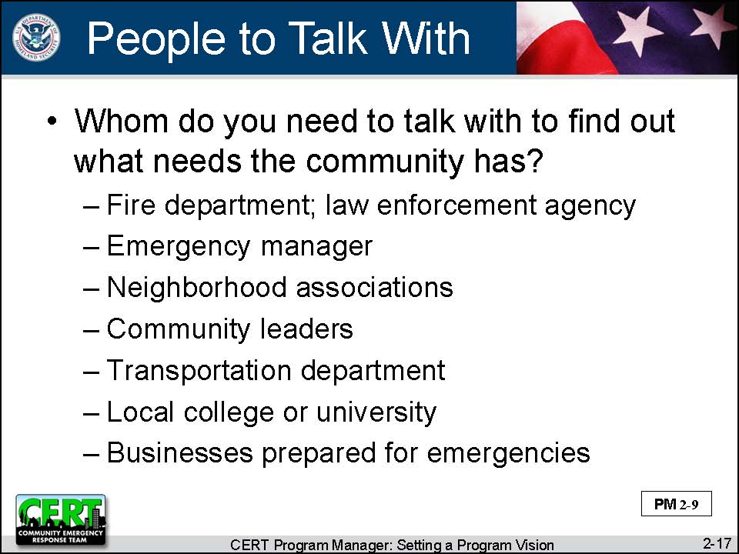  Display Slide 2-17  This slide is animated. The first click displays the question.  Conduct a class discussion by asking this question.  The second click displays the responses.  Before moving on, ask the participants if they have any questions. | Ask participants:  Whom do you need to talk with to find out what needs the community has?  Summarize the discussion by reviewing a partial list of people you want to talk to:  - Fire department  - Law enforcement agency  - Emergency manager  - Neighborhood associations  - Community leaders  - Transportation department  - Local college or university  - Businesses who have prepared for emergencies, either voluntarily or because they are required by law
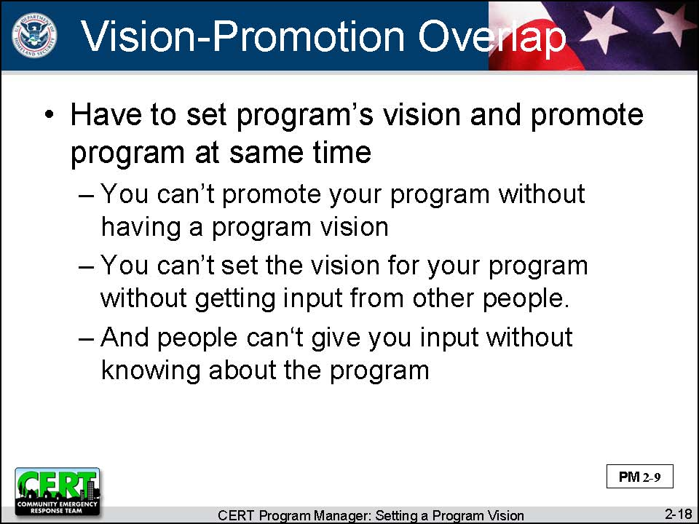  Display Slide 2-18 | Say that there is an overlap between setting your program’s vision and promoting your program (Unit 3). They really have to be done together.  - You can’t promote your program without having a program vision.  - You can’t set the vision for your program without getting input from other people.  - And people can’t give you input without knowing about the program.
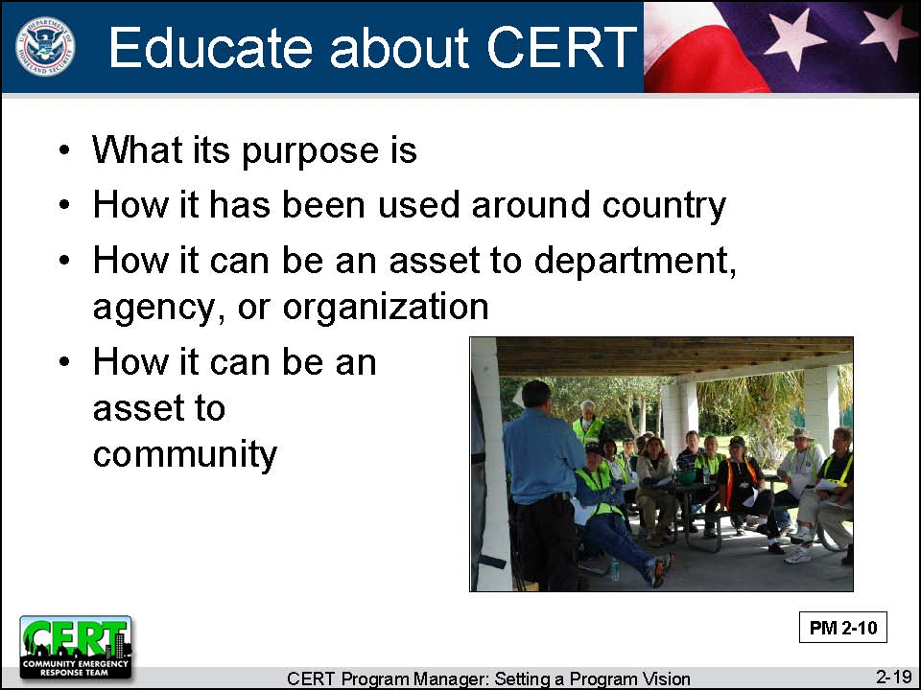  Display Slide 2-19 | Explain that therefore, when you talk with people to assess your community’s needs, you should also be prepared to educate them about the CERT Program:  - What its purpose is  - How it has been used around the country  - How it can be an asset to their department, agency, or organization  - How it can be an asset to your community
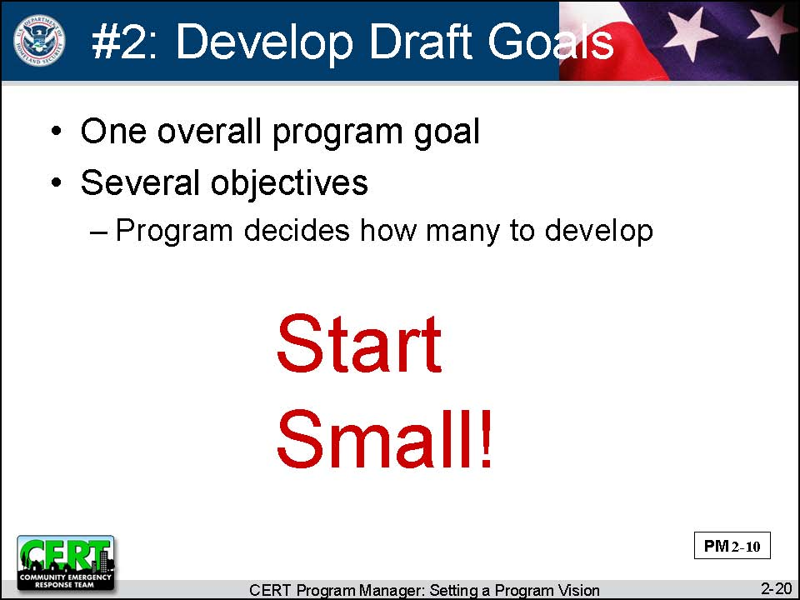  Display Slide 2-20 | Step #2: Develop Draft Goal/Objectives  Tell participants that, once they have assessed the community’s needs, the program organizers will have gotten some direction for developing draft goal/objectives.  Explain that the number of objectives to be developed will be determined by the program. However, new programs should make sure that the startup phase is manageable. Start small!
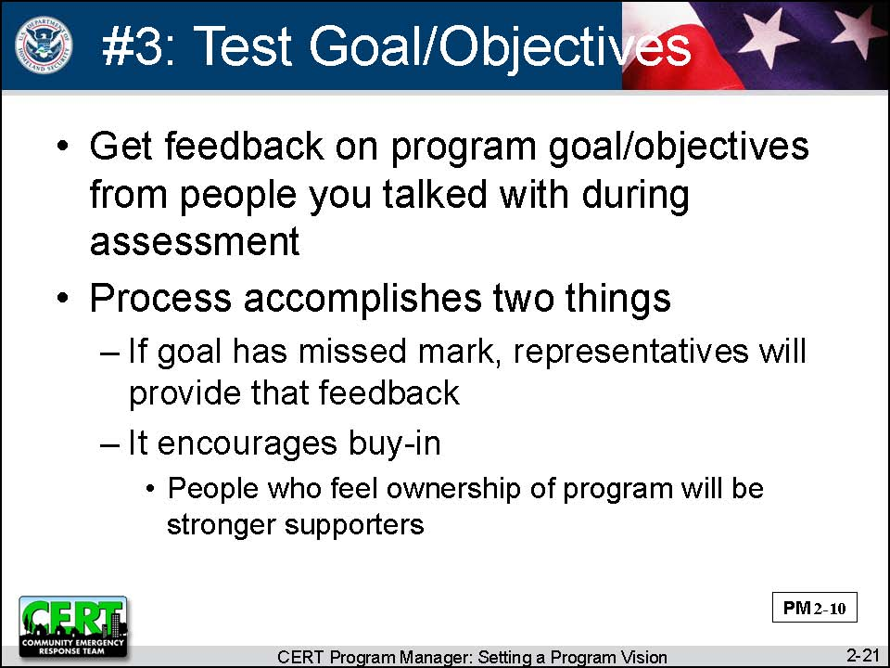  Display Slide 2-21 | Step #3: Test Goal and Objectives with Sponsors and Stakeholders  Say that the program organizers should return to the representatives they talked with earlier and get feedback on the program goal and objectives. This process accomplishes two things:  - If a goal has missed the mark, the representatives will provide that feedback.  - It encourages buy-in. People who feel some ownership of the program will be stronger program supporters.
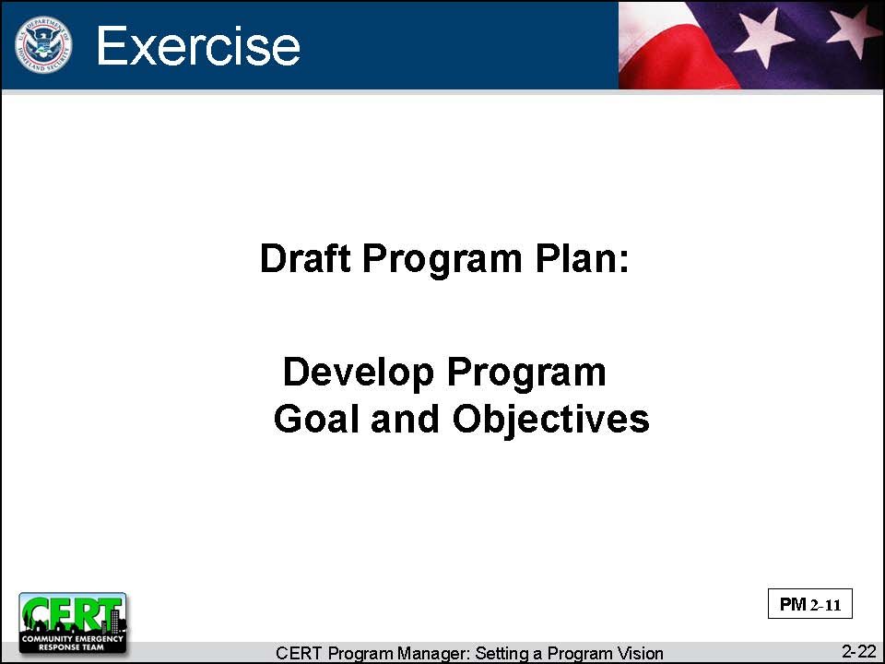  Display Slide 2-22 | Exercise: Draft Program Plan: Develop Program Goal and Objectives  Purpose: New Program Managers will draft a program goal and 1-2 objectives for their program. They will list people that they want to ask to review the draft goal and objectives.  Established Program Managers will review their current program goal and objectives to see if the objectives are achievable and appropriate and how they might be revised. They will list others who should review the updated goal and objectives
Instructions: Follow the steps below to conduct the exercise.
- Refer participants to the Draft Program Plan in Unit 1 of the Participant Manual and the Instructor Guide.
- Ask participants to complete the first section, Program Goals and Objectives, individually.

Debrief: Discuss the exercise with participants.
(New Program Managers) Was it easy to come up with a goal and objectives?
(Experienced Program Managers) Do you want to revise your current goal and objectives?
(All) Do you think you have identified the right people to be involved in your goal and objectives development? Why? Ask for some examples of the people participants have identified.

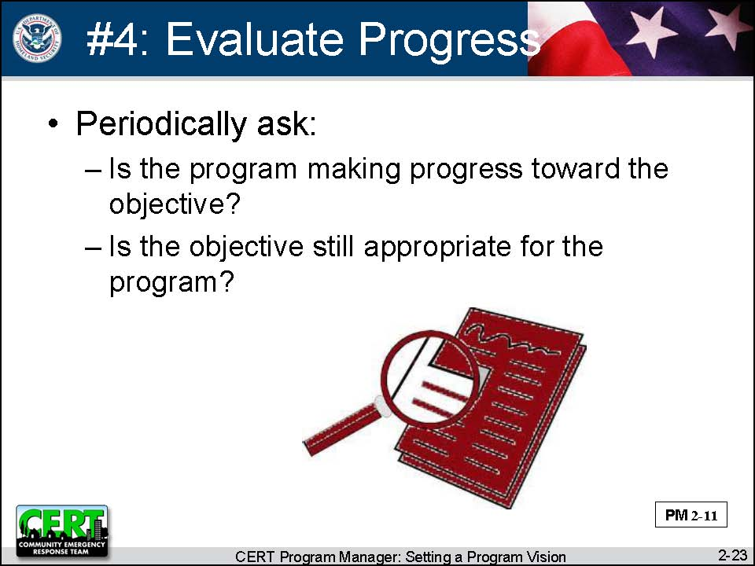  Display Slide 2-23 | Step #4: Periodically Evaluate Progress  Explain that a CERT program does not set an objective once, put it in a drawer, and forget about it. Program objectives reflect and define the program. Therefore they periodically must be evaluated.  Say that the CERT program wants to find out:  - Is the program making progress toward the objective?  - Is the objective still appropriate for the program?
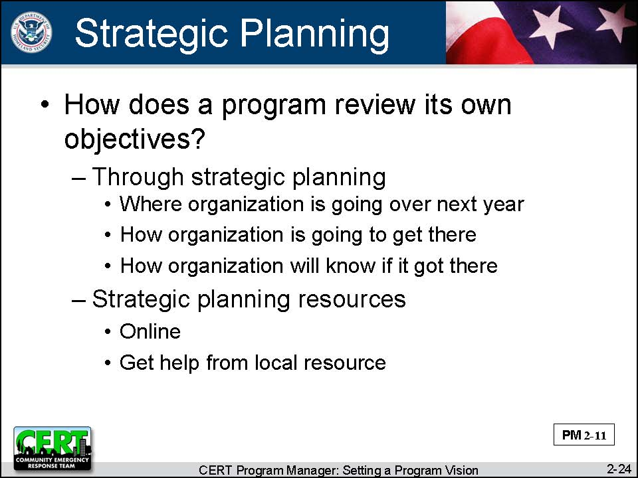  Display Slide 2-24  This slide is animated. The first click displays the question.  Conduct a class discussion by asking this question.  The second click displays the responses.  Before moving on, ask the participants if they have any questions. | Ask participants:  How does a program review its own objectives?  Summarize the discussion by explaining that reviewing a program’s objectives is often part of the process known as “strategic planning.” Strategic planning determines:  - Where an organization is going over the next year  - How the organization is going to get there  - How the organization will know if it got there  Explain that strategic planning is not very complicated, but it is also not a skill that most Program Managers have. However, there are lots of resources available:  - There is a great deal of information online.  - This course will offer a few tools for strategic planning.  - Program Managers should also consider finding a strategic planner to assist the CERT program. Some sources might be:  - A community college  - A local volunteer clearinghouse  - Someone who works for one of the sponsors
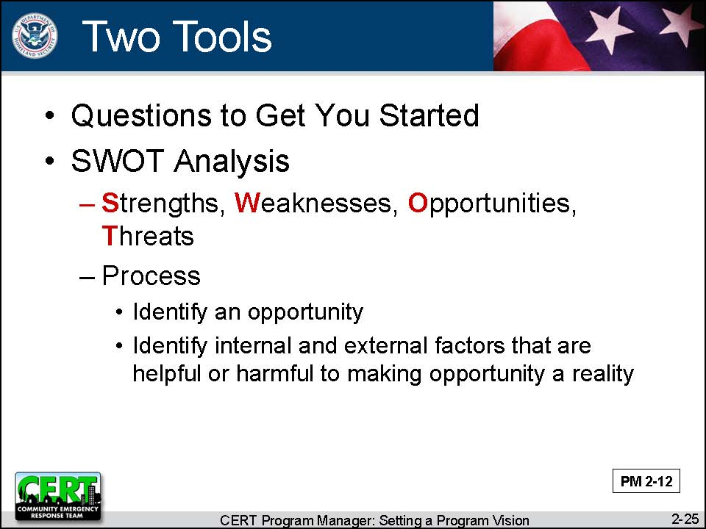  Display Slide 2-25  PM, P. 2-13 and 2-14  Refer participants to the tools on the next two pages. The questions are self-explanatory. Quickly walk through the SWOT Analysis template.  If you have time, practice using the SWOT Analysis. Ask the class to volunteer an opportunity a CERT program might consider. Then brainstorm strengths, weaknesses, opportunities, and threats. | Describe two tools that a CERT program could use for strategic planning:  - Questions to Get You Started  - This series of questions developed by the National CERT Program will help a CERT program determine its community's strengths and challenges and its implementation strategy.  - This list is in the Participant Manual and on the following page in the Instructor Guide.  - SWOT Analysis  - SWOT stands for strengths, weaknesses, opportunities, and threats.  - SWOT Analysis is a strategic planning method used to evaluate the strengths, weaknesses, opportunities, and threats involved in an opportunity.  - In SWOT Analysis you specify an opportunity and identify the internal and external factors that are helpful or harmful to making the opportunity a reality.

PM, P. 2-13 and 2-14 | Questions to Get You Started
Take a few minutes to review the questions below. Answering these questions will help you determine your community's strengths and challenges and your strategy for implementing the CERT program.
Category | Questions
Baseline of Community Awareness | - How would you assess the community's awareness of risk?  - Have there been community-based public safety efforts?  - Have some homeowners and businesses implemented preparedness measures?
Industry and Business | - What businesses have a history of actively preparing for emergencies?  - What businesses are required by law to maintain response plans?  - What businesses are the most influential employers in your community?  - Which businesses have a corporate culture that encourages volunteerism?  - What are the prominent business organizations or associations in your community?
Media | - Which of the television, radio, or print media in your community are more community-service oriented?  - Are there journalists or reporters who have prepared stories on natural hazards, emergency preparedness, or emergency response exercises?  - Which local media outlets have the greatest potential to be effective partners?  - Can you encourage the favorite local weather forecaster to be an active participant?
Health Care Providers | - Which health care providers are most active in promoting public safety?  - Can you encourage medical professionals to participate actively to promote preparedness?
Community Leaders | - Which community leaders might champion this initiative?  - Which community organizations are typically active in community initiatives or events?  - Can you get explicit support from local public officials?
Educational Institutions | - Have any educational institutions participated in any type of natural hazard preparedness or response activities?  - Are there any existing initiatives at area colleges and universities that would make a natural partner with CERT (e.g., programs in emergency planning or public education)?  - Does the local school district require its students to perform community service?

PM, P. 2-15 | SWOT Analysis Template
Opportunity that you are evaluating:____________________________________
 | Helpful |  | Harmful
Internal | Strengths  Positive internal factors within your control. Things you could build on. |  | Weaknesses  Negative internal factors within your control. Things you should restrict or improve.
External | Opportunities  Positive external factors outside your control. Things you could build on. |  | Threats  Negative external factors outside your control. Things you should try to minimize.
Instructor Guidance |  | Content
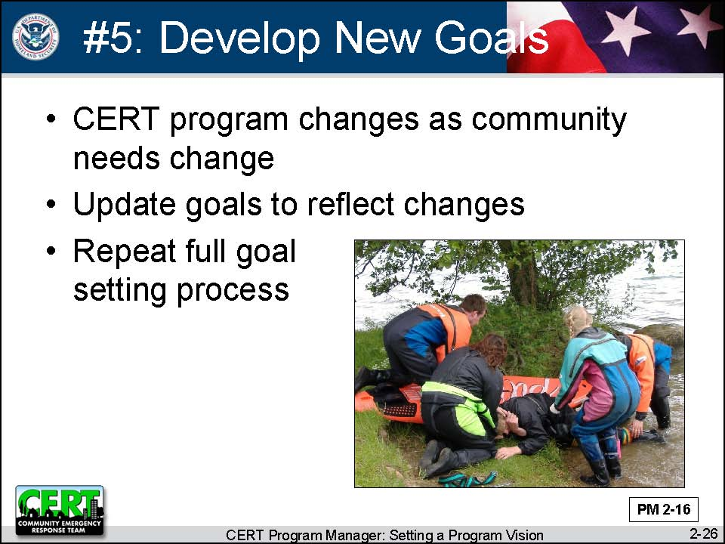  Display Slide 2-26 |  | Step #5: Develop New Goal and Objectives as Needed  Tell participants that the final step in the goal setting process is to develop new goal/objectives as needed. The CERT program will change over time as the community’s needs change. The program must update its goals to reflect those changes.  Remind participants to follow the goal setting process even though it may be tempting to skimp on it.  - Assess the community’s needs and the sponsor’s needs.  - Test draft goal and objectives with the sponsors and stakeholders.  - Periodically evaluate progress.

Instructor Guidance | Content
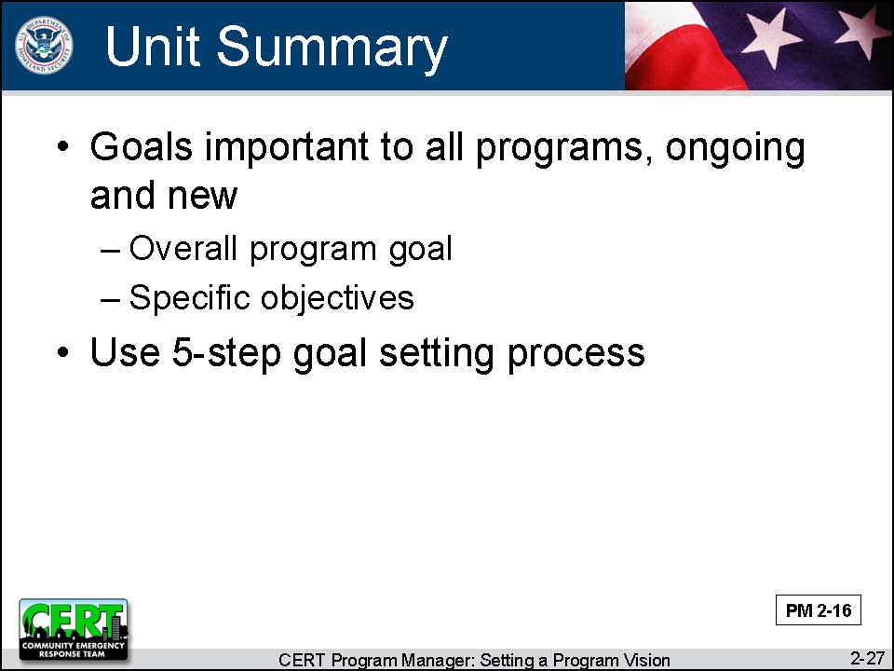  Display Slide 2-27 | Unit Summary  Tell participants that they should understand by now that a CERT program is not developed in isolation. If the program is going to be successful, it has to prove that it will be a resource for the community. To be a resource for the community the program must know where it is going and how it is going to get there.  Say that goals and objectives are the tools we use to lay out the program’s future. They are an important aspect of managing existing programs as well beginning new programs. Programs must develop an overall program goal and several objectives using the goal setting process.
 | Do you have any questions about anything covered in this unit?
Transition
The remainder of the course will focus on strategies for reaching and evaluating your program goal and objectives.
The next unit will discuss the importance of program promotion and how to promote to different audiences.

[This page intentionally left blank]

