DCIS Login Procedures and Initial Award Screens

The login procedure is begun by accessing the DCIS website (http://dcis.hh.gov/). Then clicking the hyperlink “FY2004 DCIS Login”.

Screen 1 – DCIS Login Screen
To complete the login process, enter your username and password and then click the Login button.

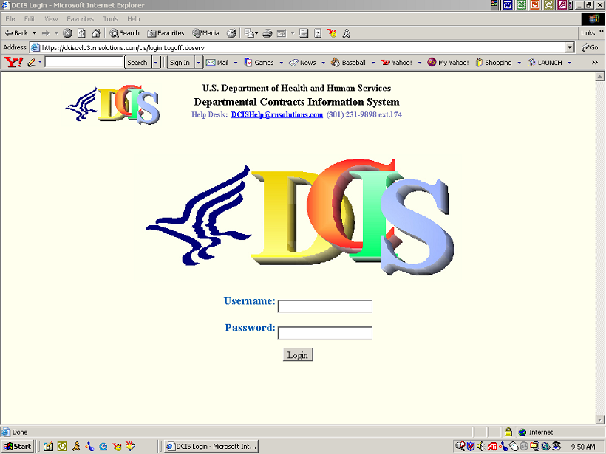

Screen 2 – DCIS Function Selection Screen

A successful login results in Screen 2 appearing on the monitor.
Click New from the ICAR Menu Bar to enter a new record.

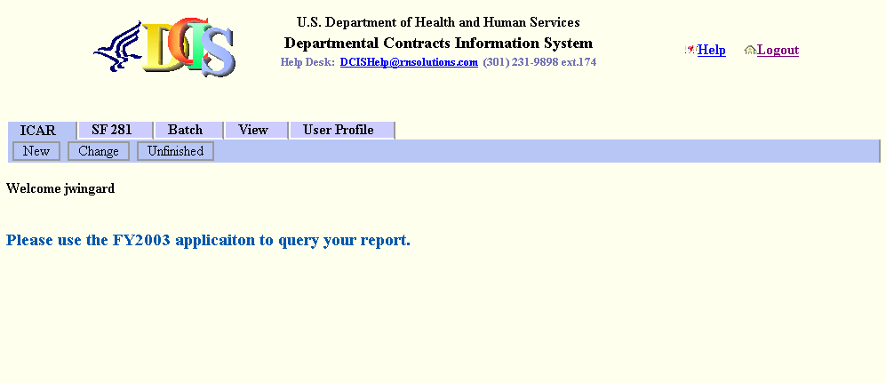

Screen 3 – New Contract Information

From the IDV/Award Type drop-down, select the IDV/Award Type. Note: In this example we selected IDV-IDC Indefinite Delivery Contract - see below.

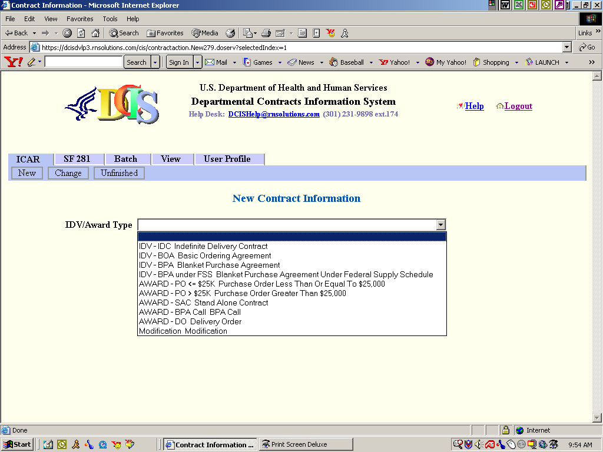

Screen 4 – New Contract Information
Click Next.

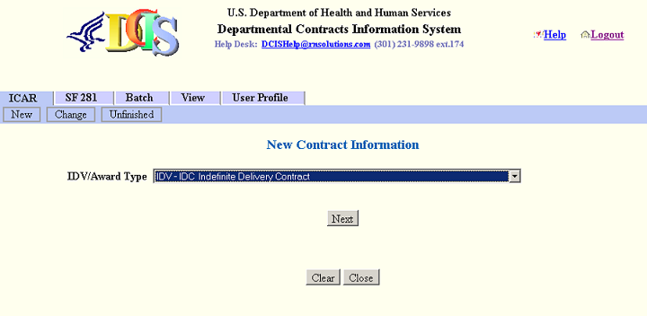

Screen 5 – New Contract Information

Select your Office Code, if applicable.

From the Type (Mechanism) drop-down, select the Type (Mechanism). Note: In the example we selected

Select the Fiscal Year in which the contract was award and then enter in the 5-digit sequence/serial number. Do not enter any data in the Order Number field when entering the initial award.

Enter in the 4- digit modification number (i.e., if initial enter 0000, if you leave the field blank, DCIS will assume this is the initial contract and will put 0000 in the modification number field).

Click Create.

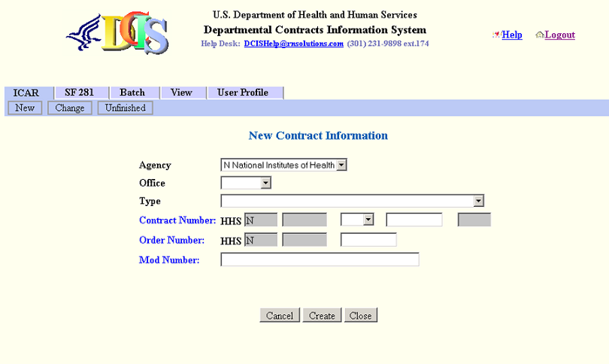

Screen 6 – New Contract Information (DCIS Data Screen)
Key the remaining data into the numbered fields. After you have entered the record, click Verify to validate the record.

Once all the data has been verified click Save to save your data/entry.



