

DEPARTMENT OF
HEALTH AND HUMAN SERVICES
ACQUISITION HUMAN CAPITAL PLAN


APRIL 12, 2010
Table of Contents
I. Purpose of Plan 1
II. The Need for Increased Acquisition Resources 4
HHS’ Acquisition Workload: Fiscal Years 2010-2014 5
Attaining Capacity 8
Increasing Capability 12
III. Projections for Acquisition Workforce Growth and Supporting Methodology 13
Projected Increases in the Acquisition Workforce 13
Data Methodology for Determining Obligations and Actions 19
Regression Methodology and Results 19
Projecting Future Staffing Needs 21
Training Budget Projections 21
IV. HHS’ Acquisition Workforce: Accomplishments 22
Acquisition Workforce Human Capital Succession Plan 22
Acquisition Workforce Development: Training and Certification 23
Career Development 26
Recruitment and Retention 29
Acquisition Integration and Modernization Initiative 29
V. HHS’ Acquisition Workforce: Improvement Goals, Strategies, Priorities, and Challenges 31
Acquisition Workforce Improvement Goals 31
Strategies for Recruiting and Retaining a High-performing Workforce 32
Priorities 35
Challenges 36
Appendix A – HHS’ Organizational Profile and Acquisition Workforce Governance 37
Appendix B – HHS’ Strategic Priorities 41
Appendix C – HHS’ Acquisition Savings Goals 42
Appendix D – HHS’ Acquisition Workforce Profile 43
Appendix E – Acquisition Workforce Competencies 52

I. Purpose of Plan
The Department of Health and Human Services (HHS or the Department) is pleased to submit its initial Acquisition Human Capital Plan, hereafter “AHCP” or plan. This plan represents the HHS response to the October 27, 2009 request from the Acting Administrator, Office of Federal Procurement Policy (OFPP)—Acquisition Workforce Strategic Development Plan for Civilian Agencies—FY 2010-2014. It also will serve as a living document, which HHS will review and update on a periodic basis to assess whether our efforts to ensure a highly qualified, stable HHS acquisition workforce are succeeding. This process will not only enable us to refine our numbers and report our accomplishments and challenges through an annual update, but also will allow us to judge changed circumstances and whether mid-course corrections are necessary.
HHS’ AHCP addresses our ongoing efforts to meet the identified needs of our current acquisition workforce for training and development to ensure a highly qualified cadre of professionals, maximize our ability to retain those staff, and recruit comparable individuals to add to or replace staff in the acquisition workforce. The AHCP represents a significant shift in emphasis from ad hoc recruitment efforts generally targeted only at those in the contracting job series to systematic and comprehensive strategies to develop longer-term development, growth, and succession plans for the broader acquisition workforce. This shift in emphasis is consistent with approaches being taken government-wide, as well as HHS-specific initiatives and activities intended to improve our acquisition process and outcomes. We intend to make this plan part of our overall portfolio of tools and techniques to improve the acquisition process, which goes hand-in-hand with initiatives to improve the HHS acquisition workforce.
For HHS, the acquisition workforce is comprised of individuals in the following job series or serving the following functions:
- All individuals in General Schedule (GS) 1102, 1105, and 1106 series; and personnel in any other GS series who may be given: (1) warrant authority (e.g., U.S. Public Health Service Commissioned Corps personnel), (2) delegation of authority to contract for low-dollar commercial off-the-shelf training (e.g., HHS University), (3) Federal Acquisition Certification in Contracting (FAC-C) certification, or (4) Head of Contracting Activity (HCA) designation.
- Contracting Officers’ Technical Representatives (COTRs) (typically within a program office) who are appointed by Contracting Officers to monitor or manage performance under one or more contracts, or COTR candidates who obtain an HHS FAC-COTR certification (the latter then serve as a qualified cadre of individuals that can assume COTR duties as needed as a result of attrition or a workload surge).
- Project Managers and Program Managers (P/PMs) who currently monitor or manage one or more contract-related projects and programs (respectively), or P/PM candidates who obtain an HHS FAC-P/PM certification (who serve as a cadre of available individuals in the event of creation of new programs or attrition).
It should be noted that, at HHS, individuals who serve as COTRs and P/PMs (hereafter, “PMs”) are in varying job series, depending on the type of program or requirement for which they have responsibility. COTRs, in many cases, perform those responsibilities as an auxiliary duty. This factor is an important reality to consider as we move forward to strengthen our acquisition workforce.
This plan addresses not only the human capital management aspects of the acquisition workforce, i.e., the numbers of people carrying out the acquisition function, their training, strategies for recruitment and retention, and succession planning, but also the need to improve the acquisition process, enhance policy and oversight, and have systems and databases that support management of the acquisition function.
The plan is comprised of four sections following this “purpose” section:
- The Need for Increased Acquisition Resources
- Projections for Acquisition Workforce Growth and Supporting Methodology
- HHS’ Acquisition Workforce: Accomplishments
- HHS’ Acquisition Workforce: Improvement Goals, Strategies, Priorities, and Challenges
It also includes five appendices that include organizational background and specialized information to support our plan:
- Appendix A—an overview of HHS and the governance structure for the HHS acquisition workforce
- Appendix B—HHS’ strategic plan goals
- Appendix C—HHS’ acquisition savings goals
- Appendix D—a detailed profile of the HHS acquisition workforce
- Appendix E—acquisition workforce competencies
The Federal acquisition environment is becoming increasingly dynamic, with greater emphasis on (1) use of contracting techniques providing less risk to the Government,
(2) performance-based techniques, and (3) accountability and transparency, including data quality, as well as continuing changes in what we buy, particularly as technology continues to change. At HHS, given our mission and the goals set forth in our strategic plan, we are at the forefront of many of the Administration’s initiatives—whether involving health care reform, public health challenges, influenza pandemics, bioterrorism threats, or finding causes and cures for diseases that affect the Nation’s population. In recent years, we have faced significant challenges for the acquisition function -- and the people, processes, and systems that are at its heart -- and expect that the next five years will present comparable challenges.
This plan is designed to help HHS increase both the capacity and capability of its acquisition workforce by FY 2014. Specifically, it will be used by HHS OPDIVs and STAFFDIVs as they develop their FY 2012 and future budget requests – consistent with the Administration’s three-year discretionary funding freeze. An important first step toward achieving the goals of this plan will be to allocate the $7 million requested in the President’s FY 2011 Budget for strengthening HHS’ acquisition workforce -- to the extent Congress appropriates the funds. In addition, HHS will determine the budgetary impact of Open Government and health care reform initiatives on its acquisition workforce.

II. The Need for Increased Acquisition Resources
While we have anecdotally known for many years that our need for acquisition resources has not kept pace with the increase in workload—whether measured by obligations or complexity—the government-wide initiatives to enhance the acquisition workforce have resulted in our conducting a detailed review of the availability of, and shortfalls in the number and qualifications of those resources. This assessment reveals that we need to increase our acquisition workforce staffing and must engage in continuous training of both our existing staff as well as those newly brought into the acquisition workforce. We also must ensure that we have strategies for attracting and retaining individuals that view acquisition as a career field and profession in which individuals can excel, thus maximizing the benefit we obtain from investing in them. HHS continues to refine relevant processes and procedures to identify its acquisition workforce needs—in terms of overall size, recruitment, retention, and training and development.
This section of our AHCP provides our justification for the following:
- Increasing the number of individuals that comprise our acquisition workforce overall, whether through hiring or assignment—we estimate HHS needs about $20M in additional salary costs over 5 years to cover an estimated 261 additional positions in the contracting series (199 in the 1102 series and 62 in the 1105 series; but we also make the case for using fewer 1105s). We also project an increase of about 1,000 COTRs and 183 PMs. If the source of these increases were new hires only, the budgetary requirements for salaries would be about $100M and $20M, respectively. In percentage terms, if staffing is to be aligned with projected obligations, HHS’ 1102s, COTRs and PMs would need to experience an overall increase of about 20% -- from FY 2010 through FY 2014. HHS can help expand its acquisition workforce by taking the following three steps:
- Reducing reliance on contractors as a means of carrying out operational acquisition functions.
- Ensuring that the acquisition workforce keeps pace with workload requirements, including fully qualified COTRs and PMs.
- Filling new contracting positions at entry and mid-levels to serve as the pool from which future senior-level staff can be selected.
- Allocating an increased number of positions to functions that historically have not received needed attention, such as cost-price analysis, post-award administration, and oversight.
- Developing or obtaining specialized resources that enhance the quality of the acquisition function, such as procurement attorneys.
- Providing more resources for acquisition workforce training.
- Focusing on acquisition as a career with corresponding career development paths.
- Providing tools and techniques that facilitate an efficient and effective acquisition process, including use of automation and improved processes.
- Overseeing performance for conformance with improved acquisition outcomes.
To help grow our acquisition resources, we will work closely with HHS’ Heads of Contracting Activity (HCA) to ensure proper allocation of the additional $7M of acquisition workforce funding requested in the President’s FY 2011 Budget. In tandem, HHS will determine the budgetary impact of Open Government and health care reform initiatives on its acquisition workforce.

HHS’ Acquisition Workload: Fiscal Years 2010-2014
This subsection addresses the HHS acquisition workload and its composition, including breakdown by contract type, use of performance-based acquisition, post-award administration workload, and other workload drivers. As shown in Figures 1a and 1b below, HHS projects an increase in anticipated obligations through FY 2014. FY 2009 has been adjusted for the effects of the American Recovery and Reinvestment Act (Recovery Act) on our obligations. At this time, we cannot project the full effect of the recent passage of health care reform on acquisition obligations, but it is clear we will spend hundreds of millions more than we did in previous years as a result.
Our estimate of the overall increase in obligations of about 20%, from FY 2010 to FY 2014, is based on a regression analysis of the rate of obligations growth from FY 2005 through 2009 – adjusted for FY 2009 Recovery Act obligations and other factors. Given the passage of health care legislation and that the FY 2011 Budget’s out-year estimates for HHS decline over time, the future of HHS’ procurement obligations is difficult to predict. However, when we update the AHCP next year, we believe our actual experience with the award of health care reform contracts will improve the reliability of our predictions. Nevertheless, under the totality of circumstances, we believe our projection methodology -- including the concomitant estimated derivation of future acquisition staffing levels -- represents a reasonably conservative approach. The details of our regression analysis may be found in Section III of this plan.

Figure 1a. Projected HHS Obligations – FY 2010-FY 2014
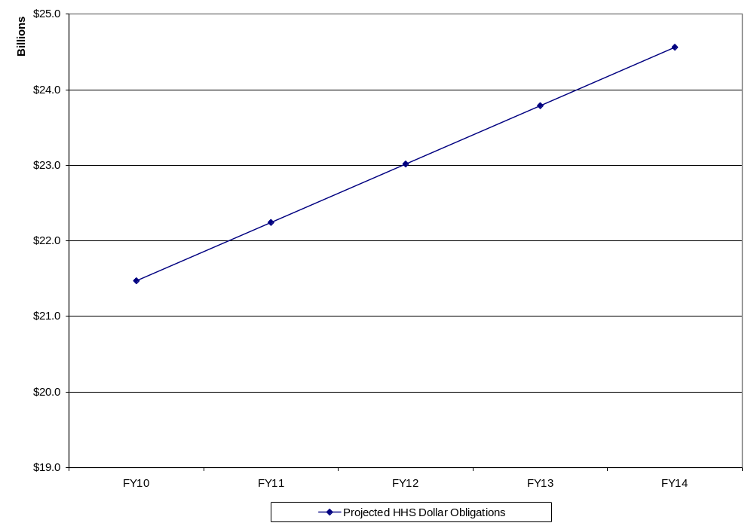
Figure 1b. Actual HHS Obligations - FY 2005 – FY 2009
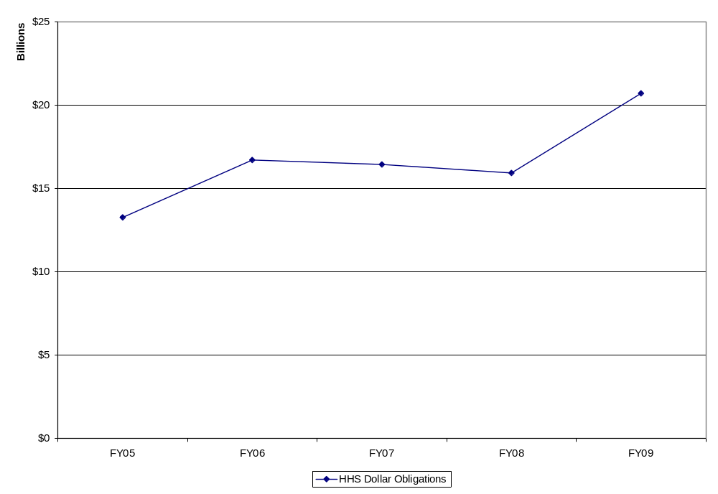
Source: FPDS-NG
As part of our analysis, we also looked at number of actions over time and projected those numbers as well. While the HHS numbers suggest that there will be a decrease in the number of actions, we believe greater reliance should be placed on the increase in obligations. There is not a proportional relationship between number of actions and required resources, and the number of actions alone is not indicative of workload. Contracts are becoming more complex. Also, because the number of actions can be affected by business processes, e.g., full funding of fixed-price contracts, and other factors, we do not believe there necessarily is a direct correlation between obligations and actions. These data are shown in section II of this plan.
As shown in Figure 2. below, of those amounts obligated in FY 2009, 42 percent was for commodities (e.g., information technology hardware and software, laboratory supplies) while the greater proportion—58 percent was for services, which includes biomedical research and development, construction, system development, and janitorial services.
Figure 2. HHS Obligations by Product and Service Codes – FY 2009
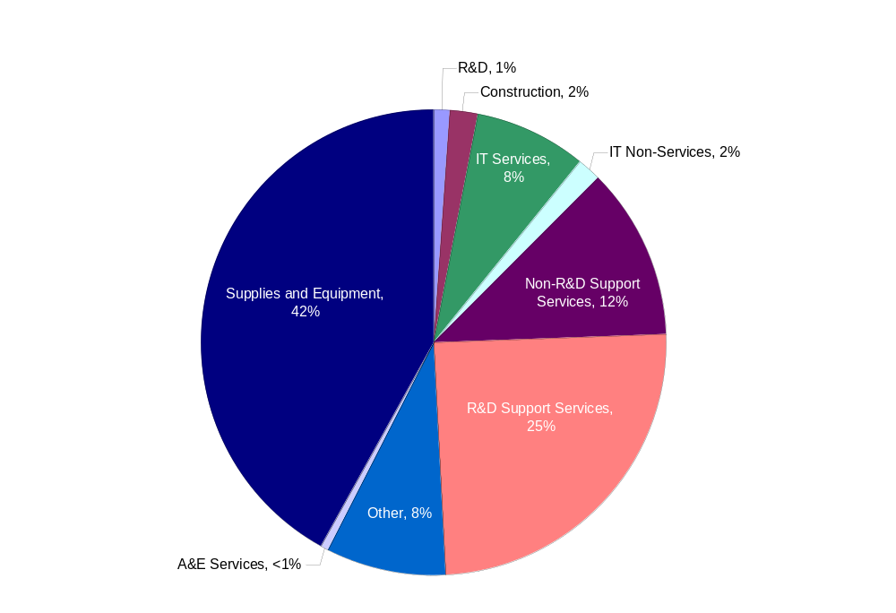
Source: FPDS-NG
Figure 3 shows the HHS acquisition portfolio by pricing family/type of contract for FY 2009.
Figure 3. HHS Obligations by Contract Type – FY 2009
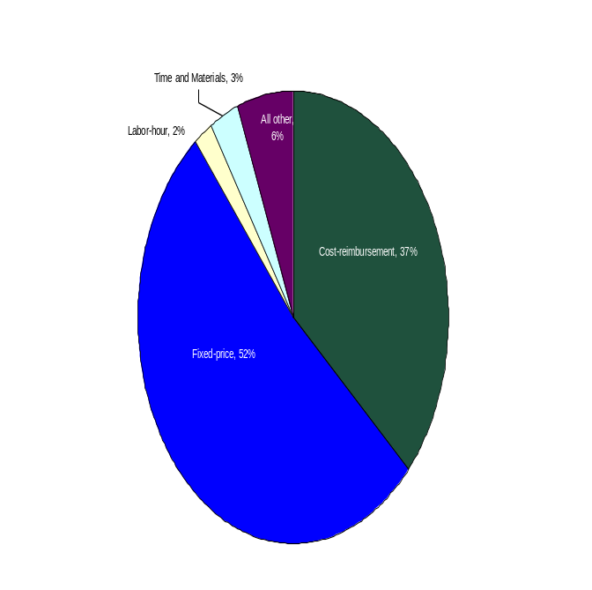
Source: FPDS-NG
Consistent with government-wide initiatives, we are working on reducing the number of cost-reimbursement, time and materials, and labor-hour contracts. However, as a Department that acquires considerable research and development and research-related services through the acquisition process—services that do not lend themselves to fixed-price arrangements—we recognize that HHS still will have a considerable number of cost-reimbursement instruments.
In addition, since most HHS contracts and orders (other than simplified acquisitions) are awarded for multiple years, whether using options, multi-year contracting under Federal Acquisition Regulation (FAR) 17.1, or other funding methods, the HHS acquisition workforce, which operates in a cradle-to-grave environment, has a significant post-award administration and closeout workload that is not captured in these numbers alone. One example of that workload is the effort involved with oversight of performance-based acquisitions. In FY 2009, about 25 percent of our obligations and about one-third of our actions other than simplified acquisitions were categorized as performance-based acquisitions. See also Figure 14 in the next section of this AHCP.

Attaining Capacity
From a macro standpoint, the projected increase in HHS’ obligations between FYs 2010 through 2014 will result in an increased need for individuals in the three acquisition workforce categories—contracting, COTR, and PM. This discussion of “capacity,” i.e., having the needed number of individuals, is consistent with the use of that term in the October 27, 2009 OMB memorandum. We also intend to increase capacity by increasing productivity—making certain the right people are doing the right job and have the right tools to do the job. Our plan is not simply to hire an increased number of Contract Specialists to operate on the front line. Rather, we intend to collectively determine areas where payoff may be highest in terms of augmented resources, based on tasks not being done or being done well. For example, in light of the emphasis on use of fixed-price contracts, we will assess the tradeoffs in using some of our additional positions to hire trained cost-price analysts in lieu of additional cost-price training for all Contract Specialists. Similarly, if we can free Contract Specialists from ministerial tasks or tasks that can be better handled with automation, it will free up time for the in-depth analysis that is more rewarding for job satisfaction.

Contracting Series
Figure 4 shows, by percentage, the breakdown of the 1,453 individuals in the 1102, 1105, and 1106 series as of the end of FY 2009, as supplemented by 50-60 on-site contractor full-time equivalents assisting in contract administration and closeout responsibilities. We have not included other contractor support in these calculations, i.e., support services provided predominantly at the contractor’s location.
Figure 4. Total HHS Contracting Staff – FY 2009
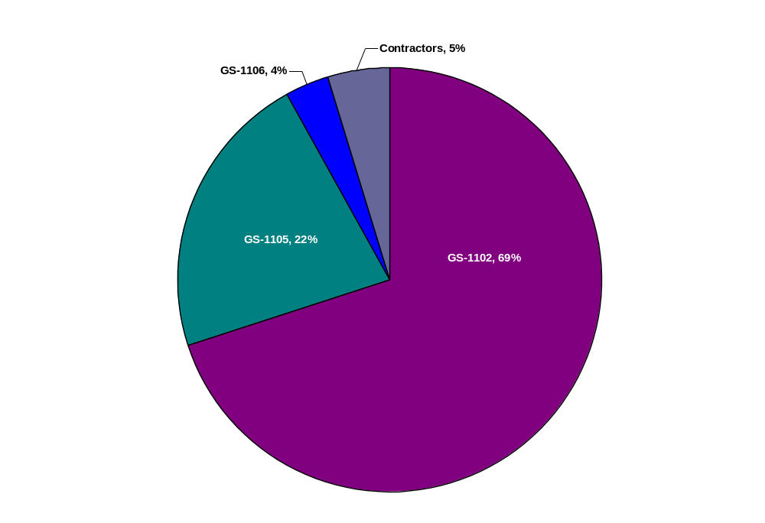
Source: HHS’ Human Resources Database
As of the end of FY 2009, HHS had 1,068 individuals in the 1102 series, with almost 50 percent of them in senior-level positions (GS 13-15). We also had 331 individuals in the GS 1105 series, and 54 individuals in the GS-1106 series. The number of individuals in the GS 1102 series has remained fairly constant from FY 2005 through FY 2009, with hiring to replace staff lost through attrition (separation or retirement) or internal promotion. No significant increase in staffing occurred during that period to reflect either the increase in obligations or complexity. Additional positions, if authorized, have generally been few in number and not based on a systematic assessment of human resource needs in relation to workload.
Another indicator of workload is the number of individuals with warrants and the number of contracts or orders for which they have responsibility. Figure 5 shows the number of individuals in the 1102 series with warrants.
Figure 5. Number of HHS Contracting Officers in the 1102 Series
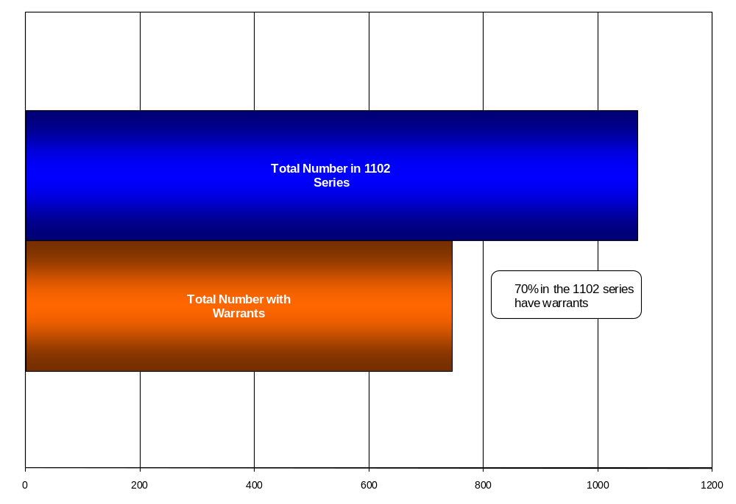
Based on unique Procurement Instrument Identifier (PIIDs), individuals in the 1102 and 1105 series handled an average of about 50 actions per Contracting Officer in FY 2009.
Although the number of individuals in the GS 1105 series has increased since FY 2005, we do not project a commensurate increase over the next 5 years department-wide. Several of the HHS OPDIVs continue to have a need for individuals in the GS 1105 series, due to the organization, i.e., offices that engage solely or primarily in simplified actions. However, our projections indicate a decrease in the need for GS 1105s as much of the purchasing activity has been displaced by the use of the purchase card or ordering against established instruments. It should be noted that this decrease will come as individuals retire and are not replaced. The GS 1105 series is not generally a source for Contract Specialists as these individuals may not be able to meet the qualification standards, i.e., they are not a fungible resource. We also believe that entry level Contract Specialists should be exposed to simplified methods as part of their career path rather than hiring individuals in a capped series. The next section of the AHCP shows the projections for simplified acquisition obligations and the number of individuals in the GS 1105 series.
We also have not included GS 1106s in our staffing projections. The number of individuals in this series has diminished over time, especially with increased use of automation. Further, these individuals serve in an administrative support capacity and, therefore, are not responsible for a discrete portfolio of work.
For FY 2012, we project the need for 65 additional positions in the contracting series. This would represent about an 11 percent increase over our FY 2009 combined total of GS 1102s and GS 1105s. GS 1102 positions would be allocated primarily to entry- and mid-level positions. Based on the above, additional positions (versus hiring as a result of attrition) for FYs 2013 through 2014 would require an increase of about 4 percent per year over the prior year, with an overall increase from FY 2009 to FY 2014 of between 13 (of the combined total of GS 1102s and 1105s) and 20 percent (GS 1102 only) if staffing is to align with projected obligations. The trend analysis that supports these numbers is shown in the next section of this plan.

Contracting Officers’ Technical Representatives
As of the end of FY 2009, we had approximately 6,000 COTRs. We project the need for an additional 1,000⁺ by FY 2014—an increase of just under 20 percent. The trend analysis that supports these numbers is shown in the next section of this plan.
This number needs to be qualified by the fact that, even though our number of actions shows a decrease in the out-years, we need to have a trained and ready cadre of COTRs that can be assigned to projects as needed, whether as the result of reassignment, attrition, extended leave, new programs, or other factors. Capability is discussed in the next subsection of the business case. Also, given the size and complexity of some projects and the fact that COTR responsibilities often are auxiliary responsibilities, there may be dual assignment of co-COTRs. It also needs to be recognized that, because of the nature of COTR designation and duties, the additional COTRs may come not only from new hires but also from internal reassignment.

Project and Program Managers
If we use a similar projection methodology for PMs, we also would expect a need for about a 20 percent increase from 980 in FY 2009 to 1,163 in FY 2014 (see the trend analysis in the next section of this AHCP). However, we recognize that this methodology does not fit the definition and function of a PM, i.e., there is not necessarily a linear relationship between dollars and the number of PMs nor between the number of actions and the number of PMs. PMs may be responsible for one contract or multiple contracts that comprise all or part of a program. Given that (1) project management is receiving increasing attention at HHS, through the use of techniques such as enterprise performance life cycle (EPLC) and earned value management, and (2) we are viewing major investments as broader than activities that require an OMB Exhibit 300, we believe our own business processes will drive a need for more PMs and, therefore, the need to ensure that those individuals are qualified. This aspect of the PM workforce is discussed below and in the remainder of this plan in relation to workforce “capability.”

Increasing Capability

Training
The other part of acquisition workforce planning addressed in the October 27, 2009 OMB memorandum is capability. Generally, when we discuss capability we think of increasing individual capabilities. Training is a large part of our plan. We have seen increases in training dollars requested and applied as we seek to have our existing workforce achieve the pertinent FAC program prerequisites. We should keep in mind that training of those staff is not a one-time activity, as well as recognize the need to train an influx of new staff or newly assigned staff. One of the challenges we describe in the last section of this plan (section V) is the training needs that will occur beginning in FY 2012. With the entire Federal civilian acquisition community looking at “upsizing” at a 5 percent rate, we cannot assume that many of our new hires in the contracting series will have an in-depth background in Federal acquisition.
Using the FY 2009 average training expenditure per person of about $540 and projecting that amount to the total acquisition workforce (current plus projected, as described above), we would need $6.0M for training in FY 2012, with an increase to $6.3M in FY 2014 (which includes an inflation factor of 1.9 percent). Of the estimated aggregate amount spent in FY 2009 on acquisition workforce training, 72 percent of the total was spent on COTR training, 15 percent on contracting workforce training, and the remaining 13 percent on PM training. However, we assume that we will need to devote at least $1,500 a year per person, i.e., an average increase of at $1,000 per person, for the additional 199 GS 1102 positions (projected through FY 2014) to train those individuals for FAC-C certification. Similarly, for COTRs, because we plan to look at a multi-tiered approach to certification (see section V of this plan), we anticipate the need for additional funding for training for both the existing and projected COTR workforce. In total for the acquisition workforce, we anticipate the need for an additional $500,000-750,000 per year for each fiscal year through FY 2014 above our straight-line projections.

Other Capacity-Building Activities
In addition to training, we believe there are other capability-building activities that will enhance HHS’ acquisition performance. Chief among these are simplifying processes; issuing additional policy and guidance when necessary; using automation to make the job simpler, e.g., through web-based reference materials; developing meaningful performance metrics and the ability to oversee their achievement—all of which will help HHS’ management and staff make more well-informed decisions. All of these activities will take resources. These types of activities can be carried out only by the dedication of human resources from planning through implementation and evaluation. We expect that an increase in the number of positions will help in this regard, supplemented, as necessary, by contract support for short-term or specialized needs.

III. Projections for Acquisition Workforce Growth and Supporting Methodology
In this section of the AHCP, we provide the graphic depiction of our projected workforce needs and required training dollars based on total projected obligations for the period 2010 through 2014 and explain our data methodology. We also show trends in the number of actions for purposes of comparison and indicate the effect of newly awarded contracts on subsequent-year contract administration. We note, however, that looking at output in terms of obligations or actions does not take into account quality or increased demands that have been placed on acquisition staff.

Projected Increases in the Acquisition Workforce
The following figures provide the detail concerning the increased staffing needs outlined in the preceding business case. We used a 5-year “look back” as the basis for our projections. Accompanying salary costs were derived by using the following assumptions concerning average grade level: 1102 = GS-12, step 5; 1105 = GS-7, step 5; COTRs = GS 13, step 1, and PMs = GS 14, step 1.

Trends and Projections Based on Obligations
The following figures show the trend analysis for acquisition workforce requirements based on obligations. For each function, we show the numbers for the previous 5 years and the period FY 2010 through FY 2014.
Figure 6. Projected Need for GS 1102s Based on Obligations – FY 2010-FY 2014
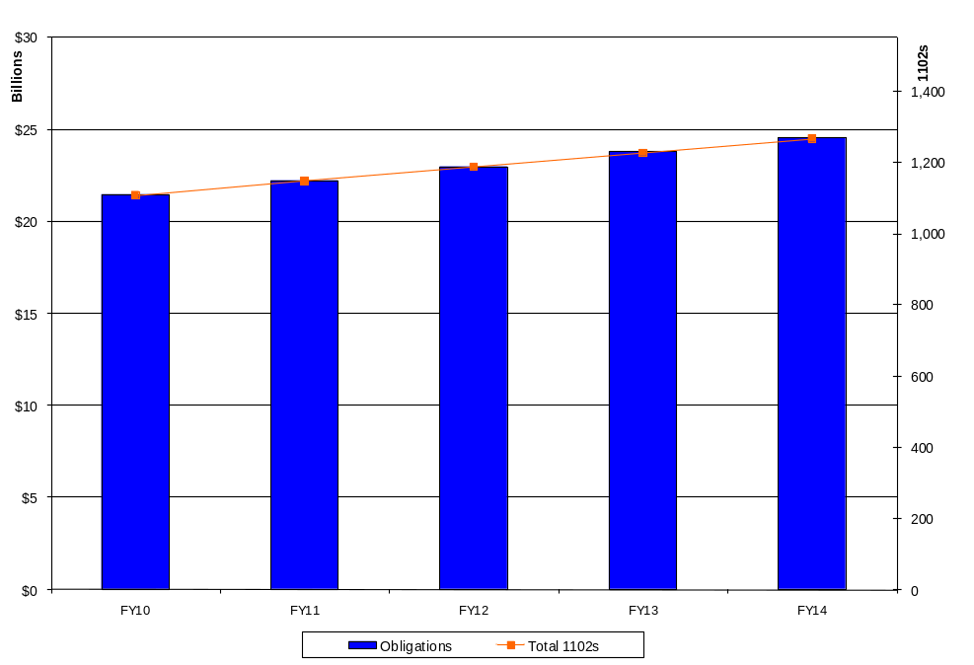
Figure 7. GS 1102s and Obligations – FY 2005 - FY 2009
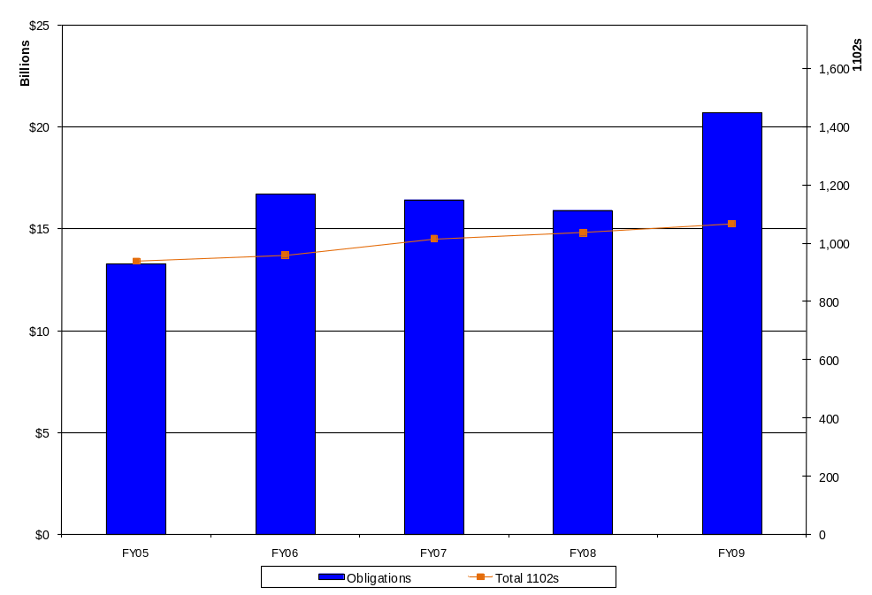
Source: FPDS-NG and HHS’ Human Resources Database
Figure 8. Projected Needs for COTRs Based on Obligations - FY 2010 – FY 2014
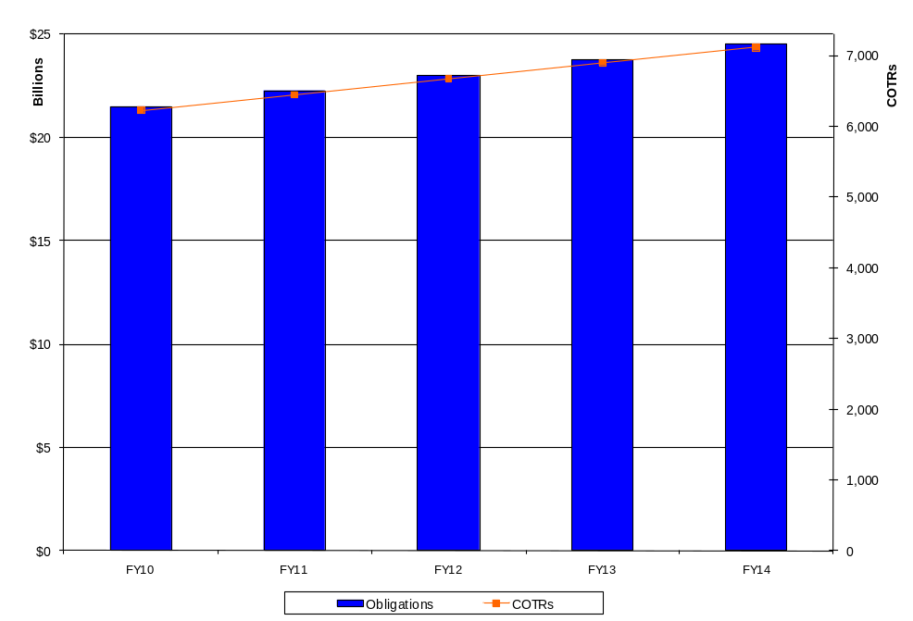

Figure 9. COTRs and Obligations – FY 2005 - FY 2009
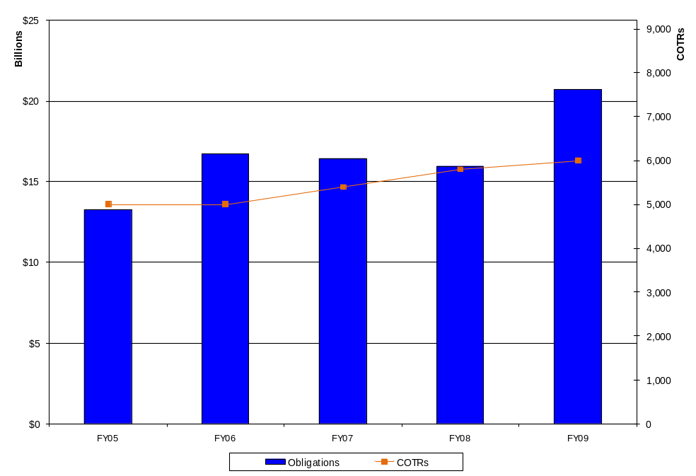
Source: FPDS-NG and HHS’ HCA Survey
Figure 10. Projected Needs for PMs Based on Obligations - FY 2010-FY 2014
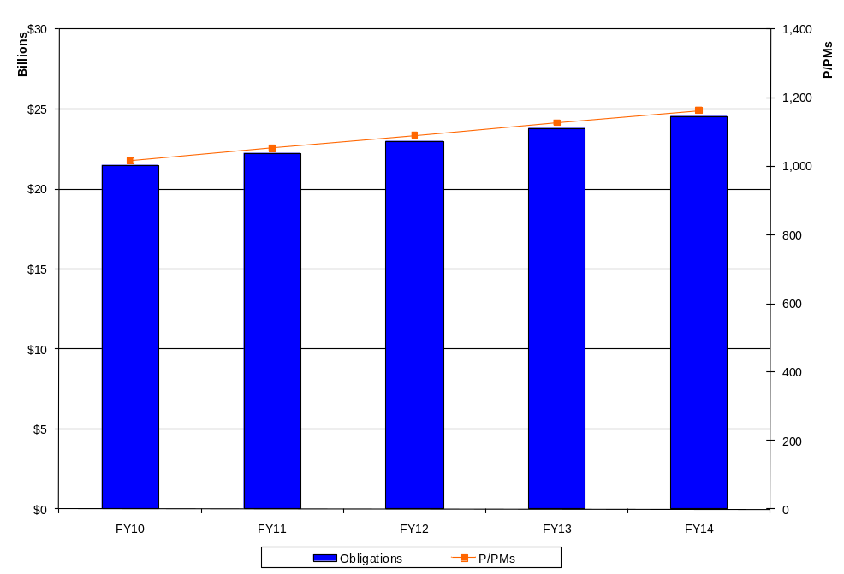

Figure 11. PMs and Obligations – FY 2005 - FY 2009
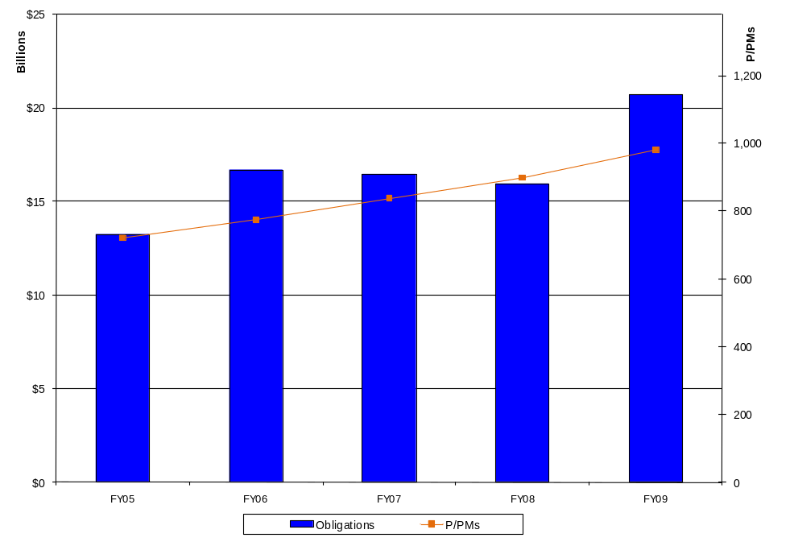
Source: FPDS-NG and HHS’ HCA Survey

Trends and Projections Based on Actions
Figures 12 and 13 show the trend analysis for number of actions.
Figure 12. HHS’ Projected Actions - FY 2010 - FY 2014
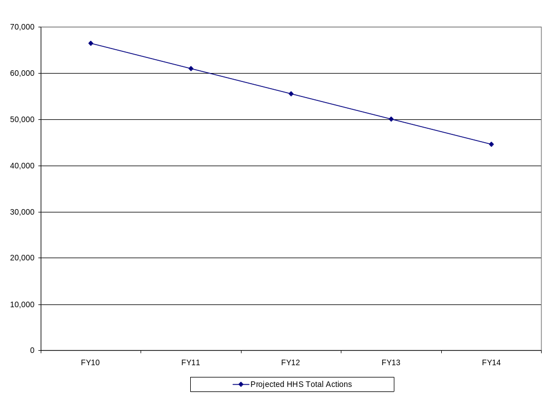
Figure 13. HHS’ Actions – FY 2005 - FY 2009
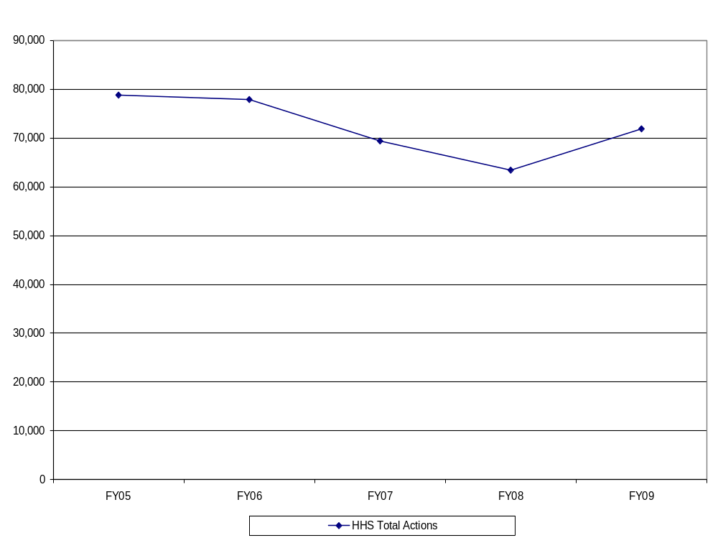
Source: FPDS-NG

Simplified Acquisitions
Simplified acquisitions represent a significant part of our volume of actions. While they are included in the overall experience and projection figures above, we show them separately in Tables 1 and 2 in order to indicate their relationship to our overall portfolio. While the number of simplified actions continues to represent a major part of our portfolio, the proportion has been dropping. We would expect the projected reduction in the number of actions would result in a further decrease in the number of simplified acquisitions. From the contracting workforce standpoint, since simplified acquisitions have become more complex, despite their name, we believe that this is fertile ground for entry-level Contract Specialists and, hence, would not expect to be hiring GS 1105s in proportion to the magnitude of these actions in our portfolio.
Table 1. Simplified Acquisitions as Part of the HHS Portfolio - Actions
 | Simplified Acquisition Actions - Number
 | FY 2005 | FY 2006 | FY 2007 | FY 2008 | FY 2009
Simplified Acquisition Actions | 68,214 | 65,648 | 55,853 | 45,774 | 51,398
Total Actions | 77,103 | 75,794 | 67,657 | 60,585 | 69,674
Percentage of Simplified Acquisitions | 88.47 | 86.61 | 82.55 | 75.55 | 73.77

Table 2. Simplified Acquisitions as Part of the HHS Portfolio - Obligations
 | Simplified Acquisitions - Obligations (in billions)
 | FY 2005 | FY 2006 | FY 2007 | FY 2008 | FY 2009
Simplified Acquisitions | $0.82 | $0.77 | $0.73 | $0.74 | $0.86
Total Obligations | $10.97 | $13.99 | $14.31 | $13.37 | $19.38
Percentage of Simplified Acquisitions | 7.47 | 5.48 | 5.13 | 5.54 | 4.45

Post-Award Administration Workload
Many HHS contracts have performance periods that extend beyond the year of award. To depict the workload associated with these contracts that may not be captured through reportable contract actions in succeeding years, we use the concept of a “moving average,” i.e., initial awards made in one year have a contract administration workload for the duration of the performance period, whether or not accompanied by contract actions. Using our adjusted FY 2009 baseline, Figure 14 shows that, while actions related to FY 2009 awards with a 5-year period of performance may decrease over time, the post-award administration workload does not decrease in as linear of a fashion.
Figure 14. Notional View of Contract Administration Workload
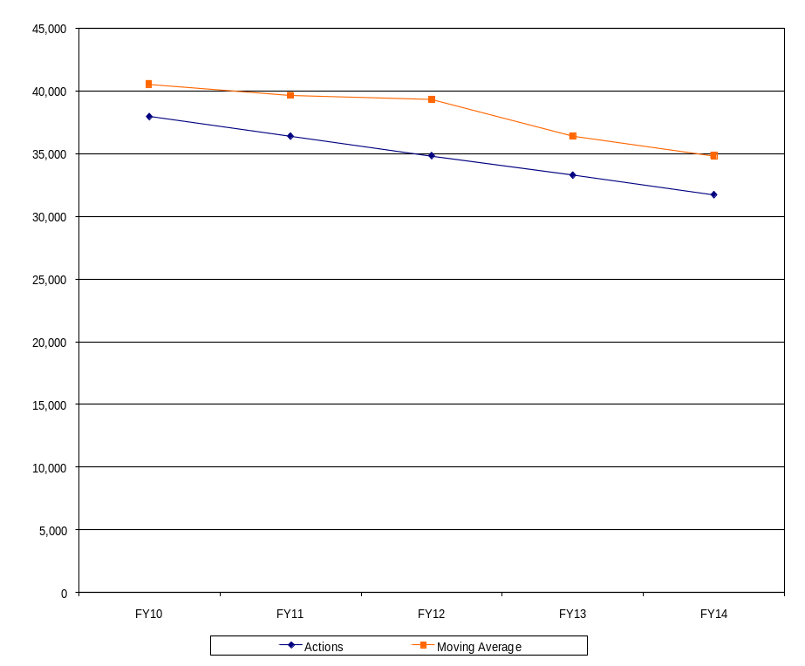

Data Methodology for Determining Obligations and Actions
Notwithstanding that the description of our data methodology below may be difficult to follow for the non-statisticians among us, we felt that it would serve a useful purpose to document the statistically-reliable approach HHS adopted to develop its AHCP. It will also help to shape and inform future updates to our AHCP.
The data we used to generate the projections in the preceding figures were the FPDS-NG data on HHS’ obligations and contract actions for FYs 2005 through 2009. Since FPDS-NG does not include some of the workload that HHS contracting offices perform, e.g., non-procurement contracts awarded by the Indian Health Service and contracts awarded using non-appropriated funds, we adjusted the FPDS-NG data by adding the data for those awards. We excluded FY 2009 obligations of Recovery Act funds; however, no similar adjustment was made for the remaining Recovery Act obligations for FY 2010. It was considered unnecessary given the linear projection from FY 2009. Adjustments to the data were made for the applicable fiscal years. Some were adjusted for each year; others were adjusted for only some of these 5 fiscal years

Regression Methodology and Results
The methodology used to generate the projections was ordinary least squares regression. The assumption underlying this methodology is that future changes in dollar obligations and contract actions will resemble past changes in dollar obligations and contract actions. We also assume that dollar obligations and contract actions can be expressed in terms of a linear relationship. An R-squared of 84 percent indicates that the model used for the projections matches the FY 2005 through FY 2009 obligation data very well. Specifically, 84 percent of the variability in the FY 2005 through FY 2009 obligations is captured by the model.
In those cases where past data has indicated that these assumptions are unwarranted, multiple regression allows an adjustment for discontinuities in the data. We found FY 2009 to be such a discontinuity. FY 2009 saw a sharp increase over FY 2005 through FY 2008 in both HHS’ dollar obligations and contract actions. As a consequence, we adjusted our regression model to account for this discontinuity and made the assumption that future changes from the FY 2009 baseline would resemble the trend from FY 2005 through FY 2008. In part that discontinuity resulted from Recovery Act obligations and actions; the remainder may have been due to H1N1 and similar activities. Therefore, because we cannot project at this juncture whether FY 2010 will grow at the same rate as FY 2009, we used conservative assumptions to generate projections for dollar obligations and contract actions through
FY 2014. As health care reform, Open Government, and other initiatives develop, we will revisit these assumptions.

Output for HHS’ Dollar Obligations
SUMMARY OUTPUT
Regression Statistics
R Square | 0.841587155
Standard Error | 1500277011
Observations | 5

 | Coefficients | Standard Error | t Stat | P-value
Intercept | -1.53497E+12 | 1.34625E+12 | -1.140180821 | 0.372352285
Fiscal Year | 772764508.5 | 670944276.3 | 1.151756615 | 0.368513421
2009 Discontinuity | 3182992579 | 2372146238 | 1.341819711 | 0.311704494

Output for HHS’ Total Contract Actions
SUMMARY OUTPUT
Regression Statistics
R Square | 0.928556262
Standard Error | 2396.850465
Observations | 5

 | Coefficients | Standard Error | t Stat | P-value
Intercept | 11031310.3 | 2150775.939 | 5.128990938 | 0.035974601
Fiscal Year | -5461.7 | 1071.904114 | -5.095325158 | 0.036425808
2009 Discontinuity | 13177 | 3789.75334 | 3.477007293 | 0.07368951

Projecting Future Staffing Needs
In order to project future acquisition and program staffing needs, we assumed that the ratio of staff to dollar obligations would be constant from FY 2009 through FY 2014. In order to account for inflation, we adjusted the dollar obligations from FY 2005 through FY 2008 so that they were expressed in terms of constant 2009 dollars. We also assumed that staff in
FY 2010 through FY 2014 would be as productive as they were in FY 2009. Using these assumptions, we generated staffing needs based on the projected obligations.

Training Budget Projections
In order to estimate our training budget for acquisition and program staff from FY 2010 through FY 2014, we took the FY 2009 training budget and adjusted it for projected staff numbers and current estimates of future inflation. For annual updates to our AHCP, we will revisit the Administration’s most current economic assumptions regarding inflation on a yearly basis.

IV. HHS’ Acquisition Workforce: Accomplishments

Acquisition Workforce Human Capital Succession Plan
In support of the acquisition workforce goals of Section 855 of the National Defense Authorization Act (NDAA) of 2008, Section 869 of the National Defense Authorization Act of 2009, and OFPP’s and the Federal Acquisition Institute’s (FAI) initiative to strengthen the recruitment, retention, and development of Contracting Officers, COTRs and PMs, HHS prepared an Acquisition Workforce Human Capital Succession Plan for Calendar Year 2009. That plan was a high-level blueprint encompassing effective training needs assessments and leadership development for HHS’ acquisition workforce.
The Acquisition Workforce Human Capital Succession Plan targeted HHS’—
- future acquisition workforce needs,
- recruitment goals for Federal intern programs,
- acquisition workforce training goals,
- retention of high-performing acquisition professionals, and
- challenges in using existing hiring authorities and programs.
In that plan, HHS recognizes that one of the greatest challenges we face in managing our acquisition workforce is having fundamental tools to make sure the right people with the right skills are in the right jobs. The target areas addressed in that plan require HHS to take a global look at the skills, competencies, and performance metrics needed for acquisition professionals—in our current and future workforce.
HHS will link those objectives to HHS’ AHCP, which will guide the growth in capacity and capability of HHS’ acquisition workforce through FY 2014. HHS views these plans as strategic roadmaps to build and maintain a professional, flexible, and results-oriented acquisition workforce. This includes—
- ongoing assessment to identify any needed adjustments to the scope and composition of HHS’ acquisition workforce, organizational and individual proficiency levels, and the baseline against which change can be measured;
- actions to timely assess and fulfill training needs; provide leadership and other development opportunities, and establish incentives; and
- other activities aimed at identifying and obtaining required resources.
Accordingly, HHS has begun to focus on the following:
- Recruitment and budgetary strategies.
- Workforce retention by rewarding performance and creating mentor and coaching programs that foster harmonious work environments.
- Tailored acquisition training and development.
- Business strategies that comply with human capital initiatives.
- Improvements to contract writing/information management systems (e.g., PRISM, Departmental Contracts Information System, iProcurement) to streamline contracting and automated tracking processes.
- Change management.
Our accomplishments in these areas are discussed in this section; our goals, strategies, priorities, and challenges are discussed in the final section of this plan.

Acquisition Workforce Development: Training and Certification
An objective of the FAC programs is to provide members of the acquisition workforce with standardized training that will prepare them to meet the challenges and changes ahead and become the Federal government’s business leaders. The certification programs also facilitate the career development of the acquisition workforce through assessment of employee skills, implementation of individual development plans (covering competency-based training supplemented by on-the-job training), and adherence to minimum standards of education, training, and experience. HHS and its OPDIVs use these certification programs as an opportunity to provide visibility to the wide-ranging nature and importance of HHS’ acquisition workforce. We also use them as a means to communicate with those communities concerning their training and development needs.
Our approach to training and certification of contracting staff has a longstanding history in HHS. HHS has had a successful acquisition training program since the early 1970s. In 1977, the HHS Acquisition Certification Program was established and linked to the HHS Acquisition Training Program. In 1990, the HHS Acquisition Career Development Program was launched, which established four levels of certification. This program was in place until
FY 2001, when HHS changed its acquisition training course curricula to mirror that offered by many of the civilian agencies, while teaching the competencies in the former “Contract Specialist’s Training Blueprints.” Many of these courses were reviewed by the American Council on Education (ACE) and contained recommendations for college-level credit.
HHS’ courses for contracting staff have evolved over the years as a result of several OFPP policy letters and the alignment of civilian agency acquisition training courses with those of the Department of Defense (DoD). The most recent policies include OFPP Policy Letter 05-01, “Developing and Managing the Acquisition Workforce,” dated April 15, 2005, and further guidance issued under the OMB memorandum, dated January 20, 2006, which established the framework for the FAC-C program for civilian agencies. HHS successfully transitioned its prior program, with four levels of certification, to the three levels under the new FAC-C program. The FAC-C courses integrate the core contracting competencies, with business and technical subcategories, developed by FAI in partnership with OFPP. By meeting the experience, education, and training requirements for each of the three levels of the FAC-C program, a Contract Specialist will meet the prerequisites to become a warranted Contracting Officer should there be an organizational need.
In addition to the courses prescribed for the three levels of FAC-C certification, HHS established a separate and unique Simplified Acquisition Certification (SAC) program for GS 1105s or individuals interested in obtaining contracting authority at or below the simplified acquisition threshold as defined in FAR Part 2.101. The SAC program consists of two levels: SAC-A, and SAC-B. The rationale behind establishment of the SAC-A and SAC-B was that many GS 1105s do not meet the educational requirements that would allow them to be classified as GS 1102s. Before being allowed to independently conduct simplified acquisitions up through the simplified acquisition threshold, personnel must first obtain an HHS Simplified Acquisition Certificate, which is issued at the OPDIV level. In addition, there are certain aspects of simplified acquisitions that vary from other contracts.
Minimum training, experience, and performance requirements for HHS’ SAC-A are:
- Training – Basic Simplified Acquisition Procedures or Defense Acquisition University’s CON 237, “Simplified Acquisition Procedures “ (CON 237 on line) and Advanced Simplified Acquisition Procedures or Appropriations Law.
- Experience – 6 months of hands-on experience in simplified acquisition. Such experience may be from either the public or private sector.
- Performance rating – Satisfactory performance rating for most recently completed performance period from HHS or previous workplace.
Minimum training, experience, and performance requirements for HHS’ SAC-B are:
- Training – Basic Simplified Acquisition Procedures or DAU’s CON 237 and Advanced Simplified Acquisition Procedures or Appropriations Law, CON 100, CON 110.
- Experience – One year of experience in simplified acquisition, 6 months of which must be hands-on experience in simplified acquisition. Such experience may be from either the public or private sector.
- Performance rating – Satisfactory performance rating for most recently completed performance period from HHS or previous workplace.
The body of knowledge to be a COTR or PM, while addressed through training, did not have a comparable certification program. We have successfully implemented the FAC-COTR and the FAC-P/PM programs and continue to work toward certification of the entire HHS acquisition workforce, including those who handle our simplified acquisitions, as discussed below. We also believe that there should be multiple levels of FAC-COTR certification similar to both the FAC-C and FAC-P/PM programs.

Competency Gaps
Driven by the FAC-C, FAC-COTR, and FAC-P/PM programs, HHS has laid the foundation for developing, implementing, and refining acquisition training programs (covering instructor-led, on the job, and on-line training) to help close identified competency gaps. In an effort to identify competency gaps, HHS has participated in the annual government-wide Acquisition Workforce Competency Surveys, sponsored by OFPP and FAI, which were intended to establish a baseline of competencies for the acquisition workforce and to determine areas where resources should be concentrated to improve or maintain essential contracting skills. In addition, HHS recently administered (March 2010) an HHS-developed Acquisition Workforce Training Survey, which was sent to HHS’ entire acquisition workforce, to gauge current competencies and training needs. HHS’ acquisition workforce competency gaps have been identified for each of the FAC programs as follows. Some of these are gaps that have previously been identified; however, this recent survey represents the most comprehensive assessment of our acquisition workforce.
The three most significant competency gaps identified for each function are shown below.
Table 3. Competency Gaps – March 2010
Federal Acquisition  Certification Program | 1 | 2 | 3
Contracting | Performance-Based Acquisition | Dispute Resolution and Termination | Bid Evaluation
Contracting Officer’s Technical Representation | Defining Government Requirements in Commercial and Non-Commercial Terms | Market Research | Effective Pre-Award Communication
Program and  Project Manager | Capital Planning and Investment  Assessment | Legal Government and Jurisprudence | Cost-Benefit Analysis
Source: HHS’ Acquisition Workforce Training Survey, March 2010
The survey also revealed that, for all three functions, individuals feel that they have the necessary personal and interpersonal skills to effectively carry out their responsibilities,
e.g., customer service, teamwork, flexibility, oral and written communication, problem solving, and decision making. Competency gaps are addressed further in Appendix E to this AHCP.

Addressing Competency Gaps through Training and Other Means
The Office of Grants and Acquisition Policy and Accountability (OGAPA), Division of Acquisition (DA), continues to partner with HHS University to target competency gaps, and develop acquisition training initiatives to address contract compliance/internal controls and required soft skills for the HHS acquisition workforce. As part of the implementation of the FAC-COTR, FAC-C and FAC-P/PM programs, HHS’ goal is to develop and refine its training programs to help close the identified competency gaps. In addition, HHS is considering or has implemented specialized training in areas such as cost realism, independent government cost estimates, small business requirements, intellectual property, appropriations law, information security and Privacy Act, and Section 508 compliance. For example, HHS requires its contracting professionals to take training in earned value management, performance-based acquisition, Federal appropriations law, green purchasing, and Section 508 compliance. The requirement for HHS’ Contract Specialists and Contracting Officers to take these courses recognizes the need to close skill gaps (determined by senior management) in these areas.
While HHS seeks to close identified competency gaps through training, whether classroom or web-based, and whether HHS-developed or commercially sponsored, we believe there are other equally effective ways of enhancing workforce knowledge and skills. HHS is moving forward with various initiatives, such as: fostering community of practice websites; improving knowledge management through use of decision trees and electronic desk references; developing guidance materials, e.g., a market research guide; and conducting a department-wide acquisition symposium. Additionally, HHS will continue to benchmark with internal and external stakeholders and identify best practices, through venues such as:
- HHS’ Executive Committee for Acquisition (ECA) (described in Appendix A to the AHCP)
- OFPP’s COTR and PM Functional Advisory Boards
- OFPP’s Chief Acquisition Officers Council (CAOC)
- FAI’s Interagency for Acquisition Career Management Council (IACMC)
- OMB’s Chief Human Capital Officer (CHCO) Council

Career Development
With a growing need for a strong and well-trained acquisition workforce, career development for current and future employees stands at the forefront of HHS’ initiatives. In addition to training and certification, HHS has initiatives such as mentoring, leadership development, and intern programs to help the acquisition workforce obtain the necessary skills and training to accomplish its mission. By preparing suitable employees to fill vacant key positions through mentoring and job rotations, HHS expects to be able to prevent a “knowledge gap.”
Based on HHS’ March 2010 Acquisition Workforce Training Survey, HHS’ acquisition workforce, categorized by function, expressed interest in the career development opportunities specified in Table 4. Figure 15 shows additional detail for COTRs.
Table 4. Preferred Career Development Opportunities
Federal  Acquisition  Certification  Program | 1 | 2 | 3
Contracting | Individual  Development | Mentor/Coaching | Succession  Planning Programs
Contracting  Officer’s Technical Representation | Individual  Development | Mentor/Coaching | Rotations
Program and  Project Manager | Individual  Development | Mentor/Coaching | Succession  Planning Programs
Source: HHS’ Acquisition Workforce Training Survey, March 2010
Figure 15. COTR Preferences on Career Development Opportunities
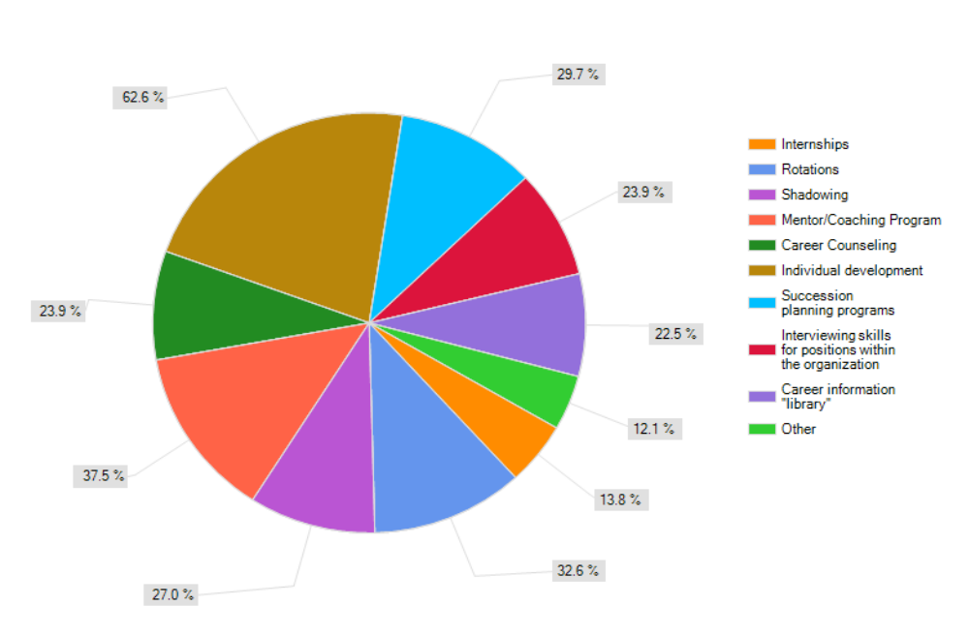
Consistent with these priorities, HHS has begun several initiatives to address career development needs.

Rotation Program
We have developed a blueprint for an acquisition-based rotation program. The program will enhance career development opportunities by providing members of the acquisition workforce with job rotations. The rotation program will consist of details or assignments in an HHS office other than the employee’s own and the assignments will not exceed 12 months. The rotations are linked with the career development planning process so that the employee understands the developmental needs addressed by each rotational assignment. Both job-related and developmental-related objectives are defined jointly by the employee and the supervisor whenever the employee assumes a new assignment or position. The program will include three types of rotational assignments: full-time, part-time, and virtual.
HHS’ goal is for its rotational program to produce the following benefits:
- Increase networking and career growth opportunities.
- Increase team building/cooperation.
- Assist program personnel in more fully understanding the Government contracting process.
- Assist contracting personnel in understanding how program offices operate.
- Enhance job competencies/experience and delivery of on-the-job training.
- Encourage employees to benchmark with other offices to adopt and tailor best practices.
- Increase variety and challenges that come from new projects or new assignments.
- Benefit the host organization by completing projects and providing quality services.

Mentoring Program
On January 29, 2009, HHS University launched a department-wide Mentoring Program. Through participation in the HHS Mentoring Program, protégés can actively chart their professional paths by networking with experienced mentors across OPDIVs to share knowledge, skills, experiences, tools, and best practices. The program highlights include—
- senior-to-junior and peer-to-peer mentoring platforms,
- on-line application and matching system,
- mentor/protégé orientation, and
- training and networking events
With dedicated funding, HHS plans to incorporate an acquisition track in the mentoring program to address the specialized needs of our contracting workforce.

Recruitment and Retention
With respect to adding to or replacing our current workforce, HHS has made great strides in integrating Direct-Hire with Quick-Hire and streamlining the overall Direct-Hire process, although we still face challenges as described in the final section of this plan. HHS has issued a policy governing the use of Rehired Annuitants; however, more work needs to be done to develop a practical strategy to make full use of that authority.
We are using a variety of tools and techniques to attract and retain a diverse acquisition workforce that can serve HHS’ needs now and into the future. Foremost, we are fostering an environment in which the acquisition workforce feels that (1) they are valued members of the overall HHS workforce in terms of accomplishing the HHS mission and (2) their valued opinions are sought and acted on. These tools and techniques also include: reasonable compensation, promotional opportunities, bonuses and other incentives, challenging and varied assignments, improved physical working environment and quality of work life, and full implementation of the telework policy.

Acquisition Integration and Modernization Initiative
Overlaying our efforts to improve the capacity and capability of the acquisition workforce is the HHS Acquisition Integration and Modernization (AIM) initiative. Our AIM initiative was developed to drive acquisition management improvements, ensure improved effectiveness and efficiency, and establish quality program goals and performance improvement plans across the Department. HHS has had this “umbrella” initiative in place for close to 7 years. The AIM initiative has resulted in a number of achievements to standardize and streamline acquisition processes and systems. While such initiatives usually are not cited as enhancing career development or retention, we believe that consistency in processes across HHS does much to free up staff to perform substantive work and facilitates movement of staff among the HHS OPDIVs, thus helping to retain individuals in whom we have made an investment as HHS employees.
Our AIM initiative also encompasses a number of performance and quality aspects—some of which initially predated AIM—that help us judge how well our organizational components—and, thus, those who carry out the work—are doing. These indicators and metrics help us to gauge needed areas of emphasis and training, in addition to those that are self-identified through competency surveys. Among these efforts are
- Procurement Management Review (PMR) program—HHS has a PMR program that uses a customized version of the Government Accountability Office’s “Framework for Assessing the Acquisition Function at Federal Agencies.” Because the framework includes as one its four cornerstones, Human Capital, we will be able to assess the interplay among our acquisition workforce goals and objectives, their implementation at the awarding activity level, and their effect on acquisition outcomes.
- Acquisition dashboard—HHS has an acquisition dashboard in place that allows quarterly assessment of OPDIV progress against specified measures. The dashboard is sufficiently flexible to allow the measures to represent current initiatives. For example, we have used it to measure: use of strategic sourcing, reduction in closeout backlogs, and progress toward certification. We plan to use the Acquisition Dashboard as one means of developing workforce management metrics and evaluating performance against them.
- Acquisition Balanced Scorecard (BSC)—For many years, HHS has used a series of surveys linked to the BSC perspectives, including vulnerability indices derived therefrom, to determine how contracting staff, Project Officers/COTRs, and vendors view the efficiency and effectiveness of the HHS acquisition process. The results of those surveys have been used to drive process and other improvements. The Acquisition BSC also will be a means for us to develop more refined measures of the effectiveness of our acquisition workforce development and retention strategies.

V. HHS’ Acquisition Workforce: Improvement Goals, Strategies, Priorities, and Challenges
Through the convergence of HHS’ recognition of the need to improve the acquisition process, Administration initiatives, and mission-related needs of HHS, we now have both the imperative and the opportunity to strengthen our current acquisition workforce and plan for the future needs of our acquisition workforce—both current and future hires. With additional resources, necessary visibility and management attention, and change management strategies, we believe that we can establish meaningful and attainable goals in increasing the capacity and capability of the acquisition workforce with payoff for our overall acquisition performance.
We note that a number of the recent statutes that have created new requirements for the acquisition function, e.g. the Federal Funding Accountability and Transparency Act and Section 872 of the National Defense Authorization Act for 2009 (Federal Awardee Performance and Integrity Information System), apply equally to financial assistance. Recognizing that HHS obligates much more of its budget in grants than in contracts—including awards to the same university constituency—and understanding the synergy that can come from joint initiatives, under the leadership of the Deputy Assistant Secretary for Grants and Acquisition Policy and Accountability, we intend to leverage our budgetary resources to make workforce and other improvements that will benefit both business functions. Also, succession planning and other human capital undertakings will not be made in an acquisition stovepipe, but rather considered in relation to their impact on HHS’ grants administration and management.

Acquisition Workforce Improvement Goals
Our acquisition workforce improvement goals are driven both by (1) government-wide initiatives, including acquisition savings goals (which includes increased use of competition and less reliance on riskier contract types) (see Appendix C to this AHCP), continued use and refinement of performance-based acquisition, and improved data quality; and (2) HHS initiatives identified through our PMRs, the Acquisition Dashboard, Acquisition BSC, and other AIM efforts. In other words, our goals are focused on improving the quality of the inputs to the acquisition process—through training, closing competency gaps, certification, and efforts to ensure workforce continuity—and the outcomes—an effective, efficient process that maximizes the benefit of expenditures to HHS and, ultimately, the taxpayers. We recognize the need to make the investment in staff, tools, and techniques and to relate that investment to performance.

Strategies for Recruiting and Retaining a High-performing Workforce
In furtherance of the HHS Senior Procurement Executive’s (SPE) specific priority to recruit and retain a high-quality acquisition workforce as reflected in various documents, including the Acquisition Workforce Human Capital Succession Plan and this AHCP, HHS expects to continue its efforts to—
- build or expand HHS’ acquisition development programs (e.g., intern, rotation, mentor) to support succession planning (e.g., recruit, hire, retain, and train the acquisition workforce);
- develop or refine HHS’ systems to track acquisition workforce metrics
(e.g., educational/certification data), as well as methodologies to project future acquisition workforce needs;
- strengthen and expand HHS’ acquisition career management resources, programs and strategies to ensure a top-notch professional workforce (including contract auditors/price analysts, procurement attorneys) and improve acquisition planning and project execution;
- conduct data-driven analysis to support HHS’ acquisition workforce planning activities; and integrate acquisition workforce planning and analysis into budget and human resource processes; and
- develop a centralized training fund to support unfunded mandates in a timely manner, e.g., areas such as performance-based acquisition, earned value management and the FAC programs, and to close competency gaps.
We plan to use available authorities as well as innovative means to ensure the continuing availability of a high-performing acquisition workforce. HHS’ strategies to recruit and retain high-quality acquisition professionals will run the gamut – from bonuses, time-off, telework and flexible work schedules, and quality step increases to rotational and cross-training assignments, mentoring, developmental/leadership opportunities, and participation in high-visibility government-wide teams.
HHS will need to hire individuals for newly authorized positions and to fill positions based on attrition. While attrition cannot be forecast in its entirety, we recognize the importance of succession planning, especially with respect to our aging workforce (see Appendix D of this AHCP for projections of the number of retirement-eligible individuals in the acquisition workforce functions through FY 2014). Succession planning establishes the foundation and direction for human capital development. It requires dedicated leadership, the commitment of budgetary resources, and technological advancements. With such prerequisites in place, HHS will be able to develop effective strategies for recruiting and retaining high-performing acquisition professionals.
We face differing challenges in recruitment and retention among the different segments of the acquisition workforce. With respect to contracting professionals, the challenge is to identify and pursue approaches that allow us to meet our short-term and longer-term requirements. In the short-term, i.e., through FY 2011, we are making increasing use of interns as a source for the HHS contracting workforce of the future but, in addition, we need to use other sources, such as college career fairs, and flexible hiring authorities as we seek to hire a number of individuals at the same time that our sister civilian agencies and DoD increase their capacity.
In the longer term, we need to focus on retaining the workforce that we have recruited and in whom we have made an investment. We plan to elicit feedback from other Federal agencies concerning optimum career ladders for the acquisition workforce to improve retention. Other beneficial approaches will include strengthening orientation programs for new employees; fostering the use of individual development plans; reinforcing the need for supervisors to provide continuous performance feedback to employees; promoting the use of exit interviews; and considering tuition assistance and student loan repayments (resources permitting).
Meeting the demand for COTRs presents a somewhat different circumstance. To meet the enormous challenges within the COTR arena, HHS needs skilled workers, first-rate managers, and performance evaluation accountability metrics. HHS’ OGAPA-DA is committed to improving the quality of HHS’ COTRs, increasing accountability of COTR performance, and reinforcing the importance of the COTR function. The role of a COTR historically has been viewed as ancillary rather than as a discrete profession. We must ensure that for new hires, at the time of hiring, those that will or may serve as COTRs are fully aware that serving as a COTR may be an integral part of their job function regardless of their job classification or grade.
HHS plans to use operational metrics to measure performance as well as gauge efforts to secure and retain exceptional COTR talent. This approach would build capacity within the COTR workforce by projecting training and developmental needs for future specialization and multi-tiered certification, i.e., our anticipated change to COTR certification to encompass multiple levels for progression similar to the FAC-C and FAC-P/PM programs. To galvanize support for these plans and bring workforce issues to the forefront, the Department is working closely with senior management within headquarters and its OPDIVs.
We also plan to employ strategies that sufficiently differentiate between the functions of a COTR and those of a PM. A PM should not be viewed as a super-COTR. In some cases, seasoned COTRs may be inappropriately assigned to complex projects in the capacity of a Level I or Level II Project/Program Manager. In this vein, it becomes increasingly important to develop and implement a career progression program, which allows COTRs (in a systematic way) to progress to more challenging program management roles. HHS’ COTRs are responsible for co-managing a wide range of simple to complex contracts. Because of this, the Department is exploring the possibility of expanding training and development for this sector of the workforce to include specialized areas and levels within its FAC-COTR program.
Project management is viewed as a bona fide profession, which deserves dedicated attention, certification and training support. HHS follows the basic principles of project and program management. Project management is the discipline of planning, organizing and managing resources to bring about the successful completion of specific project goals and objectives. It is sometimes blended with program management; however, technically a program is actually a higher-level construct: a group of related and interdependent projects. Further, HHS views a project as a temporary endeavor, having a defined beginning and end (usually constrained by cost, schedule, and deliverables), undertaken to meet unique goals and objectives. The temporary nature of projects stands in contrast to operations, which are repetitive, permanent or semi-permanent functional work to produce products or services. In practice, the management of projects versus programs is often found to be quite different, and as such, requires the development of distinct technical skills and the adoption of different management techniques. Effective program management requires achievement of the project goals and objectives within project constraints. Typical constraints are scope, time, and budget. The secondary challenge is to optimize the allocation and integration of project inputs necessary to meet pre-defined objectives.
Well-trained and experienced PMs are critical to HHS’ acquisitions and the successful accomplishment of mission goals. Skilled PMs are instrumental in developing accurate government requirements, defining measurable performance standards, and managing contractor activities to ensure that intended outcomes are achieved. Through aggressive hiring and training, HHS intends to build a cadre of versatile PM professionals. Because of HHS’ unique biomedical missions, program-specific training and development will be critical. HHS also plans to institute creative outreach and cross-pollination efforts to attract experienced COTRs to enter the program management field and become FAC-P/PM certified.
Over the next 5 years, HHS will focus on providing a more tailored and structured approach to support the needs of PMs. HHS will continue to utilize a combination of HHS University, FAI, the Defense Acquisition University, other government entities, and vendors to address competencies and training needs. Pre and post assessments and learning objectives will be used to assess current training or to develop new training.
HHS’ ACMs will continue to collaborate and benchmark with each other to establish prudent career development strategies – carefully constructed to strengthen the PM community. Assessing PMs’ performance during their career progression will help us continuously develop, monitor, and improve basic PM business processes. HHS’ vision is to adopt cutting-edge PM performance practices to strengthen the critical roles PMs play within the acquisition workforce.
A strong partnership between PMs, COTRs, and contracting professionals requires a common understanding of how to meet the government’s needs through acquisitions that deliver quality goods and services in an effective and efficient manner.

Priorities

Filling Competency Gaps
HHS historically has been challenged with insufficient sustained funding for robust implementation of customized acquisition career development programs. Given additional resources, HHS will no longer need to force fit career progression strategies into our prescribed certification programs. By assisting acquisition professionals to navigate through their career progression, HHS will be better positioned to identify and close competency gaps. Aspiring professionals will then be encouraged to strategically pursue their career development with clear direction from their leadership echelons.
HHS will explore additional and more accurate analytical methods to identify competency gaps, such as the use of organizational analysis (which identifies organizational training needs); operations analysis (which identifies training content and competencies); and individual analysis (which determines how well an employee is performing at various developmental points). We need to be continuously assessing competency gaps based on a workforce whose needs change as a result of turnover and new requirements. As a result, HHS will continue to perform customized surveys. In addition to training, gap closure methodologies will include succession planning, knowledge/skills transfer, and performance management. In addition, we will institute supervisory-based competency assessment tools with an emphasis on mission-critical acquisition and program leadership positions. We plan to integrate competency gap analysis and associated training solutions into supervisory assessments at the front lines.

Recruitment
HHS currently plans to hire about 20 procurement interns through participation in the Presidential Management Fellows Program, Federal Career Intern Program, Department of Interior’s Acquisition Intern Program, and HHS’ Emerging Leaders Program. Recruitment strategies will include diversity planning and participation at career fairs. Further, based on deliberations of a cross-functional workgroup, HHS plans to conduct a pilot intern program—under the auspices of the Department of Veterans Affairs’ Acquisition Academy—to recruit the next generation of HHS business leaders. We also plan to develop Direct-Hire announcements to recruit and select top-notch COTR candidates and PMs to professionalize those critical functions.

Career Development
Another HHS priority is to fully implement the rotation program. An initial emphasis is expected to be on the PM area because there is a need for well-trained program managers that will know how to make cost-effective business decisions, keep an investment on schedule, and stay within performance parameters. Within program management, there is a lack of qualified individuals who can, at a moment’s notice, manage the duties of a PM. Therefore, continued attention to education, training and development to improve project and program management skills is a top priority.

Challenges
The most significant challenges we face are being able to fill the additional positions we may be authorized, retain those individuals in whom we make an investment, and use funding increases consistent with our plans and priorities.
HHS will continue to refine relevant processes and procedures to identify its acquisition workforce needs—in terms of overall size, recruitment, retention, and training and development. HHS is faced with recruitment challenges, particularly at entry and mid-levels, for contracting professionals. HHS realizes that the market for contract professionals is increasingly more competitive, even with the downturn in the U.S. and global economies. As we raise our standards to hire the most qualified candidates, the talent pool is shrinking, and agencies battle each other to hire high-performing and experienced acquisition professionals.
Another significant challenge, as we attempt to better align the acquisition workforce with current and future needs, is imposition of unfunded mandates. These mandates can be in the form of required training or may be new requirements that place a drain on available resources. For example, OFPP periodically establishes unfunded training mandates for acquisition professionals for the successful implementation of new and revised mandatory acquisition training. In those cases, HHS must coordinate and deliver a host of formal and “just in time” training to communicate various changes in the acquisition field—through creative training venues, partnership with other Federal agencies, and the use of subject matter experts. In such cases, we must not only meet the mandate but also ensure that we are making the most effective use of our training funds for other needed training.
With respect to broader unfunded mandates, e.g., those that relate to implementing new legislative requirements, as well as Administration initiatives, they must be absorbed within existing staffing and funding both because of time frames that would not generally allow for “staffing up” and the fact that many of these well-intentioned requirements are applied without a full understanding of their human resource and other impacts (e.g., the need for training). The challenge presented by unfunded mandates is not unique to HHS; however, the effects of these mandates, including diverting the acquisition workforce from competing priorities and, in some cases, creating the need for additional resources, should be addressed as part of the government-wide planning process.
In addition, although the expected “tsunami” of retirements among acquisition professionals has not yet materialized – either at HHS or government-wide, the Department plans to take all necessary steps to: ascertain the latest pertinent retirement trends (including relevant ratios between eligibility to retire and actual retirement); and prevent such a crisis by aggressively implementing this AHCP. HHS is committed to being active versus reactive, to properly address this challenge. Also, we plan to work with HHS’ Office of Human Resources to gauge whether HHS’ 1102 retirement trends are better than, in line with, or worse than those of other GS job series – both within the Department and across the government. To do so, we will build on our existing retirement eligibility data -- in Figures 19 and 20 -- under Appendix D of this plan.

Appendix A – HHS’ Organizational Profile and Acquisition Workforce Governance
HHS’ Mission
HHS’ mission is “to enhance the health and well-being of Americans by providing for effective health and human services, and by fostering strong, sustained advances in the sciences underlying medicine, public health, and social services. HHS is the United States government’s principal agency for protecting the health of all Americans and for providing essential human services, especially for those who are least able to help themselves.
HHS’ Organization
HHS consists of 11 OPDIVs—including the Office of the Secretary and its Staff Divisions—which administer the Department’s numerous and varied programs. The HHS OPDIVs are as follows:
- Administration for Children and Families (ACF)
- Administration on Aging (AoA)
- Agency for Healthcare Research and Quality (AHRQ)
- Centers for Disease Control and Prevention (CDC)
- Centers for Medicare & Medicaid Services (CMS)
- Food and Drug Administration (FDA)
- Health Resources and Services Administration (HRSA)
- Indian Health Service (IHS)
- National Institutes of Health (NIH)
- Office of the Secretary (OS)
- Substance Abuse and Mental Health Services Administration (SAMHSA)
Each of these components has a distinct mission ranging from biomedical research and provision of health and social services to training of the health workforce of the future.
Contracting activities are carried out in approximately 70 contracting offices. Although most of these offices are located in the Washington, D.C, metropolitan area, there is a significant level of geographical dispersion. There also are variations in organizational structure and contracting authorities. Several HHS components have a single contracting office while others have multiple contracting offices based on the overall organization and mission. For examples, NIH, which funds both extramural and intramural research, has organized its acquisition function to meet these differing demands; IHS, which provides health services directly to eligible beneficiaries, in a variety of settings (e.g., hospital or clinic or through contracted third parties) and geographical locations has an acquisition organization that is consistent with its mission. HHS also has a contracting office at the Program Support Center that serves as a dedicated contracting office for HHS components with smaller volumes of acquisition activity and as a fee-for-service activity.
This wide-ranging organization—in terms of mission, geographical location, portfolio, and other factors, results in a complex operating environment. HHS is a highly decentralized organization that is working to develop common systems, processes, and oversight mechanisms that can balance the unique aspects of its component organizations with the need for common processes.
All of the above-named organizational components use acquisition as a means of supporting program accomplishment. However, several of them do not have contracting staffs and use a centralized contracting office for their acquisition support.
Governance
HHS has a hierarchy of individuals consistent with its organizational structure that are responsible for setting the strategic, policy and tactical direction for those who serve on the front line of the acquisition process—the acquisition workforce described in section I of this plan. The roles and responsibilities of those individuals who comprise the governance structure and their organizational location are described in the following paragraphs.

Chief Acquisition Officer
Federal agencies must designate a Chief Acquisition Officer (CAO) pursuant to Section 201 of the Services Acquisition Reform Act of 2003. HHS’ CAO is the Assistant Secretary for Financial Resources (ASFR). The ASFR oversees the budgetary, financial, acquisition, grants and Recovery Act activities of the Department.
The HHS CAO’s roles include—
- monitoring HHS’ acquisition activities to foster organizational improvement;
- establishing clear lines of authority, accountability, and responsibility for acquisition decision-making;
- promoting the use of full and open competition; and
- supporting the acquisition career management programs to—
- implement FAC programs; and
- develop strategies and plans for recruitment and retention, training, and career development.

Deputy Assistant Secretary for Grants and Acquisition Policy and Accountability
Among other things, the Deputy Assistant Secretary for Grants and Acquisition Policy and Accountability (DAS/GAPA)—
- serves as the Department’s Suspending and Debarring Official;
- oversees the performance of HHS’ SPE; and
- has the authority to redirect acquisition staff to support the preparation for, and response to, potential or actual emergencies, e.g., terrorist strikes, natural disasters, and epidemics.

Senior Procurement Executive
HHS’ Associate Deputy Assistant Secretary for Acquisition serves as the Department’s SPE. Although organizationally the SPE is under ASFR’s DAS/GAPA, the SPE is afforded direct access to ASFR in ASFR’s capacity as the CAO. The SPE provides oversight and guidance to all levels of the Department on matters related to acquisition management and policy.
To foster improved acquisition outcomes, the SPE has established priorities that include—
- recruiting and retaining a high-quality acquisition workforce;
- measuring acquisition performance in a meaningful way to produce improved results across HHS;
- maintaining a deployable emergency contracting capability;
- consolidating acquisition systems;
- streamlining acquisition processes;
- improving oversight of major acquisition investments;
- increasing small business participation, competition, and strategic sourcing;
- detecting and preventing fraud; and
- ensuring transparency and accountability of the acquisition process.

Heads of Contracting Activity
Each HHS OPDIV with contracting authority has a senior contracting official that serves as the HCA.
The responsibilities of HCAs include the following:
- Exercising specified approval authorities as indicated in the HHS Acquisition Regulation (HHSAR).
- Overseeing contracting office operations.
- Advising the SPE on cross-cutting acquisition policy and procedural matters, through HHS’ ECA—comprised of HCAs, their deputies, staff from OGAPA-DA; and chaired by HHS’ Associate Deputy Assistant Secretary for Acquisition.

Acquisition Career Managers
Because of the size and complexity of its acquisition workforce, HHS has two Departmental Acquisition Career Managers (ACMs), who are responsible for ensuring that the agency complies with OFPP workforce policies and for administering the FAC programs (FAC-C, FAC-COTR, and FAC-P/PM). In addition, consistent with the overall HHS organization, each HCA has appointed an ACM to oversee acquisition workforce issues under the HCA’s cognizance.
HHS’ Departmental ACMs are also responsible for the following:
- Conducting data-driven analysis to support agency planning activities.
- Identifying training requirements and other workforce development strategies.
- Establishing and maintaining acquisition workforce standards, in coordination with OPDIV Executive Officers and ACMs.
- In conjunction with the OPDIVs, estimating and requesting a training budget for the acquisition workforce and supporting training dollars in budget negotiations.
- Setting acquisition workforce standards for recordkeeping, including waivers and certificates of completion for coursework.
- Coordinating with OPDIV-level ACMs to ensure accurate and consistent data is maintained in training-related databases.
- Serving as principal liaison for, and advisor to, OPDIV ACMs for:
- Communicating training opportunities, and
- Communicating Federal mandates related to FAC programs.
- Disseminating relevant workforce information to HHS University, Office of the Chief Information Officer, Office for Facilities Management and Policy, and Office of Human Resources.

Appendix B – HHS’ Strategic Priorities
HHS has made significant strides in improving the lives of Americans through the efforts of every HHS OPDIV. Breakthroughs in health information technology have accelerated the development and adoption of electronic health record standards. Medicare beneficiaries have greater access to required medications because of the Medicare prescription drug benefit. The Medicaid program can tailor benefits to beneficiary needs because its modernization efforts have made the program more flexible and sustainable. HHS deploys medical supplies to help with mass casualty care, e.g., after Hurricanes Katrina and Rita. The Drug Safety Oversight Board provides independent recommendations related to drug safety to the Food and Drug Administration and shares information with health care professionals and patients. HHS’ Compassion Capital Fund strengthens the capacity of grassroots, faith-based, and community organizations to provide a wide range of social services. Advances in the understanding of basic human biology enable sequencing of the human genome.
Although HHS has made great progress in improving health outcomes for all Americans, we must continue our current efforts to sustain positive outcomes and augment them with new, innovative strategies to continue to improve the Nation’s health and well-being. At the same time, HHS must work diligently to address emerging and reemerging health threats. These include a possible influenza pandemic; the rise of drug-resistant strains of tuberculosis and HIV; and potential terrorist attacks involving chemical, biological, radiological, and nuclear agents.
HHS views the acquisition program, and the workforce that accomplishes it, as an important means by which HHS delivers on its strategic mission to improve the Nation’s health and well-being.
Appendix C – HHS’ Acquisition Savings Goals
An overlay of our projected obligations (see Figure 1a of this AHCP) is the amount of acquisition savings for which HHS is being tracked. On November 2, 2009, HHS submitted its Acquisition Savings and Improvement Plan, in response to the July 29, 2009, OMB Memorandum (M-09-25) on Improving Government Acquisition. In contributing to the development of this plan, each OPDIV HCA worked with their budget, program, and executive leadership representatives to: (1) confirm baseline contract spending from which savings were projected and explain any adjustments made to the total FY 2008 contract obligation base; (2) identify opportunities and strategies for achieving savings and estimate potential savings; and (3) identify opportunities to improve acquisition strategies to reduce noncompetitive awards (or those awarded with only one response); and cost-reimbursement, time-and-material, and labor-hour type contracts.
HHS estimates that it may save approximately $323M in FY 2010 and $343M in FY 2011, representing 4 percent from HHS’ adjusted FY 2008 contract baseline of $7.7 B (i.e., adjustments made to the base for those programs or projects that are not susceptible to significant savings). To the degree that savings can actually be documented as having been achieved, we will update projections; however, we also recognize that, even with the potential for savings, greater emphasis on acquisition strategies to increase competition, develop statements of work that are consistent with greater use of fixed-price contracts, and increased use of performance-based acquisitions does not necessarily translate to a reduced workload.

Appendix D – HHS’ Acquisition Workforce Profile
The composition of the HHS acquisition workforce at the end of FY 2009, arrayed by the three component functions, is shown in Figure 16 below. Each segment of the workforce and its distinguishing features is described in subsequent subsections of this Appendix.
Figure 16. Composition of the HHS Acquisition Workforce
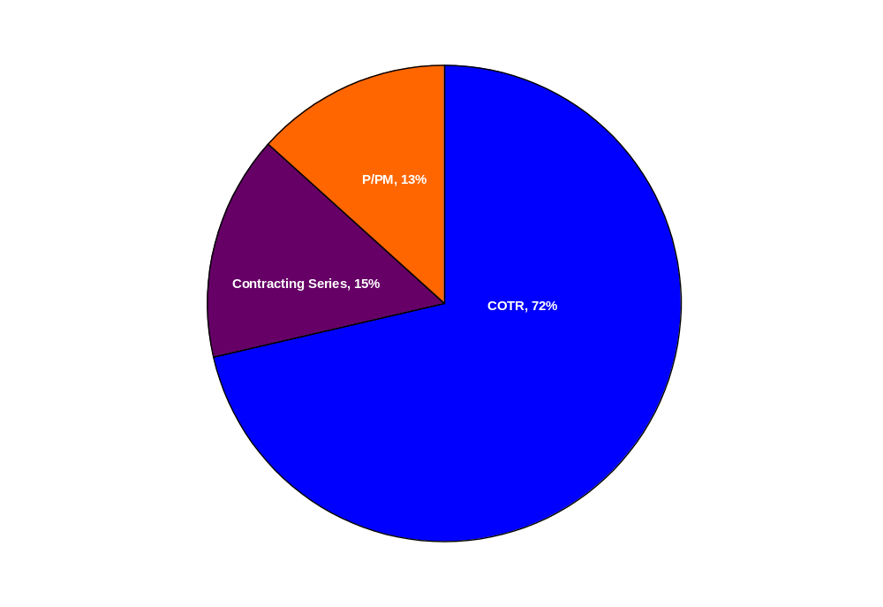
Contract Specialists and Contracting Officers
Contract Specialists generally are individuals in the 1102 series who assist Contracting Officers in those tasks related to the award and administration of contracts that, by the terms of the FAR and HHSAR, are reserved to Contracting Officers. Contract Specialists support Contracting Officers in soliciting, negotiating, awarding, and administering contracts. However, Contracting Officers also are classified as Contract Specialists for personnel purposes. In HHS, most of the GS 1102s are journeyman-level GS-12s. In addition, at HHS, individuals in the 1102 series, under a variety of position titles, may: serve as Procurement Analysts, who provide procedural guidance and oversight for acquisitions; be Cost-Price Analysts; or perform other contracting-related functions. For purposes of workforce analysis, Contract Specialist positions are classified in three categories: entry-level (GS-7-9), mid-level (GS-11-12), and senior-level (GS-13-15). Figure 17 shows the breakdown of the 1,068 individuals in the 1102 series at the end of FY 2009 by these three categories.
Figure 17. Allocation of GS 1102 Workforce by Level
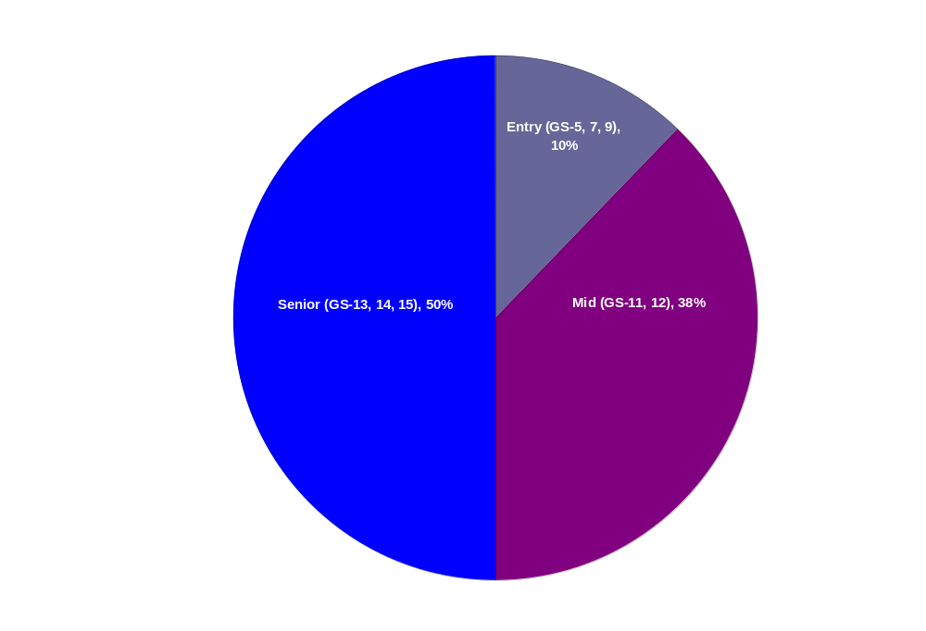
Source: HHS’ Human Resources Database
As of the end of FY 2009, HHS’ staff in the GS 1105 series were allocated as follows:
GS-4-6 = 48; GS 7-8 = 211; GS 9-11 = 72; HHS’ staff in the 1106 series were allocated as follows: GS 4 = 4; GS5-6 = 21; GS 7-8 = 29.
The aggregate amount for salaries of individuals in the GS 1102, 1105, and 1106 series for the period FY 2005 through FY 2009 is shown in Figure 18.
Figure 18. Total Salaries for all Contracting Series – FY 2005 – FY 2009
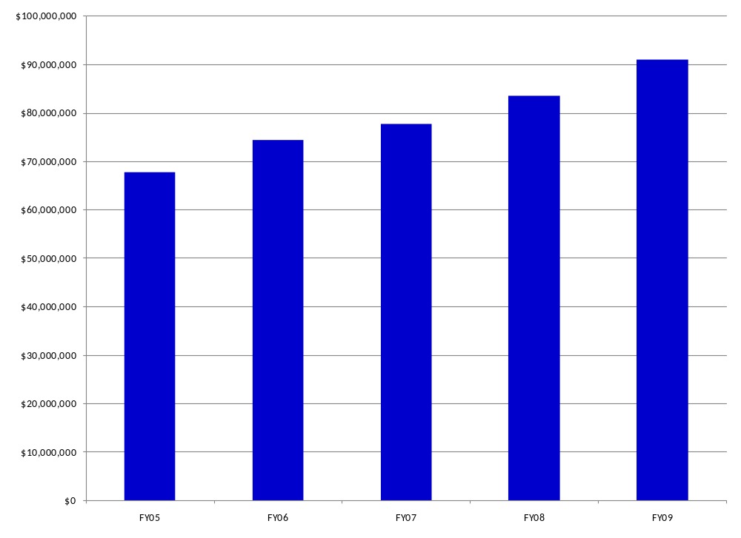
Source: HHS’ Human Resources Database
Contracting Officers’ Technical Representatives
COTRs are integral and valued members of the HHS acquisition workforce because they help to monitor and manage contracts. Further, these individuals provide the technical expertise necessary to convey the Government’s requirements, oversee the technical performance of the contractor, and ensure that deliverables meet the contractual requirements. As indicated in Figure 16 above, HHS’ COTRs represent 72 percent of the acquisition workforce.
Table 5 provides an overview of the technical aspects of contracting and the important role that HHS’ COTRs play in successful contracting.
Table 5. HHS’ COTR Responsibilities
CONTRACT PLANNING
- Advise on, or determine, a need for a product or service
- Analyze technical requirements of the product or service
- Conduct market research to establish technical requirements or identify the marketplace for goods or services
- Provide technical information to assist in determining type of contract and level of competition
- Prepare the statement of work (SOW) and help establish the solicitation’s technical terms and conditions
- Plan the technical aspects of the proposal evaluation process
CONTRACT FORMATION
- Serve on panels to evaluate bids and proposals
- Help establish the contract’s technical terms and conditions
CONTRACT MANAGEMENT
Administration:
- Serve as agency’s technical representative for contract administration
- Represent agency in technical meetings, record important facts
- Confer with program office and user groups on contract performance
- Maintain COTR file
- Assist contracting officer and contractor in understanding technical requirements
Monitoring the technical work of the contractor, and performing quality assurance and inspection of deliverables:
- Determine and list the deliverables required from the contractor, with due dates
- Monitor the contractor’s compliance with schedule (i.e., deliverables)
- Review and approve, or reject, technical deliverables
- Give technical direction to contractor
- Ensure all work is in accordance with the contract requirements
- Review and monitor progress reports and work plans
- Ensure the contractor is complying with its quality control systems
- Advise the CO of work that is accepted or rejected
- Ensure the contractor properly corrects all defects and omissions
Changes and modifications:
- Advise the CO of the need to issue change orders; develop estimates for equitable adjustments; and assist in evaluating contractor claims
- Perform a technical review of contractor proposed changes
Contractor human resources management and financial management issues:
- Ensure contractor displays required materials for EEO, contract laws, and job safety
- Report violations of labor standards to the CO
- Monitor time worked and contractor record-keeping procedures
- Ensure contractor enforces all health and safety requirements
- Ensure contractor assigns employees with the necessary capabilities, qualifications, and experience
- Review and quickly process contractor invoices
- Determine if progress or advance payment requests should be processed
Contract closeout or termination:
- Provide technical information for contract closeout and termination decisions
- Provide a copy of the COTR’s file to CO when duties end
Project and Program Managers
HHS’ PMs are located in each of its OPDIVs and are responsible for managing a wide variety of portfolios – such as information technology, construction, and research and development programs. Individuals in these multi-tiered positions are required to be knowledgeable and skilled in supporting, tactical, and/or major capital investments.
HHS’ PMs are categorized into three levels: Entry/Apprentice; Mid-level/Journeyman; and Senior/Expert. Experience, training, and role requirements for each of these levels are shown in Table 6.
Table 6. Project and Program Management Levels
Entry/Apprentice  (Level I) | Mid-level/Journeyman (Level II) | Senior/Expert  (Level III)
Experience: At least 1 year of project management experience within the last 5 years. Minimum experience should include:  - constructing a work breakdown structure;  - preparing project analysis documents;  - tailoring acquisition documents to ensure that quality, effective, efficient systems or products are delivered;  - analyzing and/or developing requirements;  - monitoring performance; assisting with quality assurance; and  - budget development. | Experience: At least 2 years of program or project management experience within the last 5 years that includes – at a minimum –experience required for the Entry/Apprentice level as well as the following:  - managing requirement changes  - performing market research;  - developing documents for risk and opportunity management;  - developing and applying technical processes and technical management processes;  - performing or participating in source selection;  - preparing acquisition strategies;  - managing performance-based service agreements;  - developing and managing a project budget;  - writing a business case; and  - strategic planning. | Experience: At least 4 years of program and project management experience on federal projects within the last 5 years that includes – at a minimum – experience required for the Mid/Journeyman level as well as the following:  - experience managing and evaluating agency acquisition investment performance;  - developing and managing a program budget;  - building and presenting a successful business case;  - reporting program results;  - strategic planning; and  - high-level communication with internal and external stakeholders.
Minimum Core Training:  24 hours - Basic Acquisition  24 hours - Basic Project Management  16 hours - Leadership and Interpersonal Skills  24 hours - Government-specific  24 hours - Earned Value Management and Cost Estimating | Minimum Core Training:  24 hours - Intermediate Project Management  16 hours - Leadership and Interpersonal Skills  24 hours - Government- specific  24 hours - Earned Value Management and Cost Estimating | Minimum Core Training:  24 hours - Advanced Acquisition Management  24 hours - Advanced Program/Project Management  16 hours - Leadership and Interpersonal Skills  24 hours - Government- specific  24 hours - Earned Value Management and Cost Estimating

Retirement Eligibility
Figure 19 shows that, of those in the GS 1102, 1105, and 1106 series, approximately one-third are retirement-eligible. Figure 20 shows that about half of the current COTR and PM workforce will be eligible for retirement by FY 2014. These numbers were derived by using the proportion of individuals in these series to the total number of HHS employees and applying that percentage to the number of individuals that will be retirement-eligible in general (based on data from the HHS Human Resources database).
Figure 19. HHS’ Contracting Workforce – Retirement Eligibility through FY 2014
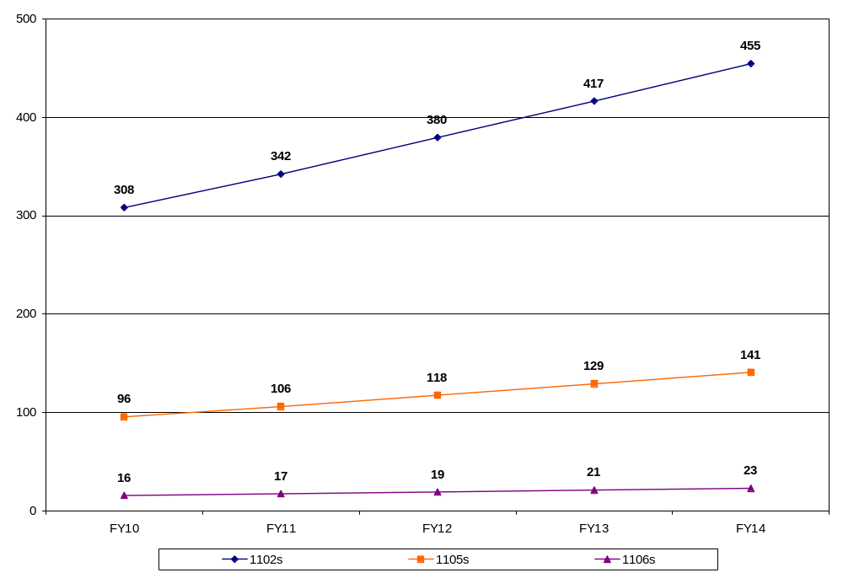
Figure 20. HHS’ COTRs and PMs – Retirement Eligibility through FY 2014
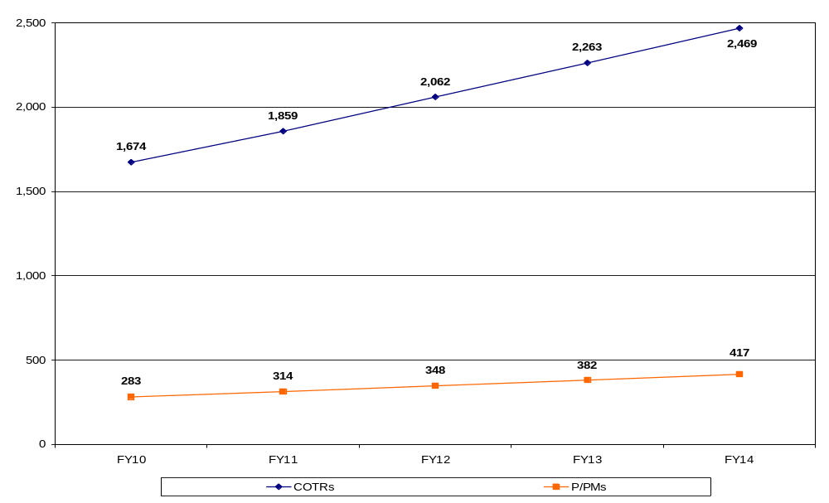
Use of Incentives for Contracting Series
Figures 21 and 22 display information concerning HHS’ historic use of certain types of incentives—cash awards, recruitment bonuses, retention bonuses, and relocation expenses—for the GS 1102, 1105, and 1106 series. Figure 21 shows, by FY, the aggregate amount spent on these types of incentives for FYs 2005-2009. Figure 22 shows the use of these incentives by contracting workforce series. In general, HHS has made limited use of incentives other than cash awards to recruit or retain contracting professionals. Cash awards during this time period accounted for between 1.5 to 2 percent of total salaries.
Figure 21. Total Incentives - Contracting Series– FY 2005 - FY 2009
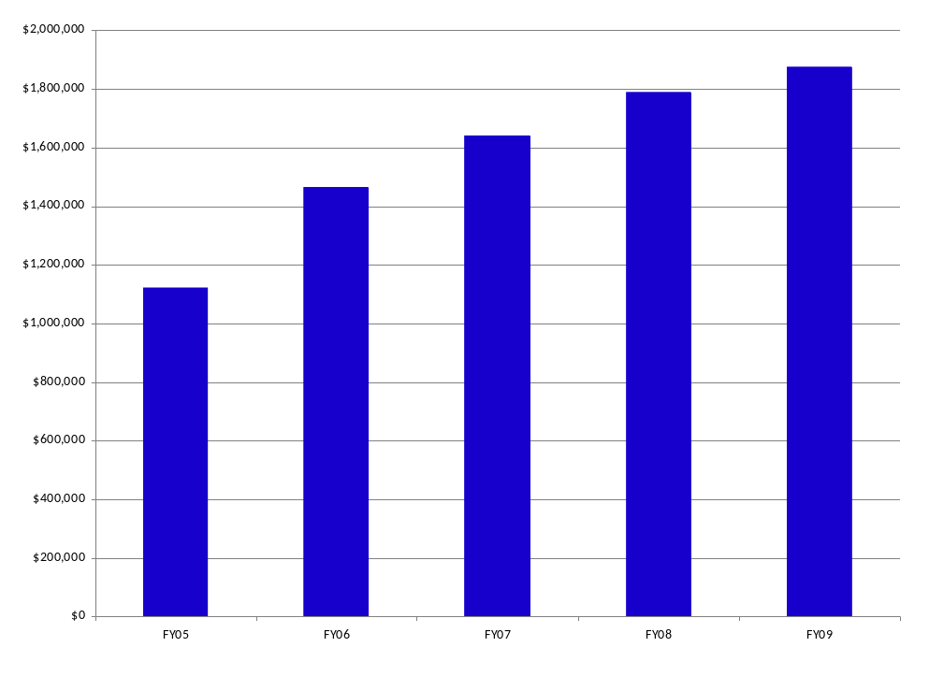
Source: HHS’ Human Resources Database
Figure 22. Total Incentives by Contracting Series – FY 2005 - FY 2009
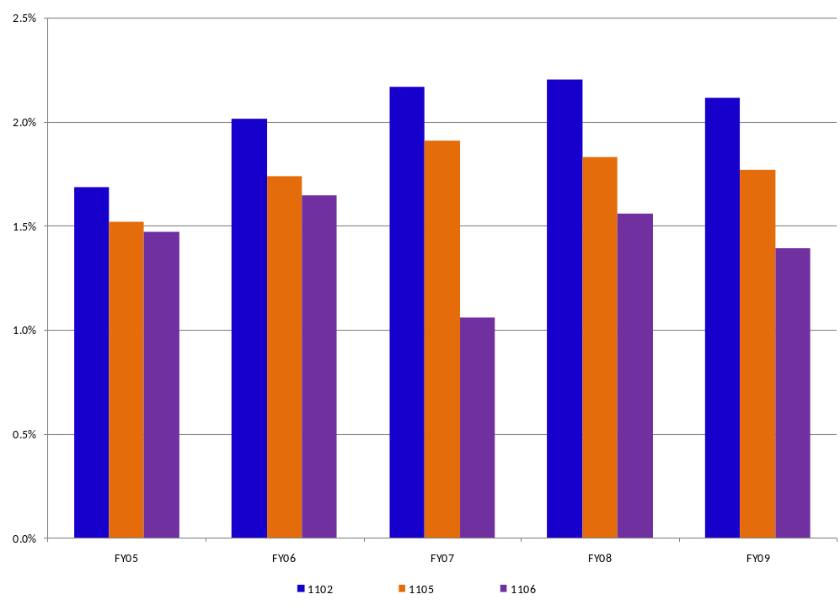
Source: HHS’ Human Resources Database

Appendix E – Acquisition Workforce Competencies
Competencies for FAC-C Certification
The required general and technical competencies for Contract Specialists to be FAC-C certified have been developed by FAI and are listed in Table 7.
Table 7. FAC-C Competencies
General Business Competencies
- Arithmetic  - Attention to Detail  - Contracting/Procurement  - Creative Thinking  - Customer Service  - Decision Making  - Flexibility  - Influencing/Negotiating  - Information Management  - Integrity/Honesty  - Interpersonal Skills  - Learning | - Math Reasoning  - Memory  - Oral Communications  - Planning and Evaluating  - Problem Solving  - Reading  - Reasoning  - Self-Esteem  - Self-Management/Initiative  - Stress Tolerance  - Teamwork  - Writing
Technical Competencies
Acquisition Phase:  - Acquisition Planning  - Strategic Planning | Project Management Phase:  - Project Management  - Contracting with Appropriate Government-wide Acquisition Systems  - Market Research

HHS assesses an employee’s ability to meet core contracting competencies by screening and selecting candidates for positions; assisting the employee and the employee’s supervisor in creating an Individual Development Plan (IDP) to close competency gaps and help achieve short- and long-term career goals; and identifying areas where training and special assignments will benefit the employee and HHS. HHS’ FAC-C certification process helps to validate and document the employee’s achievement of core contracting competencies.
Contracting Professionals—Competency Gaps
In 2007, over 70 percent of HHS’ contracting professionals in the 1102 series responded to the OFPP/FAI Acquisition Workforce Competency Survey. COTRs were not solicited for the 2007 survey. Analysis of the competencies for this survey revealed HHS gaps in the areas of Requirements Management, Dispute Resolution and Termination, Market Research, Financial Management, Negotiation, and Project Management.
In 2008, while only about a quarter of contracting professionals responded to the Acquisition Workforce Competency Survey, analysis showed that training is needed in Performance-Based Acquisition, Dispute Resolution and Termination, Small Business and Preference Program Participation, Financial Management, and Defining Requirements. Although HHS’ relatively low response rate for that survey did not rise to the level of statistical validity and lessened the ability to draw truly meaningful conclusions concerning its acquisition competency gaps, in part, the results continued to indicate a number of the gaps identified in 2007.
The results of our HHS 2010 survey are described in section IV of this plan.
Competencies for FAC-COTR Certification
FAI specifies 22 core competencies required for COTRs. HHS’ FAC-COTR program, which is discussed below, provides opportunities for obtaining each of the competencies shown in Table 8.
Table 8. FAC-COTR Competencies
General Business Competencies
- Attention to Detail  - Decision-Making  - Flexibility  - Influencing/Negotiating  - Integrity/Honesty  - Interpersonal Skills  - Oral Communication | - Planning and Evaluation  - Problem Solving  - Project Management  - Reasoning  - Self-Management/Initiative  - Teamwork  - Writing
Technical Competencies
- Acquisition Planning  - Market Research  - Defining Government Requirements in Commercial/Non-Commercial Terms  - Effective Pre-Award Communication | - Technical Analysis of Proposals  - Negotiation  - Effective Contract Management  - Performance Management

Contracting Officers’ Technical Representatives—Competency Gaps
A large majority of HHS’ COTRs are highly educated professionals serving in a variety of technical occupations. These individuals frequently work in highly complex research and development, construction, and information technology environments. Prior surveys indicated that these professionals manage contracts that involved multiple products and services—ranging from commercial off the shelf (COTs) products to professional consulting.
In 2008, a small number of COTRs participated in the FAI government-wide survey (in contrast to 2007 when COTRs were not specifically targeted as survey recipients). The government-wide analysis indicated that improved training in the competency areas of Defining Government Requirements in Commercial/Non-Commercial Terms, Performance Management, and Effective Contract Management are necessary for COTRs across the Federal government. The results of our HHS 2010 survey are described in section IV of this plan. Figure 23 shows COTR-identified competency gaps versus strength
Figure 23. COTR Top 3 Competency Strengths versus Gaps
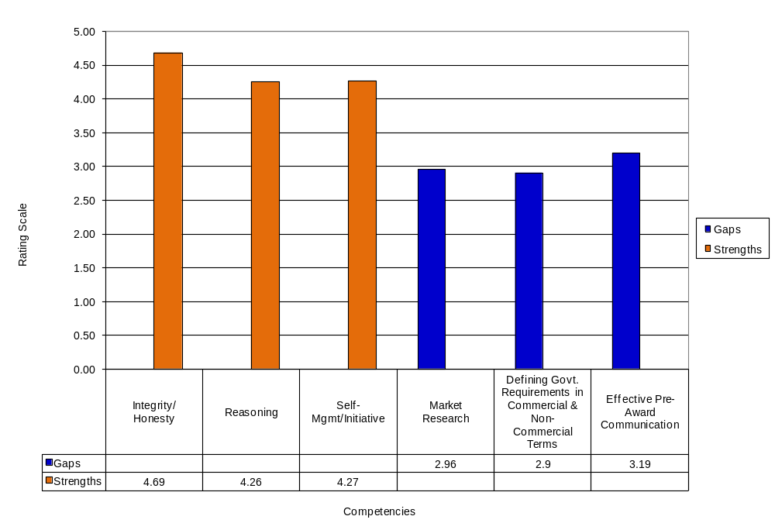
Competencies for Project and Program Management Certification
The Services Acquisition Reform Act of 2003, Public Law 108-136, expanded the definition and scope of acquisition to include activities, such as requirements development and performance management, that are performed by program and project managers. OFPP Policy Letter 05-01, “Developing and Managing the Acquisition Workforce,” (April 15, 2005) built on the Act’s broader definition of the acquisition workforce and required FAI to make recommendations for a project and program manager’s certification program. Accordingly, FAI partnered with 20 Federal agencies to recommend the competencies and framework for a FAC-P/PM program. OFFP issued a memorandum entitled “The Federal Acquisition Certification for Program and Project Managers,” dated April 25, 2007, which established the certification program’s requirements.
FAI specifies 22 core competencies for PMs. HHS’ FAC-P/PM program provides a succinct training crosswalk for achieving each of the competencies listed in Table 9.
Table 9. FAC-P/PM Competencies
General Business Competencies
- Customer Service  - Decision-Making  - Flexibility  - Interpersonal Skills  - Leadership  - Legal, Gov’t & Jurisprudence | - Oral Communication  - Organizational Awareness  - Problem Solving  - Reasoning  - Teambuilding  - Writing
Technical Competencies
- Business Process Re-Engineering  - Capital Planning and Investment  - Contracting/Procurement  - Cost-Benefit Analysis  - Financial Management | - Planning and Evaluating  - Project Management  - Quality Assurance  - Requirements Analysis  - Risk Management

Certification is required for PMs who are assigned to major capital investments as defined in Office of Management and Budget (OMB) Circular A-11, Part 7, Exhibit 300, Planning, Budgeting, Acquisition, and Management of Capital Assets. At HHS, an individual must obtain FAC-P/PM Level III certification within 1 year of the date of being assigned to an IT or construction major capital investment. Also, an individual must obtain FAC-P/PM Level II or I certification within 2 years from the date of being assigned to a non-major tactical or supporting IT or construction capital investment.
Project and Program Managers - Competency Gaps
In 2008, 49 out of 65 HHS’ Level III PMs participated in FAI’s Acquisition Workforce Competency Survey. FAI’s analysis indicated that training in the competency areas of Requirements Analysis (life-cycle and logistics), Financial Management (business, cost-estimating, and financial management), and Project Management (system engineering) was necessary.
HHS’ March 2010 Acquisition Workforce Training survey was sent to HHS’ entire PM population to gauge current competencies and training needs. The results are described in section IV of this plan.

