|  |
| --- |
| **Google Analytics for Government** |
| Quarterly Report Template |
|  |
|  |
| *Making sense of your Google Analytics data can be a daunting task. Sarah Kaczmarek partnered with the Howto.gov team to provide a quarterly report template to help you present metrics in a meaningful and engaging way. The Highlights section is a one page summary of key findings. The body of the report is designed around a series of high level questions about your website. The conclusion focuses on recent accomplishments and priority next steps, as well as identifying the authors of the report.* |
|  |
| **Sarah Kaczmarek**  Analyst, U.S. Government Accountability Office  Email: [kaczmareks@gao.gov](mailto:kaczmareks@gao.gov), Phone: 202-512-8590,  Online: [www.SarahKaczmarek.com](http://www.SarahKaczmarek.com), Twitter: [@StudioSarah](https://twitter.com/studiosarah)  *\*All views are those of Sarah Kaczmarek.* |
|  |
|  |

Agency.gov Quarterly Report

(Month – Month Year)

# Highlights

* **Traffic to Agency.gov increased/decreased by X% from the (last) quarter to the (this) quarter of FY13. Increase or decrease in traffic from the last quarter to this quarter.** This increase/decrease is primarily due (provide reasons why traffic may have changed, such as a spike in traffic during the last month of the quarter). Mobile traffic increased/decreased to X% of visits, up/down from Y% last quarter.
* **User engagement with Agency.gov was lower/higher than last quarter.** The bounce rate (measured by the percentage of users that entered and left the website from the same page) increased/decreased to X%, and a higher/lower number of visits, Y%, lasted 0-10 seconds.
* **X% of the traffic to Agency.gov was the result of (web searches, direct traffic, or referrals—note the primary source of traffic here).** Offer a description of this traffic source. For example, if most came by search, note what terms were they looking for that directed them to your site.
* **Some of the most frequent visitors to the site came from (other federal agencies, private companies, etc.).** Description of who these visitors are and their engagement with the site. For example, you can note whether the most frequent visitors were from other federal agencies, or from state governments.
* **(Optional if no primary customer) The primary customer was more/less engaged with Agency.gov than other users.** The primary customer had more/less returning visitors to the site, a longer/shorter average visit duration, viewed/less more pages per visit, and had a lower/higher bounce rate than the general public.
* **X% of the traffic to the site began on a sample page, and Y% of this traffic left without viewing any other pages.** While this bounce rate of X% may indicate users quickly found what they were looking for, there is an opportunity to improve design to further engage users.
* **Sample page and the home page were the most trafficked pages.** Overall,X% of all page views were of sample page and Y% of all page views were of the home page.

# Analysis

*Figure 1: Daily Visits to Agency.gov*

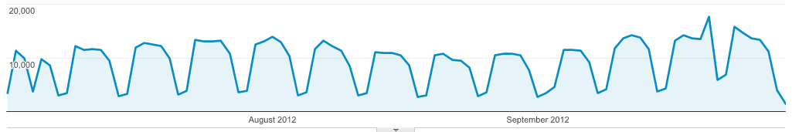 Explain spikes in traffic.

*Figure 2: Sources of Traffic to Agency.gov*

*Figure 3: Word Cloud of External Search Keywords that Generated Visits to Agency.gov*

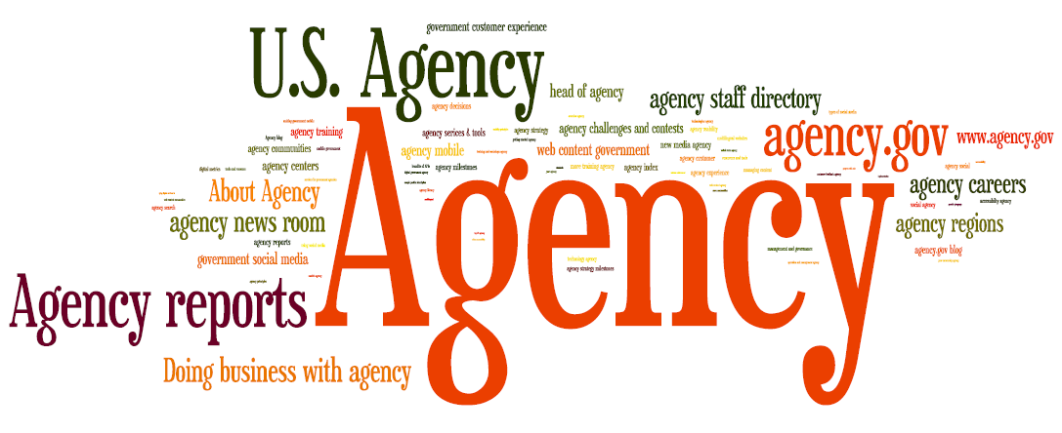

*Figure 4: Word Cloud of Internal Site Search Terms on Agency.gov*

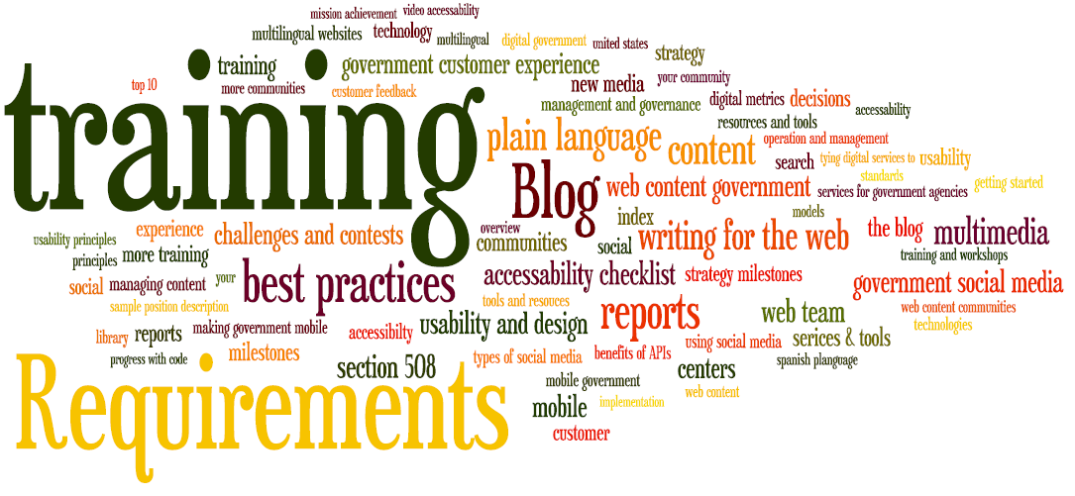

[A quick note on creating word clouds… These word clouds were made using the free site [www.Wordle.net](http://www.Wordle.net). To create word clouds in Wordle, follow these three steps. First, export your terms from Google Analytics to excel. Next combine the term or phrase with the number of visits, separated by a colon, using the concatenate function (=CONCATENATE(A2, “:”,B2). Finally, upload the new string to Wordle.net using the Advanced feature. Once you have created your word cloud you can change the layout, font, and colors.]

*Figure 5: Visitor Flow to Agency.gov*

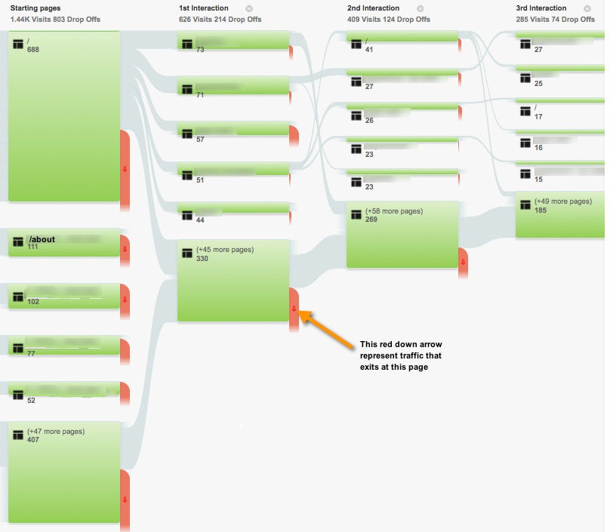

*Figure 6: Quarterly Pageviews of Key Sections of Agency.gov*

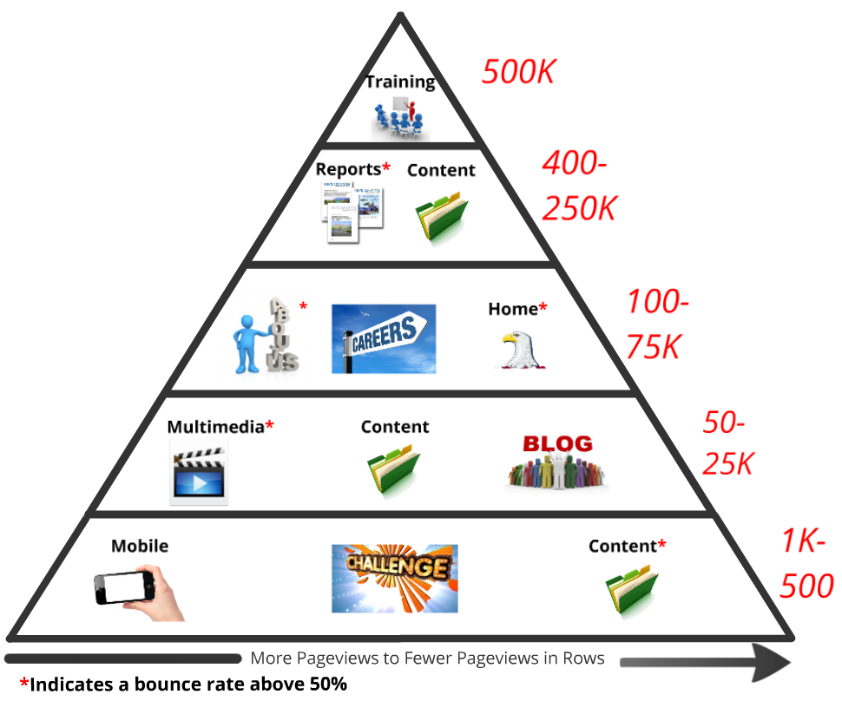

[A quick note about this graphic… The pyramid graphic was created using Prezi, a free online presentation tool. For a copy of this graphic in Prezi click [here](http://prezi.com/flfi4fv6gsin/pageview-pyramid/?kw=view-flfi4fv6gsin&rc=ref-16433502).]

# Recent Updates and Priority Next Steps

* Based on analysis of website metrics and usability testing (if applicable), we have improved the design of the… (Describe resent improvements to the site.)
* We are considering design enhancements to the… (Top priority focus for improvement.)
* While we are beginning to integrate X onto sample page, we could do more to graphically showcase the… (Second priority focus for improvement.)

# About Agency.gov Quarterly Reports

* In Month Year, Agency added Google Analytics to its website to gain insights into user engagement with Agency.gov. Report Author(s) analyzed Google Analytics metrics on users and prepared this report for the Office of Agency. The team is available to present this information at staff meetings. This is the X quarterly report prepared for Agency.